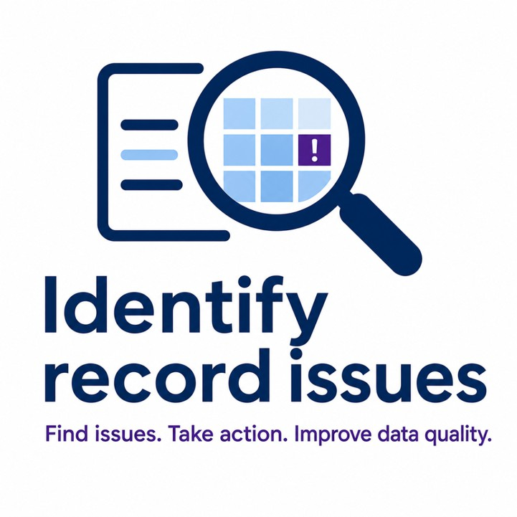

Training guide

Use the Identify Record Issues tool with confidence during routine casework

The data used in this document is fictional and is used for the purposes of illustration only

Table of Contents
Training guide 1
Purpose of this guide 2
Role of the team manager 3
Your role 4
You are expected to 4
You are responsible for 4
Purpose of the tool 4
What the tool does not do 5
How the tool works 5
Workflow of the tool 6
How it connects to existing processes 7
The expected flow is 7
Supporting your team 7
Onboarding new starters 8
Supporting tool access 8
Encouraging use of training materials 8
When to seek additional expertise 8
When to raise an incident request 9
Tool access 9
Granting & removing access 10
Sharing access 10
Resolving access issues 10
How the tool is used 10
What the tool does 11
What the tool does not do 11
What good usage looks like 11
What does the tool look like? 11
Search for a member 12
Member summary (basic data) 12
Validation notification banner 13
Core data sets 14
Identifying where issues exist 15
Row-level highlighting 16
Understanding corruption messages 16
Getting the most out of the tool 17
Ensuring effective use of features 18
How to support improvement 18
Compare data sets (critical feature) 19
How to use the ‘Compare data set’ feature 20
Updates and limitations: 21
Team metrics 23
Available metrics 24
How to use metrics as a team manager 25
Final checks and guidance 26
Key risks to monitor 27
Promoting consistency 27
Reinforcing the role of the tool 27
Additional support 27
Common questions (FAQs) 28
How do I get access for a new team member? 29
What should I do if someone cannot access the tool? 29
Where should my team access the tool from? 29
How do I know if my team is using the tool correctly? 29
What are common risks in usage? 29
What should I do if a member of my team has an issue? 29
What should I do if guidance is unclear? 30
Training materials 30
Where to training guides 31
Your role 31

For further assistance please review the video tutorials

Purpose of this guide
This guide is designed for team managers supporting the use of the ‘Identify record issues’ tool within their teams.
It focuses on:

- Supporting consistent use of the tool
- Managing access and resolving issues
- Using insights to improve performance and data quality

Use this guide to:

- Onboard new team members
- Support day-to-day use
- Reinforce good practice across your team

Role of the team manager

Your role
As a team manager, your role is to ensure your team:

  - Use the Identify record issues tool consistently
  - Interpret messages and information correctly
  - Make informed decisions based on evidence
  - Maintain high standards of data quality

You are expected to

  - Support your team to use the tool effectively
  - Identify where additional guidance or intervention is needed
  - Promote consistent approaches across your team
  - Ensure risks are understood and managed

You are responsible for

  - Adoption – ensuring the tool is used
  - Quality – ensuring outputs are understood and applied correctly
  - Consistency – ensuring similar cases are handled in similar ways
  - Support – ensuring your team knows where to go for help
The ‘Identify record issues’ tool is designed to support users in identifying potential data issues. It does not replace professional judgement. Your role is to reinforce this, ensuring the tool is used to inform decisions, not make them.

Purpose of the tool
The Identify record issues tool is part of the wider data correction and case handling service. It is used to:

  - Identify potential data issues early
  - Support investigation
  - Improve accuracy before decisions are made

This supports:

  - Faster case handling
  - Improved data quality
  - More consistent outcomes across teams

What the tool does not do
It is important to reinforce that the tool:

  - Does not fix data
  - Does not make decisions
  - Does not replace professional judgement

You should ensure your team understands:

  - The tool supports their work, it does not replace it
  - Outputs must be interpreted, not followed blindly
  - Final decisions remain with the team members

How the tool works
The tool checks a member’s record by comparing data across multiple datasets. Think of it like this:

Before you start your task, you can check to see if the members record is good or if it
has any corruptions that would slow you down before you begin your task.

A lot of corruptions can remain hidden in the data, so the tool is designed to highlight them easily and early for you to action.

Workflow of the tool
It is used:

  - Before or during case handling
  - To identify potential issues in member records
  - To support investigation and resolution

How it connects to existing processes
The tool works alongside:

  - Compendia
  - Existing validation and checking processes
  - Manual investigation where required

The expected flow is

- A case is received
- The record is checked using the tool
- Issues are identified and investigated
- Corrections are made in Compendia
- The record is rechecked using the tool

Key risks:
Not all issues are detectable by the tool.
This means:

  - The tool should not be used as the only source of validation
  - Manual checks and expertise remain essential
  - Users must apply judgement when reviewing outputs

Supporting your team
As a team manager, your role extends beyond access and oversight. You are key to building confidence and capability within your team.
You play a key role in helping your team resolve issues quickly and effectively. What action you take will depend on the type of issue.

Onboarding new starters

  - Ensure access is arranged early
  - Introduce the tool as part of existing training
  - Direct users to the ‘Quick Start’ and FAQs section of the guide

Supporting tool access
If a team member cannot find or access the tool:

  - Share the direct link to the tool
  - Direct them to the Pensions Hub where the tool is hosted If access needs to be granted or removed:
    - Contact your service delivery manager (SDM) to request this change

Encouraging use of training materials
Promote use of:

  - FAQs for quick answers
  - Share the training guide for deeper understanding
  - Use team discussions to revisit key concepts and address concerns

A confident team is more likely to use the tool effectively and consistently.

When to seek additional expertise
If the issue relates to a complex case or uncertainty in decision making:

  - Refer the query to a subject matter expert (SME)

When to raise an incident request
Raise a Halo incident request if:

  - An error page is shown when using the tool
  - A user cannot sign in to the tool
This ensures the issue is logged, tracked and resolved through the correct support route.

Tool access
As a team manager, you play an important role in ensuring your team can reliably access the Identify record issues tool.

Granting & removing access
For any changes to access permissions (including adding new users or removing existing users) you should liaise with your service delivery manager (SDM), who will action these requests through the appropriate process.

Sharing access
You will be provided with approved access links to share with your team. These should be used as part of:

  - Onboarding new starters
  - Supporting users who cannot locate the tool
  - Reinforcing access through team communications

Resolving access issues
If a pension admin experiences issues accessing the tool:

  - Encourage them to raise a Halo request
  - Alternatively, raise the issue on their behalf if needed

How the tool is used
The Identify record issues tool is designed to support users in identifying potential inconsistencies or corruptions across datasets.

What the tool does

  - Detects data corruption (broken or inconsistent data)
  - Flags integrity issues between datasets
  - Highlights where to investigate

What the tool does not do

  - It does not fix data
  - It does not guarantee a record is correct
  - It does not detect all corruption types - refer to the Pensions overview tab

What good usage looks like

  - Pension admins understand what the message is telling them
  - Pension admins compare relevant datasets appropriately
  - Pension admins make informed decisions based on evidence
Your role is not to teach every step, but to ensure your team understands how the tool supports their work and where its limits are.

What does the tool look like?

Search for a member

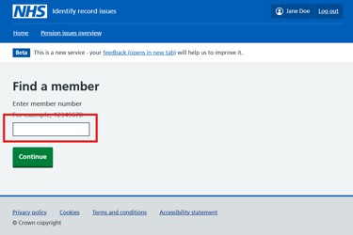
Figure 1 - Search for a member's record

How to search
  - Enter a unique member number into the search field
  - Select Continue

Key points:
  - You can search for one member at a time
  - You do not need to re-enter the member ID elsewhere


For more information consult the video walkthrough here

Member summary (basic data)
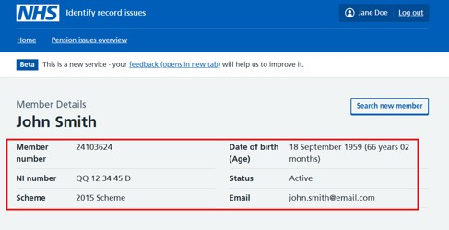
Figure 2 - Basic member information
Displays key identifying information:

  - Member number
  - Name
  - Date of birth
  - NI number
  - Scheme
  - Status

Why it matters:

Confirms you are working on the correct record before making changes.


For more information consult the video walkthrough here

Validation notification banner
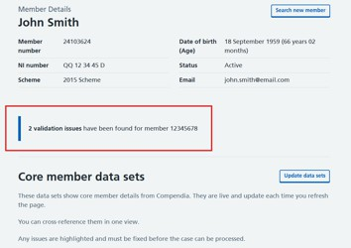
Figure 3 - Record corruption notification banner
What this tells you:
  - Whether issues exist on the record
  - The number of issues


For more information consult the video walkthrough here

Core data sets
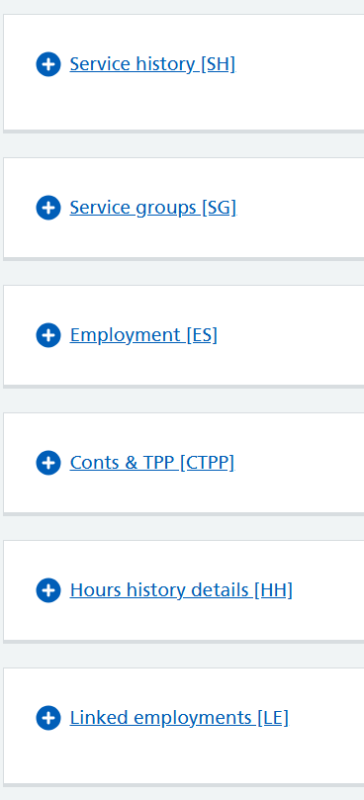
Figure 4 - Data sets on Identify record issues tool
These represent the data domains used in validation:
  - Service history [SH]
  - Service groups [SG]
  - Employment [ES]
  - Conts & TPP [CTPP]
  - Hours history details [HH]
  - Linked employments [LE]

How to use
  - Select a data set to expand
  - You can expand multiple data sets at a time
  - Review rows and highlighted issues within the sets


For more information consult the video walkthrough here

Identifying where issues exist
Each dataset shows:
  - Issue count (such as 1 issue found)
  - Visual emphasis on affected sets

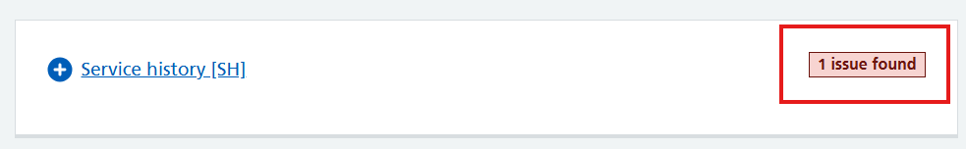
Figure 5 - Data set showing 1 corruption has been found
Key points
  - Identifies if, where, and how many issues exist within a set
  - If a set does not have an issue status - it’s likely the data is not corrupt

Row-level highlighting
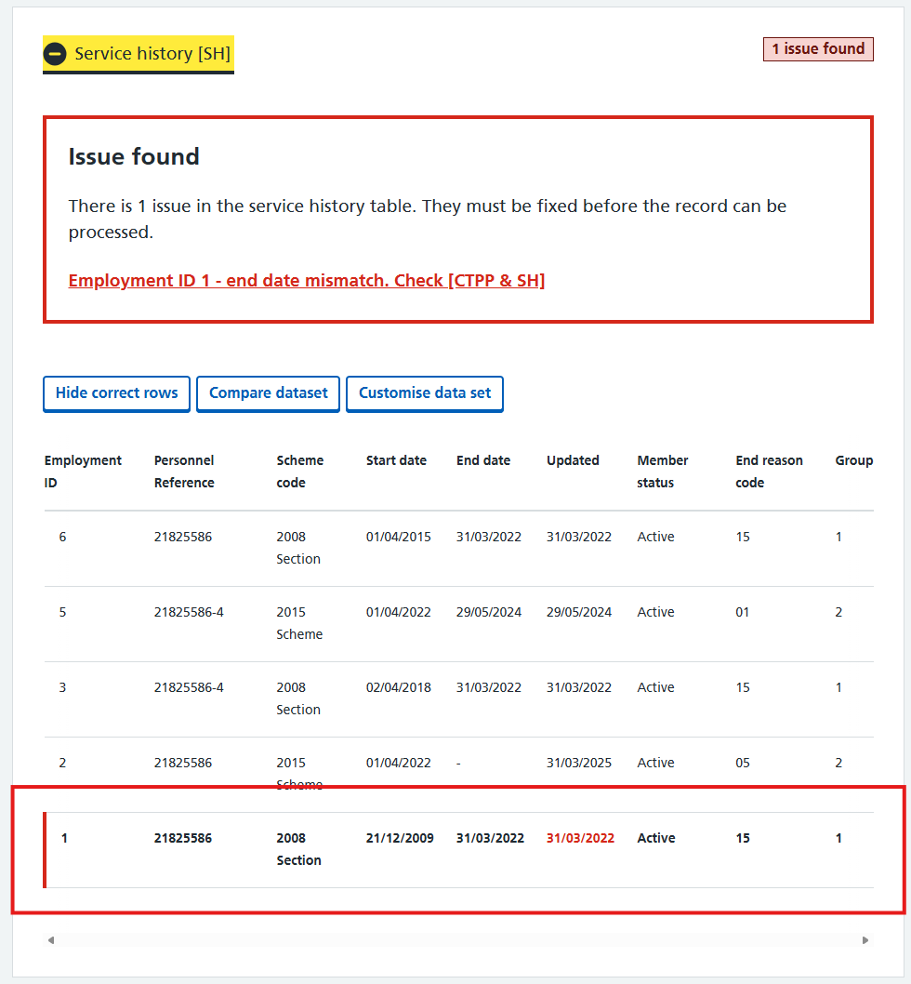
Figure 6 - Highlighted row indicating where the corruption is present in the data set
When a data set is open and where a corruption is present - the tool will highlight the affected row to help identify where the data is corrupted.
  - Specific rows are visually highlighted
  - These correspond directly to validation
failures
This helps you:

  - Pinpoint the exact record causing the issue
  - Spend less time searching for the problem

Understanding corruption messages
Each message tells you:
  - What is wrong
  - Which datasets are involved
  - Where to look
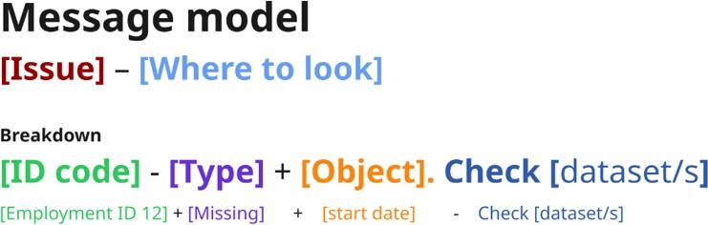
Figure 7 - Corruption message structure

For example:

“Mismatch scheme code. Check [SH & SG]”

This means:
  - Compare service history and service groups
  - Identify where scheme codes differ
  - Determine which is correct

Key notes:
  - While most messages follow this formula. Due to the complexity and verity of corruptions some messages may look different.


For more information consult the video walkthrough here

Getting the most out of the tool
As a team manager, you are responsible for ensuring your team is using the tool effectively and consistently.

Ensuring effective use of features
You should:
  - Encourage full use of key features (e.g. filtering, pagination, dataset comparison)
  - A comprehensive list of the tool’s features can be found in the pension administrators training guide
  - Check that users are not relying on partial views of data. Reinforce best practice through team discussions and reviews


For more information regarding the how to effectively use the tool and key features,
consult the video training material here

Key risks
Some risks to be aware of include:
  - Pension admins' not reviewing all pages of results (pagination risk)
  - Pension admins' overlooking certain datasets when comparing records
  - Misinterpretation of error messages

What to look for
  - Are Pension admins' using the tool?
  - Check the tool usage dashboard
  - Are Pension admins' checking all available data?
  - Are issues being consistently identified across the team?
  - Are similar errors being interpreted differently?

How to support improvement

  - Use team check-ins to reinforce good practice
  - Share examples of correct usage

  - Direct users back to the training guide where needed

Your role is to create consistency and ensure good practice.

Compare data sets (critical feature)

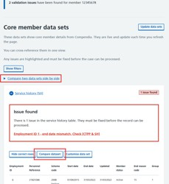
Figure 8 - How to compare data sets
This allows you to view two datasets side by side to trace mismatches.

Use when:

  - Investigating mismatches
  - A message refers to two data sets such as: Check [SH & CTPP]
  - Validating relationships between datasets (such as service history vs service groups)

How to use the ‘Compare data set’ feature

Step 1: Click compare data sets

  - You can decide to compare data sets from two areas on the tool.
- At the top of the data sets click to open the ‘Compare two data sets side by side’ link
- When in a data set - click ‘Compare data set’

Step 2: Choose datasets

  - You can only select 2 data sets
  - If you choose to compare data from within a set using the button - this set will be pre-selected for you
For example:

  - Left: Service history [SH]
  - Right: Service groups [SG]

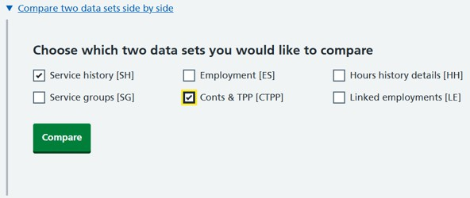
Figure 9 - Selecting the sets you want to compare

Why it’s useful:

This stops the need to screenshot data and allows you to compare live data from 2 sets next to each other to support your investigation.

Step 3: Check data

  - Work as normal to interrogate the data and investigate the issue
  - When you have finished with this view select the back button in the top left of the page

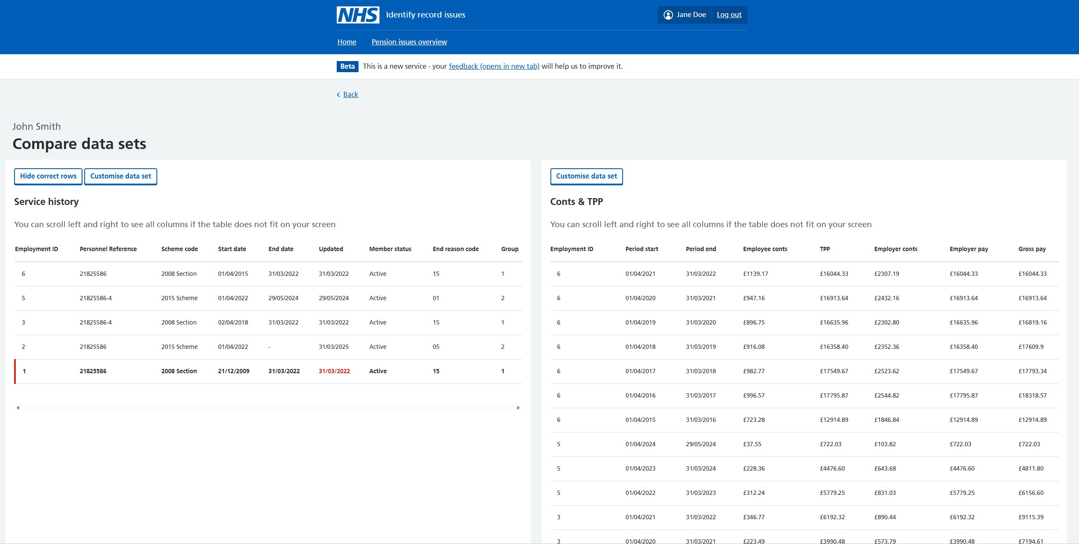

Figure 10 - Comparison view [SH & CTPP]


For more information consult the video walkthrough here

Updates and limitations:
The ‘Pensions overview page’ sits at the top in the header alongside the ‘Home’ option.
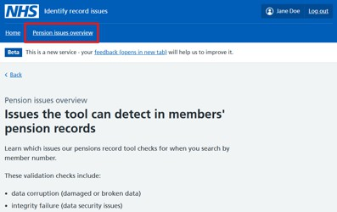
Figure 11 - Pension issues overview
The goal of this page is to help you:

  - Understand what checks exist
  - Confirm whether your issue type is supported
  - Understand limitations of the tool (what it cannot do yet)
The tool currently validates corruptions across these data sets:

  - Service history
  - Service groups
  - Employment
  - Conts & TPP
  - Hours history
  - Linked employment
These map directly to what you’ll see on the member details page.
Most importantly it details what the tool can do and what it can’t do.
If your issue is not supported by the tool:

  - Do not rely on the tool
  - Investigate manually

You are responsible for:
  - Investigating
  - Interpreting
  - Fixing


For more information consult the video walkthrough here

Team metrics
As a team manager, you can use service metrics to understand how your team is using the tool and where support may be needed.
These metrics help you:
  - Understand how the tool is being used
  - Identify where support or intervention may be needed
  - Monitor consistency and performance across your team

Access the metrics dashboard here.
Metrics are grouped across several pages to help you explore different aspects of usage and performance.

Available metrics

Usage
Shows how the tool is being used across your team.
  - Total users and potential users
  - Number of views and interactions
  - Overall engagement with the tool

Use this to understand:
  - How widely the tool is being adopted

Usage – individual
Shows usage at an individual level.
  - Who has accessed the tool
  - The date the tool was accessed

Use this to:
  - Identify who is and is not using the tool
  - Support conversations with team members and improve confidence

  - Ensure consistent adoption across the team

Average handling time (AHT)

Shows the time taken to action a case.

Use this to:
  - Compare performance between different metrics
  - Identify where handling time is higher than expected
  - Use insights to support coaching and process improvements

Average satisfaction rating (1–10)
Captures how users rate their experience of the tool.
Use this to:
  - Understand overall confidence in the tool
  - Identify trends in user sentiment
  - Keep in mind may factors can affect how a person is feeling

Ease of use (1–5)
Measures how easy users find the tool to use.
Use this to:
  - Identify usability issues
  - Understand where users may need additional support or training
  - Inform improvements to guidance and onboarding

How to use metrics as a team manager
Metrics should be used to support your team, not to measure individuals in isolation.
You should:
  - Look for patterns and trends, not one-off data points
  - Combine metrics with team feedback and observations
  - Use insights to guide coaching and support good practice
  - Review metrics regularly
  - Look for trends over time, not isolated data points
  - Use metrics alongside:
  - Your team’s feedback
  - Case outcomes
  - Your own observations
The metrics are there to support your judgement, not replace it.

Final checks and guidance
You should expect to see:

  - Consistent identification of issues across similar cases
  - Clear understanding of tool outputs and messaging
  - Evidence that users are reviewing all relevant data before concluding
  - Evidence the users are actively using the tool

Key risks to monitor
Be aware of common behaviors that can impact quality:

  - Assuming “no issues found” means no further validation is required
  - Missing issues due to incomplete review (e.g. pagination not fully checked)
  - Inconsistent interpretation of tool messages across team members

Promoting consistency
To support high-quality outcomes:

  - Encourage team discussions around complex or unclear cases
  - Share examples of good practice
  - Use the training guide as a reference point for alignment

Reinforcing the role of the tool
It is important to consistently reinforce that:

  - The tool supports identification of issues
  - It does not replace professional judgement
  - Final decisions remain the responsibility of the user

Additional support

  - Refer to the video tutorials linked in this guide
  - Use them alongside the training materials to reinforce understanding
This tool is here to help pension admins identify corruptions by supporting their investigation, not replacing it.

Common questions (FAQs)

How do I get access for a new team member?
Speak with your Service Delivery Manager (SDM) to raise a request through the SIAM process.

What should I do if someone cannot access the tool?
Ask them to raise a Halo request or raise one on their behalf if needed.

Where should my team access the tool from?
Share the access link or guide them to the home of the Identify record issues on the Pensions Hub.

How do I know if my team is using the tool correctly?
Look for consistency in how issues are identified and interpreted. Use team discussions and outputs to sense check.

What are common risks in usage?

  - Not reviewing all pages (pagination)
  - Misinterpreting messages
  - Over relying on the tool without validation

What should I do if a member of my team has an issue?

  - This depends heavily on the issue

  - Raise a service deck ‘Incident request’ if:
  - An error page is present
  - You cannot sign into the tool
  - Refer to an SME if the case is complex
  - Provide a link to the tool or Pension’s hub if they cannot find the tool
  - Contact your SDM to grant / remove access to the tool

What should I do if guidance is unclear?
Direct users to the training guide or raise feedback through appropriate channels.
Your role is to ensure your team feels supported, informed, and confident in using the tool.

Training materials
Guidance for the Identify record issues tool is available across multiple areas.

Where to training guides
Pension admins can access training support through:

  - The Identify record issues tool itself
  - The Pensions Hub
  - Formal training materials and syllabus
  - Pension Document Library
  - Community of Learning platform

Your role
You should:

  - Reinforce where guidance can be found
  - Encourage use of trusted sources
  - Avoid creation of duplicate or inconsistent materials
  - Pension Document Library (PDL) acts as the single source of truth

