|  |  |  |  |
| --- | --- | --- | --- |
| Document filename: | **<ProgrammeName>ReviewPack** | | |
| Project / Programme |  | Project | **TBC** |
| Document Reference | **<insert>** | | |
| Project Manager |  | Status | **WIP** |
| Owner |  | Version | **0.1** |
| Author | **Dr Munish Jokhani** | Version issue date | **13/08/2019** |

**<Programme Name>Review Pack**

Document management

Revision History

|  |  |  |
| --- | --- | --- |
| Version | Date | Summary of Changes |
|  |  |  |
|  |  |  |
|  |  |  |

Reviewers

This document must be reviewed by the following people:

|  |  |  |  |
| --- | --- | --- | --- |
| Reviewer name | Title / Responsibility | Date | Version |
|  |  |  |  |

Approved by

This document must be approved by the following people:

|  |  |  |  |  |
| --- | --- | --- | --- | --- |
| Name | Signature | Title | Date | Version |
|  |  |  |  |  |
|  |  |  |  |  |

Glossary of Terms

|  |  |
| --- | --- |
| Term / Abbreviation | What it stands for |
| FHIR | Fast Health Interoperability Resources |
|  |  |
|  |  |
|  |  |

Document Control:

The controlled copy of this document is maintained in the NHS Digital corporate network. Any copies of this document held outside of that area, in whatever format (e.g. paper, email attachment), are considered to have passed out of control and should be checked for currency and validity.

Contents

1 Introduction 4

1.1 Purpose of Document 4

1.2 Background 4

1.3 FHIR training material 4

2 Programme Overview 4

3 Clinical Scenario 4

4 Relevant Information Models 5

5 Architecture Overview 5

6 Links to Github 6

7 Review process 6

# Introduction

## Purpose of Document

The purpose of this document is to provide a Subject Matter Experts (SMEs) review pack for <>.

The audience of this document are the internal NHS Digital programmes using FHIR care connect resources and external stakeholders.

## Background

This document is released as phase 1 of the FHIR clinical and technical assurance process.The first phase involves creating a review pack for the external consultation which includes first draft of mapping by a core team which is published to the external community for a review period of 8 working days. Please see below diagram of the process.

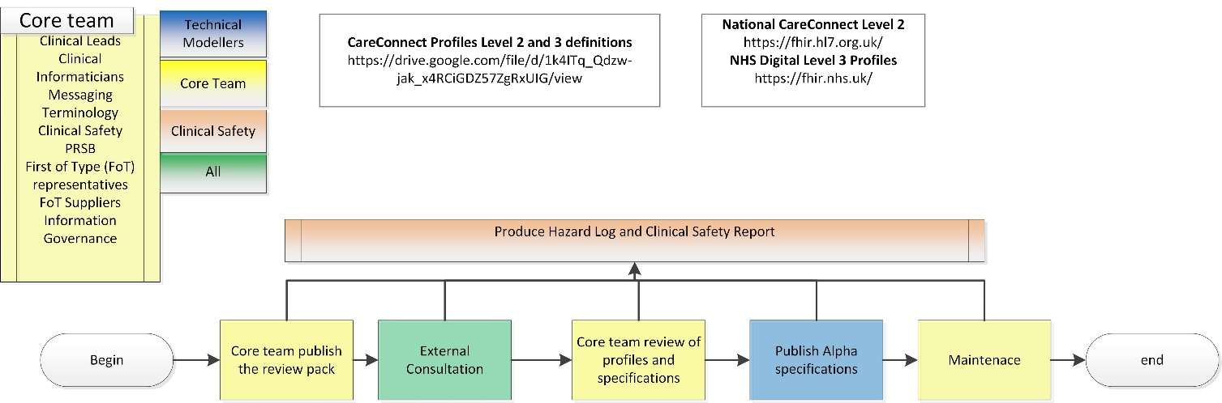

## FHIR training material

Introduction to FHIR video is available here:

<https://youtu.be/QnRgQ_dvkqc>

<https://youtu.be/BT17_5ROp3Q>

# Programme Overview

This section includes programme scope, vision, objectives and timelines.

# Clinical Scenario

*<example>*

* *Robert Smith is a 66 year old man who lives with his wife in a three bedroomed mid terraced house. He is a retired electrician.*
* *He has a past medical history of COPD and hypertension.*
* *He was referred to Hospital X MAU by his GP and subsequently admitted on the 15th April 2016. He had a 3 day history of increasing breathlessness, wheeze and a cough productive of yellow sputum. He had a low grade temperature of 37.7 degrees Celsius on admission.*
* *He made a rapid improvement, did not require any nebulised treatment on day 2 of his admission and was therefore discharged home on the evening of 16th April 2016*.

*</example>*

# 

# Relevant Information Models

*<Example>*

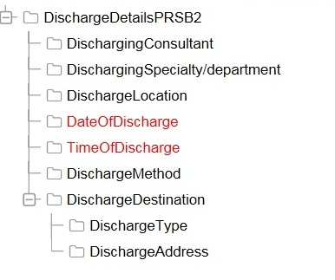

# Architecture Overview

<Example: to include FHIR paradigm e.g. REST, bundle, document and transport layer e.g. MESH>

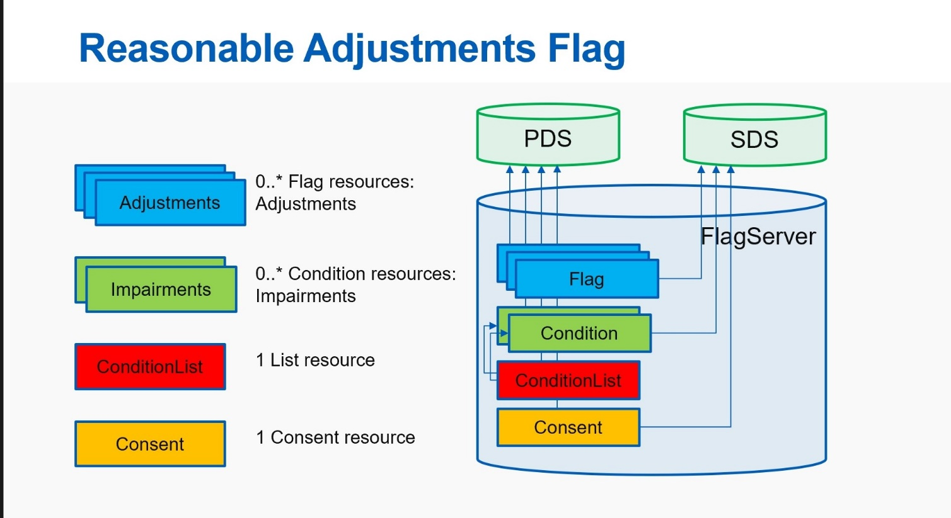

</Example>

|  |  |
| --- | --- |
|  |  |

# Links to Github

# Review process

* This review pack will be uploaded on Ryver with 8 working days to review the content.