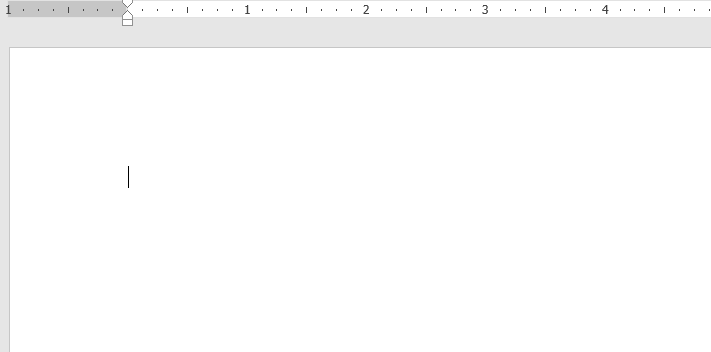

<image>1. Question 1

1. Answer 1.1

2. Answer 1.2

3. Answer 1.3

4. Answer 1.4

2

2. Question 2

1. Answer 2.1

2. Answer 2.2

3. Answer 2.3

4. Answer 2.4

4

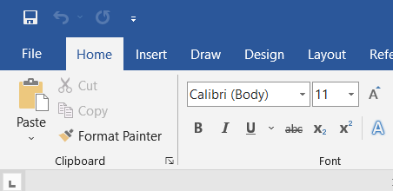

<image>3. Question 3

1. Answer 3.1

2. Answer 3.2

3. Answer 3.3

4. Answer 3.4

2