

**HTC University**

**Date: 13/05/2019**

**Prepared by:**

* Nguyễn Phi Hoàng
* Phạm Phú Thương
* Nguyễn Trung Chí

**Class: ACCP1508**

## **Faculty Guide:**



This is to certify that

Mr. / Ms.: .......................................................................

......................................................................................

......................................................................................

......................................................................................

Has successfully designed, developed and hosted

(HTC University)

Submitted by:

(Faculty Guilde’s Name and Signature)

***E-PROJECT INDEX***

1. INTRODUCTION
2. FUNCTIONAL REQUIREMENTS
3. ENTITY RELATIONSHIP DIAGRAM
4. USE – CASE DIAGRAM
5. WORKFLOW…
6. DATA FLOW DIAGRAM
7. TABLE…
8. DATABASE DIAGRAM…
9. ERD…

10. VIEW WEB PAGE…

1. **INTRODUCTION**

Currently, in the development of information systems, manual work is gradually replaced by simple operation on specialized computers and electronics. Specifically, a number of schools, business owners must manage the number of students, lecturers, courses, classes, and exponentially transcript

However, this can lead to inconvenience for business owners or student managers:

* Statistics of class time and courses
* Difficult to manage students when entering grades, number of students entering, number of classes
* Abundant human resources
* Difficult to manage

**a. Problem and solution**

**Human Resources**

To reduce manpower, save staff costs instead of having many employees. Business owners only need to hire marketing staff, lecturers, invoice importers and class managers, courses and courses for data entry for students.

**Difficult to manage**

Usually a manager must manage: teachers, courses, classes, test scores ... and must report test scores for each subject, course. However, to do this, the manager will have to deal with a lot of papers while not taking into account the loss of documents. This issue requires a software that can store student data, lecturers, classes, courses, and test scores.

**b. Benefits of the solution**

* + Easy student information
  + Easily find birth information
  + Easy to manage
  + Easily track the development of your business
  + Employees work more effectively

**c. Some key features of the solution**

* + Employees can search, view student information
  + Managers can manage students, lecturers, manage courses, classes, test scores ….
  + Business owners can view sales statistics by classes and courses

1. **FUNCTIONAL REQUIREMENTS**
   1. **Administrator**

### Login to the first page.

### Create new user.

### Edit user details.

### User profile.

### Role user.

### View all user.

### Create class.

### Update class.

### Create course.

### View all course.

### Create subject.

### View all subject.

### Update course.

### Update subject.

### Logout.

* 1. **User**
* Login to the first page.
* Change the password after login into the system.
* View course.
* View subject.
* View total marks.
* Contact us manager.
* Logout.

1. **ENTITY RELATIONSHIP DIAGRAM**
   1. **User – Role**

## 

* 1. **User - Class**

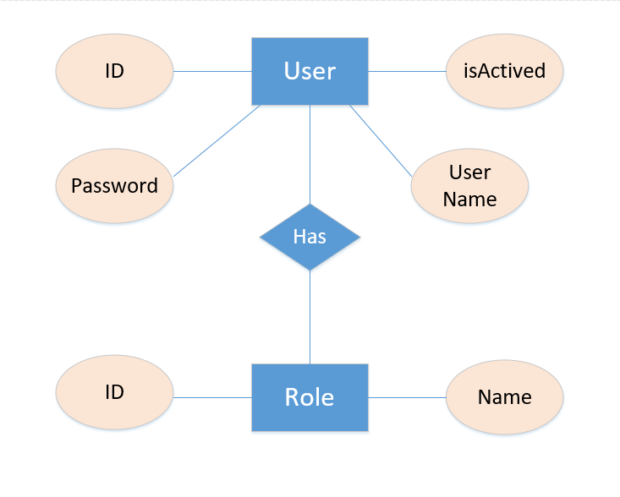

* 1. **Class – Course**

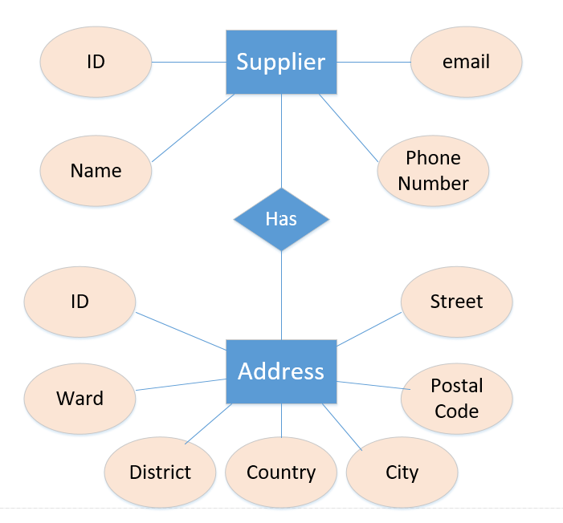

* 1. **Course – Subject**

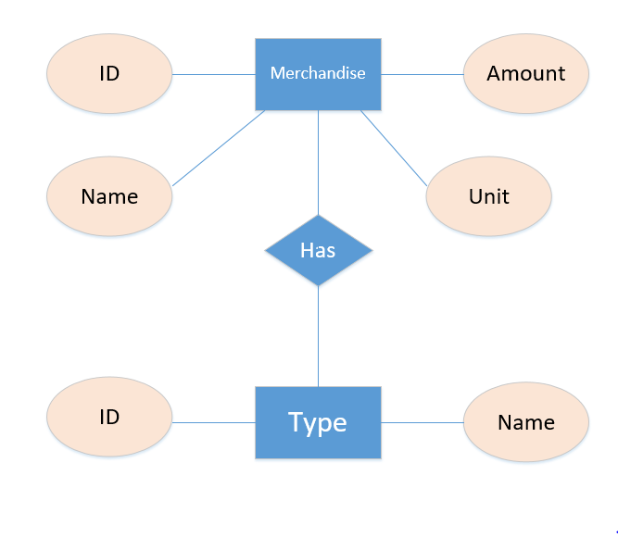

* 1. **Subject – Exam**

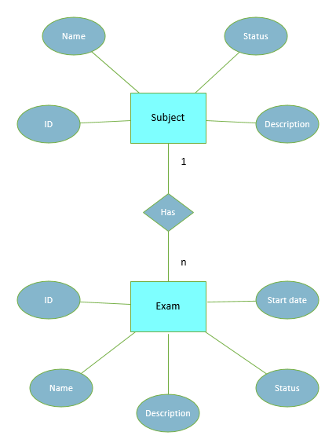

* 1. **Exam – Exam Result**

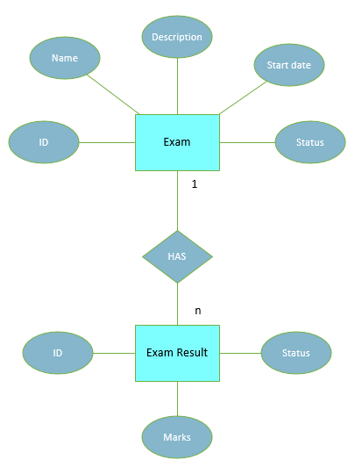

* 1. **User – Exam Result**

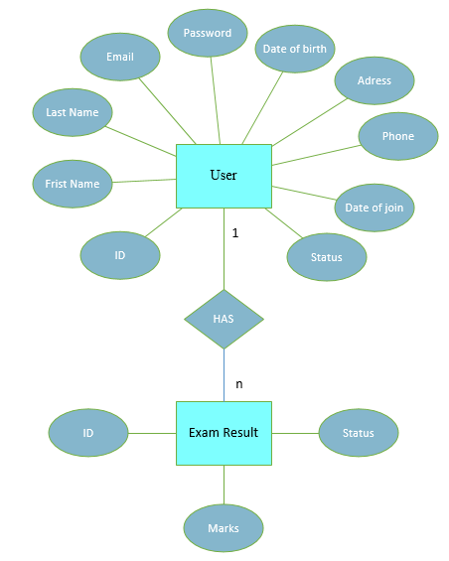

1. **USE – CASE DIAGRAM**
   1. **Overall Diagram**

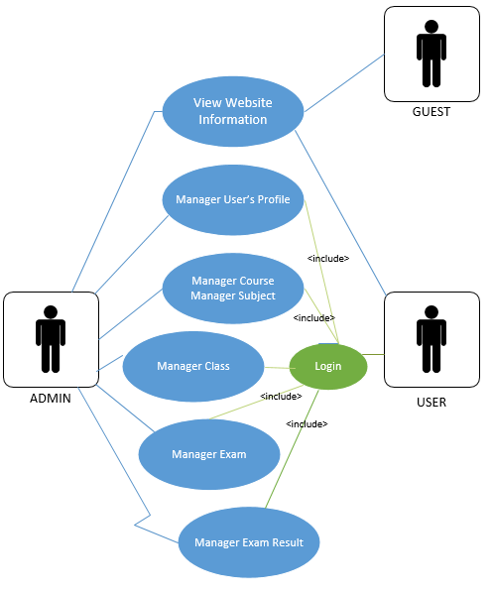

* 1. **View Website Use - Case**

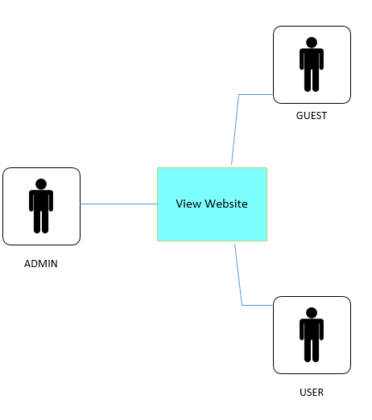

* 1. **Admin of User Use - Case**

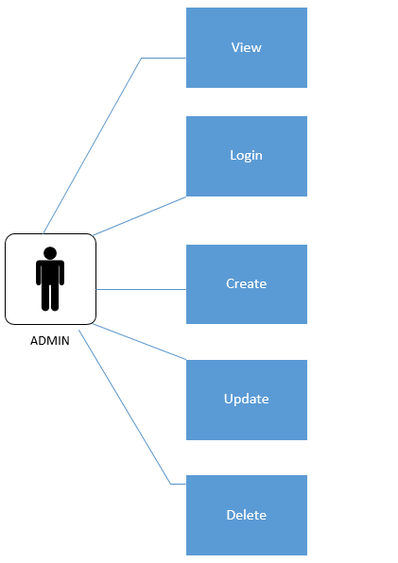

* 1. **Admin Manage Course Use - Case**



* 1. **Admin Manage Subject Use** - **Case**



* 1. **Admin Manage User’s Profile Use – Case**



* 1. **User Manage User’s Profile Use – Case**

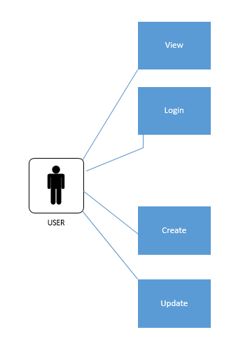

* 1. **User View Transcript - Use Case**

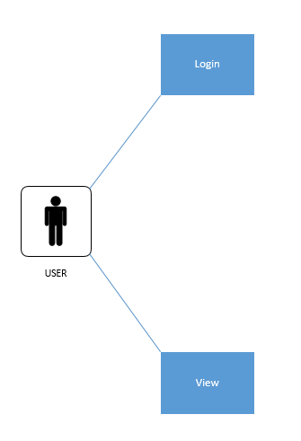

* 1. **User Manager Exam Result Use – Case**

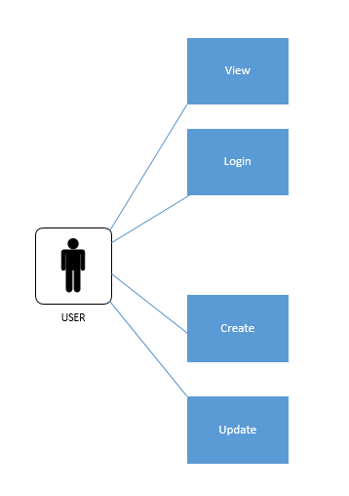

1. **WORKFLOW**
   1. **Login workflow**

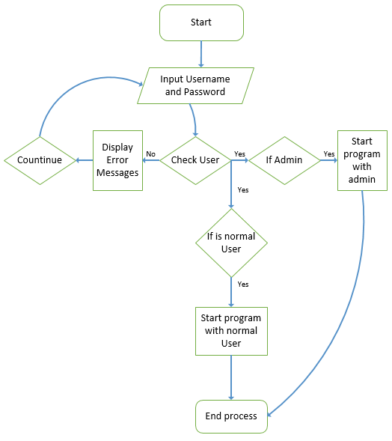

* 1. **New user workflow**   
     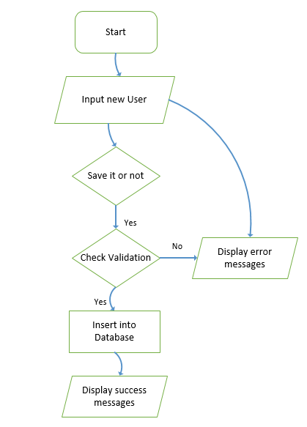
  2. **Edit user workflow**   
     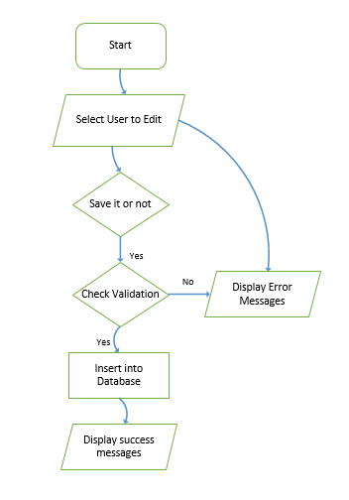
  3. **Delete user workflow**   
     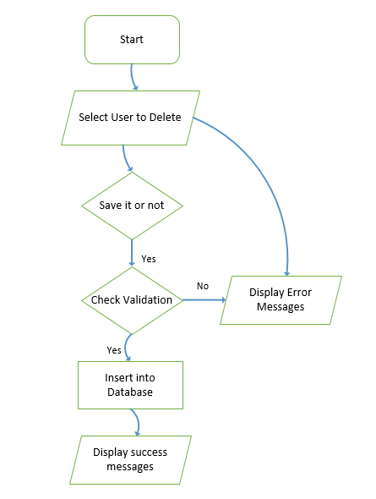
  4. **New course workflow**   
     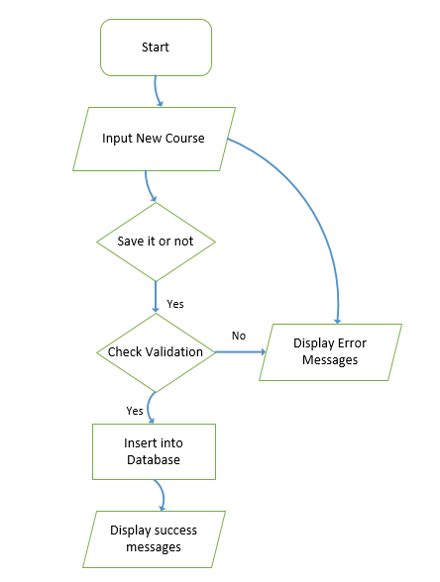
  5. **Edit course workflow**   
     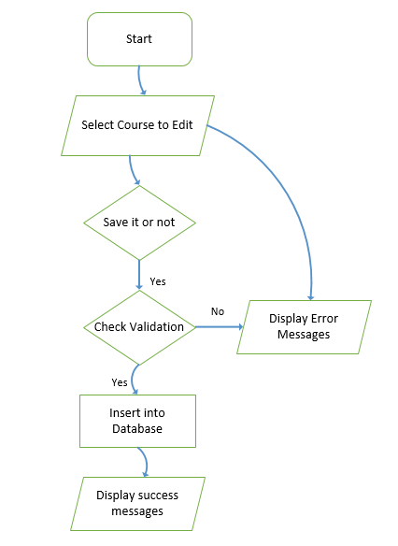
  6. **Delete course workflow**   
     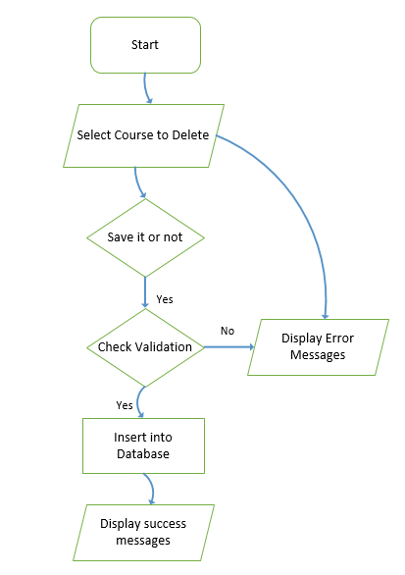
  7. **New subject workflow**

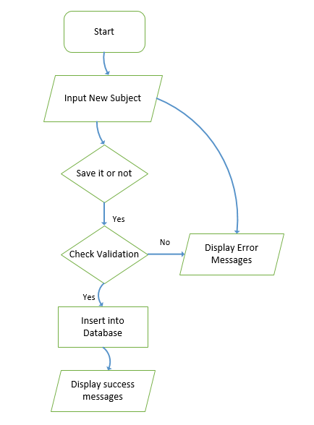

* 1. **Edit subject workflow**

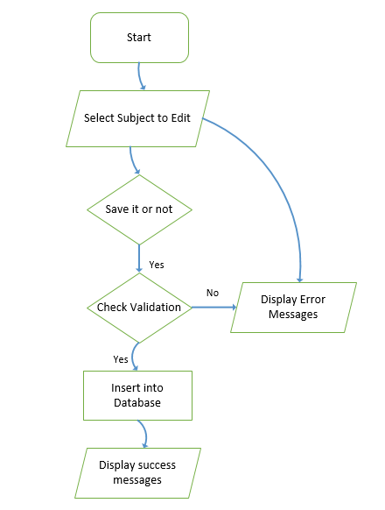

* 1. **Delete subject workflow**

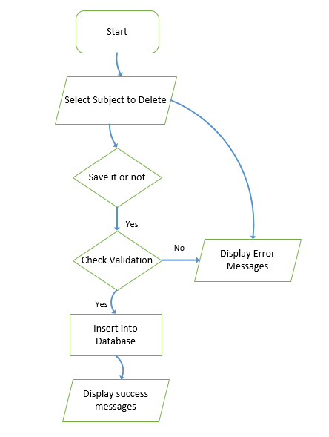

* 1. **View marks of user exam result workflow**

## 

* 1. **Edit marks of user exam result workflow**

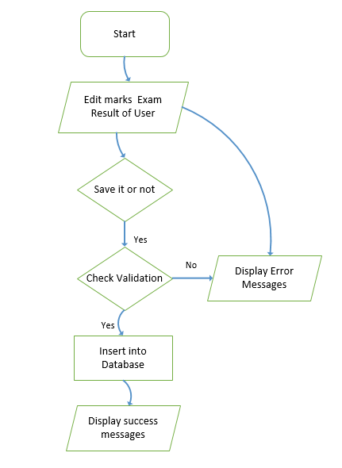

1. 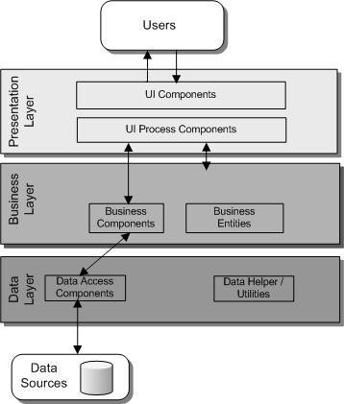 **DATA FLOW DIAGRAM**
2. **TABLE**
   1. **User**

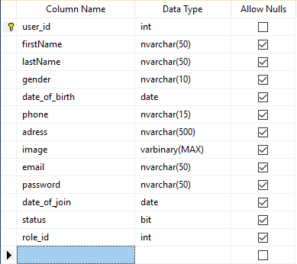

* 1. **Roles**

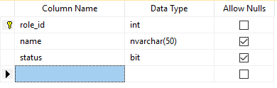

* 1. **Class**

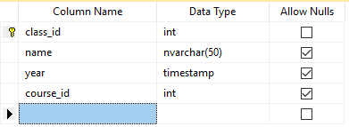

* 1. **Classroom**

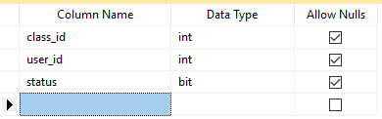

* 1. **Course**

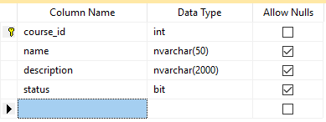

* 1. **Subject**

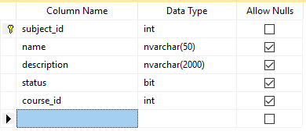

* 1. **Exam**

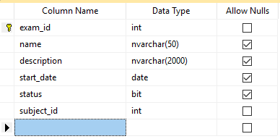

* 1. **Exam Result**

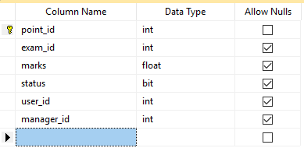

1. **DATABASE DIGRAM**

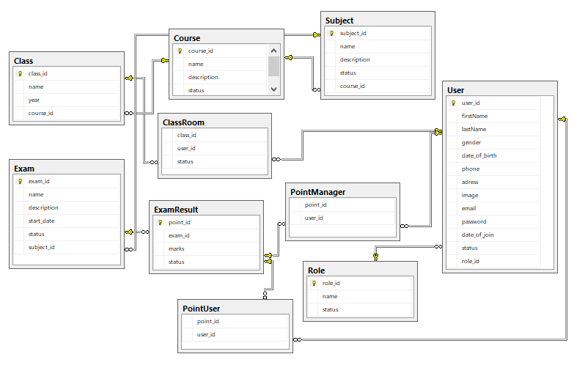

1. **ERD**
2. **VIEW WEB PAGE**