1.

*On May 26 and June 9, Chinese boats cut cables from Vietnamese oil exploration ships, Vietnamese officials say. Vietnam formally protested, saying the ships were inside its exclusive economic zone, 200 nautical miles off its coast. China contends that the ships were outside the zone. In the second case, Chinese officials say, armed Vietnamese ships were chasing a Chinese fishing vessel from the area, and a fishing net accidentally snagged the cable.*

The **Binh Minh 2** and **Viking 2** (the names of the Vietnamese seismic survey vessels) incidents have caused the latest tension between China and Vietnam, and could potentially escalate armed conflicts in the region. Knowing where the ships actually were is undoubtedly important. It could help understand the intentions behind and, at the very least, who is to blame.

Unfortunately, the details of such incidents are typically hard to verify, as there are no other witnesses beside the involved parties. For years, Vietnamese fishermen have complained about the harassments of Chinese forces in the Southeast Asia Sea. These stories rarely made international news, except for the [latest one](http://www.google.com/hostednews/ap/article/ALeqM5gvvrZYDTUCJKEHZhKhRUViJ10dKQ), partly because the facts could not be easily validated.

One tearful example of such incidents is the [Gulf of Tokin massacre](http://www.vpa.org.vn/detail_temp.jsp?page=34&id=462&cate_id=21) in 2005 where Chinese marine police opened fire at 2 Vietnamese fishing boats, killing 9 and injuring 7. China claimed that the Vietnamese fishing boats had opened fire on Chinese fishing boats to rob them. Vietnam claimed that the boats were legally fishing in the Gulf of Tonkin at the time of attacks.

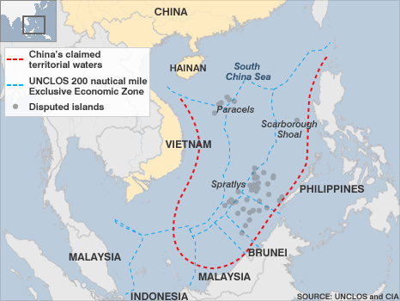

On another note, it is also worth pointing out that China’s claim based on the [U-shaped line](http://en.wikipedia.org/wiki/Nine-dotted_line) could very well overlap other claimants’ EEZs thus making them contested areas. Being inside one’s own EEZ does not necessarily mean being outside the disputed zone with China.

See [here](http://unclos1982.com/2011/06/21/how-china-can-avoid-next-conflict-minxin-pei/#2) and [here](http://unclos1982.com/2011/06/21/how-china-can-avoid-next-conflict-minxin-pei/#3) for quick analyses on the locations reported by Vietnam of the two incidents on May 26 (Binh Minh 2) and June 9 (Viking 2).

2.

*The territorial issue remains the time bomb, Mr. Cole said. “Neither Beijing nor Hanoi has given any indication that they are willing to back off their claim to complete sovereignty over the land features,” he said. “That is the crux of the issue.”*

Mr. Cole is correct that neither Beijing nor Hanoi is willing to back off their claim to complete sovereignty of the Paracels and Spratlys. However, the effect of these tiny islands on the Southeast Asia Sea disputes is still unknown because China is deliberately unclear about how the [U-shaped line](http://en.wikipedia.org/wiki/Nine-dotted_line) is drawn to show which waters it contains.

This article quoted Hong Lei that China has indisputable sovereignty over the islands and adjacent waters. But China has never described the adjacent waters. Is it the 12 nautical miles of territorial waters, or the EEZs, or the whole Southeast Asia Sea?

Had the disputed territory in the Southeast Asia Sea been clearly confined to the islands and their effective EEZs, the [media](http://unclos1982.com/2011/06/21/how-china-can-avoid-next-conflict-minxin-pei/) would have been more careful to say that the recent incidents (i.e. the Binh Minh 2 and Viking 2) happened in disputed areas.

The territorial issue in the Southeast Asia Sea would not budge an inch until China shows some real effort to clarify its claim.