1.

*As we now know, Clinton’s remarks in Hanoi in July 2010 marked a watershed in two important aspects. It decisively shifted the* perception *of the balance of power in the region. Prior to the Clinton statement, China was thought to have gained the upper hand in the region through years of painstakingly pursuing a ‘charm offensive.’*

China’s approach to the Southeast Asia Sea disputes with its neighbors cannot be solely described as a “charm offensive pursuit”. Among the Vietnamese, China is very well-known for its use of armed vessels to aggressively terrorize Vietnamese fishing activities in recent years.

On 01/08/2005, Chinese marine police opened fire at 2 Vietnamese fishing boats, killing 9 fishermen and injuring 7. The boats were [reported](http://www.vpa.org.vn/detail_temp.jsp?page=34&id=462&cate_id=21) to be fishing at 19.16oN and 107.06oE in the Gulf of Tokin when this massacre happened.

Following this event, Chinese armed fishery administration vessels have repeatedly [detained](http://tuoitrenews.vn/cmlink/tuoitrenews/features/east-sea-vn-fishermen-s-home-away-from-home-1.33528), asked for ransom, [harassed](http://vi.wikipedia.org/wiki/Vi%E1%BB%87c_Trung_Qu%E1%BB%91c_b%E1%BA%AFt_ng%C6%B0_d%C3%A2n_Vi%E1%BB%87t_Nam_n%C4%83m_2009) and even opened fire at Vietnamese fishing boats. China also enforces annual unilateral fishing bans from May to August on the Southeast Asia Sea which it ambiguously claims with the [U-shaped line](http://en.wikipedia.org/wiki/Nine-dotted_line).

As the U.S. Department of State [noted](http://www.state.gov/r/pa/ei/bgn/4130.htm):

*“Over the years, conflicting claims have produced small-scale armed altercations in the area; in 1988, 70 Vietnamese sailors died in a confrontation with China in the Spratlys. China's assertion of "indisputable sovereignty" over the Spratly Islands and the entire South China Sea has elicited concern from Vietnam and its Southeast Asia neighbors. Tensions escalated in the latter half of 2007 as, according to press reports, China pressured foreign oil companies to abandon their oil and gas exploration contracts with Vietnam in the South China Sea, including pressuring U.S. firm ExxonMobil to drop an exploration agreement with Vietnam in July 2008 in the same waters.”*

2.

*But that isn’t the case with the Paracels, which China has effective control over, but which Vietnam continues to claim. The 200-mile EEZ of the Paracels and the 200-mile EEZ extending from Vietnam’s coastal line overlap. According to reports, the incident in which a Chinese patrol boat severed the multi-million dollar seismic survey cable operated by a PetroVietnam research vessel took place in this disputed zone.*

The **Binh Minh 2** (the Vietnamese research vessel’s name) incident was [reported](http://www.vietnamplus.vn/Home/Tau-hai-giam-Trung-Quoc-vi-pham-vung-bien-VN/20115/91358.vnplus) to take place at 12o48’25”N and 111o26’48”E, 120 nautical miles (NM) from Vietnam’s continental coast and 180 NM from the Paracels’ Triton Island. Triton Island is a barren rock that does not support human habitation or an economic life of its own, so it would be absurd to say that it has an EEZ out to 180 NM, while the continental coast has only 120 NM. As shown in this [map](http://www.seasfoundation.org/library/doc_download/12-maps-of-binh-minh-and-viking-incidents), the location (marked as X) lies within the Vietnamese side of the equidistance line (the green line in the map) between the Paracel Islands and Vietnam’s coastline.

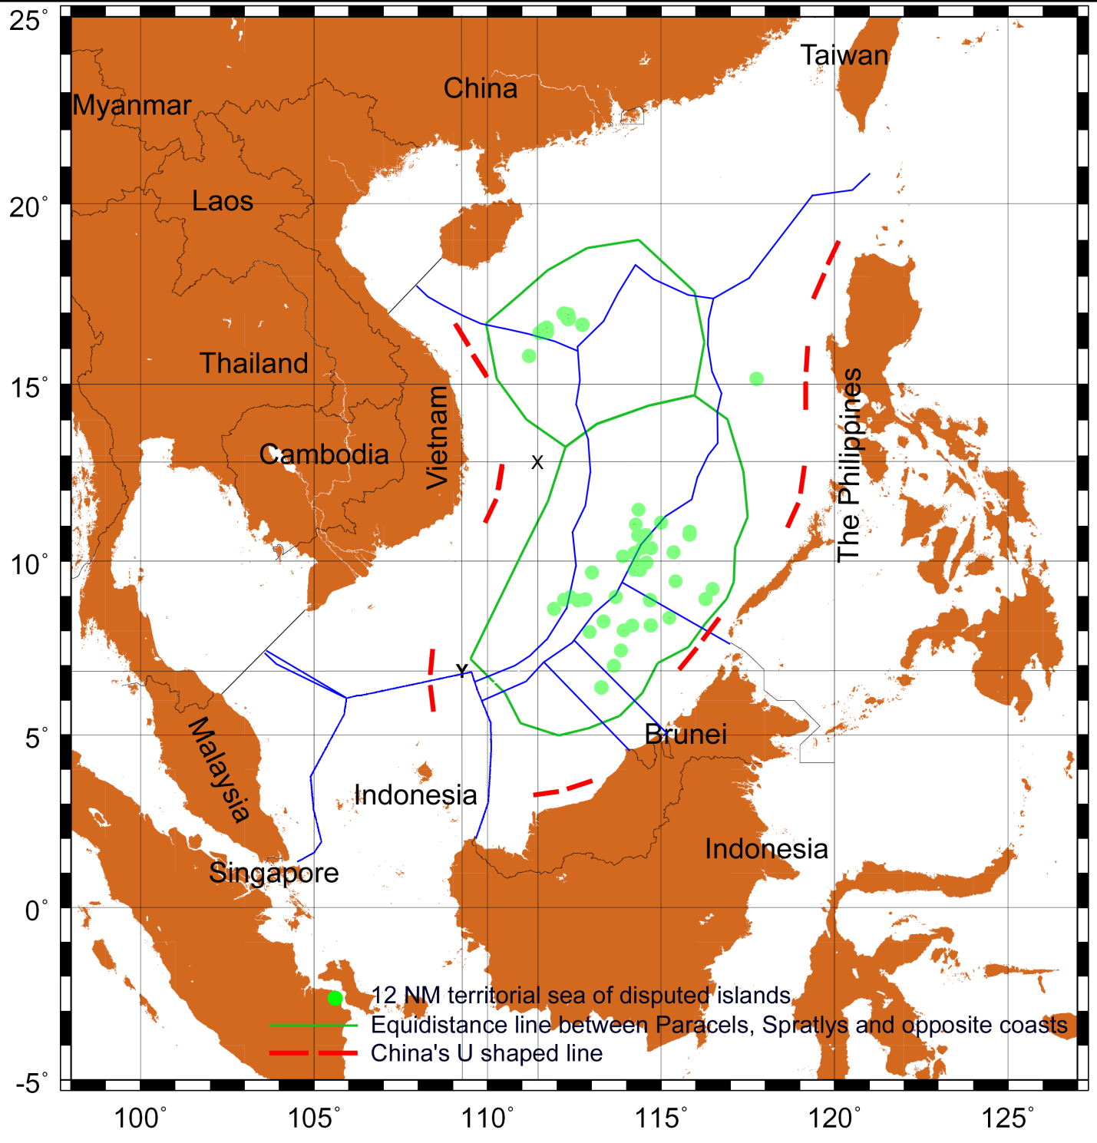

Even if the contested Paracel Islands have EEZ, due to the fact that they are tiny islands, the largest being 1.5 km2, their EEZ will fall far short of the equidistance line. If China’s claim of the waters is based on the Paracels’ EEZ, then only the Paracels’ EEZ is the contested area because Vietnam has also been claiming the sovereignty over the Paracel Islands.

Since the incident cannot happen in the EEZ of the Paracel islands, it did not happen in a disputed zone based on UNCLOS 1982.

The only thing that makes it a disputed zone is China’s [U-shaped line](http://en.wikipedia.org/wiki/Nine-dotted_line), which ambiguously claims other countries’ EEZs and is unsubstantiated based on international law.

Furthermore, if China's view is that the Paracels have EEZ out to 180 NM then the Qiongdongnan basin, in which China intends to carry out oil and gas activities, is also disputed territory.

3.

*The June 9, 2010* [sic] *incident in which a Chinese fishing boat damaged the survey cable of a Vietnamese research ship occurred in an area in the Spratlys far from Vietnamese shores.*

If the author referred to the **Viking 2** incident, which occurred on June 9, 2011, then it again would be unreasonable to say that the incident took place “in an area in the Spratlys far from Vietnamese shores”.

According to the [press briefing](http://www.mofa.gov.vn/en/tt_baochi/pbnfn/ns110610145220) by Vietnam’s Ministry of Foreign Affairs, the coordination of the seismic exploration ship Viking 2 was at 6o47’5” N and 109o17’5”E when its research cable was run into and disabled by three Chinese vessels. The location is marked as Y in the [map](http://www.seasfoundation.org/library/doc_download/12-maps-of-binh-minh-and-viking-incidents) above.

Below are the distances from Viking 2 to surrounding territories, calculated using the Generic Mapping Tool software with the “Global Self-consistent, Hierarchical, High-resolution Shoreline Database” (GSHH) dataset:

|  |  |
| --- | --- |
| **Territory** | **Distance (NM)** |
| Spratly Island (nearest Spratlys feature that could possibly have any EEZ) | 192 NM |
| Côn Đảo Island | 188 NM |
| Mekong Delta (nearest continental coastline) | 230 NM |
| North Natuna Island | 144 NM |
| Natuna Island | 168 NM |
| Hainan Island | 680 NM |

**So was this location in an area in the Spratlys?**

We do not know which waters are covered by the author’s vague term. Let’s assume the author meant the Spratlys’ EEZ, which is by far the largest body the islands can claim based on UNCLOS 1982.

We do know by the reported coordination that the location was 2 NM west of the Spratlys-Côn Đảo midpoint. But the subtle point to note is if both Vietnam's Côn Đảo Island and Indonesia's North Natuna Island are used to draw the equidistance line between the Spratlys and uncontested territories (which is how the International Court of Justice would draw the equidistance line) then the Viking 2 location would be 25 NM south west of that line.

The Spratly Island is 0.13 km2 while Côn Đảo Island alone is about 50 km2. If the Spratly Island’s EEZ is contested against Côn Đảo Island’s EEZ, the former cannot possibly go beyond the equidistance line.

Therefore, the location cannot be said to be in an area in the Spratlys.

Furthermore, it cannot be said to be in a disputed zone unless China uses the [U-shaped line](http://en.wikipedia.org/wiki/Nine-dotted_line) to claim its sovereignty over the Southeast Asia Sea and makes most of the waters a disputed zone.

Based on Vietnam’s [submission](http://www.un.org/Depts/los/clcs_new/submissions_files/submission_mysvnm_33_2009.htm) to the Commission on the Limits of the Continental Shelf (CLCS) which followed UNCLOS 1982, Viking 2 operated inside Vietnam’s EEZ.

**But was the location far from the Vietnamese shores?**

The location was 230 NM from the nearest Vietnamese shore.

However, this fact is out of the context when speaking about sovereign rights, especially if it is used to compare against the Spratlys’ distance, since the continental coast is not the only feature that is involved in the dispute.

In this case, Côn Đảo Island, which is 188 NM from the Viking 2 location, should be used as the nearest Vietnamese territory to the Viking 2 location.

4.

*In fact, many claimants have ongoing oil and natural gas exploration and production activities close to their coastal waters in the Spratlys, but China hasn’t dispatched naval vessels to disrupt them so far.*

Similarly, Vietnam, a claimant of the Paracels, has not reportedly dispatched any vessels to disrupt China’s [exploration](http://www.oilvoice.com/n/CNOOC_Announces_Deepwater_Gas_Discovery_in_Qiongdongnan_Basin/be1492e0b.aspx) in the Qiongdongnan basin.

The [Qiongdongnan basin](http://maps.ihs.com/basin-monitor-ordering-service/far-east/qiongdongnan-basin.html) can be a contested area by virtual of the contested Paracels’ EEZ.

On another note, the author should be more explicit of how close to the Spratlys the said activities had occurred. “Close” is a relative word that should not be used to describe territorial infringements and thus can discredit the article.

5.

*For a start, China should temporarily suspend its patrol activities in the disputed areas to avoid any possible accidental conflict.* *Beijing should also offer specific proposals to Hanoi on how to avoid similar confrontations in the future. For instance, imposing a temporary moratorium on exploration activities by both sides in the disputed waters should calm the nerves.*

It should be noted that the author used the term “disputed areas” throughout his article to describe the situations on the Southeast Asia Sea, which can only be true if the [U-shaped line](http://en.wikipedia.org/wiki/Nine-dotted_line) is in effect.

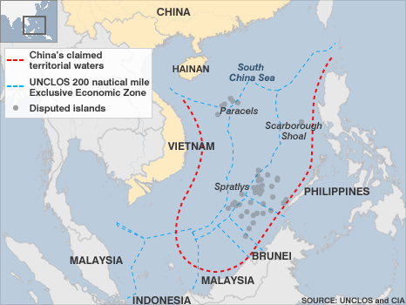

The [U-shaped line](http://en.wikipedia.org/wiki/Nine-dotted_line), or 9-dotted line, was described as a [calculated ambiguity](http://www.atimes.com/atimes/Southeast_Asia/KL08Ae01.html) used to maximize the extent of the claimed waters. Unlike any other demarcated lines, it does not characterize a definite area and the government of China has never attempted to describe it in a more scientific way.

**So what does a moratorium of exploration activities in the disputed areas means in this context?**

It could mean China and other claimants’ activities should be put on hold in the possible EEZs of the disputed islands. For example, China should stop [exploration](http://www.oilvoice.com/n/CNOOC_Announces_Deepwater_Gas_Discovery_in_Qiongdongnan_Basin/be1492e0b.aspx) and [drilling](http://news.chinaoilweb.com/China/Sinopec-to-Drill-Deepwater-Well-in-Qiongdongnan-Basin-in-2011.5585.htm) in the Paracels’ possible EEZ. Vietnam should stop similar activities in the Spratlys’ possible EEZ.

It could also mean China and other claimants’ activities should be put on hold in the waters over which other claimants have the rights based on international law (i.e. UNCLOS 1982) and China have the rights based on the [U-shaped line](http://en.wikipedia.org/wiki/Nine-dotted_line).