Daniel Green, Nhung Hoang, Richard Phillips

ENGR-27 / CPSC-72

Computer Vision Spring 2017

Matthew Zucker

**Project 1: Image Thresholding and Blob Tracking Writeup**

Our goal with this lab was to create a program that provides videos with a green screen effect. The program detects the moving objects in a video, sees the rest of the video as a ‘background’, and replaces the background with another video.

The primary challenge of this project was the creation of a mask that would identify the background of our video. To determine which regions of any given frame constituted the background, we took a temporal average of each pixel over every frame of the video. This gave us an image that looked almost identical to the background of the video. For each frame in the video, we subtracted the background image from the original image and calculated the RGB norm of each pixel. All pixels whose norms were less than a specified threshold value were identified as background pixels and were included in the mask. The background mask was quite messy due to noise in the original video. We addressed this issue by employing morphological operations, specifically closing followed by opening, to remove white dots from our mask and halos (unidentified background regions) around moving objects. This gave us a mask for every frame of the input video that identified the background. Having created the mask, we could then overlay any or video we liked over the original video to place our moving objects in a new setting.

This method relied on three assumptions about the input video. The first assumption was that the camera that shot the video was stable since our temporally averaged background image relied on a constant background. The second assumption was that the mobile objects in the video never remained in one location for too long. This would locally alter the temporal average used to create the background and result in portions of the background being left out of the mask. The third assumption was that the color of the moving object was not too similar to the background at any point in its trajectory. Much like wearing a green shirt in front of a green screen, this would have the effect of masking regions that are not actually part of the background. Given any video, the program will be able to detect the majority of a moving object. However, the morphological operations we put in place were set specifically for the two original videos we offer with the program. Additionally, we found that the higher the threshold value was, the less sensitive the program was to changes in the background, such as adjusted video focus and change in brightness.

In addition to overlaying the background of the original video with another video, we also tracked the location of the moving object(s) in the video. To detect the location of the objects, we identified contours of each frame of the video. **[Richard this is your area of expertise].**

Below, figure 1 shows the four stages of selected frames: original, after masking, after morphological operations, and with tracking. Figure 2 is a plot that shows the velocity over time of the video containing one moving object. Figure 3 is a plot that shows velocity over time for the video containing multiple moving objects.

The program would be improved with more general morphological operations and perhaps a different threshold strategy that is less sensitive to changing pixel intensities in the background. Overall, although catered to our selected videos, our green screen program is effective.

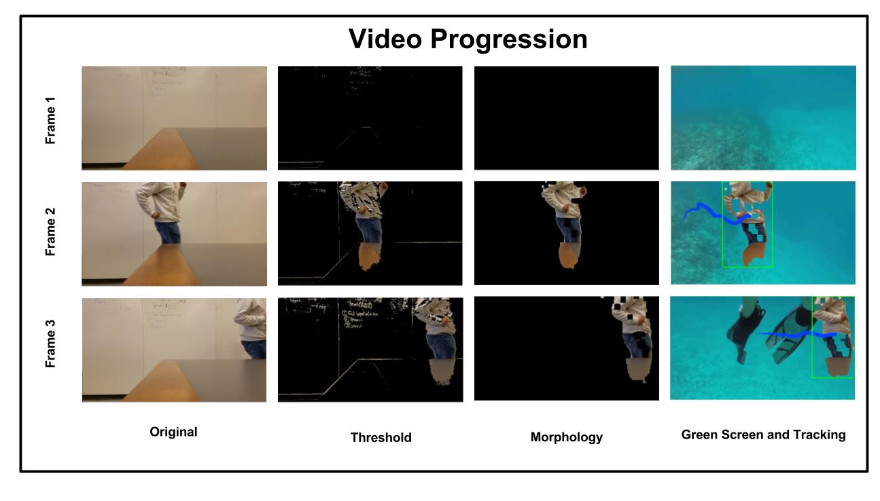

**Figure 1** shows the progression of video manipulation techniques.