Question & Answer Text Statistics
Source: Engdata(usage_binatanya_01-03-25_16-11-).csv
Dataset: 95,515 turns across 51,571 conversations

1. Coverage
Rows with empty English text are excluded from all downstream length and word statistics.
field | empty | usable
question (user_message_en) | 679 | 94836
answer (agent_response_en) | 197 | 95318

2. Conversation structure
Mean 1.85 turns per conversation, median 1, max 87. 28,632 conversations (56%) are single-turn.
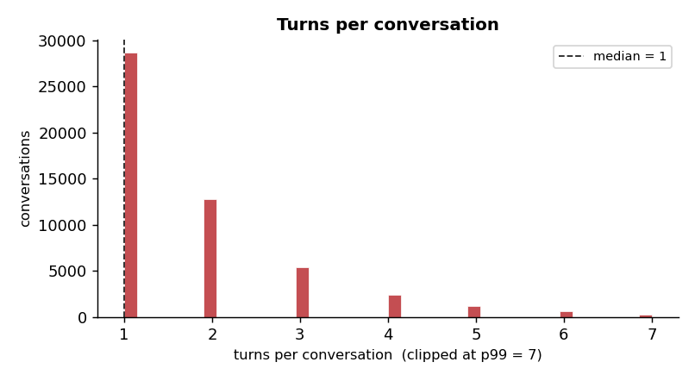

3. Length distributions
Questions are short; answers are ~15x longer. Percentiles (p25–p99) shown because both distributions are right-skewed by outliers.
metric | count | mean | std | min | max | p25 | p50 | p75 | p90 | p95 | p99
question_chars | 95515 | 48.2 | 67.4 | 0 | 11279 | 22.0 | 39.0 | 60.0 | 88.0 | 114.0 | 230.0
question_words | 95515 | 8.8 | 11.7 | 0 | 1797 | 4.0 | 7.0 | 11.0 | 16.0 | 21.0 | 43.0
answer_chars | 95515 | 1000.9 | 1010.3 | 0 | 9221 | 138.0 | 682.0 | 1550.0 | 2474.0 | 3105.0 | 4112.9
answer_words | 95515 | 135.8 | 137.6 | 0 | 1077 | 23.0 | 91.0 | 207.0 | 332.0 | 414.0 | 586.0

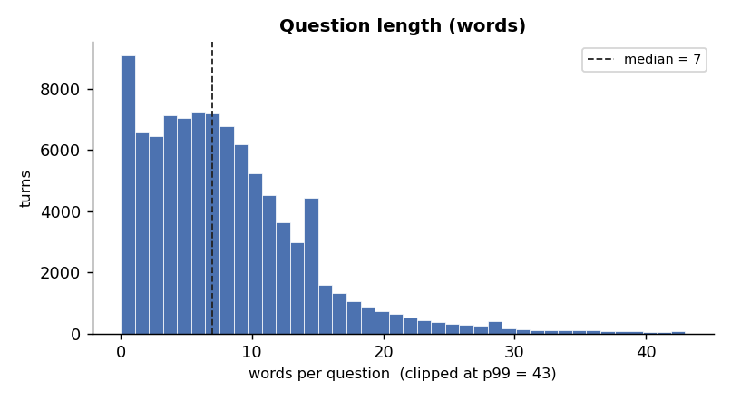
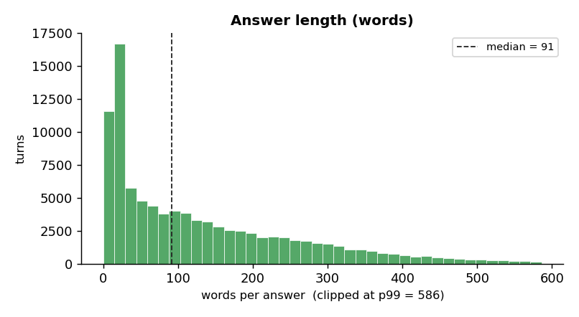
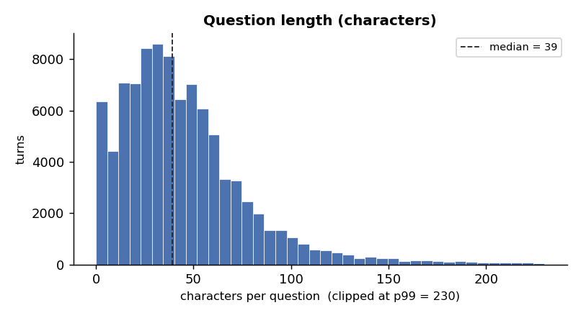
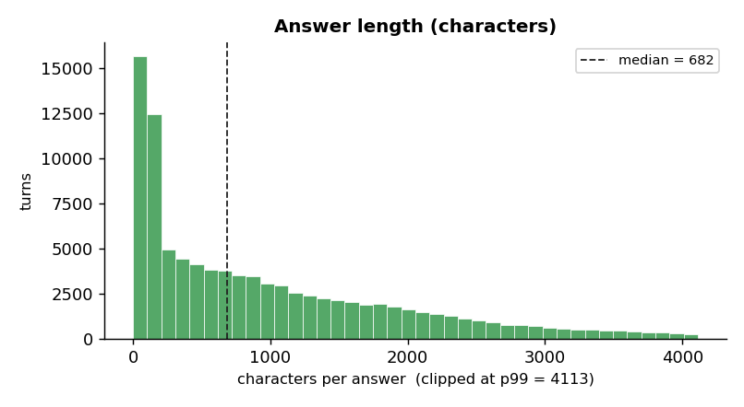

4. Feedback
Only 1,453 of 95,515 turns (1.5%) were rated. Of those: 761 thumbs-up, 692 thumbs-down — 52.4% satisfaction. The low rating rate means this signal is too sparse to segment on reliably.

5. Most frequent words

Questions
what (9,813), property (8,574), parking (7,782), want (6,728), tax (5,694), number (4,598), pay (4,576), report (4,234), need (4,123), street (3,779), know (3,543), like (3,019), payment (2,934), ticket (2,781), email (2,620), taxes (2,548), hello (2,419), who (2,399), form (2,386), municipality (2,229), school (2,204), received (2,111), beach (2,056), department (2,044), today (2,032)

Answers
parking (113,358), information (90,797), property (88,305), municipality (82,904), city (74,550), website (60,543), department (57,475), tax (54,257), payment (52,194), form (49,853), contact (48,382), online (41,355), help (40,952), municipal (37,207), report (36,707), residents (36,118), application (35,830), center (35,714), permit (34,659), request (34,646), between (34,416), metropark (34,366), street (32,942), discount (31,589), address (31,429)

6. Notes & data-quality flags
- Longest question is 11,279 chars / 1,797 words — almost certainly a paste/junk outlier; consider capping questions at p99 (~43 words).
- Answer length p99 is ~4,113 chars; a few answers reach 9,221 chars. Cap or flag before modeling.
- Histograms are clipped at p99 so the long right tail does not flatten the visible distribution; tables report the true min/max.

7. Combined Q+A topic model (LDA)
An additional LDA was fit on a merged document per conversation, where the question text (user_message_en) and the answer text (agent_response_en) are concatenated into one paragraph.

7.1 Combined topics (k = 16)
topic | top keywords
0 | parking, report, metropark, select, website, appeal, payment, pay, ticket, request, department, action, online, search, authorityid
1 | street, city, information, shelter, address, located, neighborhood, removal, shelters, kiryat, help, public, herzl, waste, evacuation
2 | building, information, construction, engineering, application, business, cityhall, planning, permit, complex, plan, municipality, renewal, licensing, city
3 | discount, property, square, tax, application, discounts, apartment, meters, income, senior, area, insurance, national, disabled, residential
4 | parking, permit, city, streets, residents, free, resident, vehicle, discount, white, blue, select, application, provides, area
5 | property, tax, payment, municipality, pay, payments, online, form, credit, taxes, bank, standing, account, direct, order
6 | park, garden, city, public, information, gardens, id, facilities, municipality, located, lighting, street, areas, publicgardens, area
7 | tender, tenders, municipality, education, submission, deadline, kindergarten, kindergartens, external, gan, information, details, municipal, date, special
8 | department, contact, phone, information, center, municipality, sunday, thursday, address, service, street, reception, pm, hours, floor
9 | information, municipal, services, help, water, city, traffic, municipality, street, provide, public, work, sorry, regarding, hello
10 | beach, independence, beaches, pm, city, events, information, day, sunset, hour, sironit, half, sanz, bathing, services
11 | contact, municipality, hotline, municipal, request, form, website, service, number, card, information, waste, resident, understand, department
12 | information, center, residents, centers, activities, senior, citizens, club, municipality, social, offers, services, courses, city, welfare
13 | pm, city, events, details, nis, class, tickets, purchase, place, held, classes, center, community, cost, information
14 | property, form, forms, process, tax, cityforms, code, tat, sug, nose, processoneclick, change, taboo, appbuilder, certificate
15 | registration, education, school, kindergarten, parents, student, form, placement, residents, documents, transfer, request, special, address, website

7.2 Topic-to-category map
Mixed topics are ones whose keywords legitimately serve both residents and businesses (building permits, generic department contact, generic municipal services), so a Mixed label means the conversation is genuinely ambiguous rather than misclassified.
category | topic | name
Resident | 0 | Parking ticket / appeal
Resident | 1 | Street, shelter, waste
Resident | 3 | Property tax discount (senior/disabled)
Resident | 4 | Parking permit (resident)
Resident | 5 | Property tax payment
Resident | 6 | Parks & gardens
Resident | 10 | Beach & events
Resident | 11 | Hotline & resident services
Resident | 12 | Senior citizens & welfare
Resident | 13 | Events & community classes
Resident | 14 | Property tax forms
Resident | 15 | School & kindergarten registration
Business | 7 | Tenders & procurement
Mixed | 2 | Building permit + business licensing
Mixed | 8 | Contact / department info
Mixed | 9 | General municipal services

7.3 Label distribution
label | conversations | share
Resident | 39,718 | 77.0%
Business | 1,446 | 2.8%
Mixed | 10,407 | 20.2%

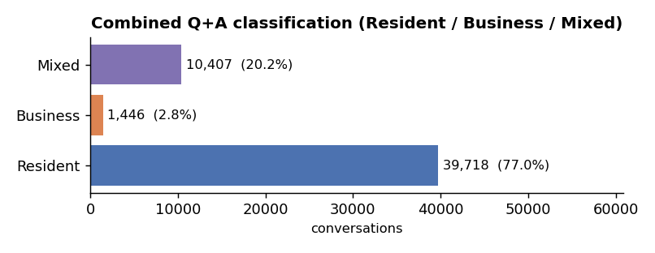

8. Per-side classification: question vs answer (separate LDA models)
This section uses the separate question-side and answer-side LDA models. Each conversation's dominant topic on each side is mapped to Resident / Business / Neutral, and three labelling modes are reported: from the question alone, from the answer alone, and from both sides agreeing.

11.1 Topic-to-sector map
Question-side (user_topic_*, k = 4):
topic | sector | top keywords
user_topic_0 | Resident | street, shelter, area, near, parking, building, construction, neighborhood, lot, removal, kiryat, live, waste, city, garbage
user_topic_1 | Mixed | email, need, school, number, department, phone, kindergarten, address, want, municipality, permit, hi, contact, looking, form
user_topic_2 | Resident | beach, today, open, day, independence, hi, does, events, hours, time, know, city, square, tomorrow, performances
user_topic_3 | Resident | property, parking, tax, pay, want, report, payment, ticket, taxes, number, received, hi, discount, need, check

Answer-side (agent_topic_*, k = 15):
topic | sector | top keywords
agent_topic_0 | Resident | education, registration, kindergarten, school, parents, student, residents, special, kindergartens, placement, address, information, transfer, children, documents
agent_topic_1 | Business | tender, municipality, tenders, submission, deadline, social, welfare, external, education, details, administration, department, municipal, services, date
agent_topic_2 | Resident | discount, property, square, tax, discounts, meters, apartment, application, income, senior, area, national, insurance, residential, disabled
agent_topic_3 | Mixed | building, information, city, shelter, street, permit, engineering, plan, shelters, planning, municipality, public, cityhall, construction, plans
agent_topic_4 | Resident | property, tax, form, forms, process, cityforms, code, tat, sug, nose, processoneclick, change, signed, appbuilder, taboo
agent_topic_5 | Resident | center, information, school, class, pm, community, city, classes, residents, centers, nis, register, street, phone, club
agent_topic_6 | Mixed | property, payment, tax, municipality, payments, online, credit, pay, form, bank, direct, standing, order, card, debit
agent_topic_7 | Resident | parking, permit, city, resident, streets, residents, vehicle, free, discount, card, white, select, application, blue, provides
agent_topic_8 | Business | form, request, application, building, documents, municipality, committee, exemption, property, pdf, department, submitted, days, support, submit
agent_topic_9 | Resident | city, removal, waste, information, street, address, help, work, taken, ben, municipality, evacuation, database, carried, traffic
agent_topic_10 | Business | business, license, licensing, information, dog, signage, application, law, municipality, event, noise, fee, environmental, appointment, veterinary
agent_topic_11 | Resident | beach, information, complex, city, public, park, beaches, garden, renewal, area, gardens, urban, street, located, accessible
agent_topic_12 | Mixed | contact, municipality, department, information, municipal, phone, help, services, hotline, service, website, thursday, public, sunday, regarding
agent_topic_13 | Resident | parking, report, metropark, select, website, appeal, payment, request, department, pay, ticket, action, online, search, authorityid
agent_topic_14 | Resident | pm, events, city, independence, details, tickets, purchase, place, square, free, information, day, nis, admission, event
- Note: no user topic is mapped to Business — Business intent shows up in user_topic_1 (Mixed) and in the answer side. This means Mode 3 (both sides agree) can never produce a Business label; conversations whose answer side is Business fall into Uncategorized in Mode 3.

11.2 Mode 1 — Question only
Sector taken from the dominant user topic. The Business count is zero by construction (see map).
label | conversations | share
Resident | 38,033 | 73.7%
Business | 0 | 0.0%
Mixed | 13,538 | 26.3%

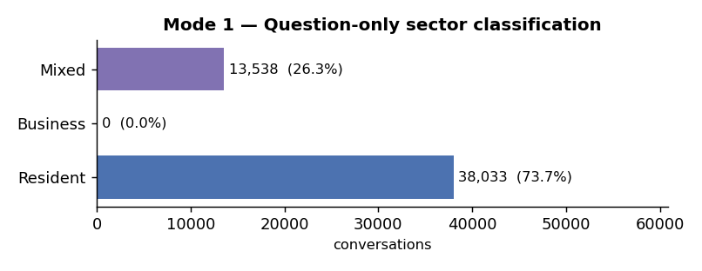

11.3 Mode 2 — Answer only
Sector taken from the dominant agent topic. All three sectors are reachable here.
label | conversations | share
Resident | 29,840 | 57.9%
Business | 3,693 | 7.2%
Mixed | 18,038 | 35.0%

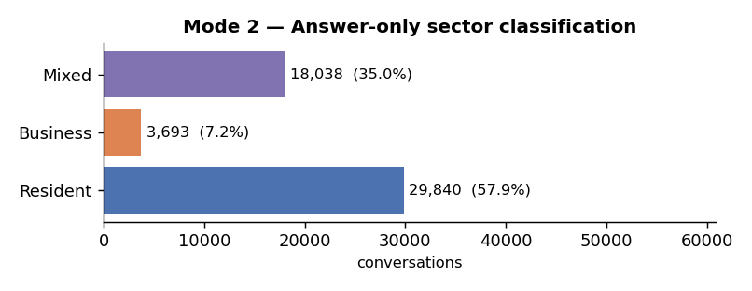

11.4 Mode 3 — Both sides must agree
A sector is assigned only when the question-side sector and the answer-side sector are the same Resident/Business/Mixed value; otherwise the conversation is Uncategorized. Agreement rate (question and answer give the same sector): 29,235 / 51,571 = 56.7%.
label | conversations | share
Resident | 23,794 | 46.1%
Business | 0 | 0.0%
Mixed | 5,441 | 10.6%
Uncategorized | 22,336 | 43.3%

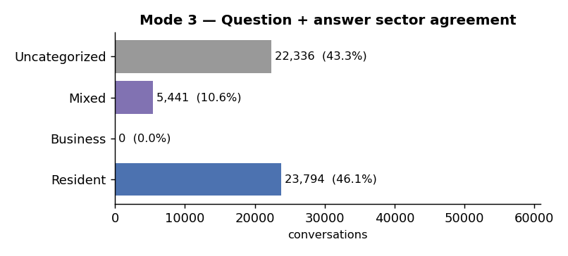

11.5 Question × Answer cross-tab
Rows = question-side sector, columns = answer-side sector. The diagonal cells are the conversations Mode 3 keeps; off-diagonal cells become Uncategorized.
question \ answer | Resident | Business | Mixed
Resident | 23,794 | 1,642 | 12,597
Business | 0 | 0 | 0
Mixed | 6,046 | 2,051 | 5,441

