HANOI UNIVERSITY OF SCIENCE AND TECHNOLOGY

School of Information and communications technology

Software Requirement Specification

Version 1.2

EcobikeRental

Subject: Software Design and Construction

Group 17

Student Name StudentID

Tran Thi Hong Nhung 20183965

Vu Thi Ngoc Lan 20183939

Duong Hue Linh 20183942

*Hanoi,* *10-2021*

Table of contents

Table of contents 1

1 Introduction 2

1.1 Objective 2

1.2 Scope 2

1.3 Glossary 2

1.4 References 2

2 Overall Description 3

2.1 Survey 3

2.2 Overall requirements 3

2.3 Business process 4

3 Detailed Requirements 5

3.1 Use case “View Station/Bike Information” 5

3.2 Use case “Rent Bike” 7

3.3 Use case “Return Bike” 9

4 Supplementary specification 13

4.1 Functionality 13

4.2 Usability 13

4.3 Reliability 13

4.4 Performance 13

4.5 Supportability 13

4.6 Other requirements 13

# Introduction

## Objective

This document contains the system requirements for EcoBikeRental Software. The main purpose of the EcoBikeRental Software is to manage the information about bikes, customer, process of renting and returning bikes.

This is the first version of the SRS document. The purpose of this document is to state all system requirements clearly for usage in the development stages ahead.

This document is meant to be viewed by both the stakeholders and the developers of the system.

## Scope

This document specifies requirements for the EcoBikeRentalSoftware, especially focus on features related to bike renting and returning

The EcoBikeRental allows users to:

* View bike information
* View dock information
* Rent bike
* Return bike

## Glossary

|  |  |  |  |  |
| --- | --- | --- | --- | --- |
| **No** | **Term** | **Explanation** | **Example** | **Note** |
| **1** | API | An API is a set of programming code that enables data transmission between one software product and another |  |  |

## References

EcoBikeRental Problem EN

# Overall Description

## Survey

* Ecopark township has an hourly bike rental service with lots of docking stations (i.e., docks) for users to rent or return bikes automatically. EcobikeRental is a software developed for this service. This software helps users to rent and return bikes, view status of docking stations, view information of a bike.
* The software has one actor: User (Guest is not considered because in this project we focus on features related to bike renting and return). User is a role of customer when they had account in system and signed in successfully.

## Overall requirements

In EcobikeRental system, user has got an account with payment information. When user signs in successfully, system displays a list of docks. User can rent bike, return bike, view information of bikes and available dock stations. With one payment method, user can only rent 01 bike. When user wants to return bike, user can choose a dock from a list that system provides.

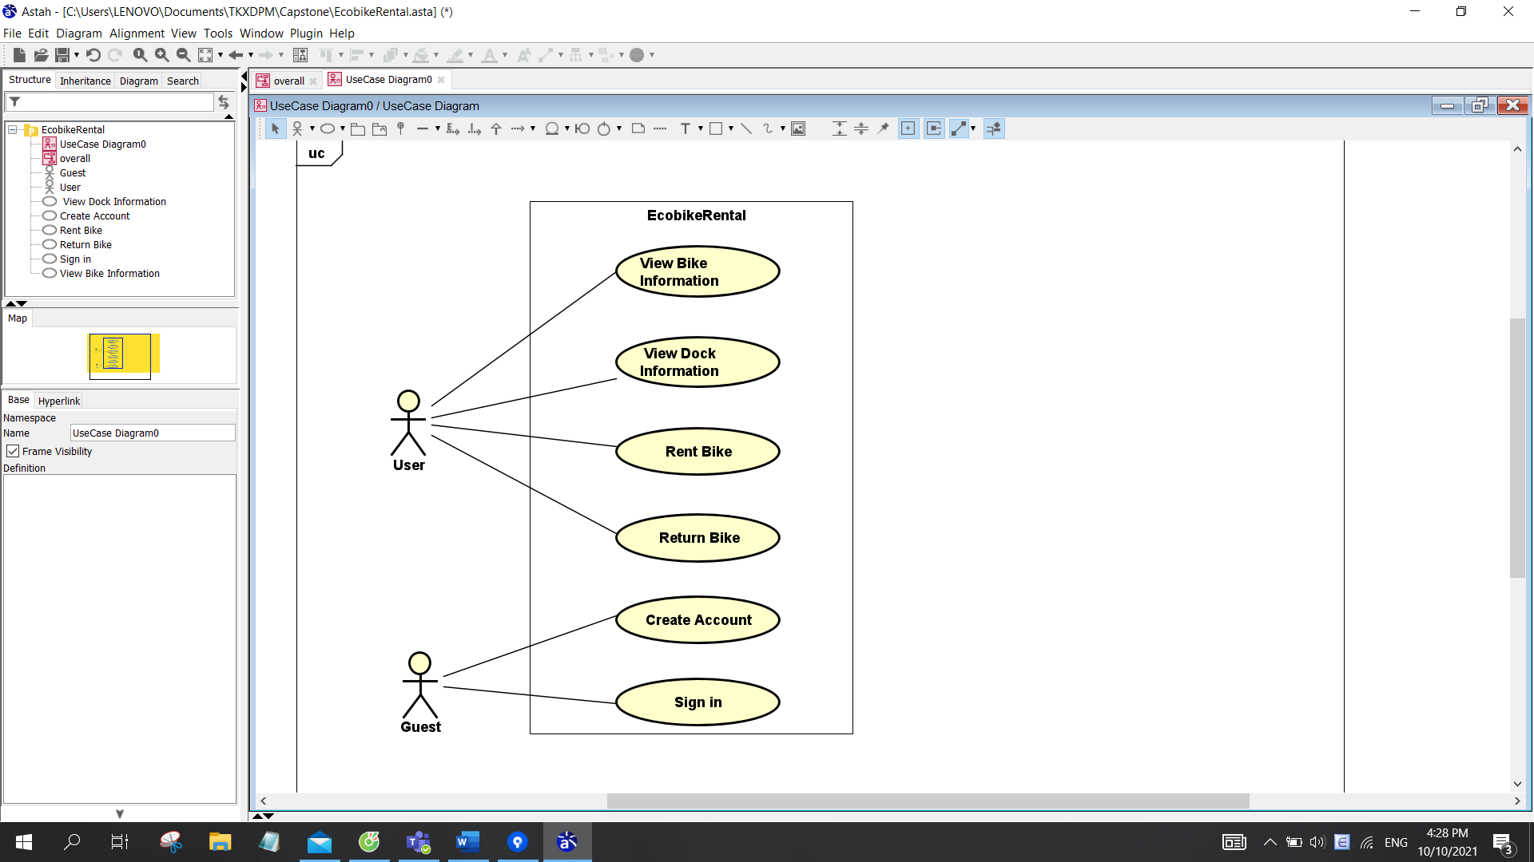

## Business process

In the first time user opens application, user must create an account with payment information for rental service. After having an account, user sign in and start to access all functions of application.

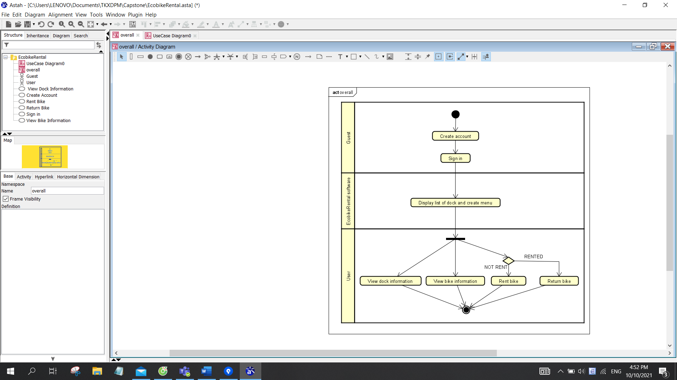

# Detailed Requirements

## Use case “View Station/Bike Information”

**1. Use case code**

UC001

**2. Brief Description**

This use case describes the interaction between users and EcobikeRental software when the user wishes to view bike information.

**3. Actors**

3.1 User

3.2 EcobikeRental software

**4. Preconditions**

User logged in on system.

**5. Basic Flow of Events**

Step 1. The EcobikeRental software displays a list of docks

Step 2. User selects a dock

Step 3. The EcobikeRental software displays detailed information about the dock

Step 4. The customer chooses a bike

Step 5. The EcobikeRental software displays detailed information about the bike

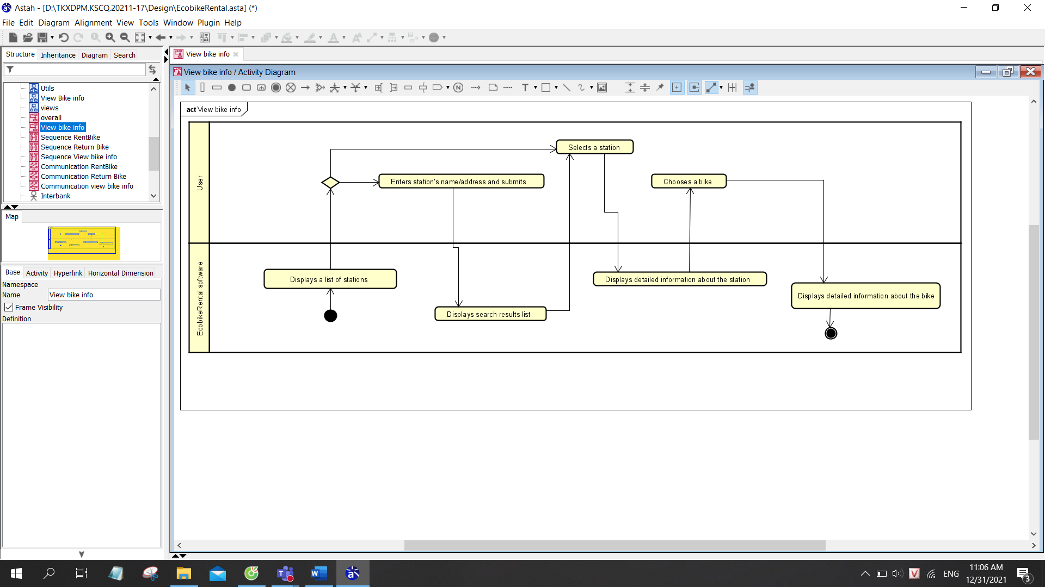

**6. Alternative flows**

N/A

**7. Input data**

*Table 1-Input data of search form*

|  |  |  |  |  |  |
| --- | --- | --- | --- | --- | --- |
| No | Data fields | Description | Mandatory | Valid condition | Example |
| 1 | Dock name |  | Yes |  | HBT1 |
| 2 | Address |  | Yes |  | 12 Street, 3 district, HN |

**8. Output data**

*Table 2-Output data of dock information*

|  |  |  |  |  |
| --- | --- | --- | --- | --- |
| No | Data fields | Description | Display format | Example |
| 1 | Dock name |  |  | HBT1 |
| 2 | Dock ID |  |  | A1234 |
| 3 | Dock address |  |  | 12 Street, 3 district, HN |
| 4 | Dock area |  |  | 50m² |
| 5 | Number of available bikes |  | ▪ positive integer | 20 |
| 6 | Number of empty docking points |  | ▪ positive integer | 30 |
| 7 | Distance |  |  | 200m |
| 7 | Walking time | Walking time from user’s location to this dock (minute) | ▪ positive integer | 30 |

*Table 2-Output data of bike information*

|  |  |  |  |  |
| --- | --- | --- | --- | --- |
| No | Data fields | Description | Display format | Example |
| 1 | Bike ID |  |  | A1233 |
| 2 | Bike type |  | ▪ standard bicycle / standard e-bike /   twin bike | twin bike |
| 3 | Battery percentage | Battery percentage of e-bikes | ▪ positive integer | 20 |
| 4 | Time limit | Remaining battery time of e-bikes (minute) | ▪ positive integer | 10 |
| 7 | Deposit | 40% of the value of the bike (VND) | ▪ positive integer | 400 000 |

**9. Postconditions**

N/A

## Use case “Rent Bike”

**1. Use case code**

UC003

**2. Brief Description**

This use case describes the interaction between users and EcobikeRental software when the user wishes to rent a bike in a dock.

**3. Actors**

3.1 User

**4. Preconditions**

User logged in the EcobikeRental Software

**5. Basic Flow of Events**

Step 1. The customer requests to rent bike

Step 2. The customer scan barcode on the lock to rent bike

Step 3. The EcobikeRental software displays the information of the bike and the payment method

Step 4.The customer choose the payment method

Step 5. The customer deposit money

Step 6. The EcobikeRental software deduct the money in the customer’s card or account

Step 7. The EcobikeRental software save the transaction

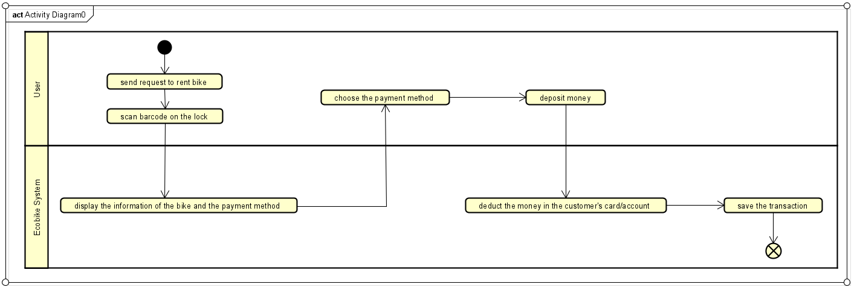

**6. Alternative flows**

N/A

**7. Input data**

|  |  |  |  |  |  |
| --- | --- | --- | --- | --- | --- |
| No | Data fields | Description | Mandatory | Valid condition | Example |
| 1 | Dock point ID |  | Yes |  | A1233 |
| 2 | Dock point address |  | 12 Street, 3 district, HN |
| 3 | Bike ID |  | Yes |  | A1233 |

**8. Output data**

|  |  |  |  |  |
| --- | --- | --- | --- | --- |
| No | Data fields | Description | Display format | Example |
| 1 | Cardholder name |  | * Case sensitive | NGUYEN VAN A |
| 2 | Card number |  | * Positive integer | 9403 2357 4568 9123 |
| 3 | Issuing bank | Name of the bank issue the card |  | TPBank |
| 4 | Expiration date |  | * mm/yy | 12/26 |
| 5 | Security code |  | * Positive integer | 123456 |
| 6 | Transaction description |  |  | Rent bike |
| 7 | Bike ID | ID of bike rented |  | A1233 |
| 8 | Dock point ID | ID of dock that user return bike |  | A1233 |
| 12 | Deposit | Deposit of the bike | * positive integer | 400,000 |

**9. Postconditions**

N/A

## Use case “Return Bike”

**1. Use case code**

UC004

**2. Brief Description**

This use case describes the interaction between users and EcobikeRental software when the user wishes to return a bike in a dock.

**3. Actors**

3.1 User

**4. Preconditions**

User rented a bike in system. There is an active network connection to the Internet.

**5. Basic Flow of Events**

Step 1. The customer requests to return bike

Step 2. The EcobikeRental software search for available dock points

Step 3. The EcobikeRental software displays a list of available dock points

Step 4. The customer chooses a dock point and confirm return bike.

Step 5. The EcobikeRental software returns deposit and deducts rental money

Step 6. The EcobikeRental software saves and displays rental transaction information

Step 7. The EcobikeRental software sends an email of transaction info to the customer

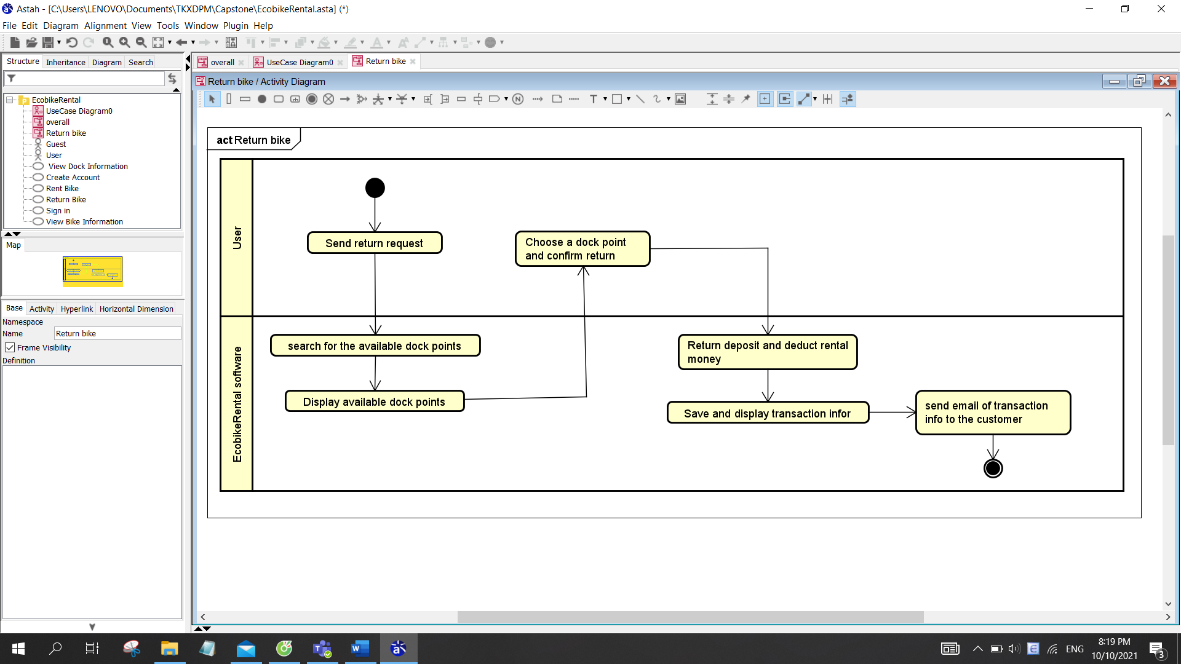

**6. Alternative flows**

N/A

**7. Input data**

|  |  |  |  |  |  |
| --- | --- | --- | --- | --- | --- |
| No | Data fields | Description | Mandatory | Valid condition | Example |
| 1 | Dock point ID | Choose from a list | Yes |  | A1233 |
| 2 | Dock point address |  | 12 Street, 3 district, HN |
| 3 | Bike ID |  | Yes |  | A1233 |

**8. Output data**

|  |  |  |  |  |
| --- | --- | --- | --- | --- |
| No | Data fields | Description | Display format | Example |
| 1 | Cardholder name |  | * Case sensitive | TRAN NHUNG |
| 2 | Card number |  | * Positive integer | 9403 2357 4568 9123 |
| 3 | Issuing bank | Name of the bank issue the card |  | TPBank |
| 4 | Expiration date |  | * mm/yy | 12/26 |
| 5 | Security code |  | * Positive integer | 123456 |
| 6 | Transaction description |  |  | Rent bike |
| 7 | Bike ID | ID of bike rented |  | A1233 |
| 8 | Dock point ID | ID of dock that user return bike |  | A1233 |
| 9 | Return time |  | * hh:mm dd/mm/yy | 12:30 31/01/22 |
| 10 | Rental period | Rental period (minute) | * positive integer | 30 |
| 11 | Currency |  |  | VND |
| 12 | Total | Total rental money | * positive integer | 150,000 |

**9. Postconditions**

N/A

# Supplementary specification

## Functionality

Users firstly need to create an account on theEcoBikeRental application,validate information, set up access permissions of the application, and set up at least onepayment method to pay charges (by linking to interbank or e-wallet)

## Usability

EcoBikeRentalis a 24/7 platform-independent system which allows novice users to use without any training.

## Reliability

The system can be repaired within 2 hours after any typical failure.

## Performance

It is expected to serve 100 users at the same time without noticeable loss of performance and to operate in an average of 200 hours without failure. The response time for the system is 1 second at normal and 2 seconds during a peak load if it is not explicitly stated.

## Supportability

N/A

## Other requirements

N/A