**DEVOPS**

**LAB11**

**NHU LY – 101429112**

1. **Build the image**

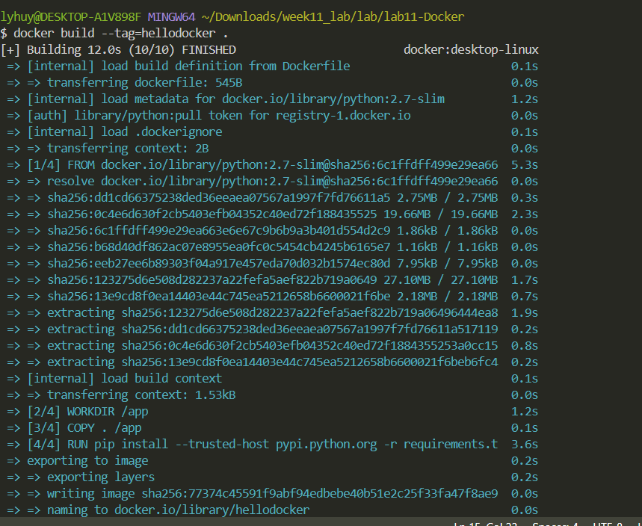

1. **Run the container:**

1. **Application is working**

**4. Stop and remove the container**