CONTENTS : Page No.

- SCOPE 1
  - AUDIENCE
  - ORGANISATION
  - APPLICABLE DOCUMENTS
- SOFTWARE REQUIREMENT SPECIFICATION 2
- FUNCTIONAL MODEL 3
- ACTIVITY DIAGRAM 8
- USE CASE DIAGRAM 11
- INTERACTION DIAGRAM
    - SEQUENCE DIAGRAM 19
    - COLLABORATION DIAGRAM 23
- STATE CHART DIAGRAM 26
- CLASS DIAGRAM 28
- IMPLEMENTATION DIAGRAM
  - COMPONENT DIAGRAM 29
  - DEPLOYMENT DIAGRAM 31

- Scope :
The following subsections describe the scope of the fast food outlet system in terms of its audience, organization, and applicable documents

  - Audience :
Customers, Administrators, Sellers.

  - Organization :
ONLINE SHOPPING CART SYSTEM

  - Applicable Documents :
The following documents provide information necessary to understand this documentation:

- Software Requirement Specification:

- System Abstract –
The Online Shopping Cart system facilitates the Customer to view the Items Products, inquire about the item details, availability of seats and many more. The major functionality of system is to allow the user to book and cancels the flights as per user requirements. It also provides the administrator or manager to modify existing flights or to introduce a new flight’s in the schedule.

- Major features provided by the system are :
- Customer
The system allows the user or member to perform flight qnuiry including flight scheduling, seats availability status, fare details, etc.

- Administrator
It allows the customer to register in order to give the services to its member .

- Online shopping system
The system allows the member to order the product as per his/her requirements. The customer is prompt to enter the customer details and credit card details. The member then receives the unique cart number .

- Product Listing
This process gives the details about the purchasing process made by the customer at the details of the shipping and taxes involved with the cost

- Administrator
The administrator module of the system allows the admin/manager to manage the products item It provides the admin /manger to modify or change the existing items or to introduce a new items. Apart from modifying the category it also allow the admin/manager to take the taxes and include the shipping charges along with the h/w s/w and service requirements.

- Functional Model.

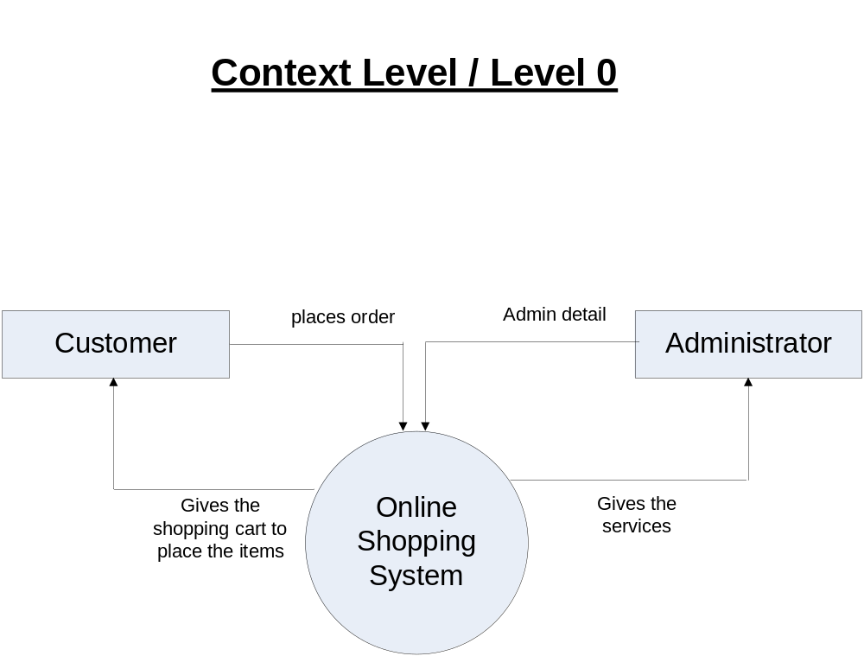

Fig 3.1 Data Flow Diagram for Online Shopping Cart Software

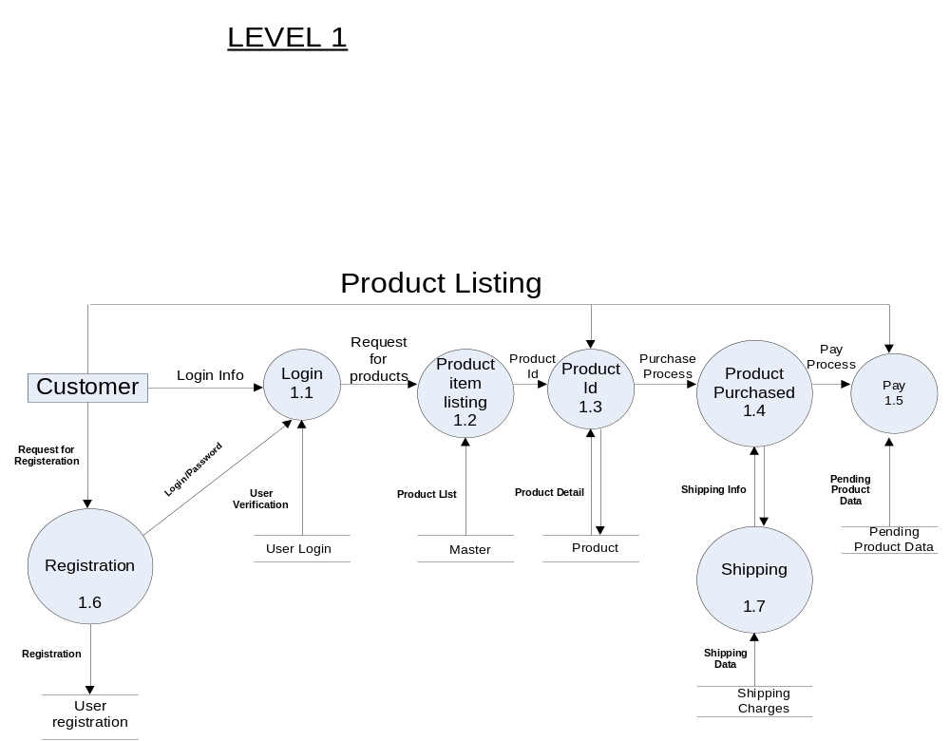 Fig 3.2 Data Flow Diagram for Product Listing

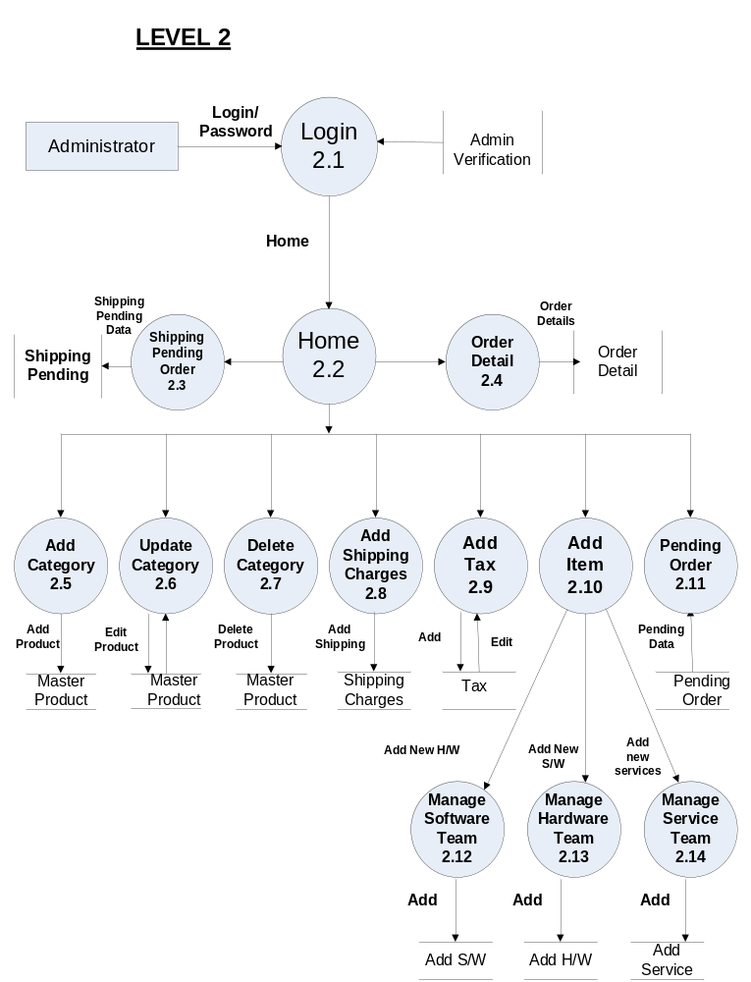 Fig 2.3 Fig : 3.3Data Flow Diagram for Administrator.

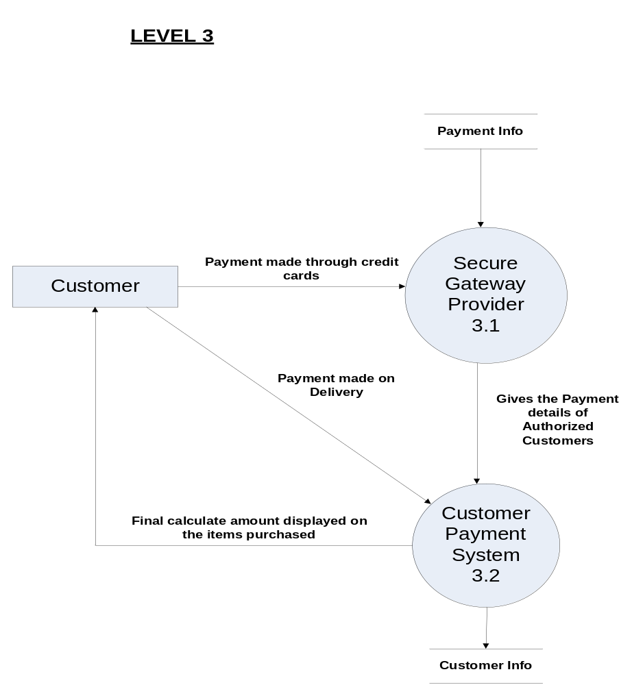 Fig Fig: Data Flow Diagram for Secure Gateway Provider.

- Activity Diagram.

- An Activity diagram is a visual representation of any system's activities and flows of data or decisions between activities.
- Activity diagrams provide a very broad view of a business process.
- They represent the dynamics of a system.
- They are flow charts that are used to show the work flow of a system.
- They show the flow of control from activity to activity in the system.
- They show what activities can be done in parallel, and any alternative paths through the
flow.
- Purpose
  - Model business workflows
  - Model operations
- Activity diagrams commonly contain
  - Activity states and action states
    - Transitions
      - Objects

Action States and Activity States
- Action states are atomic and cannot be decomposed
- Work of the action state is not interrupted.
- Activity states can be further decomposed
- Their activity being represented by other activity diagrams
- They may be interrupted
- Represented in UML by a rounded rectangle.

- Activity represents the performance of some behavior in the work flow.

Transitions
- Transitions are used to show the passing of the flow of control from activity to activity.

They are typically triggered by the completion of the behavior in the originating activity.
- When the action or activity of a state completes, flow of control passes immediately to the next action or activity state

- A flow of control has to start and end at some place
initial state -- a solid ball stop state -- a solid ball inside a circle
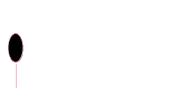

Branching
- When modeling the workflow of a system, it is often necessary to show where the
flow of control branches based on a decision point.

- The transition from a decision point contain a guard condition.
- The guard condition is used to determine which path from the decision point is taken.
- Decisions along with their guard conditions allow you to show alternative paths
through a work flow.
- A branch specifies alternate paths taken based on some Boolean expression
- A branch may have one incoming transition and two or more outgoing ones

Synchronization Bars
- In a workflow there are typically some activities that may be done in parallel.
- A synchronization bar allows you to specify what activities may be done
concurrently.
- A synchronization bar may have
  - many incoming transition and one outgoing transition, or
  - one incoming transition and many outgoing transitions.
- It is use to specify the forking and joining of parallel flows of control
- A synchronization bar is rendered as a thick horizontal or vertical line

- A fork may have one incoming transitions and two or more outgoing transitions
  - each transition represents an independent flow of control
  - conceptually, the activities of each of outgoing transitions are concurrent
    - either truly concurrent (multiple nodes)
    - or sequential yet interleaved (one node)

- A join may have two or more incoming transitions and one outgoing transition
  - above the join, the activities associated with each of these paths continues in
parallel
  - at the join, the concurrent flows synchronize
  - each waits until all incoming flows have reached the join, at which point one
flow of control continues on below the join

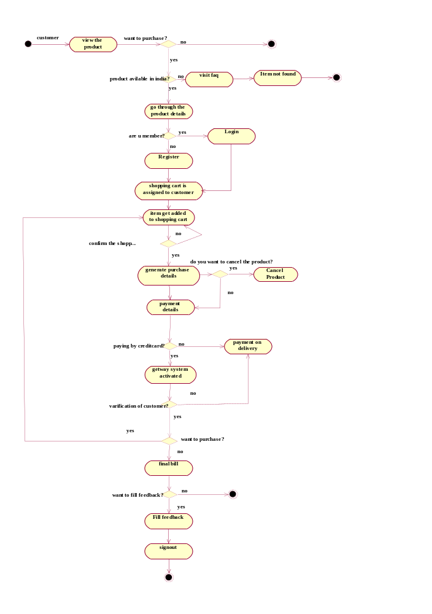
Fig 4.1 Activity Diagram :
5. Use-Case Diagram.
- The use-case concept was introduced by Ivar Jacobson in the object-oriented software engineering (OOSE) method.
- A use-case diagram is a graph of actors, a set of use cases enclosed by a system boundary, communication (participation) associations between the actors and the use cases, and generalization among the cases.
- Use case diagrams show how users interact with the system.
- Use case diagrams describe what a system does from the standpoint of an external observer. The emphasis is on what a system does rather than how.
- Use case diagrams are closely connected to scenarios. A scenario is an example of what happens when someone interacts with the system. Here is a scenario for a medical clinic.
"A patient calls the clinic to make an appointment for a yearly checkup. The receptionist finds the nearest empty time slot in the appointment book and schedules the appointment for that time slot. "
- Used during requirements elicitation to represent external behavior
- Actors represent roles, that is, a type of user of the system
- Use cases represent a sequence of interaction for a type of functionality
- The use case model is the set of all use cases. It is a complete description of the functionality of the system and its environment

Actors
- An actor models an external entity which communicates with the system:
  - User
  - External system
  - Physical environment
- An actor has a unique name and an optional description.
- Examples:
Customer

- Passenger: A person in the train
- GPS satellite: Provides the system with GPS coordinates

Use Cases
A use case represents a class of functionality provided by the system as an event flow.
A use case consists of:
- Unique name
- Participating actors
- Pre-conditions
- Entry conditions (triggers)
Item Purchased
- Flow of events
- Exit conditions (success ‘guarantees’)
- Special requirements
The Use Case diagram for whole system is as shown in fig 5.3
The <<extend>> Relationship
- <<extend>> relationships represent exceptional or seldom invoked cases.
- The exceptional event flows are factored out of the main event flow for clarity.
- Use cases representing exceptional flows can extend more than one use case.
- The direction of a <<extend>> relationship is to the extended use case

The <<include>> Relationship
- An <<include>> relationship represents behavior that is factored out of the use case.
- An <<include>> represents behavior that is factored out for reuse, not because it is an exception.
- The direction of a <<include>> relationship is to the using use case (unlike <<extend>> relationships).
Select shipping address
Add shipping address
Add Credit card type
Add Credit card number
Add credit card
Add Expiration date
Choose shipping type
Online customer
Select credit card
<<include>>
<<include>>
<<include>>
<<include>>
<<include>>
<<include>>
Fig :5.1 Use Case Diagram

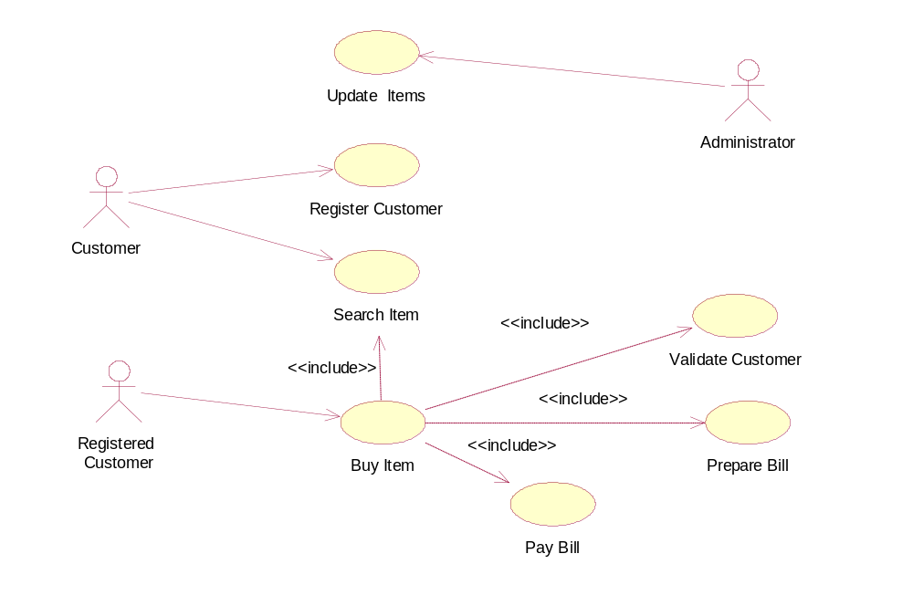

Fig 5.2 Use case Diagram

USE CASE DESCRIPTION :

Actors:
  - New Customers
  - Registered Customer
  - Administrator

Use cases:
- Search Item
- Register Item
- Buy Item
- Update Item

- Search Item
Any user can search the item. User can search the item by name or company.

- Register Customer
To buy the item, the customer has to be a registered customer. This process is used to register a customer.

- Buy Item
A registered customer can buy a item using this process. This process include search item, validate customer, prepare bill, pay bill.
Use Case Table

Use case ID | 1
Use case name | View shopping cart
Actor | Online customer
Pre-condition | Open the website
Post-condition | Search for product
Flow of events | open the website of online shopping cart

Use case ID | 2
Use case name | Search for product
Actor | Online customer
Pre-condition | View shopping cart
Post-condition | Select the product
Flow of events | Open the website, search the product from list

Use case ID | 3
Use case name | Create new user
Actor | Online customer
Pre-condition | Select the product
Post-condition | Select credit card
Flow of events | Open the website, search the product from list, select the product, create new user

Use case ID | 4
Use case name | Purchase item
Actor | Online customer
Pre-condition | Select credit card
Post-condition | Review order information
Flow of events | Open the website, search the product from list, select the product, create new user, select credit card, purchase the selected item

Use case ID | 5
Use case name | Login as registered user
Actor | Online seller and online customer
Pre-condition | Open the website
Post-condition | Sell or purchase the product
Flow of events | Open the website, Login as registered user

Use case ID | 6
Use case name | Item registration
Actor | Online seller
Pre-condition | Login into the shopping cart system
Post-condition | Confirm the registration
Flow of events | Open the website, Login as registered user, register the item into system

Use case ID | 7
Use case name | Change the information
Actor | administrator
Pre-condition | Login into the system as administrator
Post-condition | Update the system
Flow of events | Open the website, Login as administrator, make changes in the information

Use case ID | 8
Use case name | Block users
Actor | administrator
Pre-condition | Select the user
Post-condition | Update the system
Flow of events | Open the website, Login as administrator, select the user, block the user

Use case ID | 9
Use case name | Inform the deal to seller
Actor | Online Seller and shopping cart system
Pre-condition | Check the availability of item
Post-condition | Make a deal
Flow of events | Open the website, login as shopping cart system , seller sell the item to shopping cart system, inform the deal to seller

Register Item
Search for product
Choose shipping type
Select credit card
Purchase item
Review order confirmation
View shopping cart
Add item to shopping cart
Login as registered user
Online seller
Shopping Cart system
Inform the deal to seller
Block users
Administrator
Change item information
Online Customer
Create new user

fig 5.3. Use case diagram for Online Shopping System

- UML Interaction Diagram
  - Sequence Diagram :

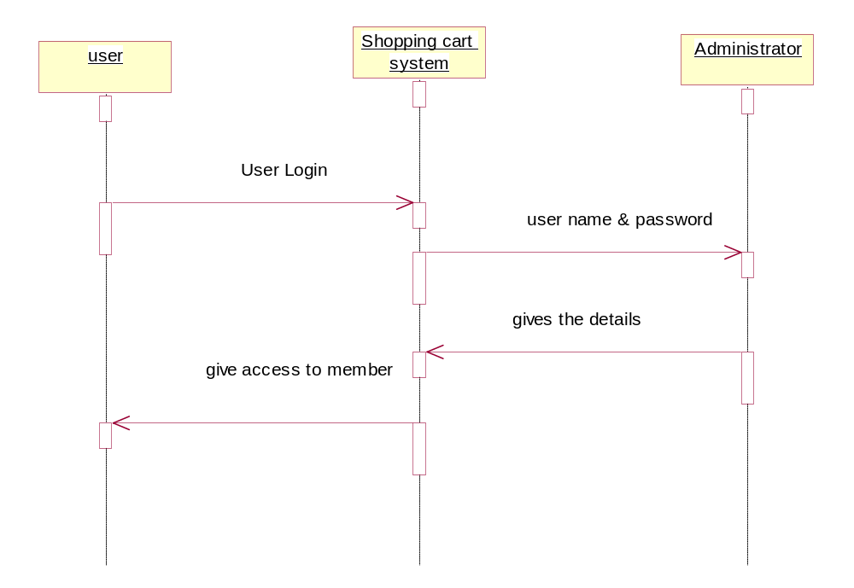
Fig.6.1.1 Sequence Diagram for User registeration

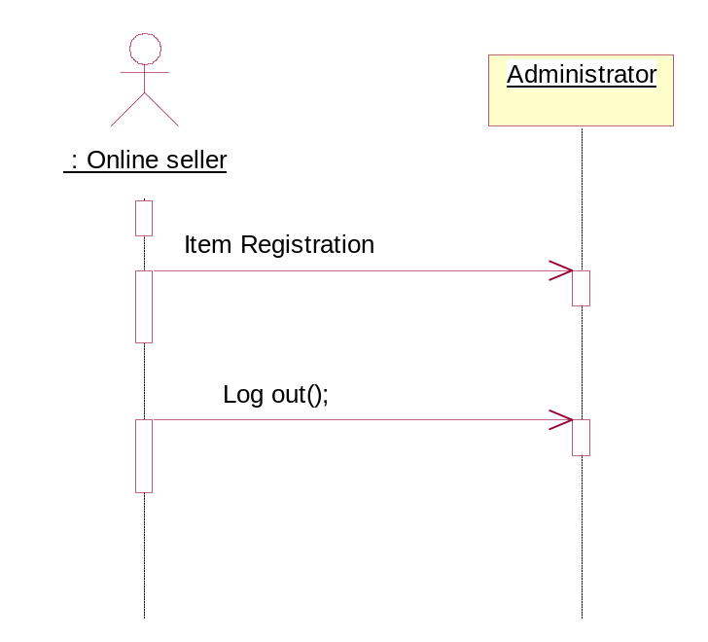
Fig.6.1.2 Sequence Diagram for Seller registeration

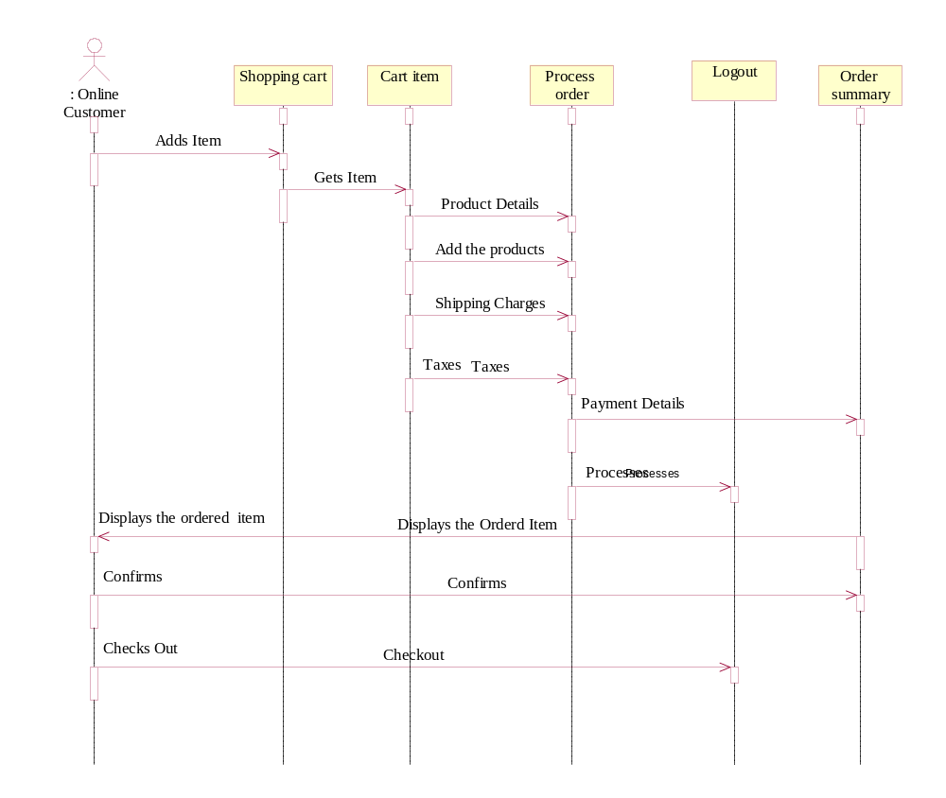

Fig.6.1.3 Sequence Diagram for Online Customer
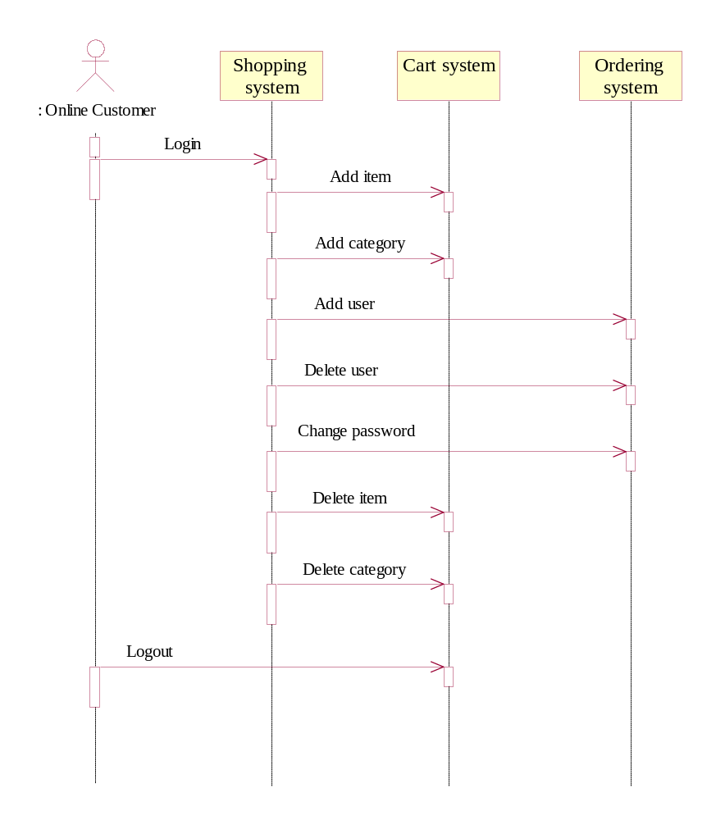
Fig.6.1.4 Sequence Diagram for Online Administrator

  - Collaboration diagrams:
They are also interaction diagrams. They convey the same information as sequence diagrams, but they focus on object roles instead of the times that messages are sent. In a sequence diagram, object roles are the vertices and messages are the connecting links.
- Collaboration diagrams show (used to model) how objects interact and their roles.
- They are very similar to sequence diagrams. Actually they are considered as a cross between class and sequence diagram.
- Sequence Diagrams are arranged according to Time.
- Collaboration Diagrams represent the structural organization of object.
- [Both sequence and collaboration diagrams are called interaction diagrams]
- Forms a context for interactions
  - May realize use cases
  - May be associated with operations
  - May describe the static structure of classes
- Collaboration diagrams contain the following:
  - Class roles (subsystems/objects/classes/actors/ external systems) as before.
  - Association roles (pathways or links over which messages flow)
  - Message flows (messages sent between class roles)

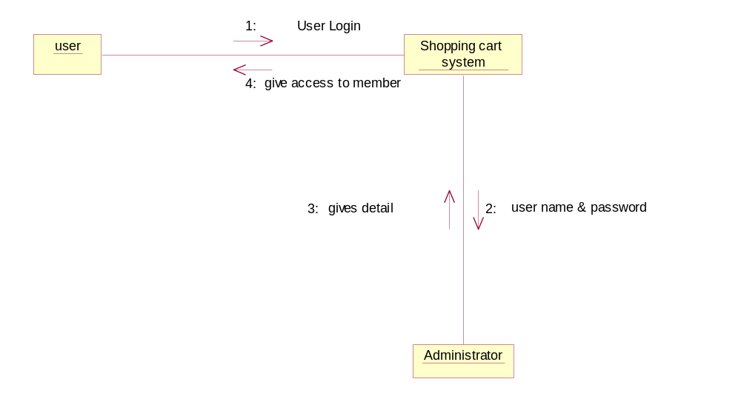 Fig.6.2.1 Collaboration Diagram for User registration

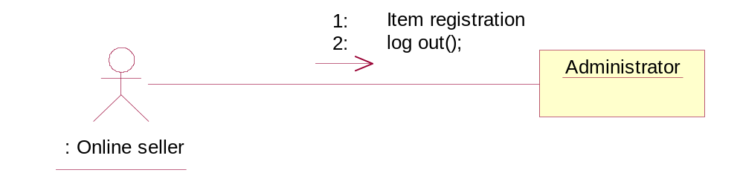

Fig.6.2.2Collaboration Diagram for Seller registeration

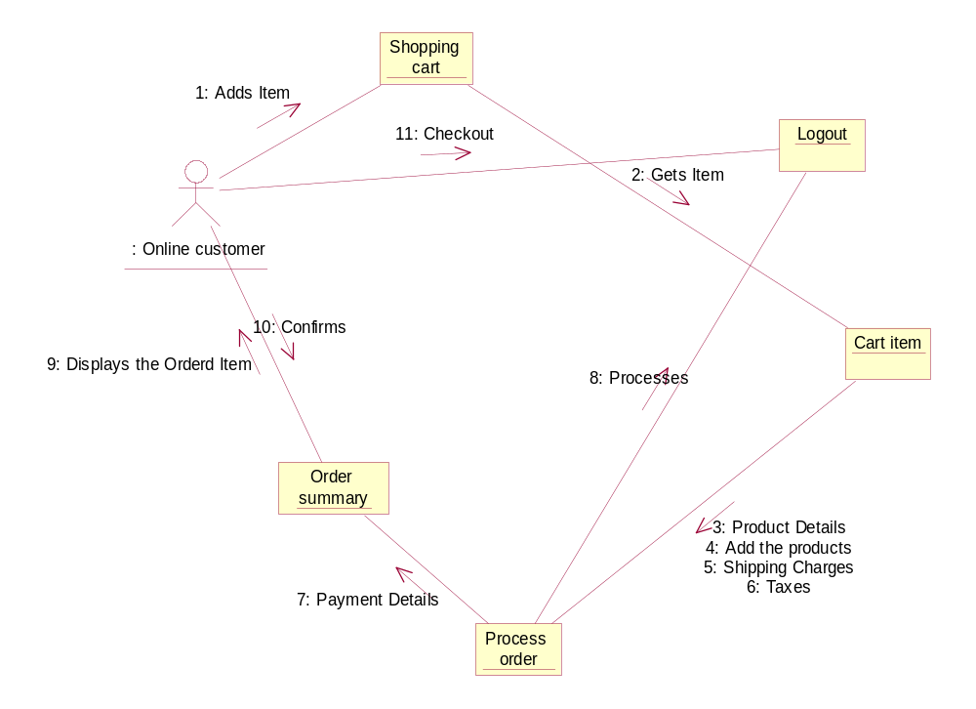 Fig.6.2.3 Collaboration Diagram for Online Customer

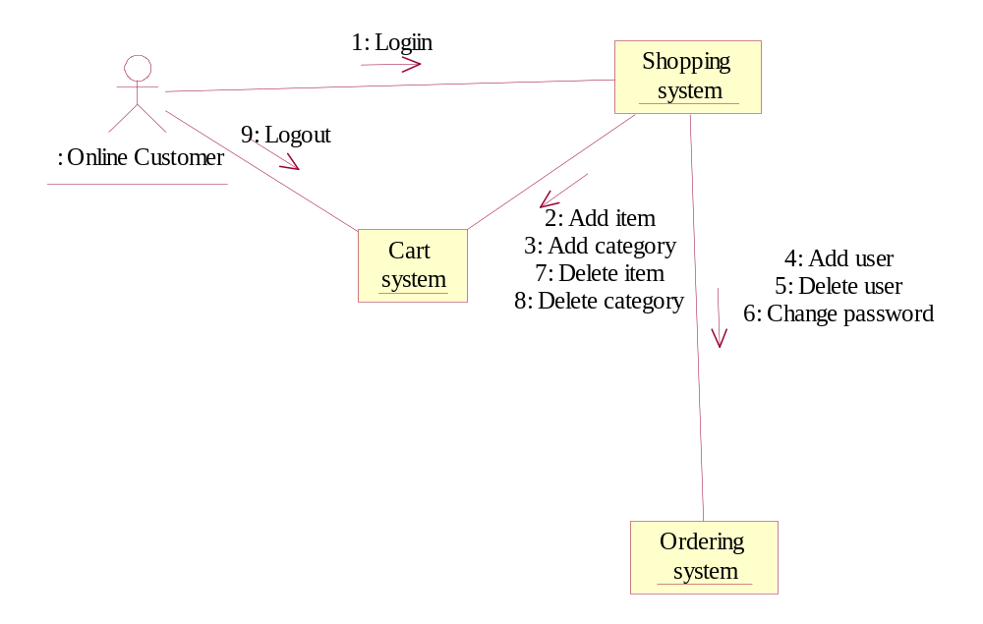

Fig.6.2.4 Collaboration Diagram for Online Administrator

- Statechart Diagram:
The name of the diagram itself clarifies the purpose of the diagram and other details. It describes different states of a component in a system. The states are specific to a component/object of a system.
A Statechart diagram describes a state machine. Now to clarify it state machine can be defined as a machine, which defines different states of an object, and these states are controlled by external or internal events.
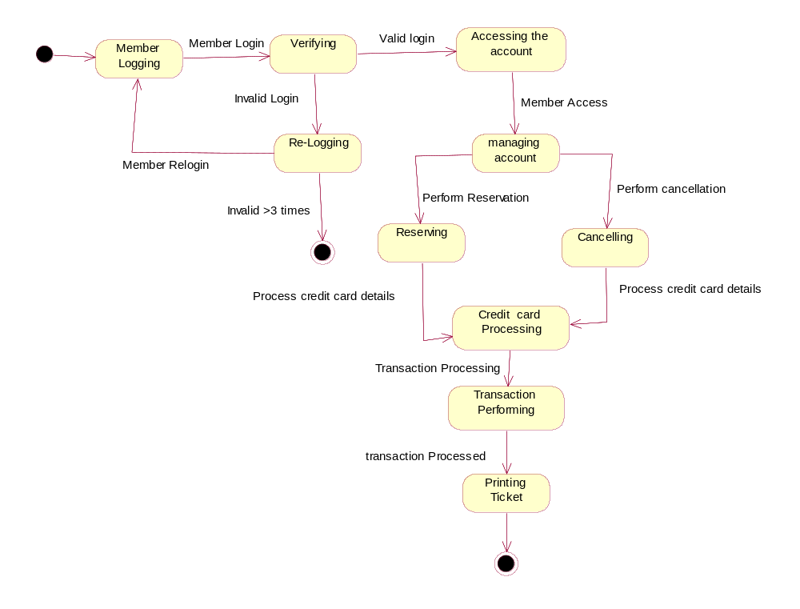
Fig.7.1 State Chart diagram for Online Shopping System

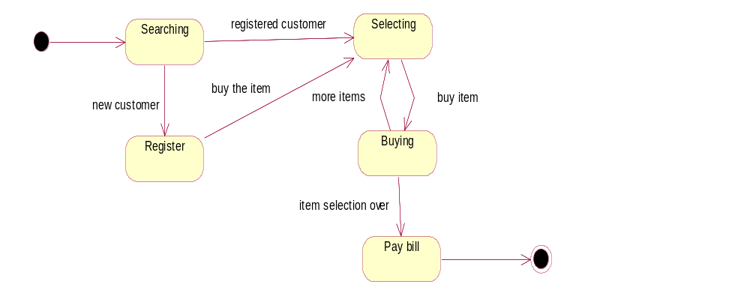
Fig7.2 State diagram for customer.
8. CLASS DIAGRAM :
TRANSACTION
transid
pnrno
transdate
amt
commit()
rollback()
Payment System
custno
custid
custname
creditcardno
BillingAddress
VeiwOrder()
PaymentDetails()
ONLINE SHOPPING CART
SYSTEM
HTTP
CartAddition
Creidtno : String
Description : String
ItemId : String
Amount : Integer
Category : String
Get_to_cart()
Check_out()
CANCELLATION
cusno : Integer
Item id : Integer
amount : Integer
retrive()
update()
CREDIT CARD HOLDER
cardno
issuedate
expirydate
verifydtls()
perform_transaction()
CUSTOMER
Number of Item : Integer
cusid : Integer
Shipnname : String
Company : String
Address : String
Payment()
CartAddition()
Cancellation()
USER
Email id : String
password : String
First name : String
Last Name : String
Street Address : String
ZipCode : Integer
City : String
State : String
Country : String
Phone : String
Login()
Registration()
Logout()
SELLER
Item name : String
Item id : Integer
Discount : Integer
Categoty : Integer
Fig 8.1 Class diagram for Online Shopping System
9.Implementation Diagram.
  - Component Diagram :
Component diagrams are different in terms of nature and behavior. Component diagrams are used to model physical aspects of a system.
Physical aspects are the elements like executables, libraries, files, documents etc that resides in a node. So component diagrams are used to visualize the organization and relationships among components in a system. These diagrams are also used to make executable systems.
Description of the component diagram for online shopping system is as follows :
Data base server contains all the database tables. It contains Administrator, Registered Customer, Seller, Item and Payment.
Application server contains Access classes package and Business classes package and view layer classes, i.e. view classes package.
Clients are the nodes having no processing capabilities. Only browser is there on this node to send a request
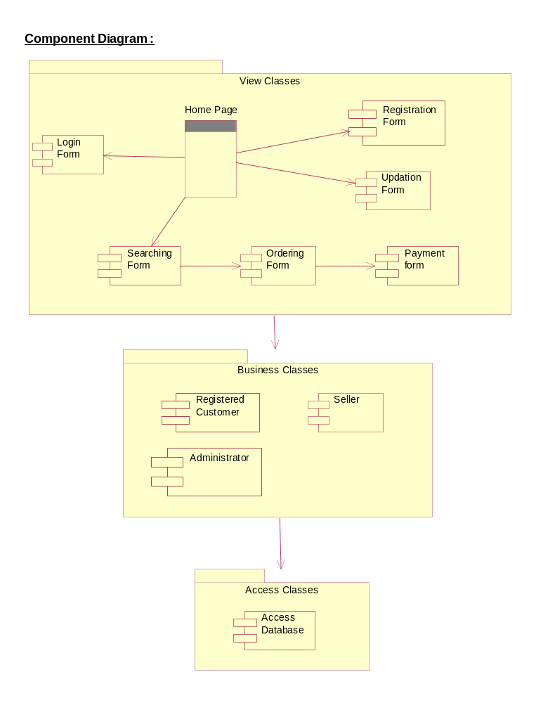

  - Deployment Diagram :
Deployment diagrams are used to visualize the topology of the physical components of a system where the software components are deployed.
So deployment diagrams are used to describe the static deployment view of a system. Deployment diagrams consist of nodes and their relationships.

.

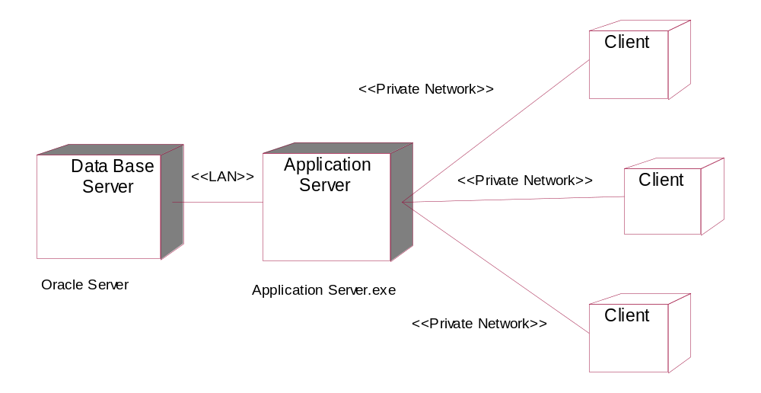

Fig 9..2 Deployment diagram for Online Shopping System.

