**Asg 4 – Debugging / Reporting Template**

**Version Control detail:**

|  |  |  |  |
| --- | --- | --- | --- |
| Author | Username | Password | Link |
| Minh Nhut Huynh |  |  | [GitHub repository](https://github.com/nhuthuynh/asg4-hotel) (this repository is made as public, no need credential to access) |

**Task 1: Replication Test Case**

**1. UAT Test Script**

|  |  |
| --- | --- |
| **Script #1: Bug 1** | |
| **Script Name** | When checkout, all of the services recorded of a room return $0.00. |
| **Use Case Tested:** | Service charges should be recorded and added correctly |
| **Test Description:** | When a guest checks out after incurring service charges during their stay, the services are reported, but the cost of each is recorded as $0.00 |
| **Pre-conditions** | Booking single room 101.  Room 101 is checked in.  Add a Bar Fridge service cost $20. |
| **Post-conditions** | Room service must be recorded |

**Before fixing the bug:**

|  |  |  |  |
| --- | --- | --- | --- |
|  | **TEST STEPS** | **EXPECTED TEST RESULTS** | **Test status** |
| ***1*** | Enter check out selection: D | Prompt enter room number | Pass |
| ***2*** | Enter room number: 101 | Display room and guest information | Pass |
| ***3*** |  | Display charged service $0.00 and total $0.00 | **FAILED** |

**Screenshots:**

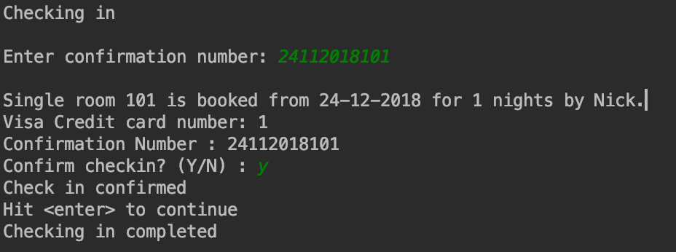

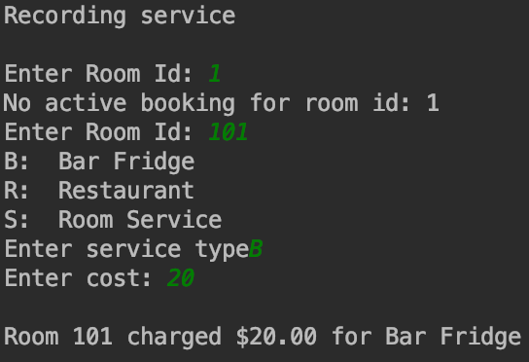

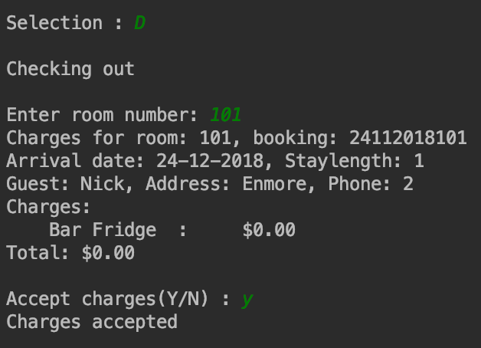

**After fixing the bug:**

|  |  |  |  |
| --- | --- | --- | --- |
|  | **TEST STEPS** | **EXPECTED TEST RESULTS** | **Test status** |
|  | Enter select add service: R | Prompt enter room id |  |
|  | Enter room id: 101 | Prompt enter type of service |  |
|  | Enter Bar Fridge service: B | Prompt enter cost |  |
| ***1*** | Enter cost: 20 | Display charged cost with the service | Pass |
| 2 |  | Prompt enter to continue | Pass |
|  | Press enter to continue | Prompt enter select | Pass |
|  | Enter record service selection: R | Prompt enter room id | Pass |
|  | Enter room id: 101 | Prompt enter cost | Pass |
|  | Enter cost: 40 | Display cost charged with the service | Pass |
|  |  | Prompt enter to continue | Pass |
|  | Press enter to continue | Prompt enter selection | Pass |
|  | Enter check out selection: D | Display information including guest name, address, phone and all charged services and total cost | Pass |

**Screenshot:**

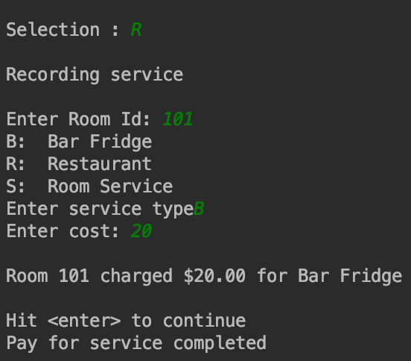

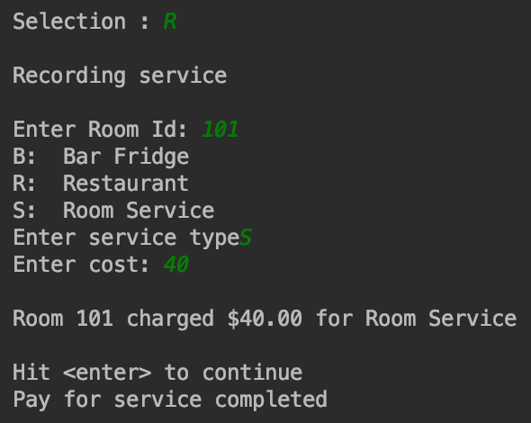

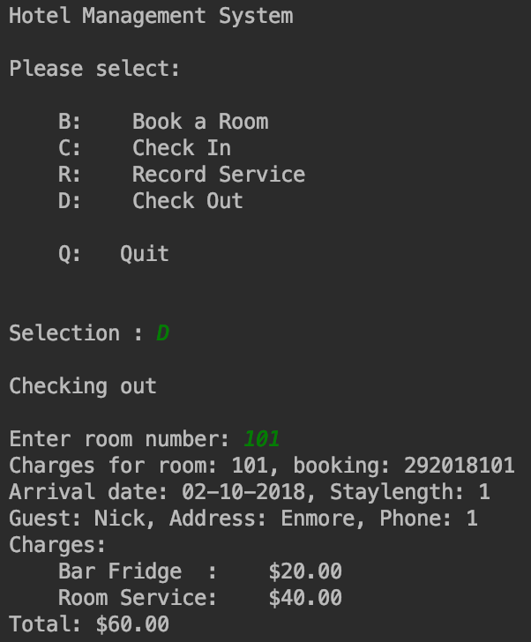

|  |  |
| --- | --- |
| **Script #2: Bug 2** | |
| **Script Name** | It is possible to charge a room for service after the guest has checked out |
| **Use Case Tested:** | Service charges should be stop recorded After a guest has checked out |
| **Test Description:** | After a guest has checked out it is still possible to charge a service to their room |
| **Pre-conditions** | Book a room 101.  Check in room 101.  Check out room 101.  Add a service for room 201. |
| **Post-conditions** | Display message no booking present for room. |

**Before fixing the bug:**

|  |  |  |  |
| --- | --- | --- | --- |
|  | **TEST STEPS** | **EXPECTED TEST RESULTS** | **Test status** |
| ***1*** |  | Prompt enter selection | Pass |
| **2** | Enter record service selection: R | Prompt enter room ID | Pass |
| **3** | Enter checked out room ID: 101 | Prompt enter service type | **FAILED** |
| **4** | Enter service type: B | Prompt enter cost | **FAILED** |
| **5** | Enter cost: 10 | Display charged cost for the room | **FAILED** |

**Screenshots:**

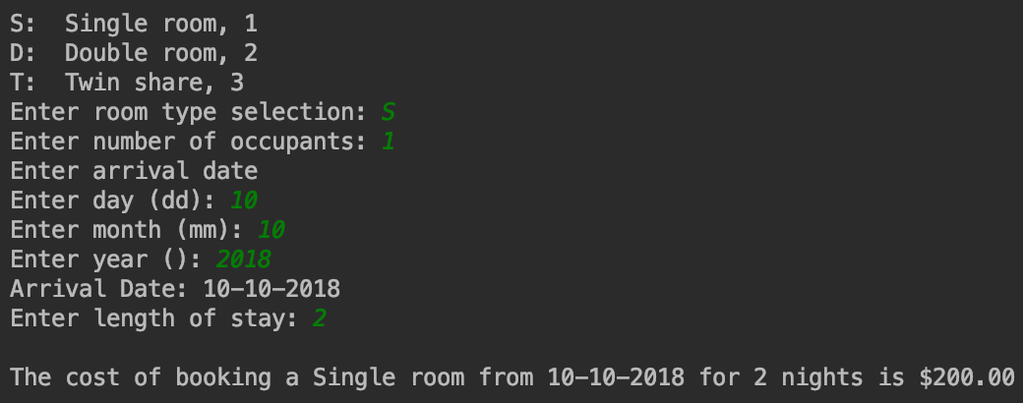

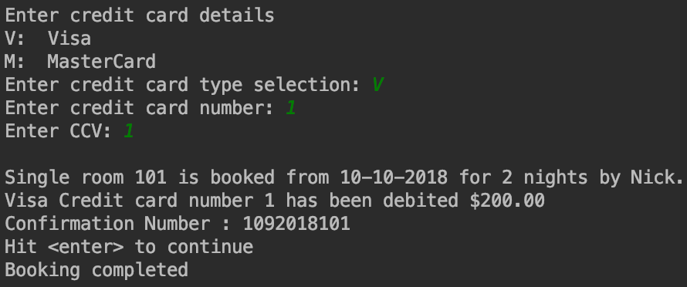

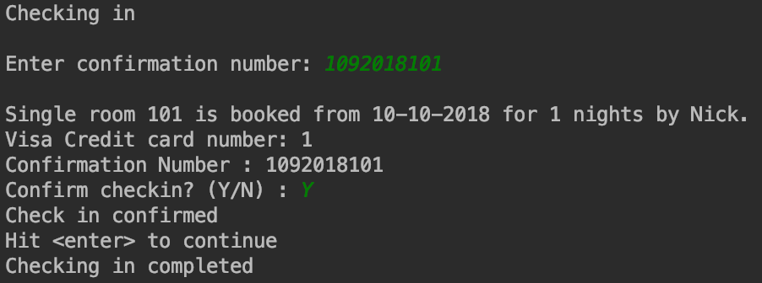

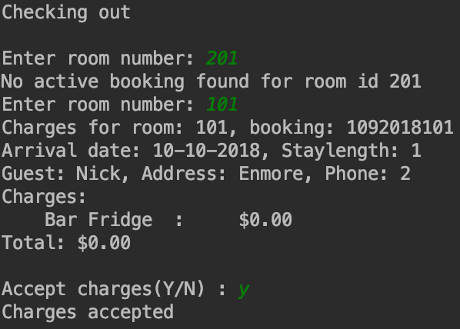

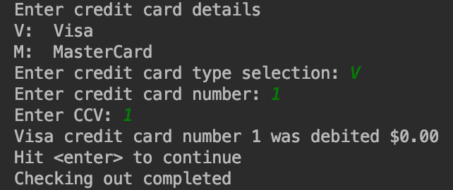

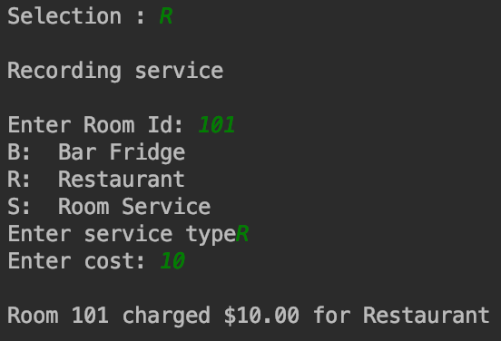

**After fixing the bug:**

|  |  |  |  |
| --- | --- | --- | --- |
|  | **TEST STEPS** | **EXPECTED TEST RESULTS** | **Test status** |
| ***1*** |  | Prompt enter selection | Pass |
| **2** | Enter record service selection: R | Prompt enter room ID | Pass |
| **3** | Enter checked out room ID: 101 | Display there is no active booking for room 101. | Pass |

**Screenshot:**

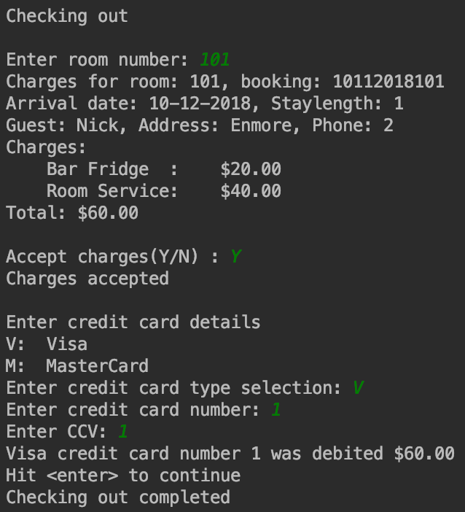

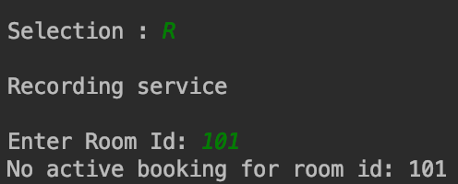

**Task 2: Simplification**

**BUG 1:** **All service charges are reported as $0.00 when checking out**  
**Unit test screenshot:**

This error caused by using wrong argument name of addServiceCharge method in Booking class

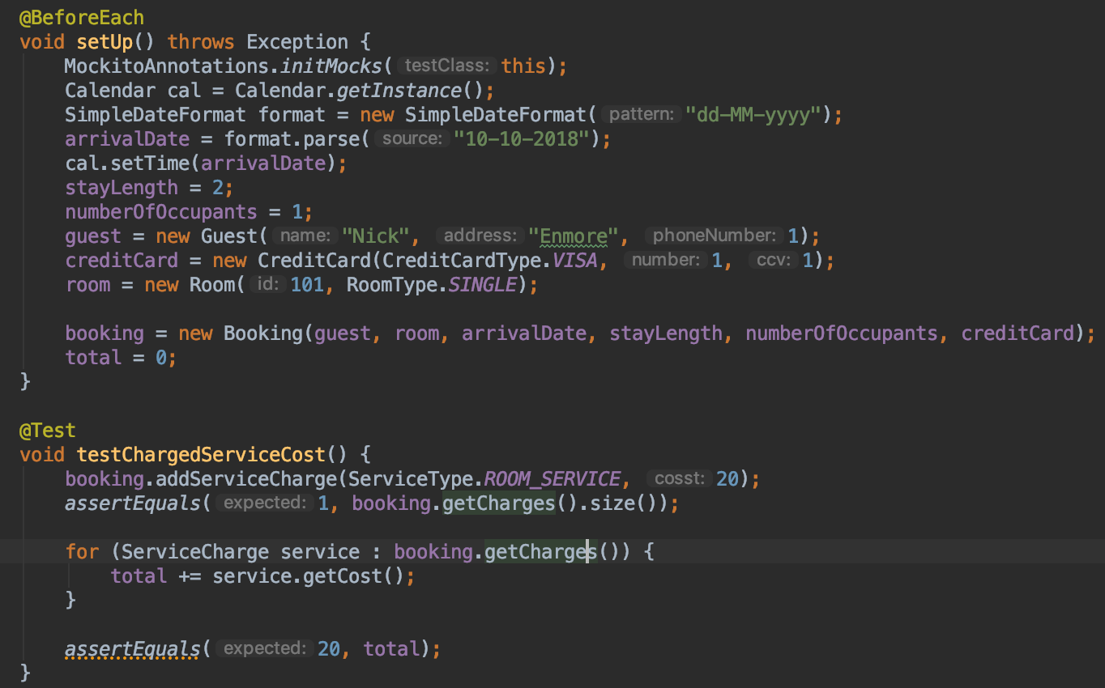

**Unit test result:**

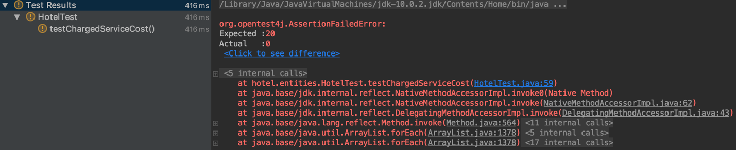

**BUG 2: After the guest checked out a room, it is possible to add service charge for the room**  
**Unit test screenshot:**

The bug caused by the checked out booking still is the activeBooking list in hotel class.

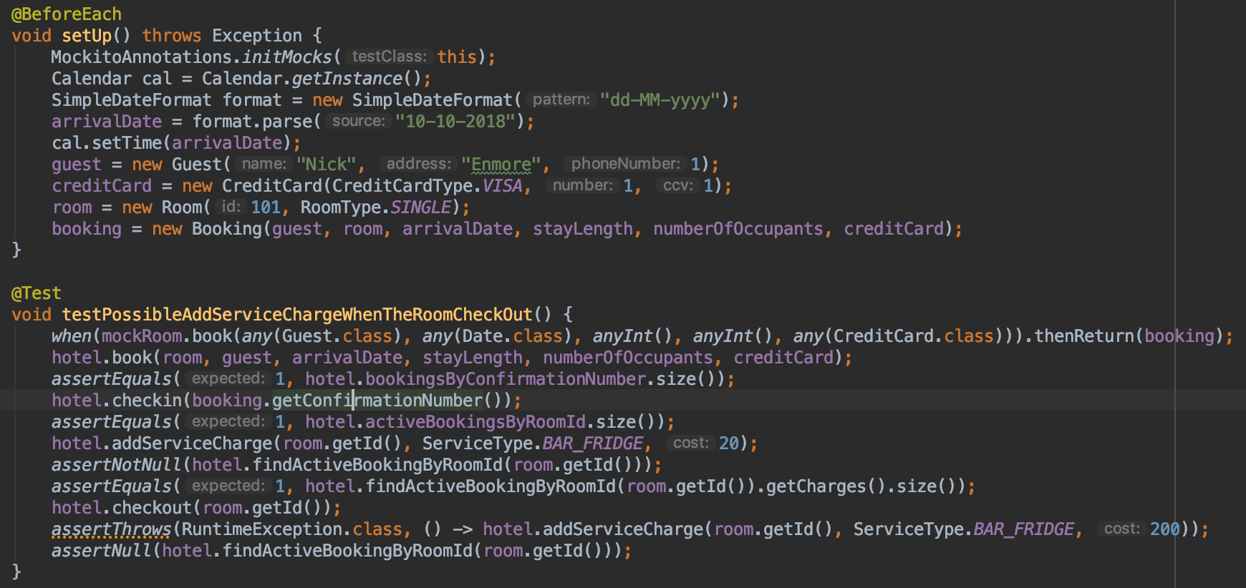

**Unit test result:**

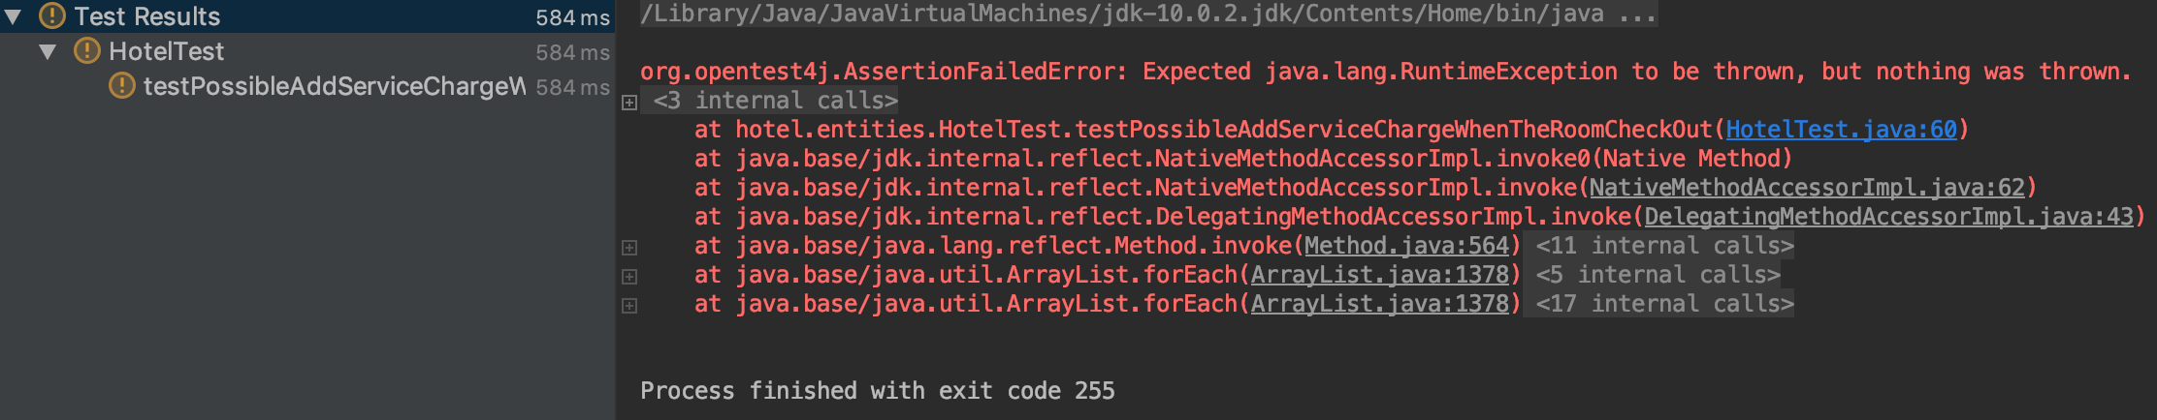

**Task 3: Tracing**

1. For each of the reported bugs, trace back through the program’s dependences from the point of failure to find the origin of the bug. Use a sequence of hypotheses and tests to support this search and document this sequence in a debugging log.
2. For each of the reported bugs, demonstrate that before the identified origin, variable values are ‘sane’ and that after the origin, at least one value is ‘infected’.
3. Record screenshots demonstrating the origin of the bug.

|  |  |  |  |  |  |
| --- | --- | --- | --- | --- | --- |
| Bug no | Description | Origin | Tracing Dependencies | Hypothesis | Screenshot # |
| 1. |  | Error:  public void addServiceCharge(ServiceType serviceType, double cosst) {  charges.add(new ServiceCharge(serviceType, cost)); }  After fix the error:  public void addServiceCharge(ServiceType serviceType, double cost) {  charges.add(new ServiceCharge(serviceType, cost)); } |  | H1: Not using the passed argument to create new service charge object.  Test: inspect addServiceCharge in Booking class  Results: passed argument for cost named ‘cosst’ but use class property named ‘cost’ to create new service charge. | Bug1Error  Bug1FixedBug  Bug1TestPass |
| 2. |  | Error:  public void checkout(int roomId) {  Booking booking = activeBookingsByRoomId.get(roomId);  if (booking == null) {  String mesg = String.*format*("Hotel: checkout: no booking present for room id : %d", roomId);  throw new RuntimeException(mesg);  }  booking.checkOut(); }  After fix the error:  public void checkout(int roomId) {  Booking booking = activeBookingsByRoomId.get(roomId);  if (booking == null) {  String mesg = String.*format*("Hotel: checkout: no booking present for room id : %d", roomId);  throw new RuntimeException(mesg);  }  booking.checkOut();  activeBookingsByRoomId.remove(roomId);  bookingsByConfirmationNumber.remove(booking.getConfirmationNumber()); } |  | H1: because booking is not removed when the room checked out. So the room is able to be added charged service.  Test: input checkout method of hotel class.  Result: the method does nothing more than changing status of the room. | Bug2Error  Bug2FixedBug  Bug2TestPass |

**Task 4: Resolution**

Bug 1:

Fixed codes:

To fix this problem we have to change the argument name from cosst to cost;

public void addServiceCharge(ServiceType serviceType, double cosst) {  
 charges.add(new ServiceCharge(serviceType, cost));  
}

to

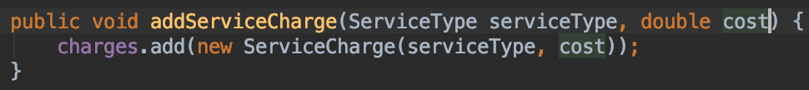

**Unit test result after fix bug:**

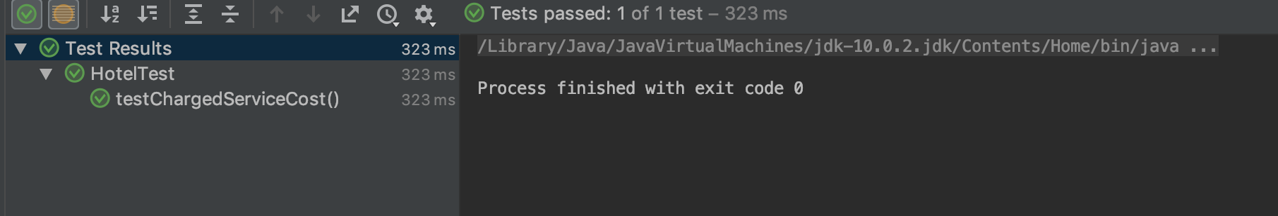

**Test result: Passed**

**Outputs of program after bugs fixed:**



Bug 2:

Fixed codes:

Remove booking item in activeBooking list of hotel when check out.

Before fixing bug:

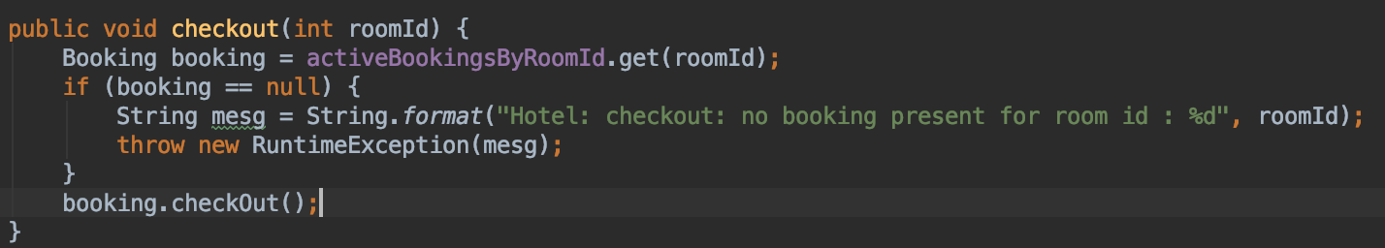

After fixing bug:

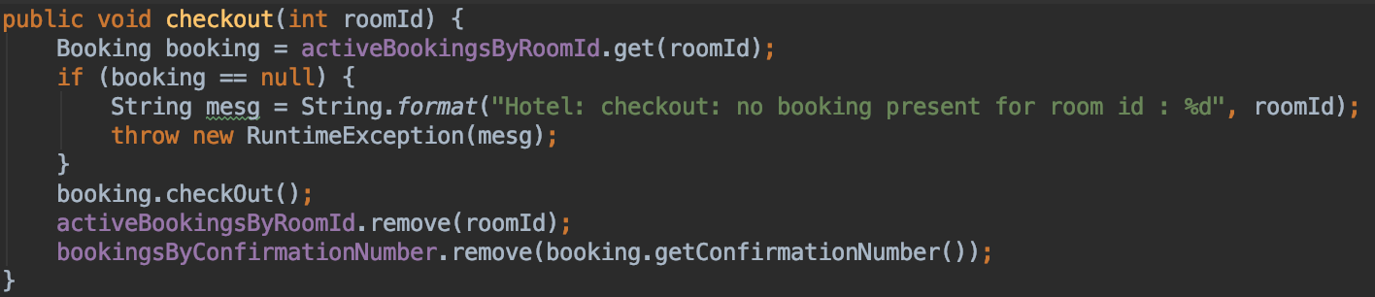

Test Result **PASSED**:

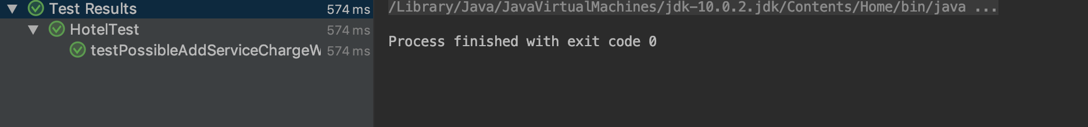

**Outputs of program after bugs fixed:**

