AngularJS Course

# Assignment 1: first AngularJS app

* Create folder name “hello”
* In “hello” folder, Create HTML file with name “hello.html”

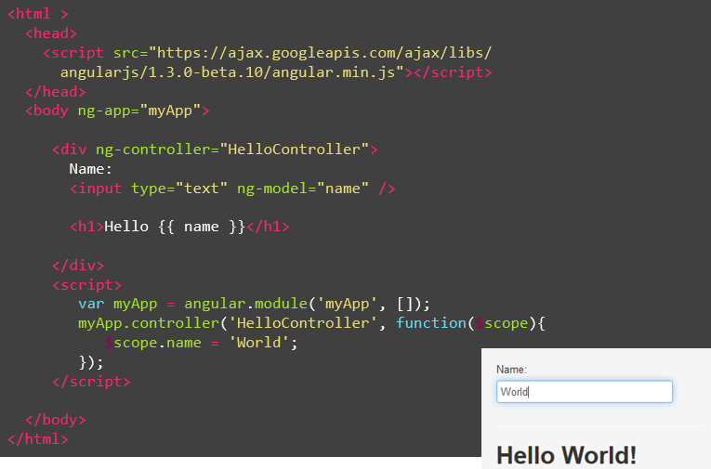

# Assignment 2: scope inheritance

* Create folder name “scope”
* In “scope” folder, Create HTML file with name “scope-inherit.html”

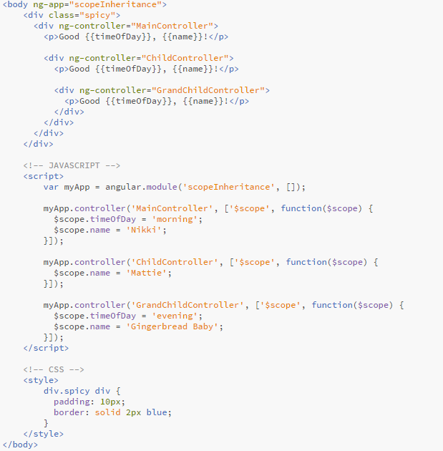

# Assignment 3: scope watch & apply

* Create folder name “scope”
* In “scope” folder, Create HTML file with name “scope-watch.html”

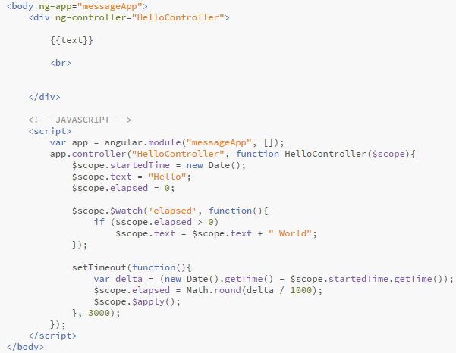

# Assignment 4: scope event

* Create folder name “scope”
* In “scope” folder, Create HTML file with name “scope-event.html”

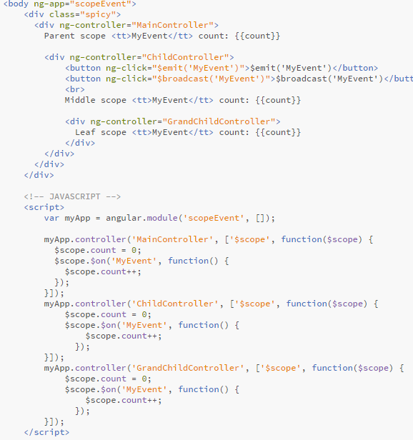

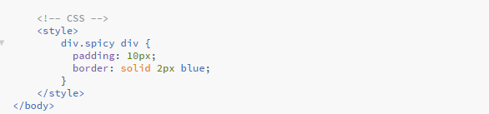

# Assignment 5: Directive

* Create folder name “template”
* In “template” folder, create HTML name call “my-customer.html”



* Create HTML file in root with name “template-directive.html”

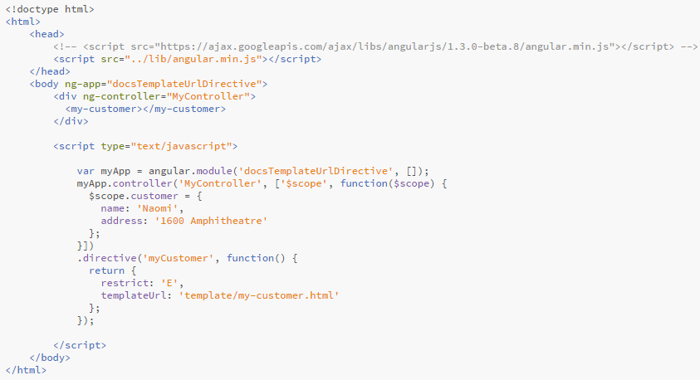

# Assignment 6: Directive with Isolated Scope

* Create folder name “template”
* In “template” folder, create HTML name call “my-customer-iso.html”



* Create HTML file in root with name “isolated-directive.html”

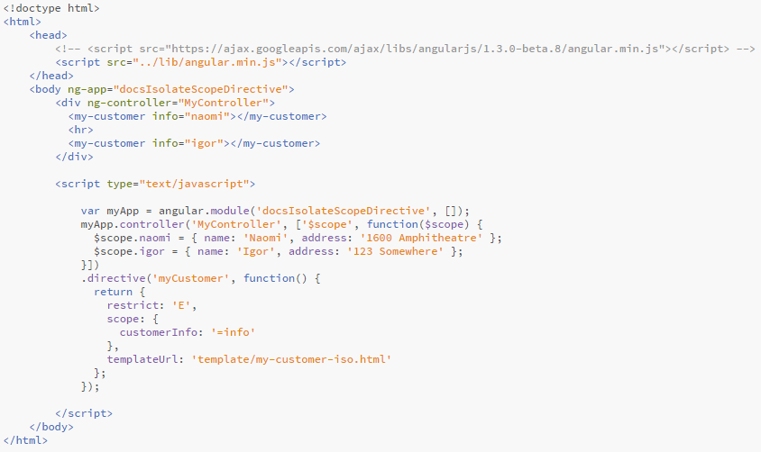

# Assignment 7: Directive that Manipulates the DOM

* Create HTML file in root with name “manipulate-directive.html”

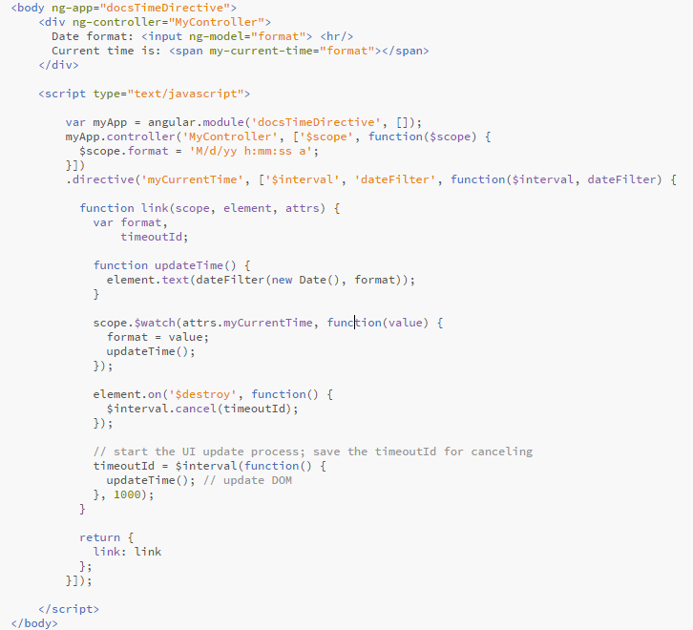

# Assignment 8: Directive that Wraps Other Elements

* Create folder name “template”
* In “template” folder, create HTML name call “my-dialog.html”



* Create HTML file in root with name “wrapper-directive.html”

