Develop web-based application for compute average scores of one student.

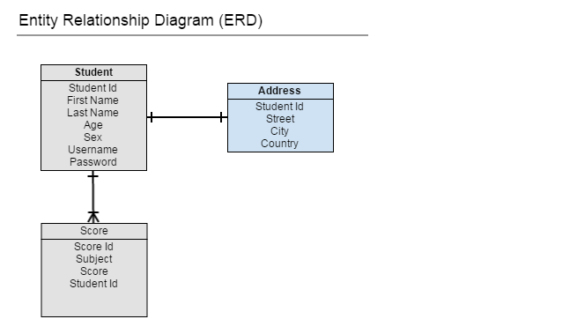

There are 5 screens, such as:

* Login screen
* List scores of student screen
* Add/Edit score of subject screen
* Add successful screen
* Delete confirmation screen

Your project must meet all the requirements listed below

* Use Spring/Spring MVC, Hibernate, JSP
* The structure of project must clearly separate to 3 layers (Controller, Service and Repository - DAO)
* Use MySQL as database
* Technology Version: Java 8, Spring 4.x, Hibernate 4.x and MySQL 5.x
* Use Maven project

How to submit project

* Email to [**ktran44@csc.com**](mailto:ktran44@csc.com)
* Email before **28/12/2015**
* Mail title: Spring Course - Your Full Name (e.g. Spring Course - Tran Van An)
* Package (attach to mail) - format: ZIP. Including Maven project and Database Script