Advance Promotion is the module that allows the admin can configure Promotion in a flexible way with the format formula.

Formula: x1-y1-z1||x2-y2-z2

x1,x2: qty of products that customer need to buy to get the discount achievement

y1,y2: qty of products will get a discount

z1,z2: the discount rate

Example: 20-5-7||30-6-10||35-9-15

By over 20 products, get 5 discount products with 7%

By over 30 products, get 6 discount products with 10%

By over 40 products, get 9 discount products with 15%

1. Backend
   1. Enable the module

Eleadtech -> Advance Promotion-> Setting -> Enable Module to “Yes”

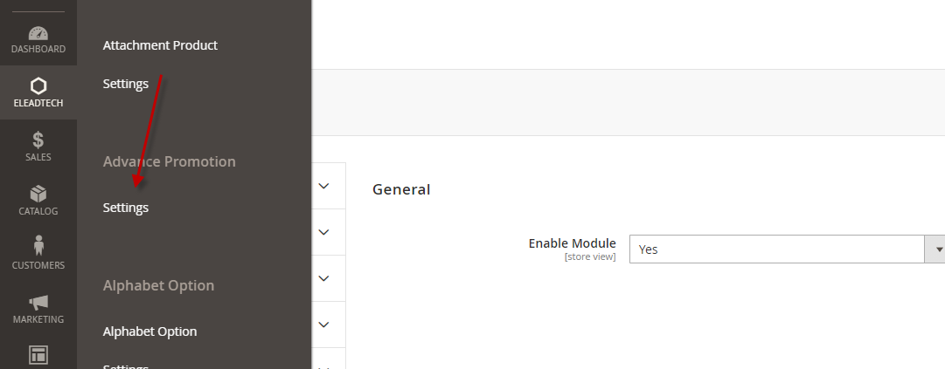

* 1. Set Up your new promotion in “Cart Price Rule”

You can see the new rule: Buy more discount more as the under images.

