Product Attachment is using if the owner of the website wants the B, C, D product will be added to cart of product A is added to cart.

The module allow to configure qty of B, C, and D. The B, C, D prices will be get from the default price of Magento.

The module also support for the rest API.

Customer could not modify B, C, and D on their card. If A is removed, B, C, D will be removed as well.

1. Backend
   1. Add Attachment Record.

Eleadtech -> Attachment Product -> Add New

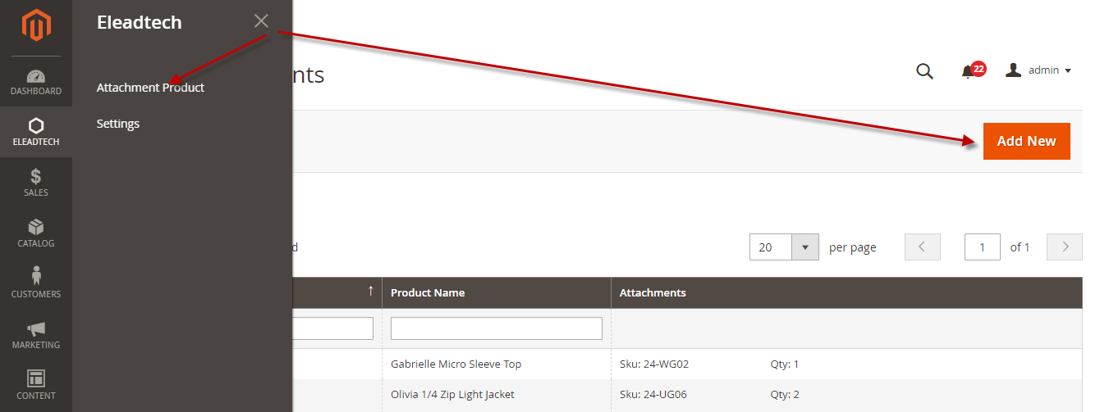

Step 1: Choose Main Product

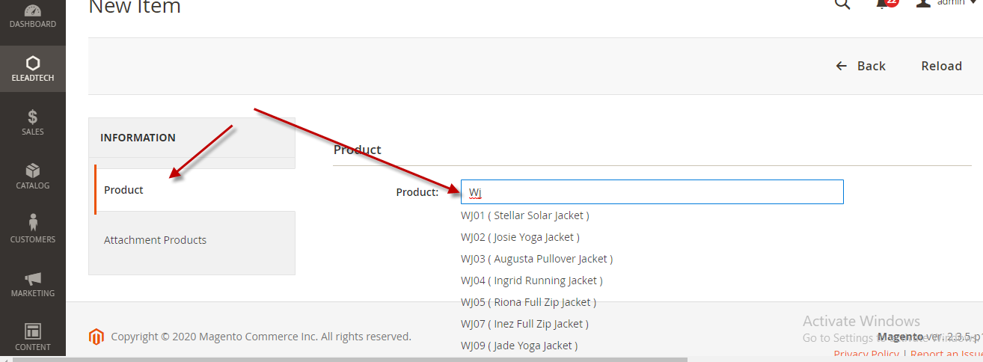

Step 2: Choose Attachment Products

Chose the attachment data and click to update data. The data will be update immediately once you click “Click here to Update Change” link.

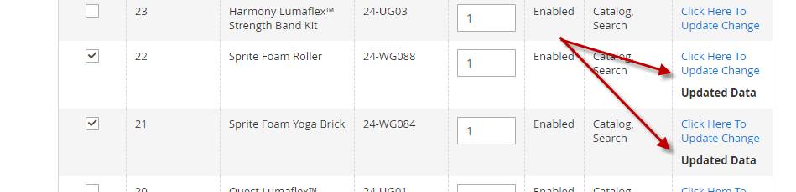

How to this affect to frontend:

Example:

Main Product: A

Product Attachments: B with qty = 7 and C with qty = 2 => 7 product B and 2 product C will be added to cart once customer adds Product A to cart.

* 1. Remove Attachment Record.

Admin can remove it on the grid page

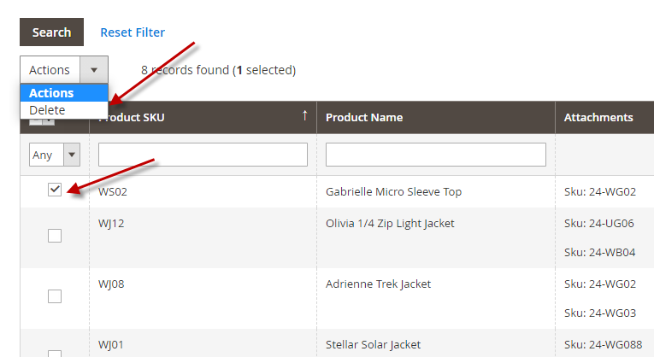

1. Frontend

A tab will be added to the product detail page called “Attachment” to show all attachment products with the corresponding quantity.

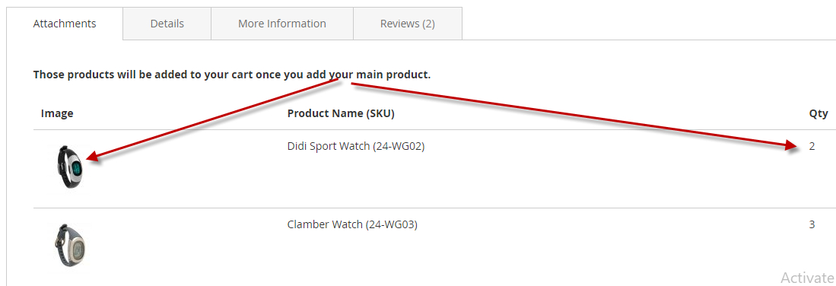

1. Support for the Rest API (mobile or third party )
   1. Override Cart Api, will add product attachment to api for the basic api as add, delete, update cart
      1. V1/carts/cartId:/items: get all item in cart
      2. V1/carts/mine/items
      3. V1/carts/cartId:/items/itemId:
      4. V1/carts/mine/items/itemId: update Item
   2. Module Api
      1. /V1/attachment/sku/:sku: get all attachments of this sku
      2. /V1/attachment/skus: get all attachments for those sku
      3. /V1/attachment/carts/:cartId: get all attachment Item Id in the cart.
2. Configuration

Admin need to enable the module and API to help this work.

