Product Slider allow customer can see all product detail on category page by slide by slide.

Check Magento 2.2, 2.3, 2.4

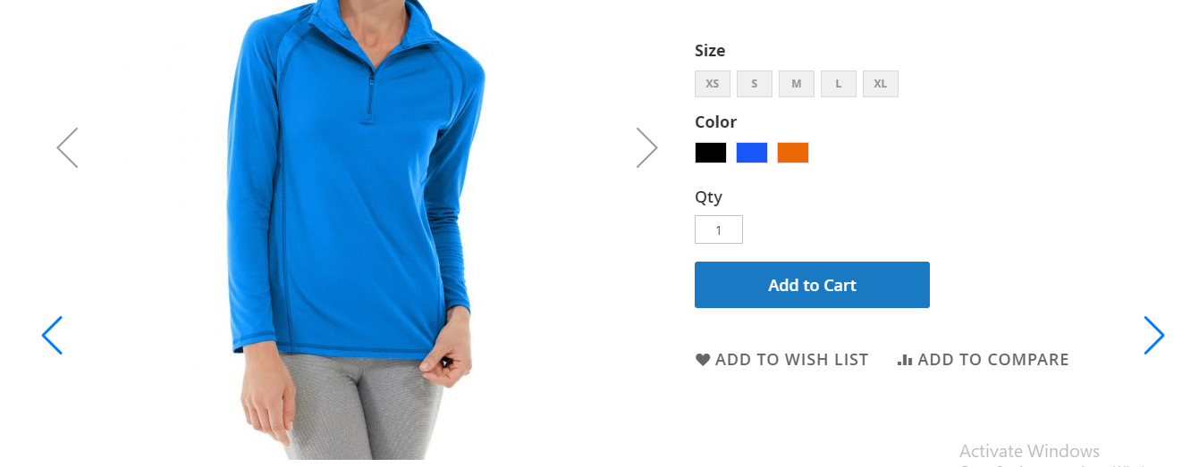

1. Backend
   1. Enable Module

Eleadtech -> Product Slider-> Setting -> Enable the module.

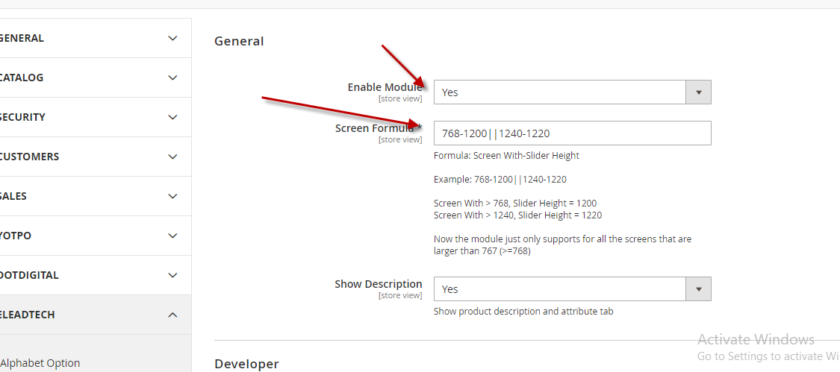

Please make sure you need to understand screen formula and follow the structure. We allow to let admin can configure the slider height base on the real height from product detail.

The module use the default height from the default theme

The slider just works on the screen > 767.

Customer can click the under icon to see how to the slider works.

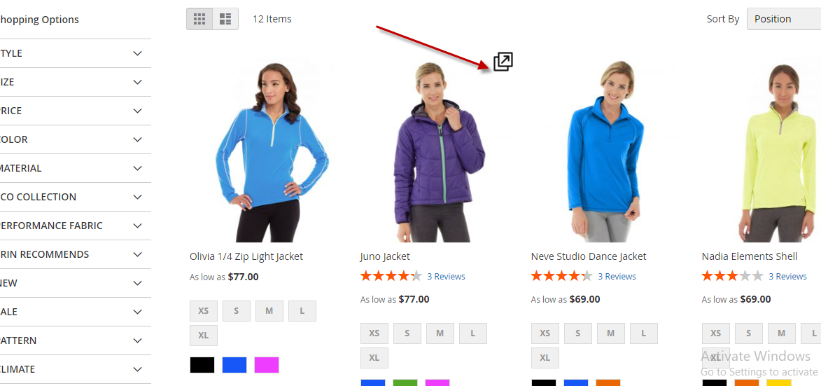

* 1. For Developer

Most of the layer navigation are using ajax to update content and left navigation. So developers need to customize this module to help it work with ajax layer navigation module.

Please remove and apply the block Eleadtech\ProductSlider\Block\Slider with template Eleadtech_ProductSlider::catalog/category/slider.phtml once you apply left and content of layer navigation by ajax.

