Alphabet option is the module allows admin can sort the attribute by alphabet (desc,asc) and position instead of only the position as default.

Test on magento 2.2, 2.3, 2.4

1. Backend
   1. Enable the module

Eleadtech -> Alphabetoption -> Setting -> Enable Module to “Yes”

Choose all attributes that you want to sort them by the new way (alphabet or position). All non-chosen attributes will be used as default.

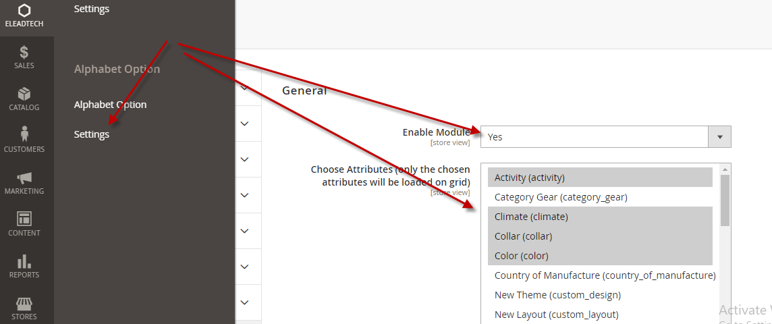

* 1. Update the attributes:

Click “Update Attributes” button to load all the attributes you chose.

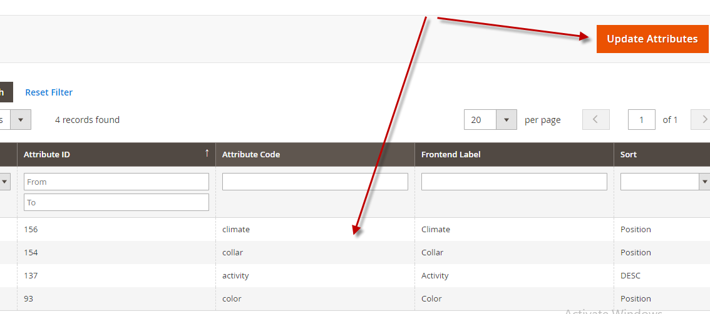

* 1. Edit attribute sorting

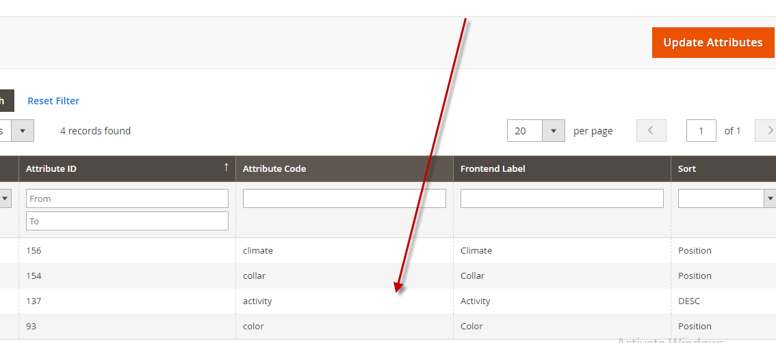

Choose the new sort you wish and save it.

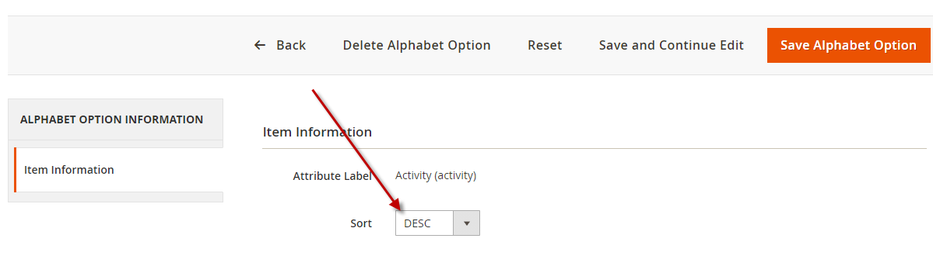

Visit Stores -> Attributes -> Product to check the result

**You will not need to move the elements when you add the new ones**

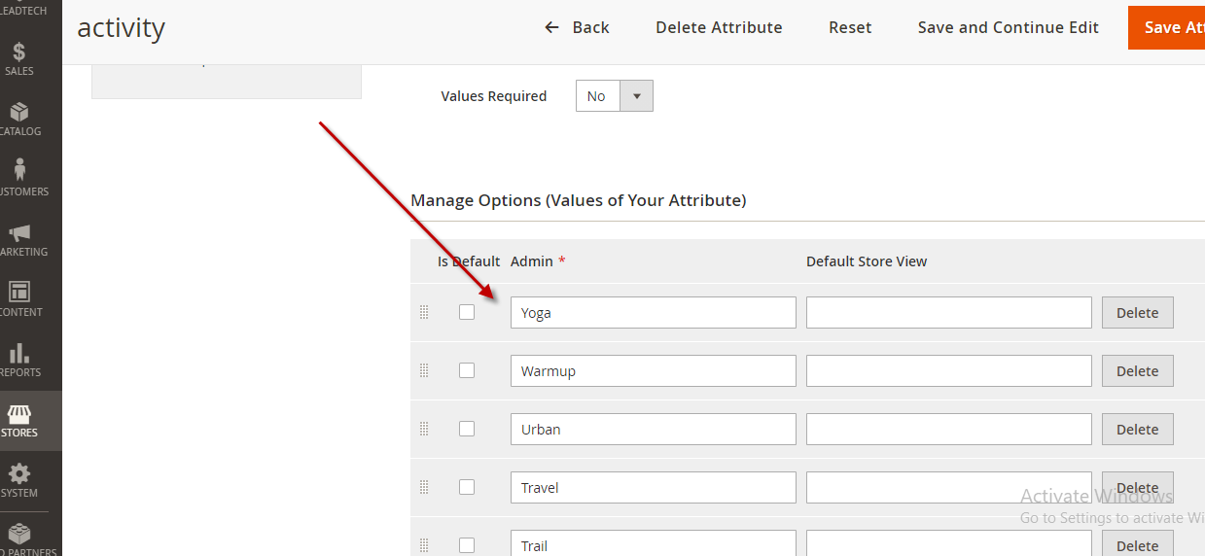

You should clear cache to see how it influences on frontend.



* 1. Cron job will adjust in 1 hour.

There is a cron job called alphabet_option_update_position will adjust the chosen attributes in 1 hour if you add the option values from the third party.