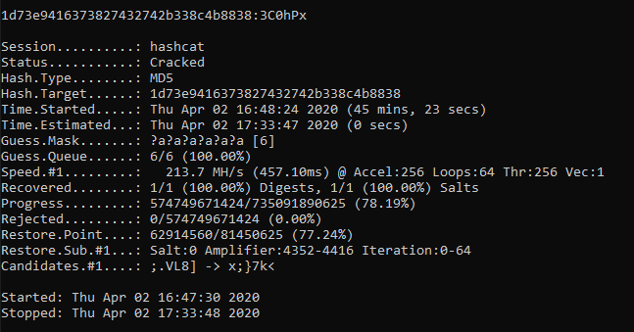

* -a: The attack mode (3 = Brute force)
* -m: The hash type on your file (0 = MD5)
* -w: The workload profile (4 = Nightmare mode)
* -i: Incremental mode with this mask (3 characters including lowercase/uppercase/number/special)
* –force: brute force

hashcat64.exe -a 3 -m 0 -w 4 hash.txt -i ?a?a?a?a?a?a --force

<https://www.md5online.org/blog/how-to-brute-force-a-password/>

45 mins

part 2

hashcat -a 3 -m 1400 hash.txt -1 ?l?u?d ?1?1?1?1?1?1?1 --force

21 mis

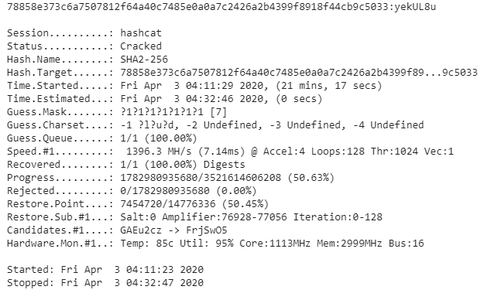

Part 3:

hashcat64.exe -a 0 -m 3200 hashb.txt rockyou.txt --force

