**GITHUB WORK-FLOW**

* 1. Update your code to catch up with other:
     1. In the terminal, go our repository iHear (big iHear)
     2. Make sure you are in the **main** branch
     3. To switch to the **main** branch, by run: **git checkout main**
     4. Run: **git pull**
     5. Run: **npm install**
  2. On our GitHub repository -> Project tab -> iHear – Task Assignment:   
     A screenshot of a computer

     Description automatically generated
  3. Select any issue that you can do in the **Todo** column (Click on issue to see detail): A screenshot of a computer

     Description automatically generated
  4. To select an issue, just Assign it to you, and move it to the column **In Progress**:  
     A screenshot of a computer

     Description automatically generated
  5. If you have any question, ask me on Discord by creating a new Thread of that issue.
  6. Back to **main** branch, then create a new branch from that branch.
     1. Your new branch should be named in this format:

**#issueNumber-Title-of-the-issue**

* Example: #42-Dashboard-Cannot-scroll-the-list-properly
  + 1. Your work must be entirely on this new branch (we can merge it to the **main** later).
    2. In terminal, switch to that new branch with command: **git checkout new-branch-name**
  1. **IMPORTANT**: Before you finish your task, please make sure your code satisfies the following requirement, otherwise your code would be rejected (at the final step) and you would have to go through all the steps again:
     1. Your code can run when compiled
     2. Your code does not generate warning nor error
     3. Your code has comments, especially on the confusing blocks.
  2. When you push your code to that new branch, git will usually prompt you this message:   
     A screen shot of a computer

     Description automatically generated  
     To resolve, just copy the highlighted command and run it.
  3. When you finish (after pushing your code) to your new branch, move the task to **In Review** column.
  4. Go back to the GitHub, open a new Pull Request (**PR**) from your branch: 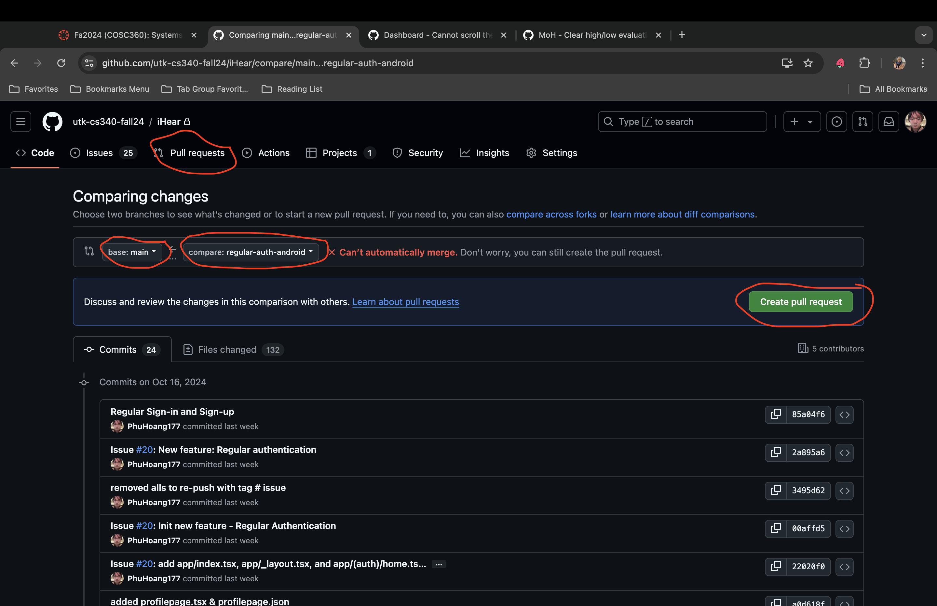
  5. Fill out all the marked properties of the **PR**: (You can assign me as the Reviewer)A screenshot of a computer

     Description automatically generated
  6. On the same PR page, when your code is approved without conflict: A screenshot of a computer

     Description automatically generated
     1. If it shows as the above picture, you can click **Merge pull request**
     2. Go back to the issue, change its status to **Done**
     3. They are all set.
  7. On the same PR page, when your code is approved WITH conflicts:
     1. On the Terminal, run:
        1. **git checkout main**
        2. **git pull**
        3. **git checkout your-branch-name**
        4. **git merge main**
     2. Then, you will have to go through each difference between main and your branch to choose which to keep, and which to discard, or keep both.
     3. Contact me or Brenna, we can help you with this for the first time.
  8. If your code is not approved, the page will show you which part you need to fix. Just fix your code, push again and re-request me.
  9. All done. I just don’t like to stop at step 13!!!