**HOW TO BUILD REACT NATIVE APP ON IOS**

**Requirements:**

* A MacBook with MacOS (mine is Sonoma 14.7).
* An iPhone (mine is iPhone 13 Pro with iOS 17.7).
* A cable to connect your iPhone to your MacBook.

**Steps:**

1. Install Xcode from the App Store
2. Install Xcode Command Line Tools:

Open Xcode -> **Settings -> Locations** and install the tools by selecting the most recent version in the **Command Line Tools** dropdown.

1. Install Watchman on your Terminal:

**brew update**

**brew install watchman**

1. Connect your iPhone to the MacBook (If one step fails, you should re-plug your iPhone and try again from Step 4a):
   1. Connect your iOS device to your Mac using a cable. Unlock the device and tap Trust if prompted.
   2. Open Xcode. From the menu bar, select Window > Devices and Simulators. You will see a warning in Xcode to enable developer mode.
   3. On your iOS device, open Settings > Privacy & Security, scroll down to the Developer Mode list item and navigate into it.
   4. Tap the switch to enable Developer Mode. After you do so, Settings presents an alert to warn you that Developer Mode reduces your device's security. To continue enabling Developer Mode, tap the alert's Restart button.
   5. After the device restarts and you unlock it, the device shows an alert confirming that you want to enable Developer Mode. Tap Turn On, and enter your device passcode when prompted.
2. Run Xcode once to initialize the first app (we can IGNORE it and go back with our Terminal later):

Open Xcode -> Settings -> Accounts -> Sign in your iCloud

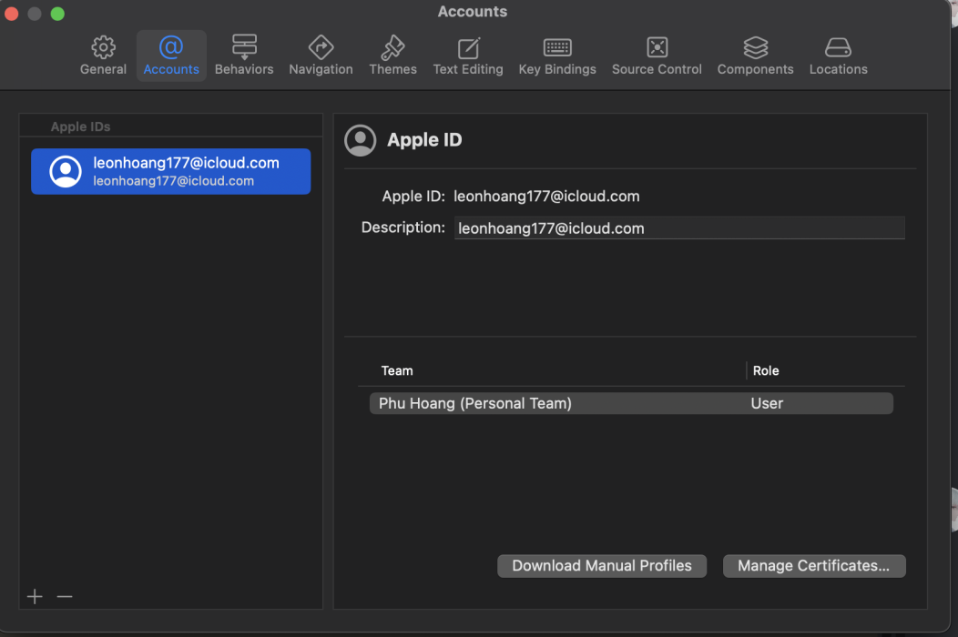

1. At the same tab: Accounts -> Manage Certificates -> Add (+) a new one for your Mac -> Done

1. Create a new project:
   1. Close Xcode (make sure to quit completely or Force quit)
   2. Unplug your iPhone
   3. Plug your iPhone back in
   4. Open Xcode again
   5. At the starting screen, click "Create New Project..."

1. Config the project according to the following in order:

This is just a “draft” app so you can have any name:

After clicking "Build" icon, it may take a while to build. When it finished, your app will automatically open on your iPhone:

1. Now we are DONE with Xcode, we will not use it anymore, but do NOT uninstall it. Let get back to our Terminal and type the following:
   1. Go to your workplace: **cd your-workplace**
   2. Create our app: **npx create-expo-app@latest**
   3. Go to your newly created app: **cd app-name**
   4. Install a dev-client library: **npx expo install expo-dev-client**
   5. Build the app on your phone: **npx expo run:ios --device**
2. Give it 5 – 10 minutes to build and it should be good. The first time may be long, but it will be faster every time you build it.
3. If you re-plug your phone, you must run this command again: **npx expo run:ios --device**