**Hình minh họa chạy chương trình:**

1. **Sử dụng nguồn dữ liệu từ SQL Server:**

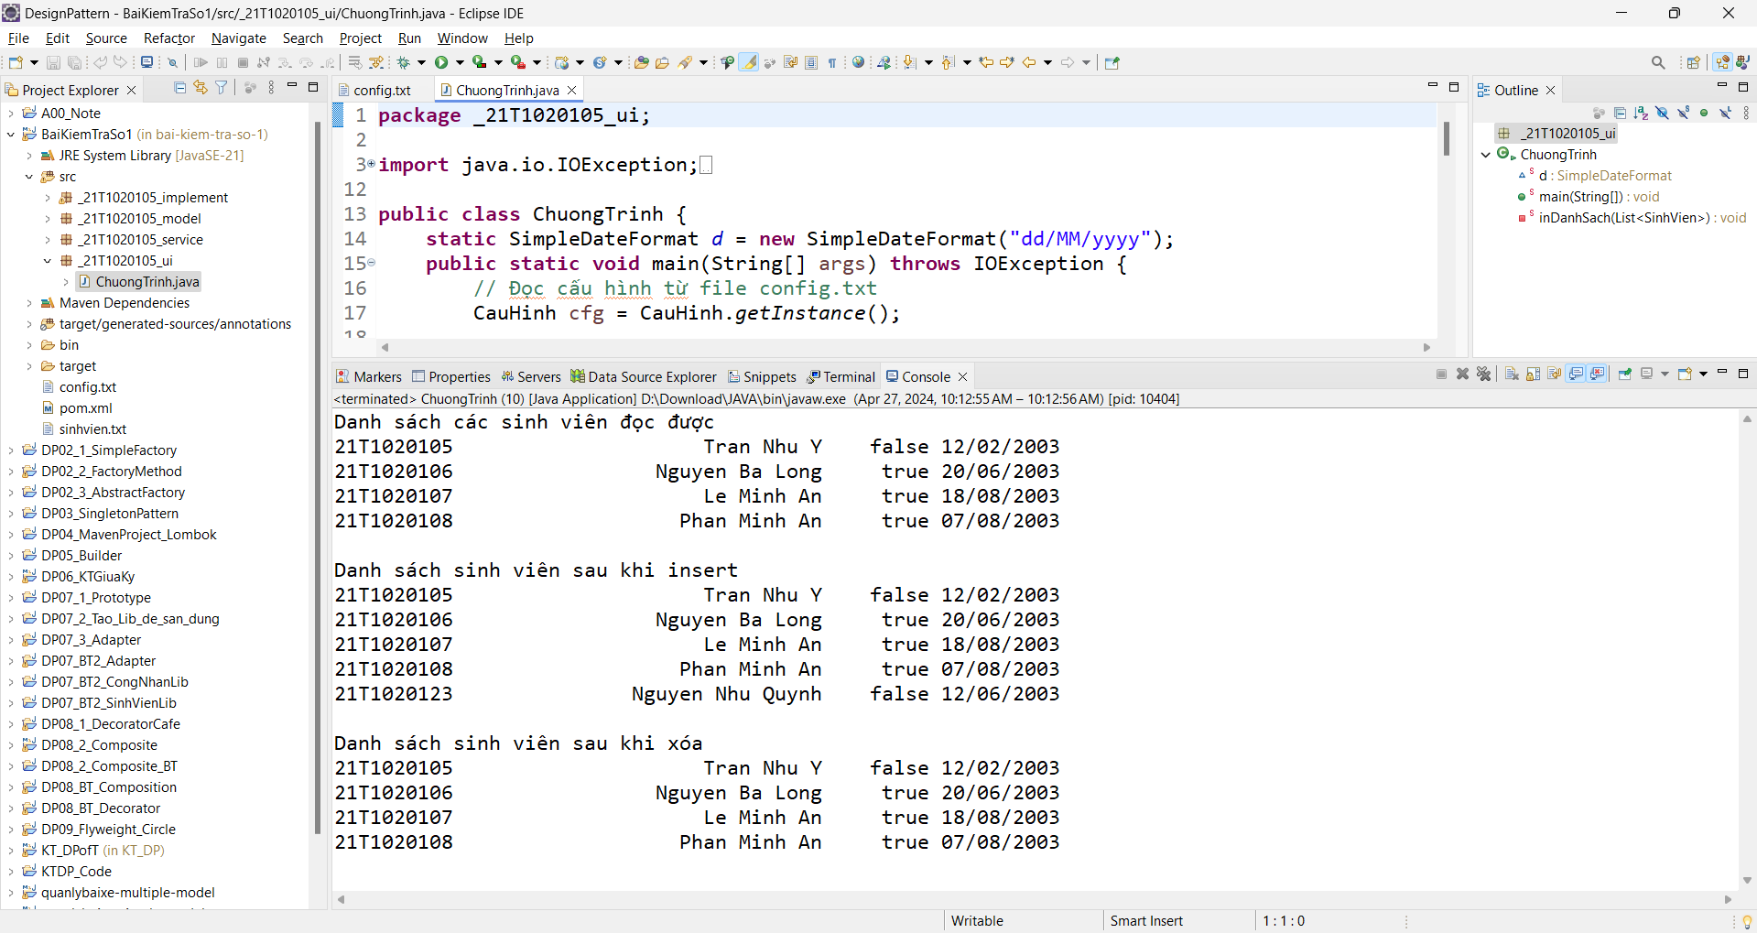

1. **Sử dụng nguồn dữ liệu từ file TXT:**

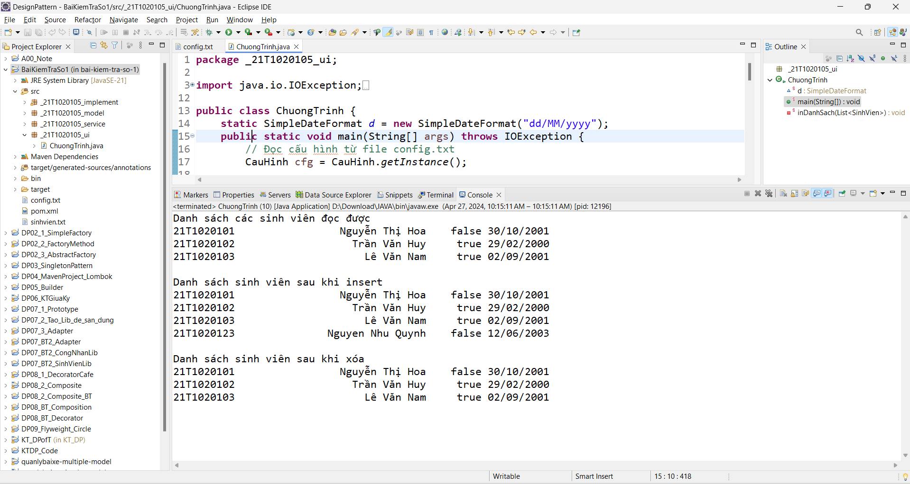

**Script của CSDL:**

USE [master]

GO

/****** Object: Database [DB_KTra_DP] Script Date: 4/27/2024 10:18:31 AM ******/

CREATE DATABASE [DB_KTra_DP]

CONTAINMENT = NONE

ON PRIMARY

( NAME = N'DB_KTra_DP', FILENAME = N'C:\Program Files\Microsoft SQL Server\MSSQL12.MSSQLSERVER\MSSQL\DATA\DB_KTra_DP.mdf' , SIZE = 4096KB , MAXSIZE = UNLIMITED, FILEGROWTH = 1024KB )

LOG ON

( NAME = N'DB_KTra_DP_log', FILENAME = N'C:\Program Files\Microsoft SQL Server\MSSQL12.MSSQLSERVER\MSSQL\DATA\DB_KTra_DP_log.ldf' , SIZE = 1024KB , MAXSIZE = 2048GB , FILEGROWTH = 10%)

GO

ALTER DATABASE [DB_KTra_DP] SET COMPATIBILITY_LEVEL = 120

GO

IF (1 = FULLTEXTSERVICEPROPERTY('IsFullTextInstalled'))

begin

EXEC [DB_KTra_DP].[dbo].[sp_fulltext_database] @action = 'enable'

end

GO

ALTER DATABASE [DB_KTra_DP] SET ANSI_NULL_DEFAULT OFF

GO

ALTER DATABASE [DB_KTra_DP] SET ANSI_NULLS OFF

GO

ALTER DATABASE [DB_KTra_DP] SET ANSI_PADDING OFF

GO

ALTER DATABASE [DB_KTra_DP] SET ANSI_WARNINGS OFF

GO

ALTER DATABASE [DB_KTra_DP] SET ARITHABORT OFF

GO

ALTER DATABASE [DB_KTra_DP] SET AUTO_CLOSE OFF

GO

ALTER DATABASE [DB_KTra_DP] SET AUTO_SHRINK OFF

GO

ALTER DATABASE [DB_KTra_DP] SET AUTO_UPDATE_STATISTICS ON

GO

ALTER DATABASE [DB_KTra_DP] SET CURSOR_CLOSE_ON_COMMIT OFF

GO

ALTER DATABASE [DB_KTra_DP] SET CURSOR_DEFAULT GLOBAL

GO

ALTER DATABASE [DB_KTra_DP] SET CONCAT_NULL_YIELDS_NULL OFF

GO

ALTER DATABASE [DB_KTra_DP] SET NUMERIC_ROUNDABORT OFF

GO

ALTER DATABASE [DB_KTra_DP] SET QUOTED_IDENTIFIER OFF

GO

ALTER DATABASE [DB_KTra_DP] SET RECURSIVE_TRIGGERS OFF

GO

ALTER DATABASE [DB_KTra_DP] SET DISABLE_BROKER

GO

ALTER DATABASE [DB_KTra_DP] SET AUTO_UPDATE_STATISTICS_ASYNC OFF

GO

ALTER DATABASE [DB_KTra_DP] SET DATE_CORRELATION_OPTIMIZATION OFF

GO

ALTER DATABASE [DB_KTra_DP] SET TRUSTWORTHY OFF

GO

ALTER DATABASE [DB_KTra_DP] SET ALLOW_SNAPSHOT_ISOLATION OFF

GO

ALTER DATABASE [DB_KTra_DP] SET PARAMETERIZATION SIMPLE

GO

ALTER DATABASE [DB_KTra_DP] SET READ_COMMITTED_SNAPSHOT OFF

GO

ALTER DATABASE [DB_KTra_DP] SET HONOR_BROKER_PRIORITY OFF

GO

ALTER DATABASE [DB_KTra_DP] SET RECOVERY FULL

GO

ALTER DATABASE [DB_KTra_DP] SET MULTI_USER

GO

ALTER DATABASE [DB_KTra_DP] SET PAGE_VERIFY CHECKSUM

GO

ALTER DATABASE [DB_KTra_DP] SET DB_CHAINING OFF

GO

ALTER DATABASE [DB_KTra_DP] SET FILESTREAM( NON_TRANSACTED_ACCESS = OFF )

GO

ALTER DATABASE [DB_KTra_DP] SET TARGET_RECOVERY_TIME = 0 SECONDS

GO

ALTER DATABASE [DB_KTra_DP] SET DELAYED_DURABILITY = DISABLED

GO

EXEC sys.sp_db_vardecimal_storage_format N'DB_KTra_DP', N'ON'

GO

USE [DB_KTra_DP]

GO

/****** Object: Table [dbo].[SinhVien] Script Date: 4/27/2024 10:18:32 AM ******/

SET ANSI_NULLS ON

GO

SET QUOTED_IDENTIFIER ON

GO

CREATE TABLE [dbo].[SinhVien](

[MaSinhVien] [nvarchar](10) NOT NULL,

[HoTen] [nvarchar](50) NOT NULL,

[GioiTinhNam] [bit] NOT NULL,

[NgaySinh] [date] NOT NULL,

CONSTRAINT [PK_SinhVien] PRIMARY KEY CLUSTERED

(

[MaSinhVien] ASC

)WITH (PAD_INDEX = OFF, STATISTICS_NORECOMPUTE = OFF, IGNORE_DUP_KEY = OFF, ALLOW_ROW_LOCKS = ON, ALLOW_PAGE_LOCKS = ON) ON [PRIMARY]

) ON [PRIMARY]

GO

INSERT [dbo].[SinhVien] ([MaSinhVien], [HoTen], [GioiTinhNam], [NgaySinh]) VALUES (N'21T1020105', N'Tran Nhu Y', 0, CAST(N'2003-02-12' AS Date))

INSERT [dbo].[SinhVien] ([MaSinhVien], [HoTen], [GioiTinhNam], [NgaySinh]) VALUES (N'21T1020106', N'Nguyen Ba Long', 1, CAST(N'2003-06-20' AS Date))

INSERT [dbo].[SinhVien] ([MaSinhVien], [HoTen], [GioiTinhNam], [NgaySinh]) VALUES (N'21T1020107', N'Le Minh An', 1, CAST(N'2003-08-18' AS Date))

INSERT [dbo].[SinhVien] ([MaSinhVien], [HoTen], [GioiTinhNam], [NgaySinh]) VALUES (N'21T1020108', N'Phan Minh An', 1, CAST(N'2003-08-07' AS Date))

USE [master]

GO

ALTER DATABASE [DB_KTra_DP] SET READ_WRITE

GO

**Dữ liệu của file minh họa của nguồn dữ liệu TXT:**

21T1020101,Nguyễn Thị Hoa,false,2001/10/30

21T1020102,Trần Văn Huy,true,2000/02/29

21T1020103,Lê Văn Nam,true,2001/09/02