Assignment 3: Understanding Algorithm Efficiency and Scalability
Randomized Quicksort and Hashing with Chaining
Nhuja Shakya
University of the Cumberlands
MSCS-532-B01: Algorithms and Data Structures
Student ID : 005058336
Dr. Michael Solomon
November 9, 2026

Assignment 3: Algorithm Efficiency and Scalability
Purpose and Implementation
This assignment compares randomized Quicksort with a deterministic first-element-pivot version and implements a separate-chaining hash table. Both sorting variants use the same iterative, three-way in-place partitioner; only pivot selection changes. The randomized method chooses an integer position uniformly from the active subarray. Three-way partitioning places duplicate pivot values into one completed middle region, so equal values do not repeatedly enter new partitions (Bentley & McIlroy, 1993). Both methods return an ascending sorted copy of the input; an explicit stack avoids Python recursion-limit failures.
Randomized Quicksort: Expected Complexity
For n distinct keys, partitioning takes Θ(n) work. If the random pivot has rank k + 1, the subproblems contain k and n − 1 − k elements. Thus the expected-time recurrence is E[T(n)] = (1/n) Σₖ₌₀ⁿ⁻¹(E[T(k)] + E[T(n − 1 − k)]) + cn. It resolves to Θ(n log n); randomization removes dependence on the original input order for the expected bound, not the possibility of an unlucky Θ(n²) execution (Sedgewick, 1978).
An indicator-variable proof makes the bound precise. Rank the distinct keys x₁ < ··· < xₙ and let Xᵢⱼ equal 1 when ranks i and j are directly compared, or 0 otherwise. The two ranks meet only when the first pivot from the rank interval [i, j] is one of its endpoints. Therefore P(Xᵢⱼ = 1) = 2/(j − i + 1). By linearity of expectation, E[C] = Σᵢ<ⱼ E[Xᵢⱼ] = Σᵢ<ⱼ 2/(j − i + 1) ≤ 2nHₙ = O(n log n). The comparison-sorting lower bound supplies Ω(n log n) for distinct keys. Our three-way partitioner may perform up to two comparisons per visited element, preserving this asymptotic expected bound, while duplicate keys are removed together.
Experiment Design
Four input distributions—random, already sorted, reverse sorted, and repeated values from eight distinct keys—were tested at sizes 250, 750, 1,500, and 3,000. Each algorithm sorted the same input values, with seven trials per configuration. The median of wall-clock measurements from perf_counter_ns was recorded. All results below were collected on a Mac running macOS 27.0.1 (arm64) with Python 3.14.7; input generation used fixed random seeds while randomized-pivot seeds varied by trial.
Empirical Quicksort Results
Table 1. Median execution time at n = 3,000 (milliseconds; seven trials)
Input distribution | Randomized | First-element pivot
Random | 2.6739 | 2.2372
Sorted | 2.2347 | 7.3234
Reverse sorted | 2.3493 | 174.9110
Repeated values | 0.3698 | 0.3555
Figure 1. Median sorting time by input distribution and array length (from benchmark_results.csv).
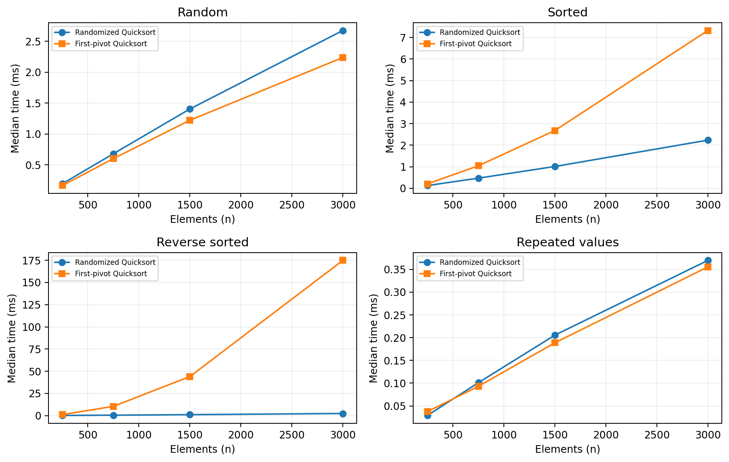
Interpretation
At 3,000 elements, reverse-sorted input took 174.9110 ms with a first-element pivot, versus 2.3493 ms with randomized pivots (about 74.5 times longer). Sorted input also favored randomized pivots (2.2347 versus 7.3234 ms). For random input, the deterministic variant was slightly faster (2.2372 versus 2.6739 ms); for repeated values, the two were close (0.3555 versus 0.3698 ms). This is consistent with deterministic first-pivot selection producing poor partitions on ordered data, whereas randomized selection usually avoids repeatedly extreme pivots. Randomized pivots add selection overhead and do not guarantee a faster individual run; three-way partitioning also makes duplicate-heavy data efficient for both algorithms. The benchmarks measure Python wall-clock time, so interpreter overhead and implementation details influence the observed constants.
Hashing with Separate Chaining
Implementation and Hash Function
The ChainedHashTable class stores a list of (integer key, value) pairs in each bucket. It supports insert, search, and delete, including value replacement for an existing key, missing-key KeyError behavior, and values equal to None. Accepted keys are nonnegative integers less than the prime p = 2⁶¹ − 1. At creation, parameters a ∈ {1,…,p−1} and b ∈ {0,…,p−1} are sampled; the bucket is h(k) = ((ak + b) mod p) mod m, where m is the current slot count. This is an affine universal-hashing-style family. The initial random parameters and bucket chains reduce dependence on any one regular key pattern, although the implementation is not intended for cryptographic security (Carter & Wegman, 1979).
Insertion scans the selected chain to update an existing key or appends a new entry. Search scans the matching chain and raises KeyError when the key is missing; deletion scans and removes the pair, then returns its old value. The implementation doubles its slot count when a new key would exceed the default load-factor threshold 0.75 and halves capacity when the load drops below 0.20, subject to the initial minimum. Each resize reinserts stored pairs into new buckets; resizing is occasional rather than a per-operation cost.
Expected and Worst-Case Cost
Let n denote the number of stored pairs and m the number of buckets. The load factor α = n/m is the expected chain length under simple uniform hashing. A search (successful or unsuccessful) and deletion by key require expected Θ(1 + α) time because they may inspect a bucket chain. Updating an existing key has the same expected cost. Appending a new key has expected Θ(1 + α) cost in this implementation because duplicates are checked before insertion; with α kept at a constant threshold and geometric resizing, insertion is expected amortized Θ(1), including rehashing. Under adversarial collisions, a chain may grow to n entries and search, update, or deletion may require Θ(n). Storage is Θ(n + m). A universal hashing family reduces expected collisions over its random parameters but does not provide a deterministic constant-time guarantee.
Load-Factor Management
Doubling capacity before α exceeds 0.75 limits expected search-chain growth while trading extra bucket-array memory for faster lookup. Lower thresholds may consume additional memory with modest benefit; higher thresholds save slots but generally increase collision work. A sustained low load factor also permits capacity reduction. Repeated resizing can affect latency, so real-time workloads may prefer scheduled growth or capacity planning.
Hash Table Demonstration and Conclusions
Table 2. Chaining outcomes for 3,000 inserted integer keys (one fixed seed)
Growth threshold | Slots | Final α | Extra entries in chains | Longest chain
0.5 | 8192 | 0.3662 | 608 | 2
0.75 | 4096 | 0.7324 | 608 | 2
2.0 | 2048 | 1.4648 | 952 | 3
The demonstration inserts and retrieves 3,000 integer keys while varying the maximum allowed load factor. At threshold 2.00, the table finished with 2,048 slots, load factor 1.4648, 952 collision entries, and a maximum chain length of 3. At thresholds 0.50 and 0.75, the maximum chain length was 2 and collision entries were 608 in both cases, but the stricter threshold allocated 8,192 rather than 4,096 slots. These outcomes illustrate the memory-versus-chain-length trade-off; collision counts depend on the specific keys and hash seed and do not directly measure lookup latency.

Validation, Limitations, and Practical Implications
Automated tests cover empty, sorted, reverse-ordered, duplicate, and negative-value arrays, as well as different random seeds and large inputs. Hash-table tests verify collisions, resizing, invalid keys, updates, deletion, and 1,200 operations checked against Python’s dictionary. Tests support confidence but do not prove correctness for every input. Only integer keys are accepted; deployment would require concurrency controls and stronger security.
For infrastructure automation, randomized sorting could organize events, while chaining could index server identifiers. Random pivots improve expected scalability but cannot guarantee fast worst-case execution. A resized hash table provides expected fast lookups at the cost of extra buckets; universal-style hashing does not replace access controls or denial-of-service protections.
To reproduce the tables and chart, rerun benchmark.py and hash_load_experiment.py, then generate_report.py. Repository: https://github.com/nhuz44/MSCS532_Assignment3.

References
Bentley, J. L., & McIlroy, M. D. (1993). Engineering a sort function. Software: Practice and Experience, 23(11), 1249–1265. https://doi.org/10.1002/spe.4380231105
Carter, J. L., & Wegman, M. N. (1979). Universal classes of hash functions. Journal of Computer and System Sciences, 18(2), 143–154. https://doi.org/10.1016/0022-0000(79)90044-8
Sedgewick, R. (1978). Implementing Quicksort programs. Communications of the ACM, 21(10), 847–857. https://doi.org/10.1145/359619.359631
Massachusetts Institute of Technology. (2015). Lecture 6: Randomized algorithms [Course notes]. MIT OpenCourseWare. https://ocw.mit.edu/courses/6-046j-design-and-analysis-of-algorithms-spring-2015/

