Heap Data Structures: Implementation, Analysis, and Applications
Nhuja Shakya
University of the Cumberlands
MSCS-532-B01: Algorithms and Data Structures
Student ID : 005058336
Assignment 4
Dr. Michael Solomon
November 9, 2026

Heap Data Structures: Implementation, Analysis, and Applications
Heap data structures provide a practical connection between algorithmic complexity and task scheduling. This project implements array-based Heapsort, compares it with hand-written randomized Quicksort and Merge Sort, and builds an indexed max-heap priority queue for a small, non-preemptive infrastructure-task scheduler. The sorting and scheduling experiments were performed in Python, with automated correctness tests and repeatable inputs.
Heapsort Implementation and Invariants
A zero-indexed Python list represents a complete binary heap: the children of index i are 2i + 1 and 2i + 2, and its parent is (i - 1) // 2. The max-heap invariant requires every parent to be at least as large as each existing child. The implementation first calls sift_down on internal nodes in reverse order, starting at n // 2 - 1, to construct a max-heap. It then repeatedly swaps the root (the maximum) with the last unsorted element and restores the heap property on the shorter prefix. This places each maximum at the end and produces ascending order without allocating a second array (Williams, 1964).
Critical Python excerpt from heapsort.py
for parent in range(n // 2 - 1, -1, -1):
_sift_down(values, parent, n)
for end in range(n - 1, 0, -1):
values[0], values[end] = values[end], values[0]
_sift_down(values, 0, end)

Best-, Average-, and Worst-Case Analysis
An individual sift_down moves at most one element per tree level, so it costs O(log n). Bottom-up heap construction is tighter than multiplying that bound by n: at most n/2^(h+1) nodes occur at height h, so the sum of node costs is bounded by n times the convergent series sum(h/2^(h+1)), giving Θ(n) heap construction. Extraction performs n - 1 swaps and restores a heap of decreasing size; the total is bounded by sum from k = 2 to n of O(log k) = O(n log n). Established best- and average-case analyses also give Θ(n log n) work for conventional Heapsort; thus best, average, and worst cases are all Θ(n log n) (Schaffer & Sedgewick, 1993).
Because the array is rearranged directly and sift_down uses iterative local variables, auxiliary space is O(1), excluding the input list itself. Heapsort is not stable: equal-valued records may change relative order. Its predictable worst-case bound is useful when latency spikes matter, while scattered parent-child accesses may reduce cache locality compared with other sorting techniques (LaMarca & Ladner, 1999).
Comparison Methodology
Three custom Python implementations were compared: in-place max-heap Heapsort, randomized-pivot Quicksort with three-way partitioning and an explicit stack, and stable bottom-up Merge Sort. Input distributions were random, already sorted, reverse sorted, and repeated integers, at 500, 2,000, and 6,000 elements. For each configuration, seven timed trials were collected using perf_counter_ns. The same dataset was passed to each algorithm, and correctness was checked against Python sorted() after timing; input copying and a warmup run were excluded from measurement. Quicksort used a different pivot seed for each trial. These are implementation-specific wall-clock timings, not a hardware-independent ranking.
Benchmark environment: Platform: macOS-27.0.1-arm64-arm-64bit-Mach-O, Python: 3.14.7, Processor: arm64.
Table 1. Median execution time (ms) for n = 6000; lower is better
Input distribution | Heapsort | Quicksort | Merge Sort
Random | 5.612 | 4.912 | 3.756
Sorted | 5.864 | 4.775 | 3.077
Reverse sorted | 5.438 | 4.764 | 3.058
Repeated values | 5.080 | 0.990 | 3.830
Note. Quicksort uses randomized pivots and three-way partitioning; seven trials per entry.
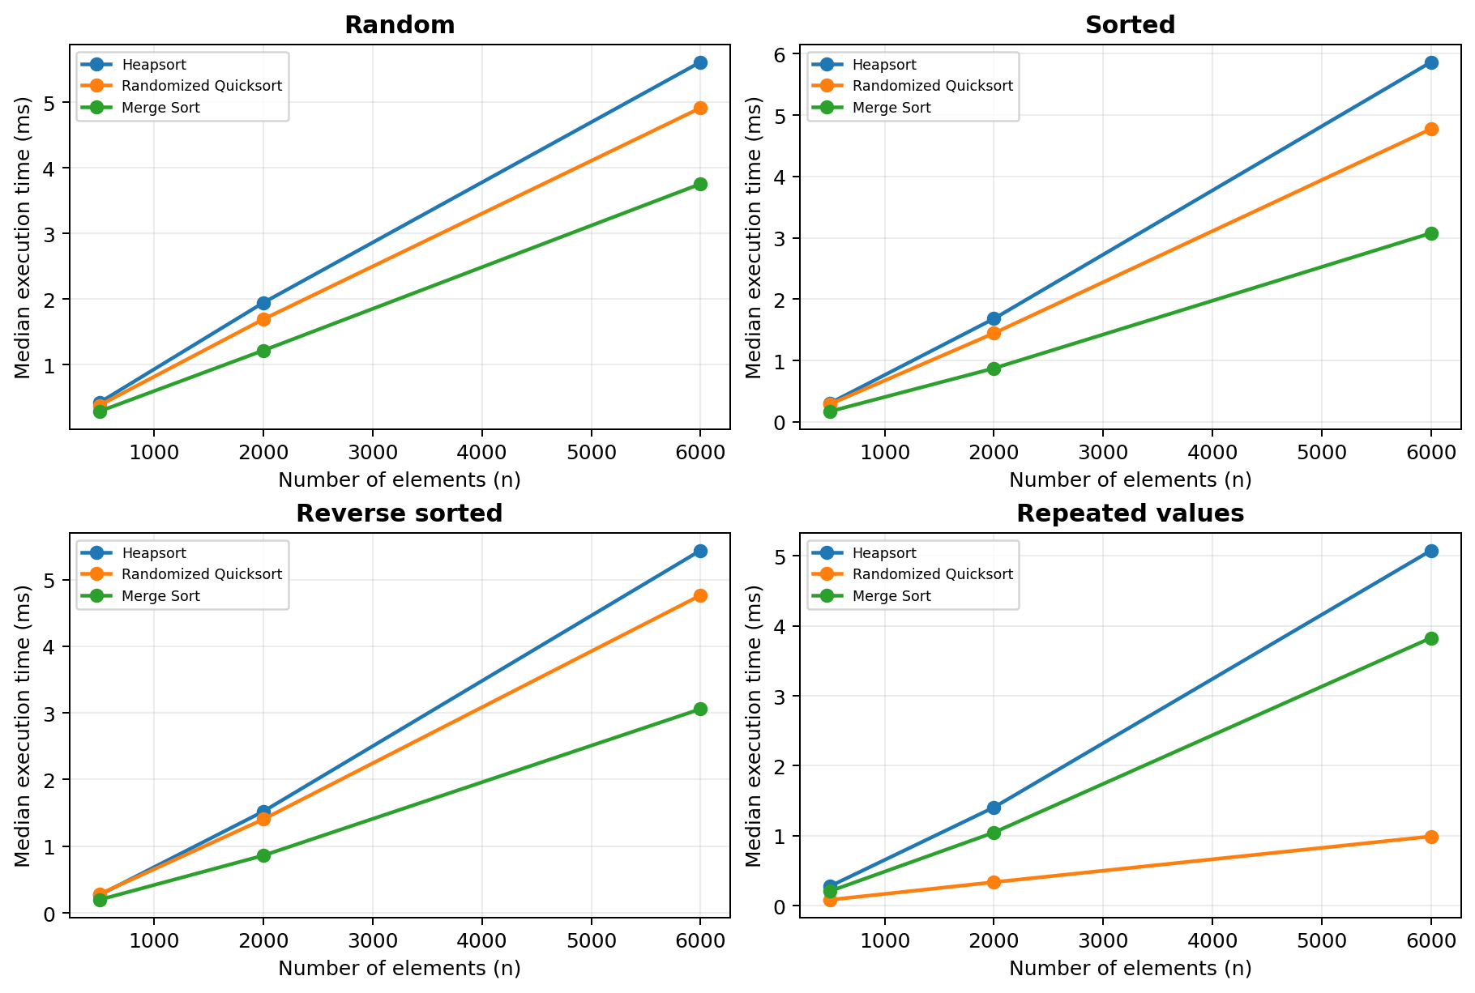
Figure 1. Median sorting time across all tested sizes and input distributions.
Observed Performance and Explanation
On random inputs of 6,000 elements, Heapsort took 5.612 ms, randomized Quicksort 4.912 ms, and Merge Sort 3.756 ms. On repeated values at the same size, Randomized Quicksort had the lowest median (0.990 ms); three-way Quicksort can group equal values in one partitioning step. Across the tested input distributions, Heapsort maintained the expected growth pattern without the O(n²) pivot-sensitivity of a naïve fixed-pivot Quicksort. Actual running times also reflect temporary storage, data movement, branches, Python interpreter overhead, and CPU cache behavior, which are not captured by Big-O notation (LaMarca & Ladner, 1999; Sedgewick, 1978).
Priority Queue Design and Operations
The project represents the queue as a Python list storing immutable Task records and insertion sequence numbers. Each Task includes a unique ID, integer priority, arrival time, duration, and optional deadline. A max-heap was chosen because a higher numerical priority should be scheduled first. For equal priorities, earlier arrival and then earlier insertion win; deadline is evaluated as an outcome, rather than overriding the priority policy. This rule makes tie handling deterministic.
An auxiliary dictionary maps task IDs to their current array indices, allowing direct lookup before a priority update. Each heap swap updates the dictionary. insert appends a task and sifts upward; extract_max replaces the root with the last entry and sifts downward; increase_key and decrease_key change one immutable task record and move it in the appropriate direction. An invalid key change, duplicate ID, or malformed Task raises an exception. These choices extend textbook binary-heap operations with efficient task-ID updates while preserving heap correctness (Python Software Foundation, n.d.).
Table 2. Priority queue operation complexity
Operation | Time | Reason
insert(task) | O(log n) | Append then sift upward
extract_max() | O(log n) | Replace root then sift downward
increase_key() | O(log n) | Index lookup + sift upward
decrease_key() | O(log n) | Index lookup + sift downward
peek() / is_empty() | O(1) | Root / length check
Heap storage is O(n), and the task-ID index map adds O(n) storage. The mapping avoids an O(n) linear search before changing a task priority. The binary heap is well suited to frequently inserting, extracting, and re-prioritizing tasks, though unlike a sorted list it cannot efficiently enumerate all tasks in priority order without repeatedly extracting them.
Scheduler Simulation and Evaluation
A discrete-time, non-preemptive simulator uses eight fictional IT jobs with different arrival times, priorities, durations, and deadlines. Tasks only enter the ready queue after arrival. When the current job finishes, the highest-priority ready job is selected. A FIFO baseline uses identical jobs but executes ready jobs in arrival order. Both policies are deterministic and run on the same single-worker workload. Deadline success is checked at completion, but deadlines are not used to reorder tasks.
Table 3. Scheduling outcomes for identical synthetic jobs (illustrative time units)
Metric | Max-heap priority | FIFO baseline
Jobs completed | 8 | 8
Makespan | 16 | 16
Mean wait | 4.625 | 4.875
Longest wait | 11 | 8
Deadline misses | 2 | 2
The priority scheduler produced a mean wait of 4.625 time units, versus 4.875 for FIFO. However, its longest wait was 11, versus 8 with FIFO. Both policies missed 2 of 8 deadlines. The small improvement in mean waiting time therefore came with a less favorable maximum wait; higher-priority work can delay routine tasks. It would be incorrect to conclude that priority scheduling always reduces deadlines or improves fairness. A production scheduling system might add aging, deadline-aware selection, preemption, capacity limits, and dependency validation.
Validation, Limitations, and Application
The standard-library unittest suite checks empty and singleton lists, negative numbers, duplicates, sorted and reverse-sorted inputs, random arrays, heap-index consistency, key increases and decreases, duplicate IDs, invalid task metadata, and non-preemptive scheduling constraints. The demonstration script shows sorting and task priority changes; the scheduler writes its detailed execution trace to CSV. The scheduler is a single-resource simulation with integer durations, no interruptions, and no prerequisite graph. The task list and deadlines are artificial, and the benchmark does not measure total process memory or real server performance. For practical use, input validation, operational safeguards, fairness policies, and observed workload characteristics would need additional study.
Conclusion
Heapsort offers consistent Θ(n log n) sorting with O(1) auxiliary space, while practical execution time depends on how an implementation interacts with data and hardware. An indexed max-heap enables O(log n) task insertion, extraction, and priority adjustment, making it suitable for configurable job selection. The scheduling experiment demonstrates that optimizing priority responsiveness can increase the wait for lower-priority work; queue design therefore requires both algorithmic efficiency and careful policy choices.

References
LaMarca, A., & Ladner, R. E. (1999). The influence of caches on the performance of sorting. Journal of Algorithms, 31(1), 66–104. https://doi.org/10.1006/jagm.1998.0985
Python Software Foundation. (n.d.). heapq—Heap queue algorithm. Python documentation. https://docs.python.org/3/library/heapq.html
Schaffer, R., & Sedgewick, R. (1993). The analysis of heapsort. Journal of Algorithms, 15(1), 76–100. https://doi.org/10.1006/jagm.1993.1031
Sedgewick, R. (1978). Implementing quicksort programs. Communications of the ACM, 21(10), 847–857. https://doi.org/10.1145/359619.359631
Williams, J. W. J. (1964). Algorithm 232: Heapsort. Communications of the ACM, 7(6), 347–348. https://doi.org/10.1145/512274.512284

