**Tạo các file class từ file java và tạo file jar:**

javac -classpath ${HADOOP_CLASSPATH} -d '/home/van/Desktop/countWord/classes' '/home/van/Desktop/countWord/src/WordCount.java'

jar -cvf countWord.jar -C classes/ .

**Các câu lệnh:**

- put file data lên hdfs:

hadoop fs -put '/home/van/Desktop/countWord/input/data.txt' /WordCount/Input

- chạy file jar cho ra output:

hadoop jar '/home/van/Desktop/countWord/countWord.jar' WordCount /WordCount/Input /WordCount/Output

**Ouput:**

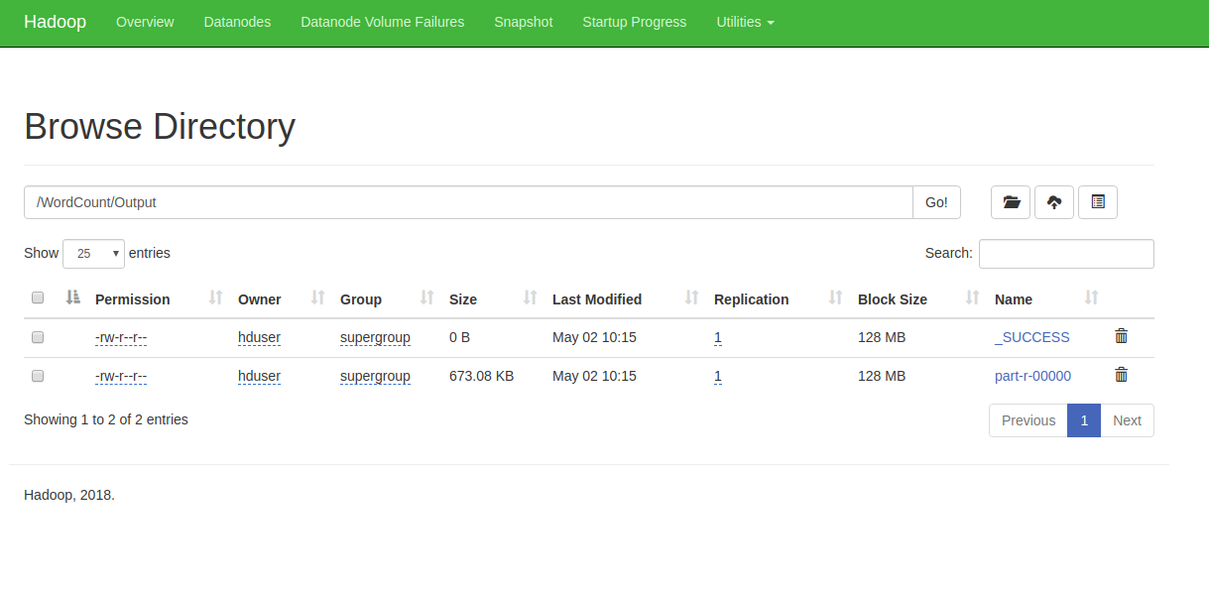

Mở file part-r-00000 sau khi tại về:

