部署

安装
Readme.md

配置
服务器配置 /etc/hosts
128.196.97.189 registry.eccom.com.cn
128.196.97.189 gitlab.eccom.com.cn
128.196.97.189 sonarqube.eccom.com.cn

容器内登录docker hub仓库
# docker exec -it $jenkins-name docker login registry.eccom.com.cn -u admin -p Harbor12345

Jenkins使用

凭据

Gitlab用户密码配置
下载代码的用户名密码
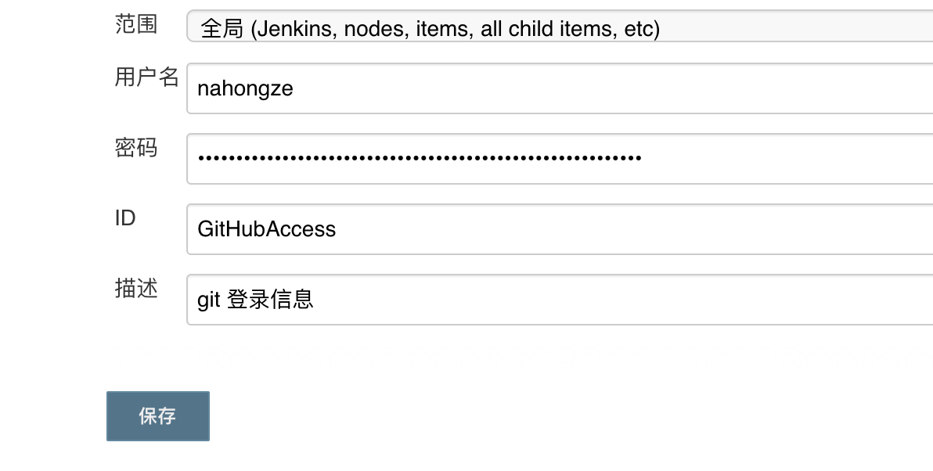

服务器节点用户密码配置

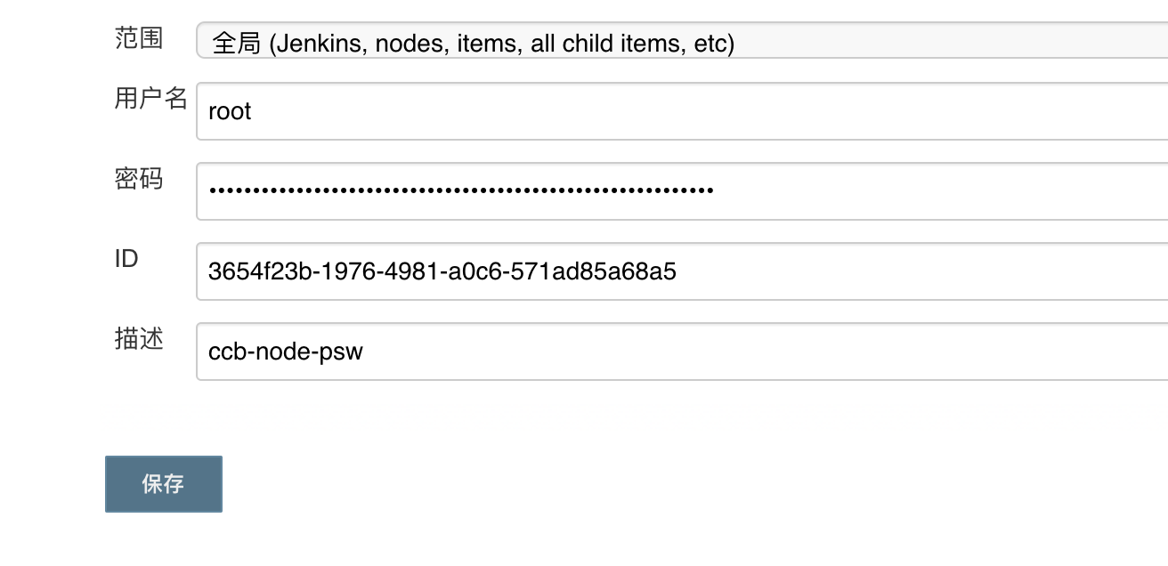

节点配置
被纳管的节点部署jdk git ，此节点的标签是 node-16
pipline中需要用到以上两个工具
yum install java-1.8.0-openjdk* -y
yum install git
参考如下配置
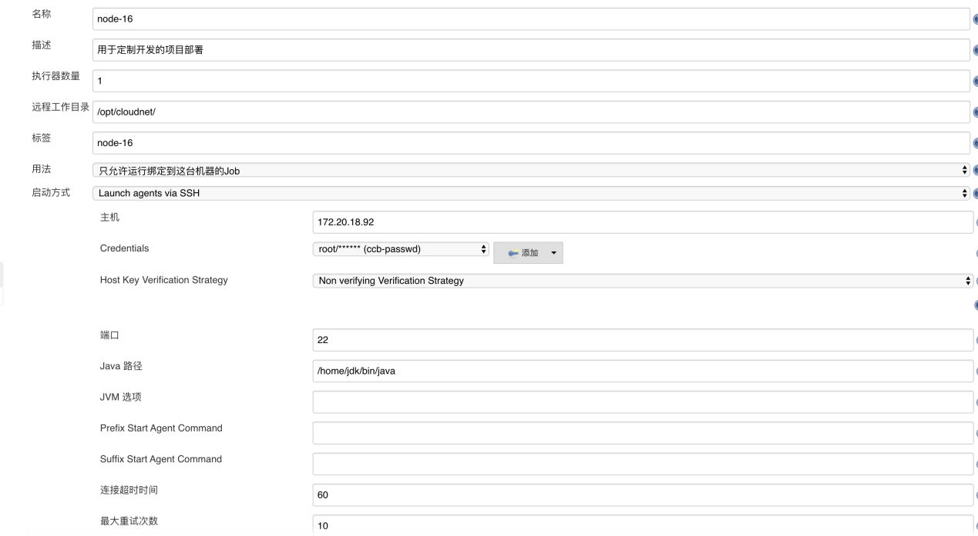
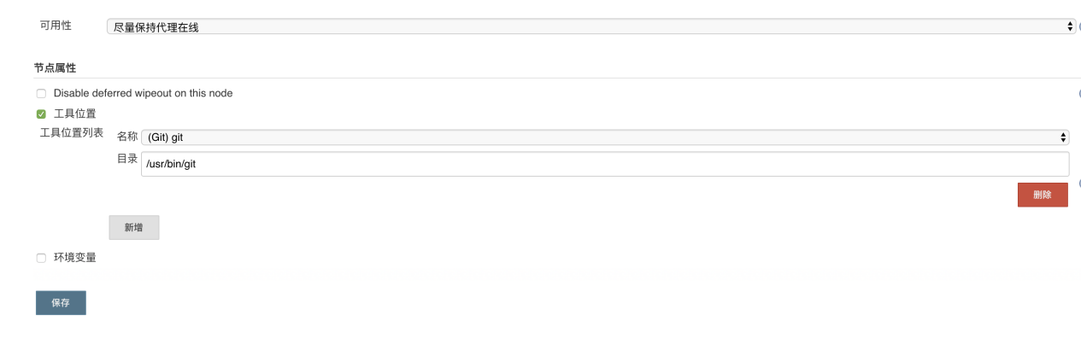

创建Pipline任务
修改斜体参数，放入脚本框内即可。

Web

pipeline {

agent none

parameters {

string(name: 'service_name', defaultValue: 'ccb-web', description: '填写服务名称 「 pom中的 artifactId 」')

string(name: 'tag', defaultValue: 'dev', description: '版本')

string(name: 'api_servers', defaultValue: '172.20.18.90:8000', description: '服务网关')

}

stages {

stage('source build') {
agent {
node{
label "master"
}
}

steps {
git branch: 'master', credentialsId: 'GitHubAccess', url: 'http://gitlab.eccom.com.cn:8929/neteagle_c/ccb4.0/ccb-web.git'
sh 'yarn config set yarn-offline-mirror /opt/nodejs/npm-packages-offline-cache && yarn config set yarn-offline-mirror-pruning true'
sh 'cp /usr/local/share/.yarnrc ./'
sh 'yarn install -offline'
sh 'yarn build'
sh 'docker build -t registry.eccom.com.cn/eccom/ccb-web:$tag .'
sh 'docker push registry.eccom.com.cn/eccom/ccb-web:$tag'
}
}

stage('deploy'){
agent {
node{
label "node-16"
customWorkspace '/opt/cloudnet/ccb-web'
}
}
steps {
sh '''
cat <<EOF> docker-compose.yml
version: '3.0'
services:
${service_name}:
image: "registry.eccom.com.cn/eccom/${service_name}:${tag}"
restart: always
network_mode: "host"
environment:
- api_servers=server ${api_servers};
EOF
'''
sh 'docker-compose down'
sh 'docker-compose up -d '
}
}
}
}
执行任务
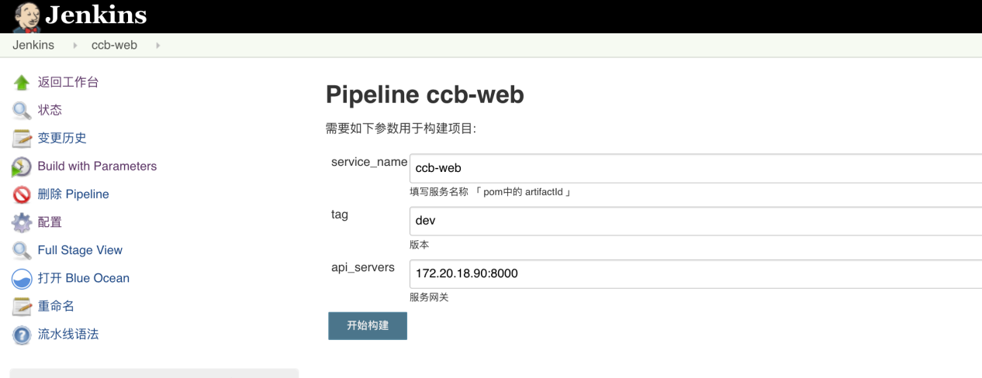

任务执行过程查看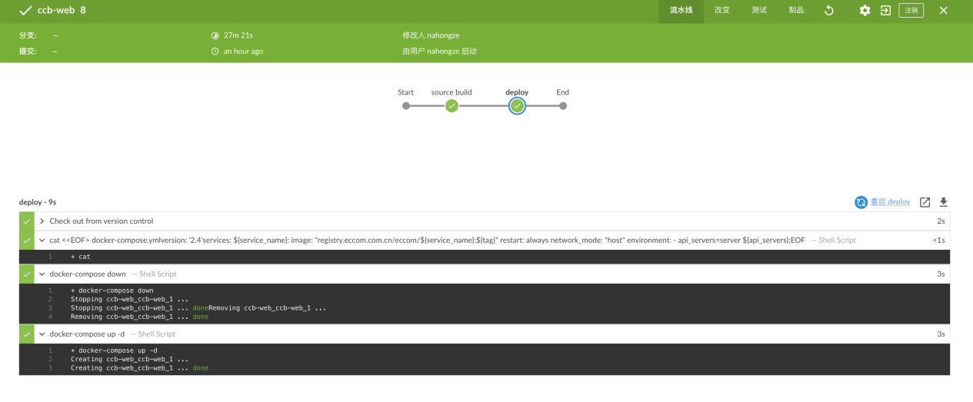

Java
pipeline {

agent none

parameters {

string(name: 'service_name', defaultValue: 'ccb-service', description: '填写服务名称 「 pom中的 artifactId 」')

string(name: 'tag', defaultValue: 'dev', description: '版本')

string(name: 'eureka', defaultValue: 'http://172.20.18.90:8080/eureka,http://172.20.18.92:8080/eureka', description: 'eureka注册地址')

}

stages {

stage('source build') {
agent {
node{
label "master"
}
}
tools {
maven 'maven'
}

steps {
git branch: 'master', credentialsId: 'GitHubAccess', url: 'http://gitlab.eccom.com.cn:8929/neteagle_c/ccb4.0/ccb-service.git'
sh 'mvn clean package -DskipTests docker:build docker:push'
}

}

stage('deploy'){
agent {
node{
label "node-16"
customWorkspace '/opt/cloudnet/ccb-service'
}
}
steps {
sh '''
cat <<EOF> docker-compose.yml
version: '2.4'
services:
${service_name}:
image: "registry.eccom.com.cn/eccom/${service_name}:${tag}"
restart: always
network_mode: "host"
environment:
- profile=ccb
- eureka-server= ${eureka}
cpus: 1
mem_limit: 2g
EOF
'''
sh 'docker-compose down'
sh 'docker-compose up -d'
sh 'docker logs -f --tail 100 ${service_name}_${service_name}_1'
}
}
}
}

执行任务
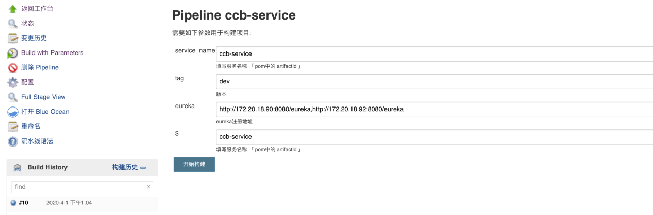

任务执行过程
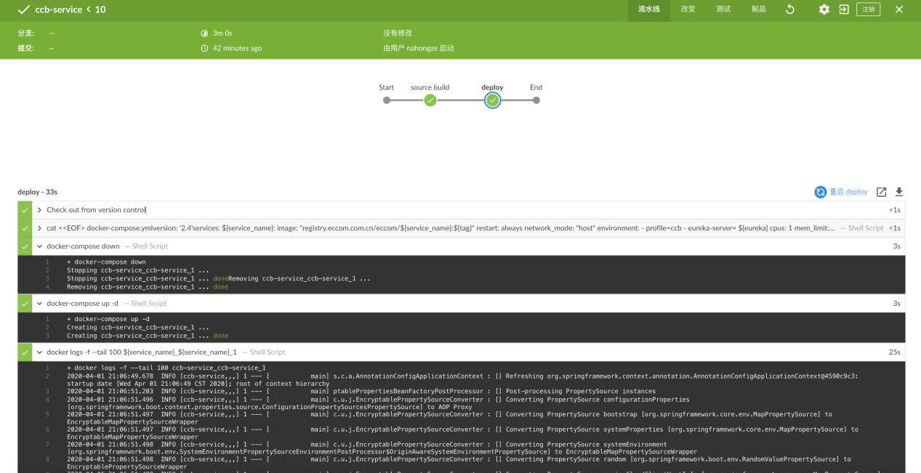

更新编译缓存

Maven-repo
有网环境下的maven仓库缓存拷贝至
home/jenkins_root/jenkins_opt/maven/mvn-repo

Node offline-cache
# cd web-project
# yarn config set yarn-offline-mirror ./npm-packages-offline-cache
# yarn config set yarn-offline-mirror-pruning true
# mv ~/.yarnrc ./
# yarn clean
#yarn install
查看npm-packages-offline-cache是依赖的离线包

参考https://classic.yarnpkg.com/blog/2016/11/24/offline-mirror/

拷贝至/home/jenkins_root/jenkins_opt/nodejs/npm-packages-offline-cache
# yarn global dir
拷贝到/home/jenkins_root/jenkins_opt/nodejs/global
# yarn cache dir
拷贝到/home/jenkins_root/jenkins_opt/nodejs/cache

缓存目录展示
