lab4.R

2024-01-24

# My first R script  
# Nicholas Chiu, Lab 4  
  
x <- 1:50  
plot(x, sin(x))

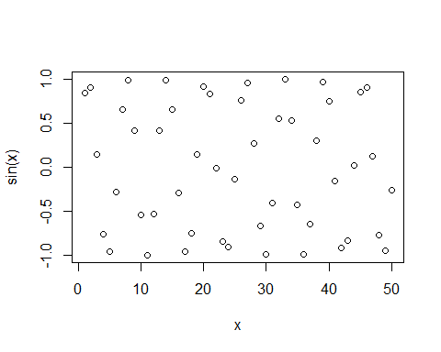

plot(x, sin(x), typ = "l")

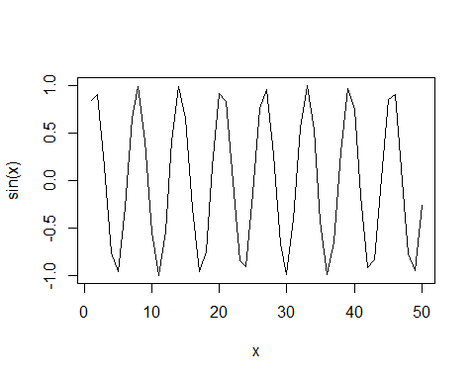

plot(x, sin(x), typ = "l", col = "blue")

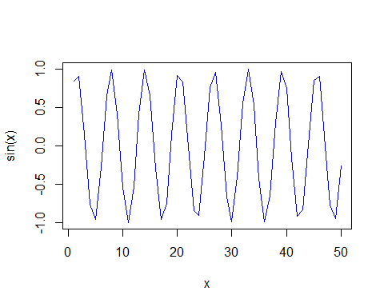

plot(x, sin(x), typ = "l", col = "blue", lwd = 2)

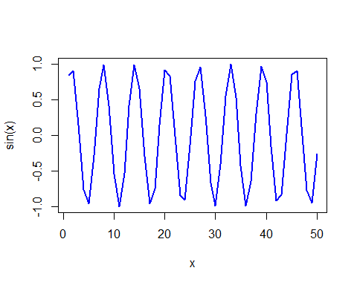

plot(x, sin(x), typ = "l", col = "red", lwd = 2, xlab = "Hello")

