1. Data of Packages and Addons is stored in BridgePay web service. Right?

2. Do either HTML or picture is provide for UI design?

3. Do you confirm the design of packages and addons Now? For example, there are how many packages and what are their name.

4. There is no login and register function now. Right?

5. Existing discount?

6. The payment method

7. Web Service and Ajax.

8. Browser compatibility.

1. Setup the testing environment for unit testing.

2. What is the package category?

3. It must be configurable via CPS UI web.config file.

4. the .Domain property of the cookie must be set to 2nd level domain of the site CPS UI is running on

5. ***CPSGetAvailableAddOns. If the user selected AddOns before, does this method mark the AddOns?***

***6. There are checkbox and radio about the addons. Then, how can I differ it?***

***7. We only display the addons and its group names when the package include them. Right?***

***8.(china) You say the jquery is only used in ajax reqestion. Can we use it to deal with others in the web page, for example, the display.***

***9.How can I judge the AddOns Fee is Monthly Fee or OneTime Fee.***

***The consult of meeting in the morning of 12/06/2012***

***1. The Billing calculating is in the server.***

***2. There are two kinds of addons. One is Business and the other is others.***

***3. We should validate Card Number before send to Bayback***

Add-Ons: (Trail: will show nothing)

Technology

Data Transfer

Data Pages

Email

Storage

Support

1. Credits of Your Package section can’t be found in Mock-ups and RFP document, so do you forget to include it? *How should I display it in Your Package section? Same as Amount Due?*

2. How can I get One-Time Fee information from ***CPSGetCurrentAccountPackage*** Method and ***CPSCalcNewPackage*** Method?

3. The format description is wrong

4. Business category consists and only consists 6 subsection; Other categories consist and only consist 3 subsections.

5. . It is not reality, and Data Transfer subsection in other categories also need ***CPSGetAccountPackages*** method.

6. There are only 6 subsection now.

1. How do if a plan includes Add-Ons? Use ***CPSGetAvailableAddOns*** method and return null value?

2. I changed IBridgePay by hand.

3. 是不是 DataTasfer, DataPages4个都是



4. data_pages_unit, Email and Storeage unit是什么？

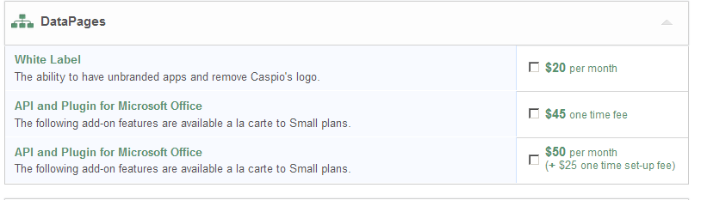

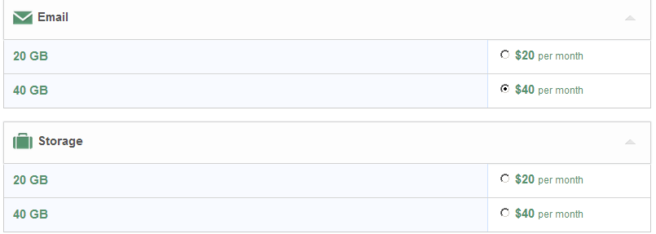

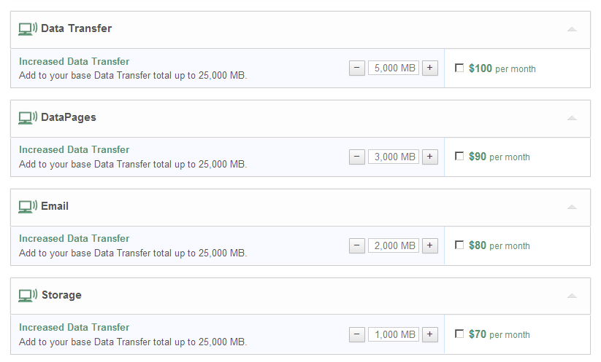data_transfer_unit =5000

data_transfer_fee =100

data_pages_unit = 3000

data_pages_fee =90

emails_unit =2000

emails_fee =80

storage_unit =1000

stogare_fee=70

Is the title and description from ***CPSGetAvailableAddOns***?

|  |  |
| --- | --- |
| Group | Datasource |
| Technology | ***CPSGetAvailableAddOns out of group*** |
| Support | ***CPSGetAvailableAddOns Addons in group*** |
| Data Transfer | ***Title and description are from CPSGetAvailableAddOns where group’s Name = “Data Transfer” in the XML***  ***Unit and Unit Fee are from CPSGetAccountPackages:*** data_transfer_unit , data_transfer_fee |
| DataPages | ***Title and description are from CPSGetAvailableAddOns where group’s Name = “***DataPages***” in the XML***  ***Unit and Unit Fee are from CPSGetAccountPackages:*** data_pages _unit , data_ pages _fee |
| Email | ***Title and description are from CPSGetAvailableAddOns where group’s Name = “***Email***” in the XML***  ***Unit and Unit Fee are from CPSGetAccountPackages:*** emails_unit , emails _fee |
| Storage | ***Title and description are from CPSGetAvailableAddOns where group’s Name = “***Storage***” in the XML***  ***Unit and Unit Fee are from CPSGetAccountPackages:*** storage_unit , storage_fee. |

7. We found “stogare_fee” in description of ***CPSGetAccountPackages. It is miss spelled. Please confirm it.***

I am very glad that I have the chance to be working with you. We start trial work officially today. This is my daily report.

2012/12/11

marketing_content in ***CPSGetAccountPackages;***