**Caspio Payment System**

**UPDATE/CHANGE LOG**

|  |  |  |
| --- | --- | --- |
| **Date** | **Version** | **Comments** |
| 11/28/12 | v.1.0 |  |
| 12/03/12 | v.1.1 | Updated new UI flow for package selection |

## **OVERVIEW**

Caspio is looking to build the next generation of its internal service payment system to replace the existing system. The new system should be easily maintained and updated without having to change/update the existing codes/implementation. Below are some general requirements

**General Requirements**

* The interface is password protected (please see the technical document for authentication module)
* Packages/Addons should be Database driven so that we can easily add or remove one or more packages by just updating the data in a table in the Database
* Add-ons are driven based on the type of package. For instance, “Small” package will not have “DataPages”, “Emails”,… but “Professional” will do have these options.
* Each option within a add-on is also table-driven. We can add or remove any options in each add-on category by adding new records or remove records from a table in the database respectively.

## **UI MOCK-UPS**

***Figure 1.a – Select Package***

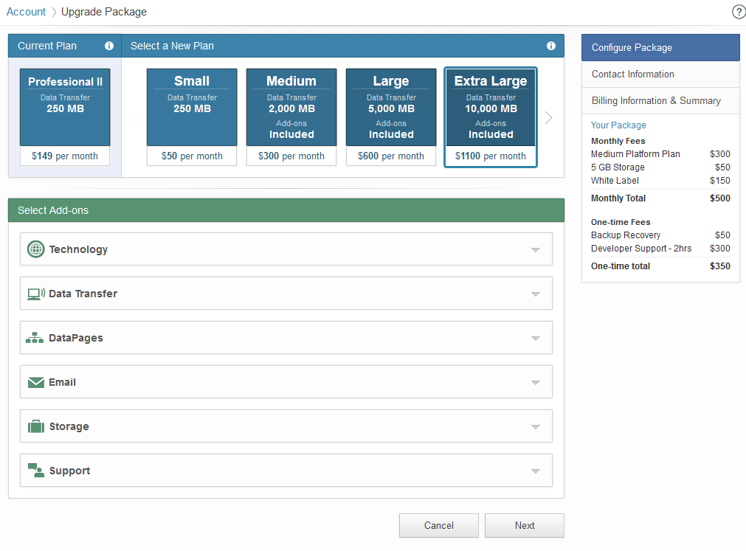

***Figure 1.b – Package Add-on***

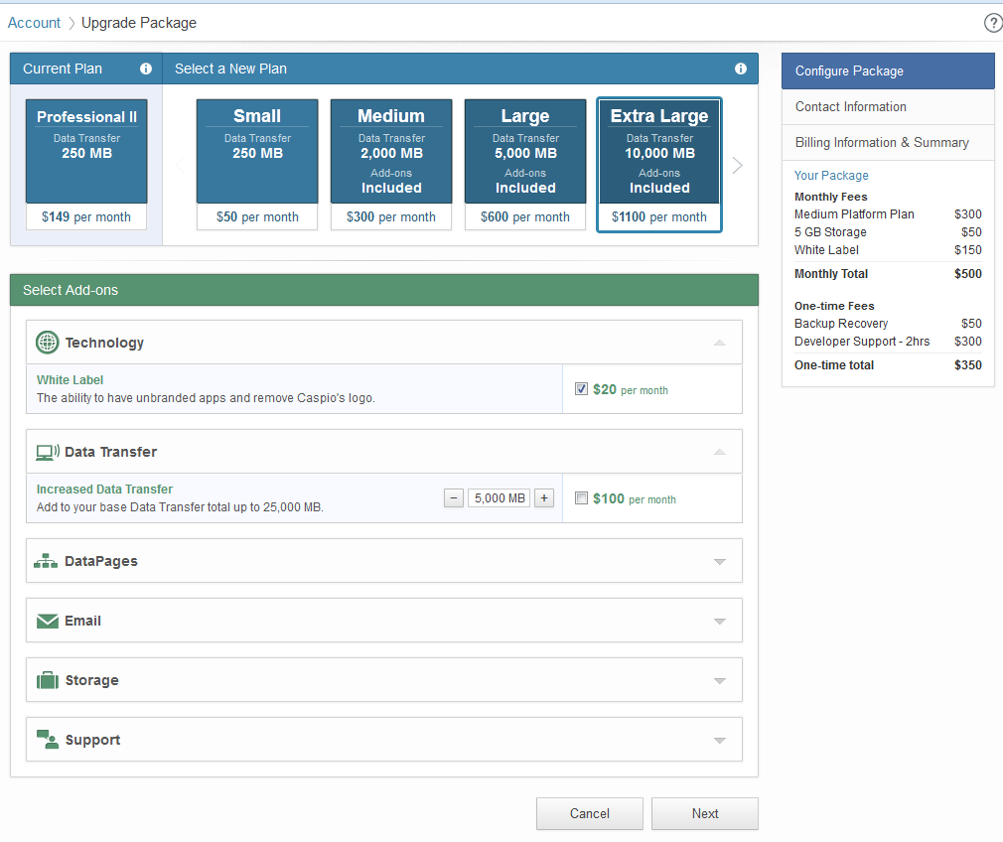

***Figure 2.a –*** Contact Information

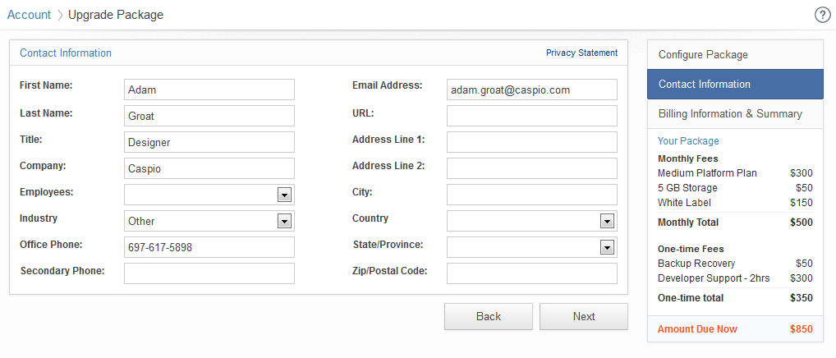

***Figure 3.a –*** Payment Information – New Customer

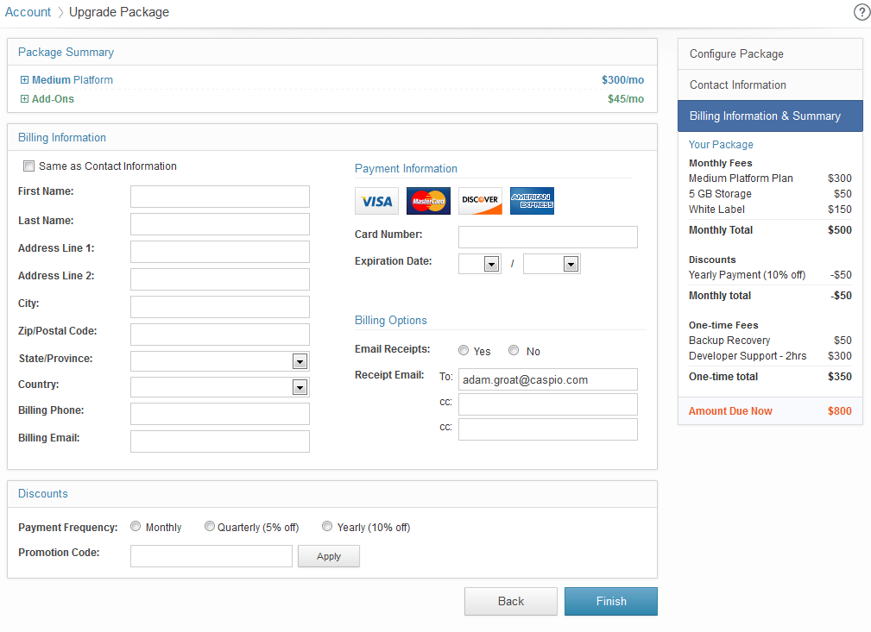

***Figure 3.b –*** Payment Information (existing customers)

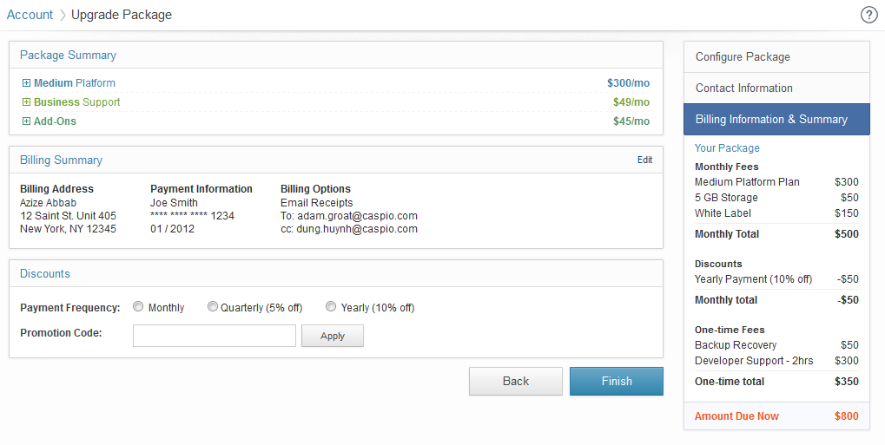

***Figure 3.c –*** Payment Information – Summary Expand

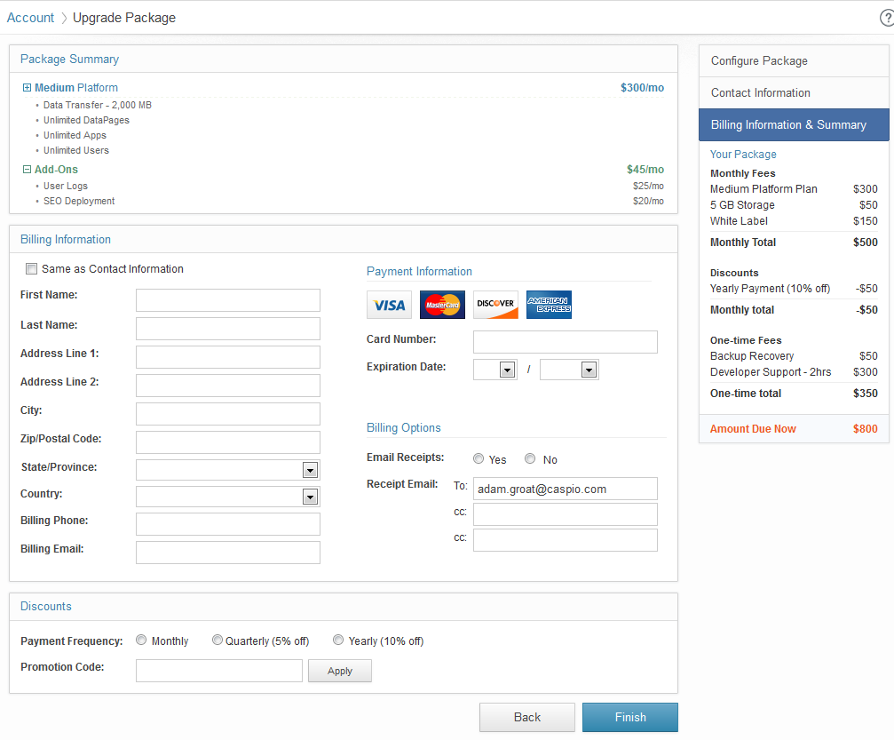

***Figure 4.a –*** Confirmation Information

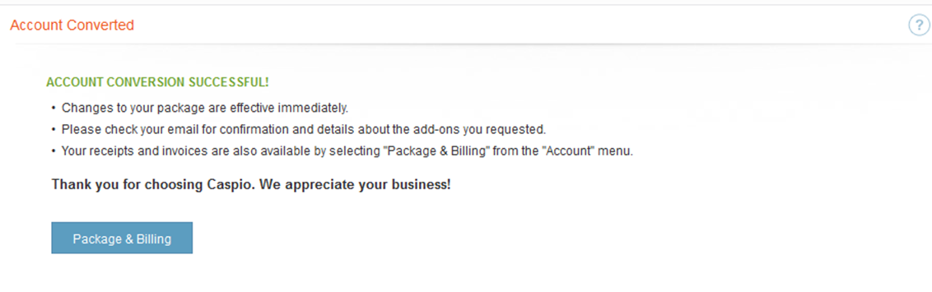

## **SPECIFICATIONS**

1. **Package Selection** *(figure 1.a – 1.b)*

Contain 3 sections

* Packages
* Add-ons
* Cart Summary
  + 1. **Packages –** The package section contain 2 sections
* The customer’s current package.
* The new packages that customers can select.

Based on the selection, show dependent add-ons categories and hide non-related add-ons. Customers don’t have to select a new package. They can stay at the current package and select additional add-ons feature and continue.

* + 1. **Add-ons** – This section contains all the add-ons based on the selected package above
* One-time fee + monthly recurring.
* Monthly recurring.
* One-time fee
  + 1. **Cart Summary** – Based on the user’s selections, cart will show the summary of package selection and add-ons with total monthly and one-time fee amount due
    2. **Button – Right-Aligned**
* “Cancel” – If click go back to the package overview page (section 17.3.1)
* “Next” – if click go to either Contact information or Payment Information page

1. **Contact Information** *(figure 2.a)*

### This Page is optional and is only shown if the customer is a new customer who have not provided the contact information before. For existing customers, who have already provided the contact information before will not be required to complete this step and be redirected to the payment page below.

### “Privacy Statement” link to <http://www.caspio.com/company/legal/privacy-statement.aspx> open in new browser.

### **Contact Information Section (see figure 2.a)**

* All fields are required except the following fields
  + Secondary Phone
  + Address Line 2
  + URL

If users do not fill out all the required fields before click the “Next” button show inline error message above the first field “You must fill out all the required fields before go to the next step.” and either error indicator next to each required field or highlight the text field with a different colour.

* **Button – Right-Aligned**
  + “Back” – If click go back to the Package Selection page
  + “Next” – If click next go to the payment page.

1. **Payment Information** *(figure 3.a – 3.c)*

Contains three sections:

* “Package Summary”
* “Billing Information”
* “Discounts ”

### **Package Summary Section**

* Contains the list the new package and add-ons selected by customer in the previous page. Each section can be expanded to view the package/add-on details information and collapse if needed.

### **Payment Information**

* If the account has existing billing information then show billing info as read-only *(see figure 3.b)*
* If the account does not have billing information, show the billing section as editable *(see figure 3.a)*

### **Discounts**

* Contain two options
  + Prepayment
    - If the account has no existing discount or discount less than 5% (please note that the percentage discount for payment is arbitrary and may be updated in the future. If do so, the codes should not be required to be changed and complied again.) Monthly (default if none selected; for existing users it will be their selection)
      * Monthly
      * Quarterly (5% off)
      * Monthly (10%)
    - If the account has existing discount rate between 5% to 10%
      * Monthly
      * Quarterly
      * Yearly (10%)
    - If the account has existing discount rate greater than 10%
      * Monthly
      * Quarterly
      * Yearly
  + Coupon Code
    - Customer can apply the promotional code to get the discount on monthly payment
    - If the code is invalid, display “<red text>The promotional code you entered is invalid</red text>” below the text field, leave the wrong code in the box.
    - If success,
      * Clear the promotional code from the text box but do not disable the Apply button. In case we allow combo discount codes or different levels of discount in the future, but currently we only allow one promotion code can be applied.
      * Show the discount text and amount and recalculate the total fee and amount due in the box on the right
      * If there is prepayment discount already applied to the fee, remove the existing discount and apply the new discount

### **Buttons – Right-Aligned**

* “Back” – Go back to the previous page
* “Finish” – if click, show popup with text and progress icon to indicate the payment is current processed.

Please wait while we process your payment.

<Progress Icon>

If success, go to account conversion confirmation page

If failed, show the error message above the billing information section. If the billing information in the read-only mode, auto change it to editable mode so users can update and resubmit for process.

1. **Confirmation** *(figure 4.a)*

* Show confirmation message.
* Send email with receipt attachment to recipients specified in the billing options