## Coursework 1

## Wildlife Park Record Keeping System

## Introduction

A sophisticated record-keeping system has been designed to meet the expanding needs of Jonny's Nocturnal Zoo; a vital wildlife park situated at the far end of Brooke shire County. Due to municipal bylaws that prohibit the use of compilers and high-level languages, the particular problem is that 64-bit x86 assembly code must be used. This paper describes the system's architecture, setup, and operation with the goal of assisting Jonny Zookeeper in effectively overseeing the animals and personnel in his growing zoo.

The system makes use of a number of specially designed assembly language-written Input/Output (I/O) library functions made for the Linux x86_64 architecture. These functions make it easier to interface with the console and enable effective data input and output while adhering to assembly programming limitations.

Now let's explore the specifics of the I/O library functions that are essential to the assembly-based Jonny's Nocturnal Zoo record-keeping system.

|  |  |
| --- | --- |
| Function Name | Description |
| print_string_new | Print a null-terminated string pointed to by RDI. |
| print_uint_new | Print the unsigned 64-bit integer value contained in the RDI register. |
| print_int_new | Print the signed 64-bit integer value contained in the RDI register. |
| print_nl_new | Print a newline character to the console. |
| print_char_new | Print an ASCII character using the ASCII character code stored in the low 8 bits of the RDI register (dil). |
| read_char_new | Read a single ASCII character code from console input into the RAX register. |
| read_string_new | Read a string from console input into a buffer and return a pointer to the buffer in RAX. |
| atoi | Convert a number string pointed to by RDI to a 64-bit integer. Returns ULLONG_MAX on error. |
| read_uint_new | Read an unsigned 64-bit integer value from the console and store the result in the RAX register. |
| read_int_new | Read a signed 64-bit integer value from the console and store the result in the RAX register. |
| copy_string | Copy a null-terminated string pointed to by RSI (source) into a string pointed to by RDI (destination). |
| strings_are_equal | Compare strings pointed to by RDI and RSI. Returns 1 if equal, 0 otherwise. |
| print_address_new | Print the pointer value contained in the RDI register in hexadecimal format. |

Table: Library functions

The key registers utilized in the provided assembly code for the Input/Output (I/O) library functions:

1. General-Purpose Registers:
   * **rax**: Used as a return value for functions. It may also hold the syscall number for system calls.
   * **rbx**: Preserved across function calls, used as a general-purpose register.
   * **rcx**: Used as a counter in loops, also a general-purpose register.
   * **rdi**: Destination index, often used to store function parameters.
   * **rsi**: Source index, another register used for function parameters.
2. Stack and Base Registers:
   * **rsp**: Stack pointer, points to the top of the stack.
   * **rbp**: Base pointer, used to establish a stack frame.
3. Special Purpose Registers:
   * **r13**: Used to point to specific memory locations, such as input or output buffers.
4. Status Flags:
   * **Zero Flag (ZF)**: Indicates whether the result of an operation is zero.
   * **Sign Flag (SF)**: Reflects the sign (negative or non-negative) of the result.
   * **Carry Flag (CF)**: Set if an operation generates a carry or borrow out of the most significant bit.
   * **Parity Flag (PF)**: Indicates the number of set bits in the binary representation of the result.
   * **Overflow Flag (OF)**: Indicates if the result is too large for the destination operand to hold.

## Objectives:

The primary objectives of the wildlife park record-keeping system are to:

* + Efficiently store detailed information about each badger and staff member.
  + Provide functionalities for adding and deleting badgers and staff.
  + Calculate and display relevant information, such as years of service, annual salary, age, and stripiness.
  + Implement search functionalities for locating specific badgers and staff members based on their unique identifiers.

Prerequisites for Running the Assembly Program:

1. Virtual Box with Lubantu:
   * Ensure you have VirtualBox installed on your system.
   * Download and set up a Lubantu (Linux Ubuntu-based distribution) virtual machine within VirtualBox.
2. NASM x86/x64 Assembler:
   * Install NASM (Netwide Assembler) on your Lubantu system.
   * This can typically be done using the package manager.

sudo apt-get update

sudo apt-get install nasm

1. joey_lib_io_v9_release.asm Library:
   * Ensure it is in the same directory as your main assembly program or in a location accessible during assembly/linking.
2. libasm_io-master:
   * Download and set up **libasm_io-master**

(<https://github.com/Teriks/libasm_io>)

* + This library is contains support files required by the main program.
  + Follow the steps mentioned in Readme.md to setup.

1. Assembler and Linker:
   * Set up an appropriate build system that uses the NASM assembler and linker (gcc) to build the assembly program.

## Definition of records and data structures:

1. **Badger:**  
   A Badger Record encompasses various attributes related to individual badgers. Each field within the Badger Record holds specific information such as Badger ID, Name, Home Sett, Number of Stripes, Sex, Month of Birth, Year of Birth, and Staff ID. These fields collectively form a coherent unit representing a badger's details.

|  |  |
| --- | --- |
| Field | Description |
| Badger ID | String containing 'b' as the first character, followed by six digits and a null terminator. |
| Name | String with a maximum length of 64 characters. |
| Home Sett | String representing the home sett (Settfield, Badgerton, or Stripeville) with a maximum length of 12. |
| Number of Stripes | Unsigned integer of 8 bits, ranging from 0 to 255. |
| Sex | Single character (M or F), represented by an unsigned integer of 8 bits. |
| Month of Birth | Unsigned integer of 8 bits, representing the month (1 to 12). |
| Year of Birth | Unsigned integer of 16 bits, representing the birth year with four digits. |
| Staff ID | String starting with 'p', followed by seven digits and a null terminator. |

1. Staff:

The Staff Entry structure defines the parameters for each staff member, including their personal and professional details. Each entry consists of the following fields:

|  |  |
| --- | --- |
| Field | Description |
| Surname | String representing the surname of the staff member, maximum length 64 characters (including null terminator). |
| First Name | String representing the first name of the staff member, maximum length 64 characters (including null terminator). |
| Staff Id | String containing the staff ID, starting with 'p' followed by seven digits and a null terminator (9 bytes). |
| Department | String representing the department (Park Keeper, Gift Shop, or Cafe), maximum length 12 characters (including null terminator). |
| Starting Salary (£) | Unsigned integer of 32 bits, representing the starting annual salary in £. |
| Year of Joining | Unsigned integer of 16 bits, representing the year of joining. |
| Email Address | String representing the email address of the staff member, maximum length 64 characters (including null terminator). |

## Code for adding badgers and staff:

Commands to run the code:

To build:

nasm -g -f elf64 -o test-io.o test-io.asm

To link:

gcc test-io.o /usr/lib/libasm_io.a -no-pie -o test-io

(replace /usr/lib/libasm_io.a with actual location of libasm_io.a file)

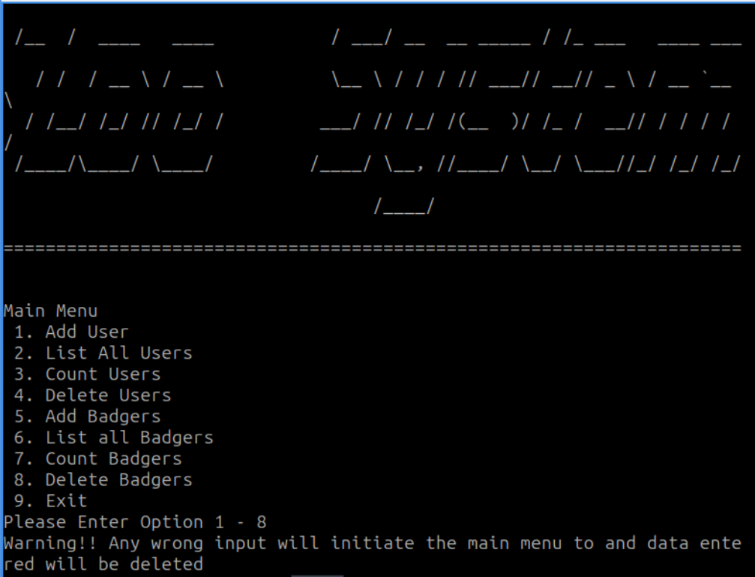

Figure: Main menu

## Add Staff/User

The Add staff function is very similar to add staff on selecting option 1.

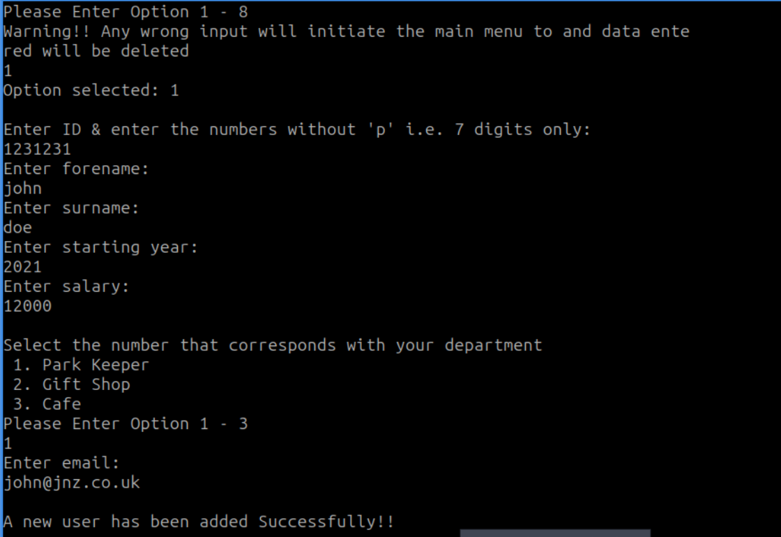

Figure: Add staff

## List all Staff

List all staff function shows all the staff members adding two more fields called salary and year of service. The year of service is calculated by comparing the year of joining and the current year.

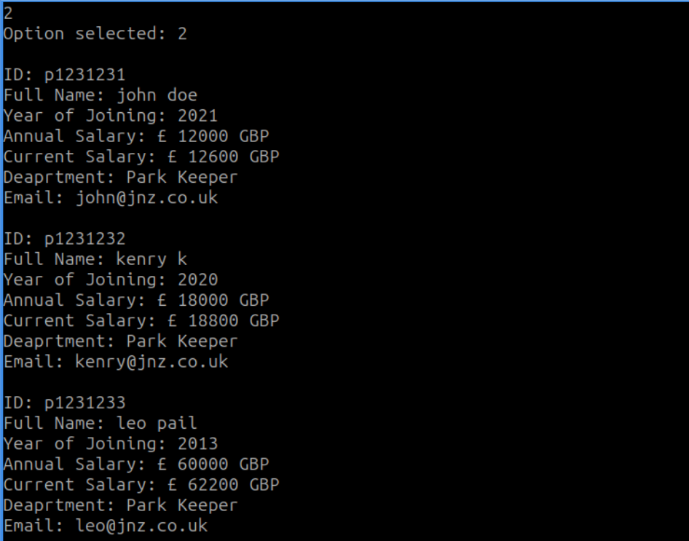

Figure 11: List all staff

## Delete staff

The delete staff function removes a staff with the id inserted by the user. This function shift left all staff members of one position in the register in order to overwrite the staff designed to be eliminated. If the staff member is in the last position allocated of the array, the software sets all bytes of the staff as null.

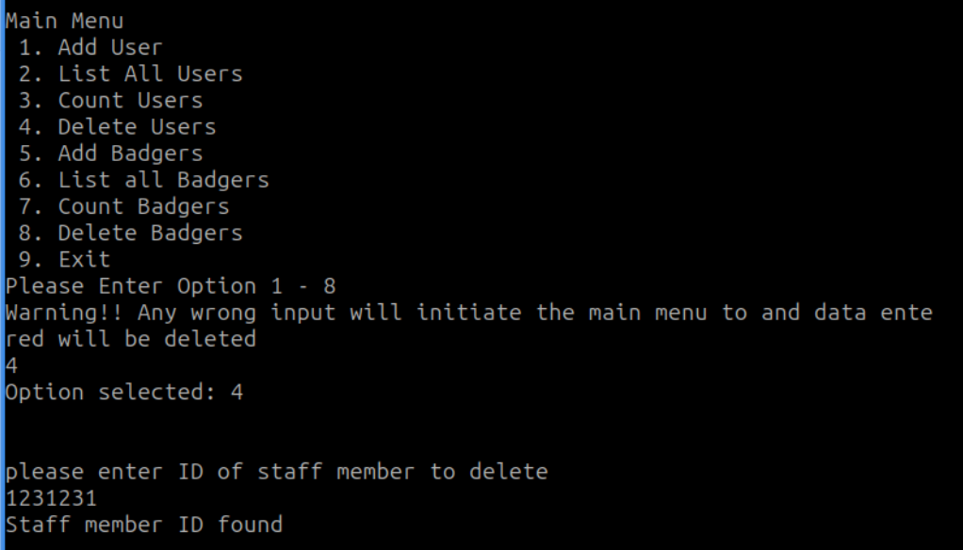

Figure: Delete staff

## Add Badger

Add badger is initiated by selecting option 1:

1. Check if the Badger Array is Full:
   * The code starts by comparing the current number of badgers (**[current_number_of_badgers]**) with the maximum allowed number of badgers (**max_num_badgers**).
   * If the current number is less than the maximum, it means there is space to add a new badger, and the code jumps to the label**. array_is_not_full**.
   * If the current number is equal to or greater than the maximum, the array is considered full, and it displays a message (**prnt_array_full**), then jumps back to the main menu (**jmp .menu_loop**).
2. Array is Not Full:
   * If the array is not full, it prints a new line (**call print_nl_new**) for better formatting.
   * It then calls a function (**add_badger**) to add a new badger to the system.
   * After adding the badger, it jumps back to the main menu (**jmp .menu_loop**).

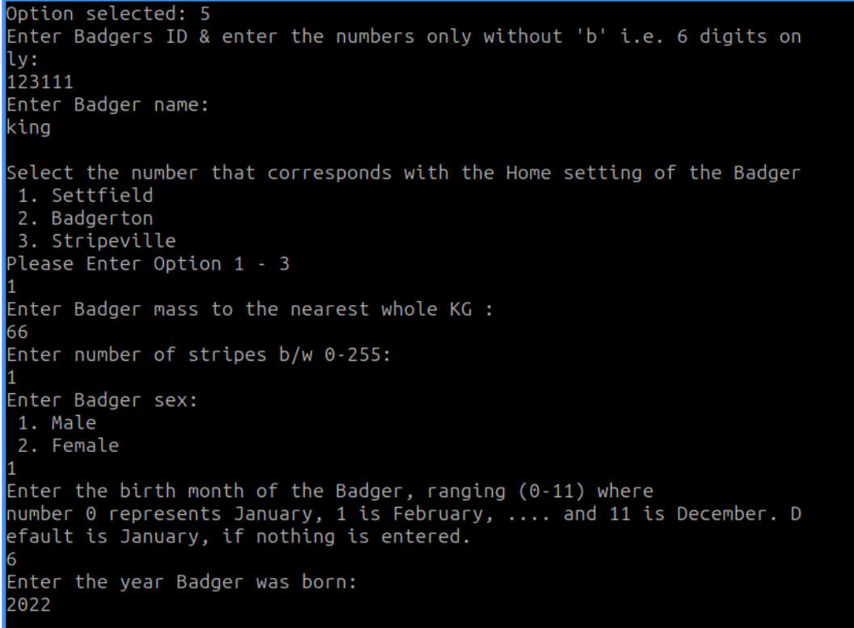

Figure: Add badger

## List all Badgers

List all badger is the second function of the main menu. This function shows all the badgers in the array; if the array is empty, the function will show an error message.

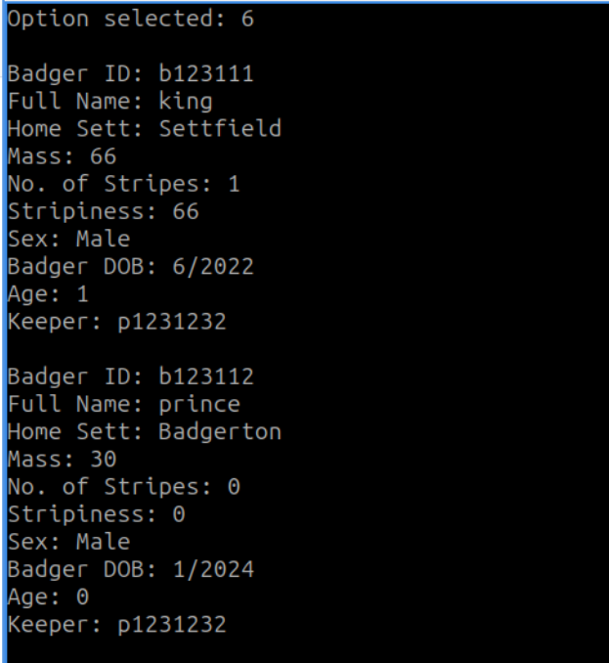

Figure: List all badgers

## Delete badger

Option 8 triggers the delete operation. It removes a badger with the id inserted. If the badger is in the last position allocated of the array, the software sets all bytes of the badger as null.

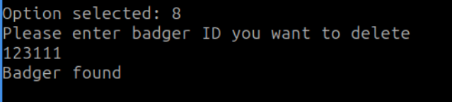

Figure: Delete badger

## Conclusion

In conclusion, this project has successfully implemented a Badger Management System using assembly language, specifically tailored for the SASM assembler. The system offers a range of functionalities, including adding and displaying badgers, managing staff details, and performing various operations on badger data. Throughout the development process, attention was given to the efficient use of memory and adherence to system requirements. The implemented IO library, created by Joe Norton, greatly facilitated input/output operations and enhanced the overall functionality of the program.

The use of data structures, such as arrays, and the careful definition of records for badgers and staff members contribute to a robust and organized system.

The project also incorporates user-friendly interfaces, allowing easy interaction with the Badger Management System. While the system currently supports basic operations, future enhancements could include more advanced features, error handling mechanisms, and optimizations for better performance. Moreover, additional functionalities, such as sorting and searching capabilities, could be integrated to further improve the user experience.

## References

1. Simple x64 bit IO library for nasm assembly programs. API is based on Dr. Paul Carters x32 bit IO library used in his old tutorials: [*https://github.com/Teriks/libasm_io*](https://github.com/Teriks/libasm_io)
2. x86 Assembly documentation (<https://docs.oracle.com/cd/E19253-01/817-5477/817-5477.pdf> )
3. *Sasm*. [Online]. Available: <https://dman95.github.io/SASM/english.html>
4. Stack Overflow and Community Forums.

# APPENDIX A

CODE OF COURSEWORK 1:

;To build:

;nasm -g -f elf64 -o test-io.o test-io.asm

;To link:

;gcc test-io.o /usr/lib/libasm_io.a -no-pie -o test-io

; (replace /usr/lib/libasm_io.a with actual location of libasm_io.a file)

; change the path where u placed the joey-lib_v9_release.asm file

%include "/home/malware/asm/joey-lib_v9_release.asm"

global main

section .data

prnt_badg_art db 10,\

"COURSEWORK 1", 10, 0

prnt_main_menu db 10,\

"Main Menu", 10,\

" 1 Add User", 10,\

" 2 List All Users", 10, \

" 3 Count Users", 10,\

" 4 Delete Users", 10,\

" 5 Add Badgers", 10,\

" 6 List all Badgers", 10,\

" 7 Count Badgers", 10,\

" 8 Delete Badgers", 10, \

" 9 Exit", 10,\

"Please Enter Option 1 - 8", 10,\

"Warning!! Any wrong input will initiate the main menu to and data entered will be deleted", 10, 0

prnt_program_exit db "Program exited normally.", 10, 0

prnt_option_selected db "Option selected: ", 0

prnt_invalid_option db "Invalid option, please try again.", 10, 0

department_question db 10,\

"Select the number that corresponds with your department", 10,\

" 1 Park Keeper", 10,\

" 2 Gift Shop", 10,\

" 3 Cafe", 10, \

"Please Enter Option 1 - 3", 10, 0

prnt_current_month db "Enter current month:", 10, 0

prnt_current_year db "Enter current year:", 10, 0

prnt_enter_surname db "Enter surname:", 10, 0

prnt_enter_forename db "Enter forename:", 10, 0

prnt_enter_salary db "Enter salary:", 10, 0

prnt_enter_year db "Enter starting year:", 10, 0

prnt_enter_id db "Enter ID & enter the numbers without 'p' i.e 7 digits only: ", 10, 0

prnt_enter_email db "Enter email:", 10, 0

prnt_array_full db "Can't add - storage full.", 10, 0

prnt_array_empty db "Staff array is empty", 10, 0

prnt_number_of_users db "Number of users: ", 0

prnt_error db "Error", 0

prnt_user_success db "A new user has been added Successfully!! ", 10, 0

email db "@jnz.co.uk", 0

park_keeper db "Park Keeper", 0

gift_shop db "Gift Shop", 0

cafe db "Cafe", 0

;Displaying staff details

prnt__staff_salary_gbp db " GBP",0

prnt__staff_letter_p db "p", 0

prnt__staff db "ID: ", 0

prnt__year db "Year of Joining: ", 0

prnt__name db "Full Name: ", 0

prnt__salary db "Annual Salary: £ ", 0

prnt__staff_current_salary db "Current Salary: £ ", 0

prnt__dept db "Deaprtment: ", 0

prnt__email db "Email: ", 0

;delete staff prompt

prnt_prompt_user_delete_id db "please enter ID of staff member to delete", 0

prnt_del_user_id_found db "Staff member ID found", 0

prnt_del_user_id_notfound db "Staff member ID not found", 0

size_delete equ 1 ; use this to indicate that the record has been deleted

size_forename equ 64 ;we define size of block of memory that we want

size_surname equ 64 ;to reserve and store in size_name_of_field

size_id equ 4

size_dept equ 12

size_salary equ 4

size_year_of_joining equ 2

size_email equ 64

size_user_record equ size_delete + size_forename + size_surname + size_id + size_dept + size_salary + size_year_of_joining + size_email

max_num_users equ 100

size_users_array equ size_user_record*max_num_users

current_number_of_users dq 0

current_number_of_badgers dq 0

current_year equ 2024

current_mon equ 1

prnt_enter_badger_id db "Enter Badgers ID & enter the numbers only without 'b' i.e 6 digits only:", 10, 0

prnt_enter_badger_name db "Enter Badger name:", 10, 0

home_sett db 10,\

"Select the number that corresponds with the Home setting of the Badger", 10,\

" 1 Settfield", 10,\

" 2 Badgerton", 10,\

" 3 Stripeville", 10, \

"Please Enter Option 1 - 3", 10, 0

prnt_enter_badger_mass db "Enter Badger mass to the nearest whole KG :", 10, 0

prnt_enter_badger_stripes db "Enter number of stripes b/w 0-255:", 10, 0

prnt_enter_badger_sex db "Enter Badger sex:", 10, \

" 1 Male", 10, \

" 2 Female", 10, 0

prnt_enter_badger_birth_month db "Enter the birth month of the Badger, ranging (0-11) where ", 10, 0

prnt_enter_badger_birth_year db "Enter the year Badger was born:", 10, 0

prnt_number_of_badgers db "Number of Badgers: ", 0

prnt_badger_birth_format db "number 0 represents January, 1 is February, ... and 11 is December Default is January, if nothing is entered.", 0

prnt_enter_badger_keeper db "Please enter the keeper ID of the badger (7 digit number)", 10, 0

prnt_badger_add_success db "A new Badger is added successfully!!", 10, 0

settfield db "Settfield", 0

badgerton db "Badgerton", 0

stripeville db "Stripeville", 0

male db "Male", 0

female db "Female", 0

prnt_del_badg_id_notfound db "No badger with this id was found", 10, 0

prnt_badg_array_empty db "The badger array is empty", 10, 0

prnt__badger_letter_b db "b", 0

prnt__badger_ID db "Badger ID: ", 0

prnt__badger_name db "Full Name: ", 0

prnt__badger_home_sett db "Home Sett: ", 0

prnt__badger_mass db "Mass: ", 0

prnt__badger_stripes db "No of Stripes: ", 0

prnt__badger_stripiness db "Stripiness: ", 0

prnt__badger_sex db "Sex: ", 0

prnt__badger_birth_month db "Badger birth month: ", 0

prnt__badger_birth_year db "Badger birth year: ", 0

prnt__badger_letter db "b", 0

prnt__badger_birth db "Badger DOB: ", 0

prnt__badger_age db "Age: ", 0

prnt__badger_keeper db "Keeper: ", 0

prnt_prompt_badg_delete_id db "Please enter badger ID you want to delete", 0

prnt_badg_id_err db "No badger with this ID exists", 0

prnt_del_badg_id_found db "Badger found", 0

size_badger_id equ 4

size_badger_name equ 64

size_badger_home_sett equ 12

size_badger_mass equ 2

size_badger_stripes equ 1

size_badger_sex equ 7

size_badger_birth_month equ 1

size_badger_birth_year equ 2

size_badger_record equ size_delete + size_badger_id + size_badger_name + size_badger_home_sett + size_badger_mass + size_badger_stripes + size_badger_sex + size_badger_birth_month + size_badger_birth_year + size_id

max_num_badgers equ 500

size_badgers_array equ size_badger_record * max_num_badgers; Note that max_num_badgers is an immediate operand since it is defined at build-time

section .bss

users: resb size_users_array

temp_users: resb size_user_record

badgers: resb size_badgers_array

temp_badgers: resb size_badger_record

section .text

add_user:

push rbx

push rcx

push rdx

push rdi

push rsi

mov rcx, temp_users

mov byte[rcx], 1

inc rcx

; get user id

mov rdi, prnt_enter_id

call print_string_new ; print message

call read_uint_new

mov DWORD[rcx], eax

cmp rax, 999999

jle .error

cmp rax, 10000000

jge .error

add rcx, size_id

mov rdi, prnt_enter_forename

call print_string_new ; print message

call read_string_new

mov rbx, rax

call string_length

cmp rax, 63

ja .error

mov rsi, rbx ; store address in rsi

mov rdi, rcx

call copy_string

add rcx, size_forename

mov rdi, prnt_enter_surname

call print_string_new ; print message

call read_string_new

mov rbx, rax

call string_length

cmp rax, 63 ; check if string is larger than 63 characters, allowing space for null

ja .error

mov rsi, rbx ; store address in rsi

mov rdi, rcx

call copy_string

add rcx, size_surname

mov rdi, prnt_enter_year

call print_string_new ; print message

call read_uint_new

mov WORD[rcx], ax ; we are only going to copy 1 word of RAX

add rcx, size_year_of_joining

mov rdi, prnt_enter_salary

call print_string_new ; print message

call read_uint_new

mov DWORD[rcx], eax

;get department

mov rdi, department_question

call print_string_new ; print message

call read_int_new

cmp rax, 1

jne .check_gift_shop

mov rsi, park_keeper

jmp .add_department

.check_gift_shop:

cmp rax, 2

jne .check_cafe

mov rsi, gift_shop

jmp .add_department

.check_cafe:

cmp rax, 3

jne .department_error

mov rsi, cafe

jmp .add_department

.department_error:

mov rax, -2

jmp .error

.add_department:

add rcx, size_salary

mov rdi, rcx

call copy_string ; copy string from into user record in array

; get email

mov rdi, prnt_enter_email

call print_string_new ; print message

call read_string_new

mov rbx, rax

call string_length

cmp rax, 63 ; check if string is larger than 63 characters, allowing space for null

ja .error

mov rsi, rbx

lea rsi, [rbx + rax - 10] ; go the last 10 bytes of the user string and check its "@jnz.co.uk"

lea rdi, [email]

call strings_are_equal

cmp rax, 1

jne .error

add rcx, size_dept

mov rsi, rbx

mov rdi, rcx ; store address in rsi

call copy_string

call print_nl_new

mov rdi, prnt_user_success ; inform user is added successfully!!

call print_string_new

call print_nl_new

; copy temp array into array

mov rcx, users ; base address of users array

mov rsi, temp_users

mov rbx, 0

; find an empty spot to copy to

.find_spot_to_add_user:

cmp byte[rcx],1

jne .do_user_copy

add rcx, size_user_record

inc rbx

cmp rbx, max_num_users

jl .find_spot_to_add_user

.no_space_user:

mov rdi, prnt_array_full

call print_string_new

.do_user_copy:

mov rdi, rcx

call copy_string

add rsi, size_delete ; delete flag

lea rdi, [rcx + size_delete]

call copy_string

add rsi, size_id ; size ID

lea rdi, [rcx + size_delete + size_id]

call copy_string

add rsi, size_forename ; forename

lea rdi, [rcx + size_delete + size_id + size_forename]

call copy_string

add rsi, size_surname ; surname

lea rdi, [rcx + size_delete + size_forename+size_id+size_surname]

call copy_string

add rsi, size_year_of_joining ; year of joining

lea rdi, [rcx + size_delete + size_forename+size_id+size_surname+size_year_of_joining]

call copy_string

add rsi, size_salary ; salary

lea rdi, [rcx + size_delete + size_forename+size_id+size_surname+size_year_of_joining+size_salary]

call copy_string

add rsi, size_dept ; department

lea rdi, [rcx + size_delete + size_forename+size_id+size_surname+size_year_of_joining+size_salary+size_dept]

call copy_string

inc qword[current_number_of_users] ; increment our number of users counter, since we have just added a record into the array.

mov rdi, temp_users ; clear temp array here

mov rcx, size_user_record

xor al, al

rep stosb

pop rsi

pop rdi

pop rdx

pop rcx

pop rbx

ret

.error:

mov rdi, temp_users

mov rcx, size_user_record

xor al, al

rep stosb

mov rdi, prnt_error

call print_string_new

pop rsi

pop rdi

pop rdx

pop rcx

pop rbx

ret ; End function add_user

list_all_users:

push rbx

push rcx

push rdx

push rdi

push rsi

lea rsi, [users] ; load base address of the users array into RSI

mov rcx, 0 ; we will use RCX for the counter in our loop

.start_loop: ; this is the start of our loop

mov rdi, rsi

cmp BYTE[rdi], 1 ; put a check here for the delete flag

jne .goto_next_user

mov rdi, prnt__staff ; "Staff ID: "

call print_string_new

mov rdi, prnt__staff_letter_p ; prints the "p"

call print_string_new

mov edi, [rsi + size_delete] ; the staff ID

call print_uint_new

call print_nl_new

mov rdi, prnt__name ; "Name: "

call print_string_new

lea rdi, [rsi + size_delete + size_id ] ; Forname

call print_string_new

mov rdi,' ' ; space character, between forename and surname.

call print_char_new ; print a space

lea rdi, [rsi + size_delete + size_id + size_forename] ; surname

call print_string_new

call print_nl_new

mov rdi, prnt__year ; Year of Joining:

call print_string_new

movzx rdi, WORD[rsi + size_delete + size_id+size_forename + size_surname] ; year

mov rbx, rdi

call print_uint_new

call print_nl_new

mov rdi, prnt__salary ; Salary

call print_string_new

mov edi, DWORD[rsi + size_delete + size_id+size_forename+size_surname+ size_year_of_joining]

call print_uint_new

mov rdi, prnt__staff_salary_gbp ; prints the gbp as currency

call print_string_new

call print_nl_new

mov rdi, prnt__staff_current_salary ; current salary after adding bonus

call print_string_new

movzx rdi, WORD[rsi + size_delete + size_id + size_forename + size_surname] ; start year

mov rax, current_year

sub rax, rdi ; years_worked = current_year - start_year

imul rax, 200 ; bonus = years_worked * 200

mov edi, DWORD[rsi + size_delete + size_id+size_forename+size_surname+ size_year_of_joining] ; starting salary

add rdi, rax ; current_salary = starting_salary + bonus

call print_uint_new

mov rdi, prnt__staff_salary_gbp ; prints gbp as currency

call print_string_new

call print_nl_new

mov rdi, prnt__dept ; Department:

call print_string_new

lea rdi, [rsi + size_delete + size_id+size_forename+size_surname+size_year_of_joining + size_salary] ;

call print_string_new

call print_nl_new

mov rdi, prnt__email ; Email

call print_string_new

lea rdi, [rsi + size_delete + size_id+size_forename+size_surname+size_year_of_joining+size_salary+size_dept]

call print_string_new

call print_nl_new

call print_nl_new ; go to next user record

.goto_next_user:

add rsi, size_user_record ; move the address to point to the next record in the array

add rcx, size_user_record ; increment our counter variable

cmp rcx, size_users_array

jl .start_loop ; jump back to the start of the loop (unconditional jump)

.finish_loop:

pop rsi

pop rdi

pop rdx

pop rcx

pop rbx

ret

prnt__number_of_users:

push rdi

mov rdi, prnt_number_of_users

call print_string_new

mov rdi, [current_number_of_users]

call print_uint_new

call print_nl_new

pop rdi

ret ; End function prnt__number_of_users

prnt__main_menu:

push rdi

mov rdi, prnt_main_menu

call print_string_new

pop rdi

ret ; End function prnt__main_menu

string_length: ;common function for both badgers and staff for length

push rcx

push rbx

push rdi

sub rcx,rcx ; this sets the max size to look for to be

not rcx

mov al, 0 ; We want to look for the byte 0, null terminator

mov rdi, rbx ; set the start of the string

cld

repne scasb ; perform search operation

sub rdi, rbx ; perform search operation

dec rdi

mov rax, rdi

pop rdi

pop rbx

pop rcx

ret

add_badgers:

push rbx

push rcx

push rdx

push rdi

push rsi

mov rcx, temp_badgers

mov byte[rcx], 1

inc rcx

mov rdi, prnt_enter_badger_id ; get badger id

call print_string_new

call read_uint_new

mov DWORD[rcx], eax

cmp rax, 99999

jle .badger_error

cmp rax, 1000000

jge .badger_error

add rcx, size_badger_id

mov rdi, prnt_enter_badger_name ; get badger name

call print_string_new

call read_string_new

mov rbx, rax

call string_length

cmp rax, 63

ja .badger_error

mov rsi, rbx ; store address in rsi

mov rdi, rcx

call copy_string

mov rdi, home_sett

call print_string_new

call read_int_new

cmp rax, 1

jne .check_badgerton

mov rsi, settfield

jmp .add_home_sett

.check_badgerton:

cmp rax, 2

jne .check_stripeville

mov rsi, badgerton

jmp .add_home_sett

.check_stripeville:

cmp rax, 3

jne .home_sett_error

mov rsi, stripeville

jmp .add_home_sett

.home_sett_error:

mov rax, -2

jmp .badger_error

.add_home_sett:

add rcx, size_badger_name

mov rdi, rcx

call copy_string

;get badger mass

add rcx, size_badger_home_sett

mov rdi, prnt_enter_badger_mass

call print_string_new

call read_uint_new

mov WORD[rcx], ax

;get Badger stripes

add rcx, size_badger_mass

mov rdi, prnt_enter_badger_stripes

call print_string_new

call read_uint_new

mov BYTE[rcx], al

;get Badger sex

mov rdi, prnt_enter_badger_sex

call print_string_new ; print message

call read_int_new ;read in option

cmp rax, 1

jne .check_female

mov rsi, male

jmp .add_badger_sex

.check_female:

cmp rax, 2

jne .badger_sex_error

mov rsi, female

jmp .add_badger_sex

.badger_sex_error:

mov rax, -2

jmp .badger_error

.add_badger_sex:

add rcx, size_badger_stripes

mov rdi, rcx

call copy_string

;get Badger birth month

add rcx, size_badger_sex

mov rdi, prnt_enter_badger_birth_month

call print_string_new

mov rdi, prnt_badger_birth_format

call print_string_new

call print_nl_new

call read_uint_new

mov BYTE[rcx], al

cmp rax, 12

jge .badger_error

add rcx, size_badger_birth_month

;get Badger birth year

mov rdi, prnt_enter_badger_birth_year

call print_string_new

call read_uint_new

mov WORD[rcx], ax

cmp rax, current_year

jg .badger_error ; badger birth year should not be greater than current year

call print_nl_new

add rcx, size_badger_birth_year

; add badger keeper

mov rdi, prnt_enter_badger_keeper

call print_string_new

call read_uint_new

; use the same check/comparison as keeper id

mov DWORD[rcx], eax ; we are only going to copy the least significant byte of RAX (AL),

cmp rax, 999999

jle .badger_error

cmp rax, 10000000

jge .badger_error

; all details added

mov rdi, prnt_badger_add_success

call print_string_new

call print_nl_new

mov rcx, badgers ; base address of badgers array

mov rsi, temp_badgers ; address of temp_badgers

mov rbx, 0

.find_spot_to_add_badger:

cmp byte[rcx], 1

jne .do_badger_copy

add rcx, size_badger_record

inc rbx

cmp rbx, max_num_badgers

jl .find_spot_to_add_badger

.no_space_badger:

mov rdi,prnt_array_full

call print_string_new

.do_badger_copy:

mov rdi, rcx

call copy_string ; copy delete flag

add rsi, size_delete

lea rdi, [rcx + size_delete]

call copy_string ; copy id

add rsi, size_badger_id

lea rdi, [rcx + size_delete + size_badger_id]

call copy_string ; name

add rsi, size_badger_name

lea rdi, [rcx + size_delete + size_badger_name+size_badger_id]

call copy_string ; sett

add rsi, size_badger_home_sett

lea rdi, [rcx + size_delete + size_badger_name+size_badger_id+size_badger_home_sett]

call copy_string ; mass

add rsi, size_badger_mass

lea rdi, [rcx + size_delete + size_badger_name+size_badger_id+size_badger_home_sett+size_badger_mass]

call copy_string ; stripes

add rsi, size_badger_stripes

lea rdi, [rcx + size_delete + size_badger_name+size_badger_id+size_badger_home_sett+size_badger_mass+size_badger_stripes]

call copy_string ; sex

add rsi, size_badger_sex

lea rdi, [rcx + size_delete + size_badger_name+size_badger_id+size_badger_home_sett+size_badger_mass+size_badger_stripes+size_badger_sex]

call copy_string ; birth month

add rsi, size_badger_birth_month

lea rdi, [rcx + size_delete + size_badger_name+size_badger_id+size_badger_home_sett+size_badger_mass+size_badger_stripes+size_badger_sex+size_badger_birth_month]

call copy_string ; birth year

add rsi, size_badger_birth_year

lea rdi, [rcx + size_delete + size_badger_name+size_badger_id+size_badger_home_sett+size_badger_mass+size_badger_stripes+size_badger_sex+size_badger_birth_month + size_badger_birth_year]

call copy_string ; birth year

inc QWORD[current_number_of_badgers] ; increment our number of users counter, since we have just added a record into the array.

jmp .end_add_badg

.badger_error:

mov rdi, prnt_error

call print_string_new

call print_nl_new

.end_add_badg:

; clear temp array here

mov rdi, temp_badgers

mov rcx, size_badger_record

xor al, al

rep stosb

pop rsi

pop rdi

pop rdx

pop rcx

pop rbx

ret ; End function add_user

list_all_badgers:

; Takes no parameters (badgers is global)

; Lists full details of all badgers in the array

push rbx

push rcx

push rdx

push rdi

push rsi

lea rsi, [badgers] ; load base address of the badgers array into RSI In other words, RSI points to the badgers array.

mov rcx, 0

.start_badger_loop: ; this is the start of our loop

mov rdi, rsi ; put the pointer to the current record in RDI, to pass to the print_string_new function

cmp byte[rdi], 1 ; check badger delete flag

jne .goto_next_badger

mov rdi, prnt__badger_ID ; Badger ID:

call print_string_new

mov rdi, prnt__badger_letter_b ; the letter b

call print_string_new

mov edi, [rsi + size_delete] ; offset of badger ID

call print_uint_new

call print_nl_new

mov rdi, prnt__badger_name ; display Badger name

call print_string_new

lea rdi, [rsi + size_delete + size_badger_id] ; offset of badger Name

call print_string_new

call print_nl_new

mov rdi, prnt__badger_home_sett ; display Badger Sett

call print_string_new

lea rdi, [rsi + size_delete + size_badger_id + size_badger_name] ; sett

call print_string_new

call print_nl_new

;display Badger mass

mov rdi, prnt__badger_mass

call print_string_new

movzx rdi, WORD[rsi + size_delete + size_badger_id+size_badger_name+size_badger_home_sett] ; mass

call print_uint_new ; print the mass

call print_nl_new

;display badger stripes

mov rdi, prnt__badger_stripes

call print_string_new

movzx rdi, BYTE[rsi + size_delete + size_badger_id+size_badger_name+size_badger_home_sett+size_badger_mass] ; stripes

call print_uint_new

call print_nl_new

; display stripiness

mov rdi, prnt__badger_stripiness

call print_string_new

movzx rax, BYTE[rsi + size_delete + size_badger_id+size_badger_name+size_badger_home_sett+size_badger_mass] ; stripes

movzx rbx, WORD[rsi + size_delete + size_badger_id+size_badger_name+size_badger_home_sett] ; mass

mul rbx ; stripiness = mass * stripes

mov rdi, rax

call print_uint_new

call print_nl_new

; display badger sex

mov rdi, prnt__badger_sex

call print_string_new

lea rdi, [rsi + size_delete + size_badger_id+size_badger_name+size_badger_home_sett+size_badger_mass+ size_badger_stripes]; move the pointer along by 129 bytes from the base address of the record (combined size of the forename and surname strings, and age)

call print_string_new

call print_nl_new

; display birth year & month

mov rdi, prnt__badger_birth

call print_string_new

movzx rdi, BYTE[rsi + size_delete + size_badger_id+size_badger_name+size_badger_home_sett+size_badger_mass+size_badger_stripes+size_badger_sex] ; month

call print_uint_new

mov rdi, '/'

call print_char_new

movzx rdi, WORD[rsi + size_delete + size_badger_id+size_badger_name+size_badger_home_sett+size_badger_mass+size_badger_stripes+size_badger_sex+size_badger_birth_month] ; year

call print_uint_new

call print_nl_new

; display badger current age

mov rdi,prnt__badger_age

call print_string_new

movzx rdi, WORD[rsi + size_delete + size_badger_id+size_badger_name+size_badger_home_sett+size_badger_mass+size_badger_stripes+size_badger_sex+size_badger_birth_month] ; year

mov rax, current_year

sub rax, rdi ; current_year - badger_birth_year = gives the badger_age

movzx rdi, BYTE[rsi + size_delete + size_badger_id+size_badger_name+size_badger_home_sett+size_badger_mass+size_badger_stripes+size_badger_sex] ; month

mov rbx, current_mon

cmp rbx, rdi

jge .curr_month_greater_than_birth ; unless current month is before their birthday,

dec rax

.curr_month_greater_than_birth:

mov rdi, rax

call print_uint_new

call print_nl_new

; assigned keeper

mov rdi, prnt__badger_keeper

call print_string_new

mov rdi, prnt__staff_letter_p

call print_string_new

mov edi, [rsi + size_delete + size_badger_id+size_badger_name+size_badger_home_sett+size_badger_mass+size_badger_stripes+size_badger_sex+size_badger_birth_month + size_badger_birth_year]

call print_uint_new

call print_nl_new

call print_nl_new

.goto_next_badger:

add rsi, size_badger_record ; move the address to point to the next record in the array

add rcx, size_badger_record ; increase our counter variable

cmp rcx, size_badgers_array

jl .start_badger_loop ; jump back to the start of the loop (unconditional jump)

.finish_badger_loop:

pop rsi

pop rdi

pop rdx

pop rcx

pop rbx

ret ; End function list_badgers

delete_badger: ; delete badger function

push rbx

push rcx

push rdx

push rdi

push rsi

.read_badg_del_id: ; get ID of badger from user

mov rdi, prnt_prompt_badg_delete_id

call print_string_new

call print_nl_new

call read_uint_new

cmp rax, 99999 ; value checks for a valid 6 digit number

jl .badg_id_err

cmp rax, 1000000

jg .badg_id_err

; if it doesn't jump, Badger ID is fine

; perform search operation to see if this badger id exists

mov rbx, badgers ; base address

mov rcx, 0 ; counter

.start_find_badg_del_loop:

.find_badg_id_del:

cmp byte[rbx], 1

jne .goto_next_badg_delete

mov edi, dword[rbx + size_delete] ; compare badger ID with user input in rax

cmp rax, rdi

je .badg_del_id_found

.goto_next_badg_delete: ; go to the next address where a record should be

add rbx, size_badger_record

inc rcx

.do_stop_badg_loop: ; check if or if not youǘe gone over

cmp rcx, max_num_badgers

jg .badg_id_err

jmp .find_badg_id_del

.end_find_badg_del_loop:

.badg_del_id_found: ; record exists with badger ID

mov rdi, prnt_del_badg_id_found

call print_string_new

call print_nl_new

mov byte[rbx], 0 ; set the delete flag to 0

dec qword[current_number_of_badgers] ; decrease the counter

jmp .end_badg_del

.badg_id_err: ; record doesn't exist

mov rdi, prnt_del_badg_id_notfound

call print_string_new

call print_nl_new

.end_badg_del:

pop rsi

pop rdi

pop rdx

pop rcx

pop rbx

ret

delete_user: ; delete user record

push rbx

push rcx

push rdx

push rdi

push rsi

.read_user_del_id:

mov rdi, prnt_prompt_user_delete_id

call print_string_new

call print_nl_new

call read_uint_new

cmp rax, 999999

jle .error_del

cmp rax, 10000000

jge .error_del

mov rbx, users ; base address of user array

mov rcx, 0 ; counter

.find_id_del_loop:

.find_user_id:

cmp byte[rbx], 1 ; delete flag must be set to 1

jne .goto_next_user_delete

mov edi, dword[rbx + size_delete]

cmp rax, rdi

je .found_user_now_delete

jmp .goto_next_user_delete

.goto_next_user_delete:

add rbx, size_user_record

inc rcx

.check_stop_user_loop:

cmp rcx, max_num_users

jg .error_del

jmp .find_user_id

.end_id_del_loop:

.found_user_now_delete:

mov rdi, prnt_del_user_id_found

call print_string_new

call print_nl_new

mov byte[rbx], 0 ; set the byte to 0

dec QWORD[current_number_of_users]

jmp .end_del

.error_del:

mov rdi, prnt_del_user_id_notfound

call print_string_new

call print_nl_new

.end_del:

pop rsi

pop rdi

pop rdx

pop rcx

pop rbx

ret

prnt__number_of_badgers:

; No parameters

; Displays number of users in list (to STDOUT)

push rdi

mov rdi, prnt_number_of_badgers

call print_string_new

mov rdi, [current_number_of_badgers]

call print_uint_new

call print_nl_new

pop rdi

ret ; End function prnt__number_of_badgers

main:

mov rbp, rsp ; for correct debugging

push rbp

sub rsp, 32

mov rdi, prnt_badg_art ; Assuming prnt_badg_art is defined earlier

call print_string_new

call print_nl_new

; Take input for the current month and set it as the new current month

;mov rdi, prnt_current_month

;call print_string_new

;call read_int_new

;mov [current_mon], rax ; Set the entered value as the new current month

; Take input for the current year and set it as the new current year

;mov rdi, prnt_current_year

;call print_string_new

;call read_int_new

;mov [current_year], rax ; Set the entered value as the new current year

.menu_loop:

call prnt__main_menu

call read_int_new ; menu option (number) is in RAX

mov rdx, rax

mov rdi, prnt_option_selected

call print_string_new

mov rdi, rdx

call print_int_new

call print_nl_new

; Now jump to the correct option

cmp rdx, 1

je .option_1

cmp rdx, 2

je .option_2

cmp rdx, 3

je .option_3

cmp rdx, 4

je .option_4

cmp rdx, 5

je .option_5

cmp rdx, 6

je .option_6

cmp rdx, 7

je .option_7

cmp rdx, 8

je .option_8

cmp rdx, 9

je .option_9

;Display error and loop back to input option in case of any error

mov rdi, prnt_invalid_option

call print_string_new

jmp .menu_loop

.option_1: ; 1 Add User

mov rdx, [current_number_of_users] ; This is indirect, hence [] to dereference

cmp rdx, max_num_users ; Note that max_num_users is an immediate operand since it is defined at build-time

jl .array_is_not_full ; If current_number_of_users < max_num_users then array is not full, so add new user.

mov rdi, prnt_array_full ; display "array is full" message and loop back to main menu

call print_string_new

jmp .menu_loop

.array_is_not_full:

call print_nl_new

call add_user

jmp .menu_loop

.option_2: ; 2 List All Users

call print_nl_new

call list_all_users

jmp .menu_loop

.option_3: ; 3 Count Users

call print_nl_new

call prnt__number_of_users

jmp .menu_loop

.option_4: ; 4 Delete user

call print_nl_new

mov rdx, current_number_of_users

cmp rdx, 0

jg .staff_array_isnt_empty ; If current_number_of_users <= 0 then array is empty

mov rdi, prnt_array_empty ; display array is empty message and loop back to main menu

call print_string_new

jmp .menu_loop

.staff_array_isnt_empty:

call print_nl_new

call delete_user

jmp .menu_loop

.option_5: ; 5 Add Badgers

mov rdx, [current_number_of_badgers] ; This is indirect, hence [] to dereference

cmp rdx, max_num_badgers ; Note that max_num_badgers is an immediate operand since it is defined at build-time

jl .badger_array_is_not_full ; If current_number_of_badgers < max_num_badgers then array is not full, so don't add new badger

mov rdi, prnt_array_full ; display "array is full" message and loop back to main menu

call print_string_new

jmp .menu_loop

.badger_array_is_not_full:

call add_badgers

jmp .menu_loop

.option_6: ; 6 List All Badgers

call print_nl_new

call list_all_badgers

jmp .menu_loop

.option_7: ; 7 Count Badgers

call print_nl_new

call prnt__number_of_badgers

jmp .menu_loop

.option_8:

mov rdx, [current_number_of_badgers]

cmp rdx, 0

jg .badger_array_is_not_empty

mov rdi, prnt_badg_array_empty

call print_string_new

jmp .menu_loop

.badger_array_is_not_empty:

call delete_badger

jmp .menu_loop

.option_9: ; 9 Exit

mov rdi, prnt_program_exit

call print_string_new

xor rax, rax

add rsp, 32

pop rbp

ret