


Central Hindu Military Education Society’s.
Dr. Moonje Institute of Management & Computer Studies
(Affiliated to S.P. Pune University & Approved by AICTE New Delhi) (Accredited by NAAC with B+ Grade)
Bhonsala Military College Campus Rambhoomi, Nashik – 422 005
☎Ph. No. (0253) 2342840, 9175917050
PUN Code : IMMN017930, DTE Code : 5119, Exam Code : 0688
Email:office@moonjeinstitute.com Website:www.moonjeinstitute.com
Date: 1/09/2026
Practical List
Name of Faculty: Mrs.Anamika Dixit

S_NO | Name of the Experiment | Date of Completion | Date of Submission
1. | Installation of Android studio.
2. | Development Of Hello World Application.
3. | Create an application that takes the name from a textbox and shows hello message along with the name entered in text box, when the  user clicks the OK button.
4. | Create a screen that has input boxes for User Name,Password, Address, Gender(radio buttons for male and female), Age (numeric), Date of Birth (DatePicket), State (Spinner) and a Submit button. On clicking the submit button, print all the data below the  Submit Button (use any layout).
5. | Design an android application to create page using Intent and one  Button and pass the Values from one Activity to second Activity.
6. | Design an android application Send SMS using Intent.
7. | Create an android application using Fragments
8. | Design an android application Using Radio buttons.
9. | Design an android application for menu.
10. | Create a user registration application that stores the user details in a database table.
11. | Create an appliction on to Create, Insert, update, Delete and retrieve operation on the database.
12. | Create an application on with three op on buttonsons, on selecting a button color of the screen will change
13. | Create spinner with strings taken from resource folder (res >> value folder) and on changing the spinner value, Image will change
14. | Create an application with login module.
15. | Create a list of all courses in your college and on selecting a  particular course teacher charge of that course should appear at the bottom of the screen

Installation of Android studio.
Step 1 - System Requirements
The required tools to develop Android applications are open source and can be downloaded from the Web. Following is the list of software's you will need before you start your Android application programming.
Java JDK5 or later version
Java Runtime Environment (JRE) 6 Android Studio

Step 2 - Setup Android Studio
Android Studio is the official IDE for android application development.It works based on IntelliJ IDEA, You can download the latest version of android studio from Android Studio 2.2 Download, If you are new to installing Android Studio on windows,you will find a file, which is named as android-studio-bundle-143.3101438-windows.exe.So just download and run on windows machine according to android studio wizard guideline.
If you are installing Android Studio on Mac or Linux, You can download the latest version from Android Studio Mac Download,or Android Studio Linux Download, check the instructions provided along with the downloaded file for Mac OS and Linux. This tutorial will consider that you are going to setup your environment on Windows machine having Windows 8.1 operating system. Installation
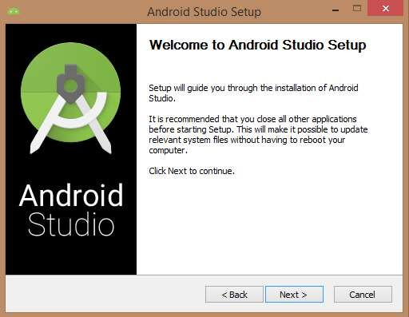
So let's launch Android Studio.exe,Make sure before launch Android Studio, Our Machine should required installed Java JDK. To install Java JDK,take a references of Android environment setup
Once you launched Android Studio, its time to mention JDK7 path or later version in android studio installer.
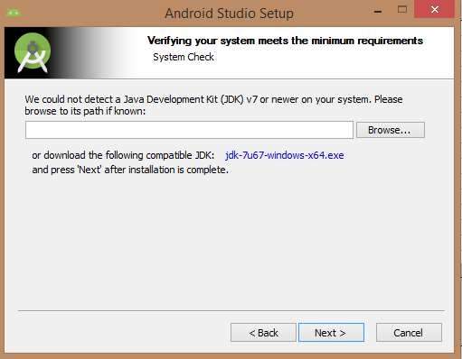
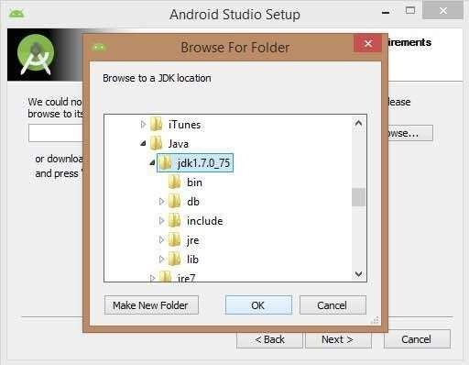
Below the image initiating JDK to android SDK
Need to check the components, which are required to create applications, below the image has selected Android Studio, Android SDK, Android Virtual Machine and performance(Intel chip).
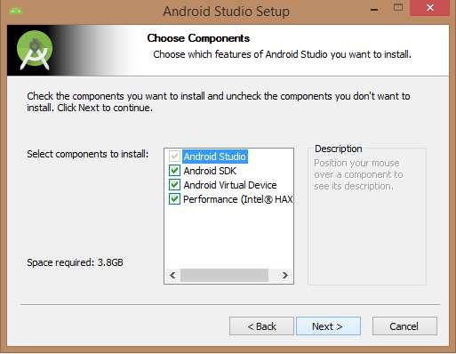
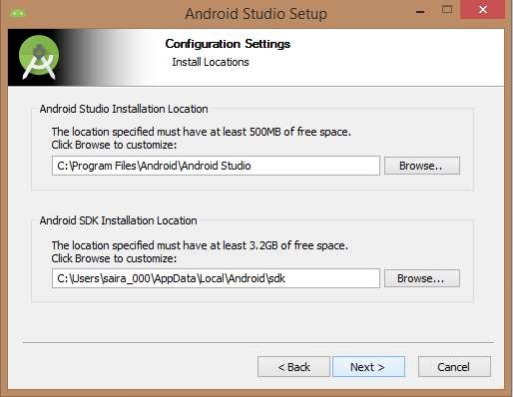
Need to specify the location of local machine path for Android studio and Android SDK, below the image has taken default location of windows 8.1 x64 bit architecture.
Need to specify the ram space for Android emulator by default it would take 512MB of local machine RAM.
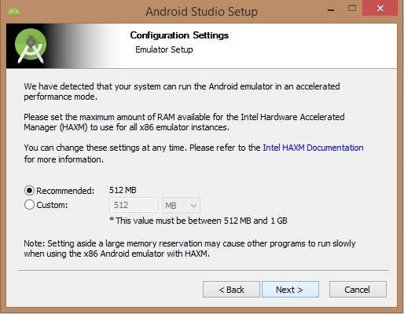
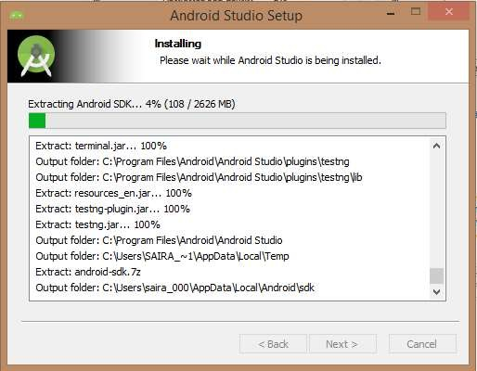
At final stage, it would extract SDK packages into our local machine, it would take a while time to finish the task and would take 2626MB of Hard disk space.
After done all above steps perfectly, you must get finish button and it gonna be open android studio project with Welcome to android studio message as shown below
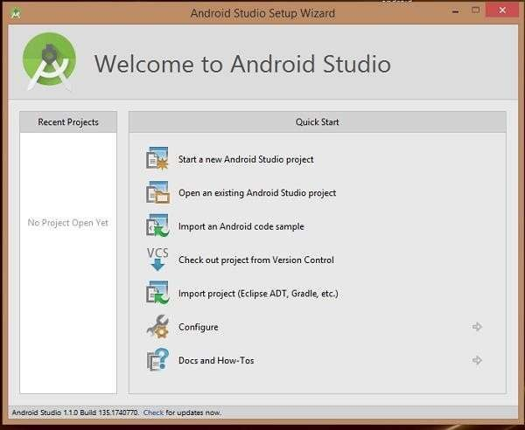
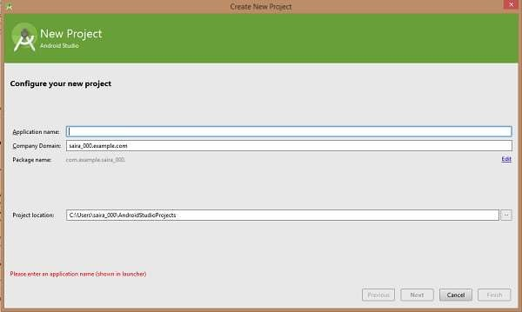
You can start your application development by calling start a new android studio project. in a new installation frame should ask Application name, package information and location of the project.
After entered application name, it going to be called select the form factors your application runs on, here need to specify Minimum SDK, in our tutorial, I have declared as API23: Android 6.0(Mashmallow)
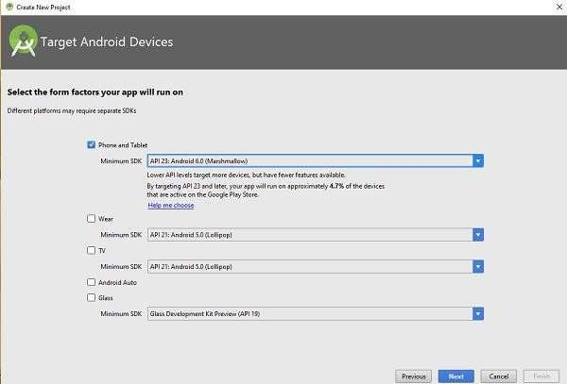
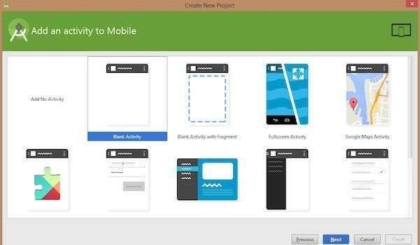
The next level of installation should contain selecting the activity to mobile, it specifies the default layout for Applications
At the final stage it going to be open development tool to write the application code.
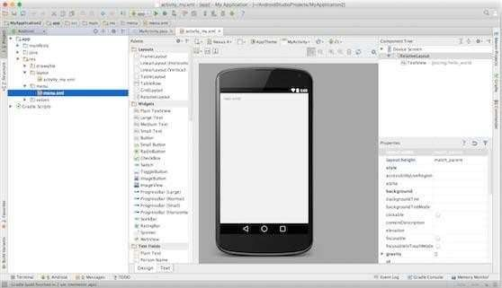
Step 3 - Create Android Virtual Device
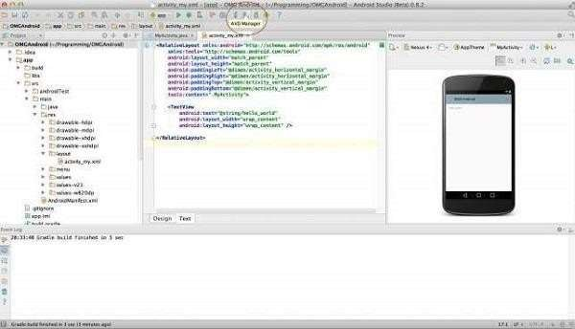
To test your Android applications, you will need a virtual Android device. So before we start writing our code, let us create an Android virtual device. Launch Android AVD Manager Clicking AVD_Manager icon as shown below
After Click on a virtual device icon, it going to be shown by default virtual devices which are present on your SDK, or else need to create a virtual device by clicking Create new Virtual device button
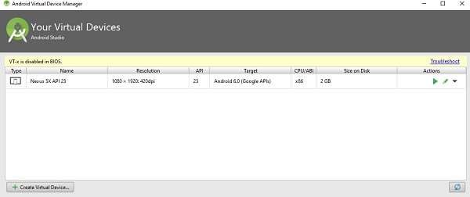
If your AVD is created successfully it means your environment is ready for Android application development. If you like, you can close this window using top-right cross button. Better you re-start your machine and once you are done with this last step, you are ready to proceed for your first Android example but before that we will see few more important concepts related to Android Application Development.

Development of Hello World Application.
activity_main.xml Code:
<?xml version="1.0" encoding="utf-8"?>

<LinearLayout
xmlns:android="http://schemas.android.com/apk/res/android"
android:layout_width="match_parent"
android:layout_height="match_parent"
android:gravity="center"
android:orientation="vertical">

<TextView
android:layout_width="wrap_content"
android:layout_height="wrap_content"
android:text="Hello World!"
android:textSize="24sp"/>

</LinearLayout>

MainActivity.java Code:

package com.example.helloworldapp;

import android.os.Bundle;
import androidx.appcompat.app.AppCompatActivity;

public class MainActivity extends AppCompatActivity {

@Override
protected void onCreate(Bundle savedInstanceState) {
super.onCreate(savedInstanceState);
setContentView(R.layout.activity_main);
}
}
Output:
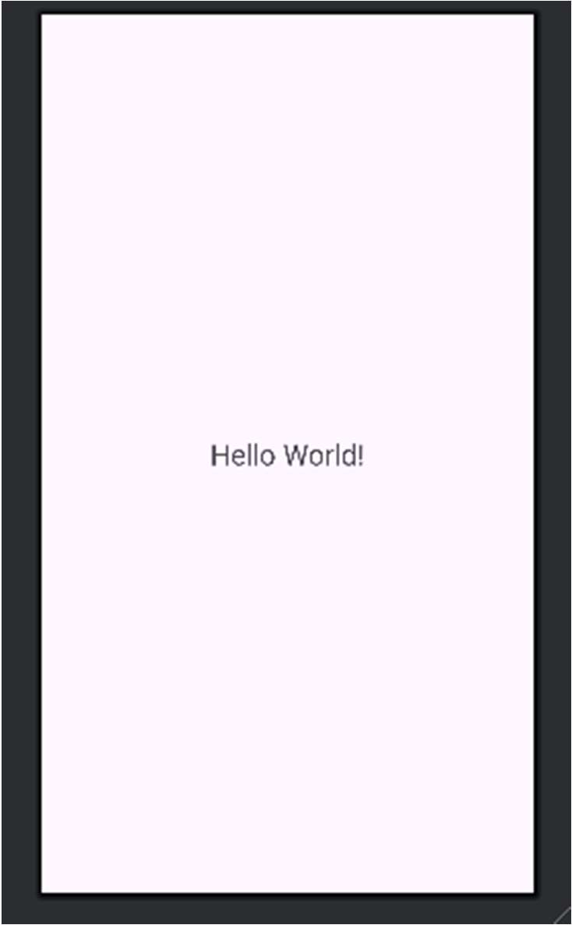

Create an application that takes the name from a textbox and shows hello message along with the name entered in text box, when the user clicks the OK button.

activity_main.xml Code:
<?xml version="1.0" encoding="utf-8"?>

<LinearLayout
xmlns:android="http://schemas.android.com/apk/res/android"
android:layout_width="match_parent"
android:layout_height="match_parent"
android:orientation="vertical"
android:padding="20dp">

<EditText
android:id="@+id/name"
android:layout_width="match_parent"
android:layout_height="wrap_content"
android:hint="Enter Name" />

<Button
android:id="@+id/ok"
android:layout_width="wrap_content"
android:layout_height="wrap_content"
android:text="OK" />

<TextView
android:id="@+id/message"
android:layout_width="wrap_content"
android:layout_height="wrap_content"
android:textSize="22sp" />

</LinearLayout>

MainActivity.java Code:
package com.example.nameapp;

import android.os.Bundle;
import android.view.View;
import android.widget.Button;
import android.widget.EditText;
import android.widget.TextView;

import androidx.appcompat.app.AppCompatActivity;

public class MainActivity extends AppCompatActivity {

EditText name;
Button ok;
TextView message;

@Override
protected void onCreate(Bundle savedInstanceState) {
super.onCreate(savedInstanceState);
setContentView(R.layout.activity_main);

name = findViewById(R.id.name);
ok = findViewById(R.id.ok);
message = findViewById(R.id.message);

ok.setOnClickListener(new View.OnClickListener() {
@Override
public void onClick(View v) {

String n = name.getText().toString();

if (n.isEmpty()) {
message.setText("Please enter your name");
} else {
message.setText("Hello " + n + "!");
}
}
});
}
}
Output
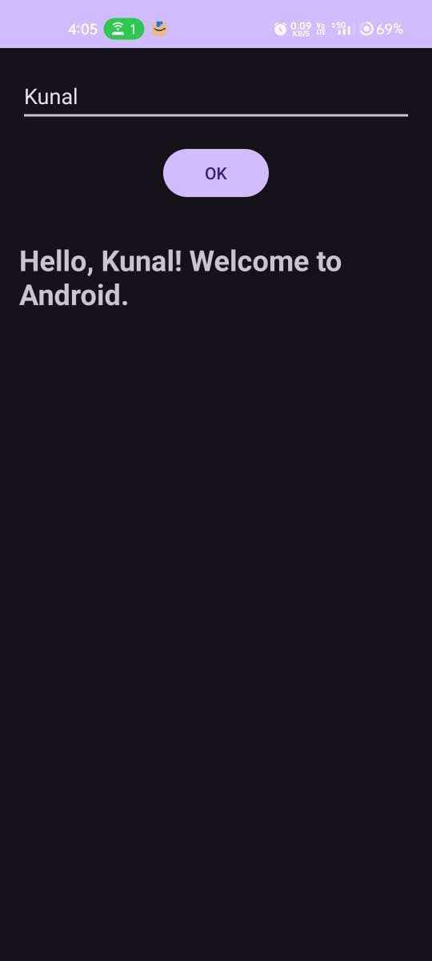
:

Create a screen that has input boxes for User Name, Password, and Address, Gender (radio buttons for male and female), Age (numeric), Date of Birth (DatePicket), State (Spinner) and a Submit button. On clicking the submit button, print all the data below the Submit Button (use any layout).

activity_main.xml Code:
<?xml version="1.0" encoding="utf-8"?>
<ScrollView
xmlns:android="http://schemas.android.com/apk/res/android"
android:layout_width="match_parent"
android:layout_height="match_parent">

<LinearLayout
android:layout_width="match_parent"
android:layout_height="wrap_content"
android:orientation="vertical"
android:padding="16dp">

<EditText
android:id="@+id/username"
android:layout_width="match_parent"
android:layout_height="wrap_content"
android:hint="User Name"/>

<EditText
android:id="@+id/password"
android:layout_width="match_parent"
android:layout_height="wrap_content"
android:hint="Password"
android:inputType="textPassword"/>

<EditText
android:id="@+id/address"
android:layout_width="match_parent"
android:layout_height="wrap_content"
android:hint="Address"/>

<RadioGroup
android:id="@+id/gender"
android:layout_width="match_parent"
android:layout_height="wrap_content"
android:orientation="horizontal">

<RadioButton
android:id="@+id/male"
android:layout_width="wrap_content"
android:layout_height="wrap_content"
android:text="Male"/>

<RadioButton
android:id="@+id/female"
android:layout_width="wrap_content"
android:layout_height="wrap_content"
android:text="Female"/>
</RadioGroup>

<EditText
android:id="@+id/age"
android:layout_width="match_parent"
android:layout_height="wrap_content"
android:hint="Age"
android:inputType="number"/>

<Button
android:id="@+id/dob"
android:layout_width="match_parent"
android:layout_height="wrap_content"
android:text="Select Date of Birth"/>

<Spinner
android:id="@+id/state"
android:layout_width="match_parent"
android:layout_height="wrap_content"/>

<Button
android:id="@+id/submit"
android:layout_width="match_parent"
android:layout_height="wrap_content"
android:text="Submit"/>

<TextView
android:id="@+id/output"
android:layout_width="match_parent"
android:layout_height="wrap_content"
android:textSize="18sp"
android:padding="10dp"/>

</LinearLayout>
</ScrollView>

MainActivity.java Code:
package com.example.formapplication;

import android.app.DatePickerDialog;
import android.os.Bundle;
import android.view.View;
import android.widget.*;

import androidx.appcompat.app.AppCompatActivity;

import java.util.Calendar;

public class MainActivity extends AppCompatActivity {

EditText username, password, address, age;
RadioGroup gender;
Button dob, submit;
Spinner state;
TextView output;

String date = "Not Selected";

@Override
protected void onCreate(Bundle savedInstanceState) {
super.onCreate(savedInstanceState);
setContentView(R.layout.activity_main);

username = findViewById(R.id.username);
password = findViewById(R.id.password);
address = findViewById(R.id.address);
age = findViewById(R.id.age);
gender = findViewById(R.id.gender);
dob = findViewById(R.id.dob);
state = findViewById(R.id.state);
submit = findViewById(R.id.submit);
output = findViewById(R.id.output);

String[] states = {"Maharashtra", "Gujarat", "Goa", "Delhi"};

ArrayAdapter<String> adapter = new ArrayAdapter<>(
this,
android.R.layout.simple_spinner_dropdown_item,
states);

state.setAdapter(adapter);

dob.setOnClickListener(new View.OnClickListener() {
@Override
public void onClick(View v) {

Calendar c = Calendar.getInstance();

new DatePickerDialog(
MainActivity.this,
(view, year, month, day) -> {

date = day + "/" + (month + 1) + "/" + year;

dob.setText(date);
},
c.get(Calendar.YEAR),
c.get(Calendar.MONTH),
c.get(Calendar.DAY_OF_MONTH)
).show();
}
});

submit.setOnClickListener(new View.OnClickListener() {
@Override
public void onClick(View v) {

int id = gender.getCheckedRadioButtonId();

if (id == -1) {
Toast.makeText(MainActivity.this,
"Select Gender", Toast.LENGTH_SHORT).show();
return;
}

RadioButton r = findViewById(id);

String data =
"User Name: " + username.getText().toString() +
"\nPassword: " + password.getText().toString() +
"\nAddress: " + address.getText().toString() +
"\nGender: " + r.getText().toString() +
"\nAge: " + age.getText().toString() +
"\nDOB: " + date +
"\nState: " + state.getSelectedItem().toString();

output.setText(data);
}
});
}
}

Output:
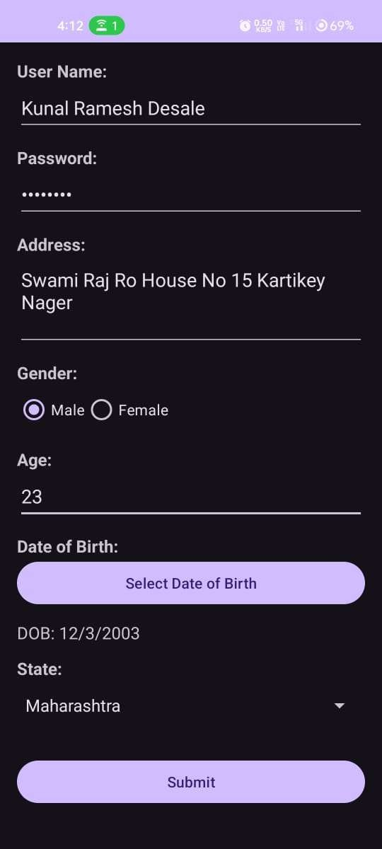
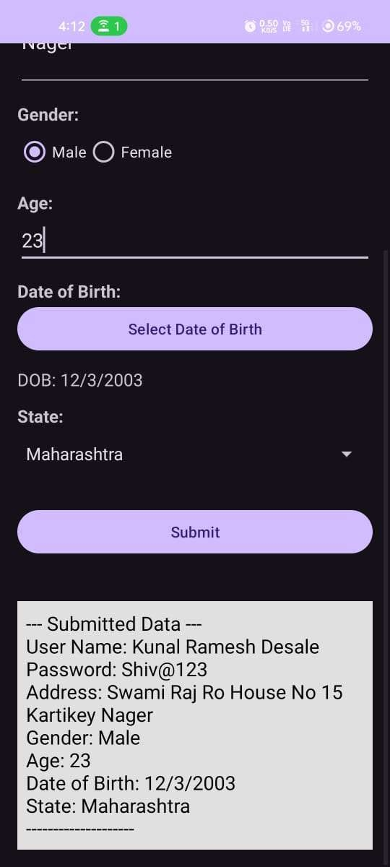

Design an android application to create page using Intent and one Button and pass the Values from one Activity to second Activity.
activity_main.xml Code:
<?xml version="1.0" encoding="utf-8"?>

<LinearLayout
xmlns:android="http://schemas.android.com/apk/res/android"
android:layout_width="match_parent"
android:layout_height="match_parent"
android:orientation="vertical"
android:padding="20dp">

<EditText
android:id="@+id/name"
android:layout_width="match_parent"
android:layout_height="wrap_content"
android:hint="Enter Name"/>

<Button
android:id="@+id/send"
android:layout_width="wrap_content"
android:layout_height="wrap_content"
android:text="Send"/>

</LinearLayout>

MainActivity.java Code:
package com.example.intentexample;

import android.content.Intent;
import android.os.Bundle;
import android.view.View;
import android.widget.EditText;

import androidx.appcompat.app.AppCompatActivity;

public class MainActivity extends AppCompatActivity {

EditText name;

@Override
protected void onCreate(Bundle savedInstanceState) {
super.onCreate(savedInstanceState);
setContentView(R.layout.activity_main);

name = findViewById(R.id.name);
}

public void send(View v) {

Intent i = new Intent(this, SecondActivity.class);

i.putExtra("name", name.getText().toString());

startActivity(i);
}
}

AndroidManifest.xml Code:

<activity android:name=".MainActivity">
<intent-filter>
<action android:name="android.intent.action.MAIN"/>
<category android:name="android.intent.category.LAUNCHER"/>
</intent-filter>
</activity>

<activity android:name=".SecondActivity"/>

activity_second.xml Code:
<?xml version="1.0" encoding="utf-8"?>

<LinearLayout
xmlns:android="http://schemas.android.com/apk/res/android"
android:layout_width="match_parent"
android:layout_height="match_parent"
android:gravity="center"
android:orientation="vertical">

<TextView
android:id="@+id/result"
android:layout_width="wrap_content"
android:layout_height="wrap_content"
android:textSize="24sp"/>

</LinearLayout>

SecondActivity.java Code:
package com.example.intentexample;

import android.os.Bundle;
import android.widget.TextView;
import androidx.appcompat.app.AppCompatActivity;

public class SecondActivity extends AppCompatActivity {

@Override
protected void onCreate(Bundle savedInstanceState) {
super.onCreate(savedInstanceState);
setContentView(R.layout.activity_second);

TextView result = findViewById(R.id.result);

String name = getIntent().getStringExtra("name");

result.setText("Hello " + name);
}
}

Output:
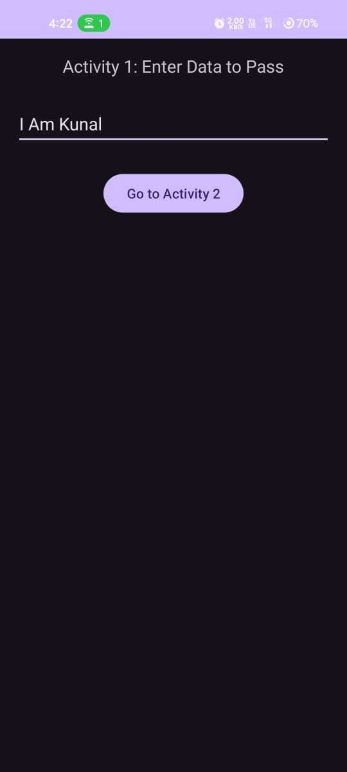


Design an android application Send SMS using Intent.
activity_main.xml Code:
<?xml version="1.0" encoding="utf-8"?>

<LinearLayout
xmlns:android="http://schemas.android.com/apk/res/android"
android:layout_width="match_parent"
android:layout_height="match_parent"
android:orientation="vertical"
android:padding="20dp">

<EditText
android:id="@+id/phone"
android:layout_width="match_parent"
android:layout_height="wrap_content"
android:hint="Phone Number"
android:inputType="phone"/>

<EditText
android:id="@+id/message"
android:layout_width="match_parent"
android:layout_height="wrap_content"
android:hint="Enter Message"/>

<Button
android:id="@+id/send"
android:layout_width="wrap_content"
android:layout_height="wrap_content"
android:text="Send SMS"/>

</LinearLayout>

MainActivity.java Code:
package com.example.smssender;

import android.content.Intent;
import android.net.Uri;
import android.os.Bundle;
import android.widget.Button;
import android.widget.EditText;

import androidx.appcompat.app.AppCompatActivity;

public class MainActivity extends AppCompatActivity {

EditText phone, message;
Button send;

@Override
protected void onCreate(Bundle savedInstanceState) {
super.onCreate(savedInstanceState);
setContentView(R.layout.activity_main);

phone = findViewById(R.id.phone);
message = findViewById(R.id.message);
send = findViewById(R.id.send);

send.setOnClickListener(v -> {

Uri uri = Uri.parse("smsto:" +
phone.getText().toString());

Intent i = new Intent(Intent.ACTION_SENDTO, uri);

i.putExtra("sms_body",
message.getText().toString());

startActivity(i);
});
}
}

Output:
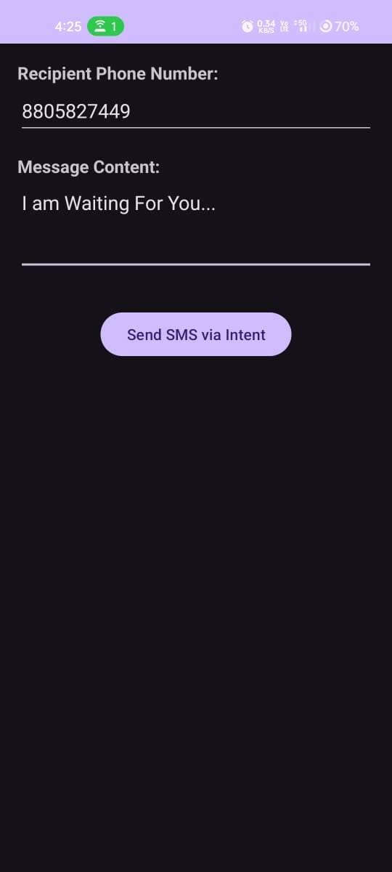

Create an android application using Fragments
activity_main.xml Code:
<?xml version="1.0" encoding="utf-8"?>

<LinearLayout
xmlns:android="http://schemas.android.com/apk/res/android"
android:layout_width="match_parent"
android:layout_height="match_parent"
android:orientation="vertical">

<androidx.fragment.app.FragmentContainerView
android:id="@+id/list"
android:layout_width="match_parent"
android:layout_height="wrap_content"/>

<androidx.fragment.app.FragmentContainerView
android:id="@+id/detail"
android:layout_width="match_parent"
android:layout_height="match_parent"/>

</LinearLayout>

fragment_list.xml Code:
<?xml version="1.0" encoding="utf-8"?>

<LinearLayout
xmlns:android="http://schemas.android.com/apk/res/android"
android:layout_width="match_parent"
android:layout_height="match_parent"
android:gravity="center"
android:orientation="vertical">

<TextView
android:id="@+id/result"
android:layout_width="wrap_content"
android:layout_height="wrap_content"
android:text="Select a topic"
android:textSize="22sp"/>

</LinearLayout>

fragment_detail.xml Code:
<?xml version="1.0" encoding="utf-8"?>

<LinearLayout
xmlns:android="http://schemas.android.com/apk/res/android"
android:layout_width="match_parent"
android:layout_height="match_parent"
android:gravity="center"
android:orientation="vertical">

<TextView
android:id="@+id/result"
android:layout_width="wrap_content"
android:layout_height="wrap_content"
android:text="Select a topic"
android:textSize="22sp"/>

</LinearLayout>

DetailFragment.java Code:
<?xml version="1.0" encoding="utf-8"?>
package com.example.fragmentapp;

import android.os.Bundle;
import android.view.LayoutInflater;
import android.view.View;
import android.view.ViewGroup;
import android.widget.TextView;

import androidx.fragment.app.Fragment;

public class DetailFragment extends Fragment {

TextView result;

public View onCreateView(LayoutInflater inflater,
ViewGroup container,
Bundle savedInstanceState) {

View v = inflater.inflate(R.layout.fragment_detail,
container, false);

result = v.findViewById(R.id.result);

return v;
}

public void show(String text) {
result.setText(text);
}
}

ListFragment.java Code:
package com.example.fragmentapp;

import android.os.Bundle;
import android.view.LayoutInflater;
import android.view.View;
import android.view.ViewGroup;
import android.widget.Button androidx.fragment.app.Fragment;
public class ListFragment extends Fragment {

public View onCreateView(LayoutInflater inflater,
ViewGroup container,
Bundle savedInstanceState) {

View v = inflater.inflate(R.layout.fragment_list,
container, false);

Button android = v.findViewById(R.id.android);
Button java = v.findViewById(R.id.java);

android.setOnClickListener(x ->
((MainActivity)getActivity()).show("Android"));

java.setOnClickListener(x ->
((MainActivity)getActivity()).show("Java"));

return v;
}
}

MainActivity.java Code:
package com.example.fragmentapp;

import android.os.Bundle;

import androidx.appcompat.app.AppCompatActivity;

public class MainActivity extends AppCompatActivity {

DetailFragment detail;

@Override
protected void onCreate(Bundle b) {
super.onCreate(b);
setContentView(R.layout.activity_main);

getSupportFragmentManager()
.beginTransaction()
.replace(R.id.list, new ListFragment())
.commit();

detail = new DetailFragment();

getSupportFragmentManager()
.beginTransaction()
.replace(R.id.detail, detail)
.commit();
}

public void show(String text) {
detail.show(text);
}
}

Output:
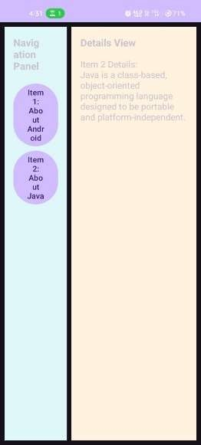
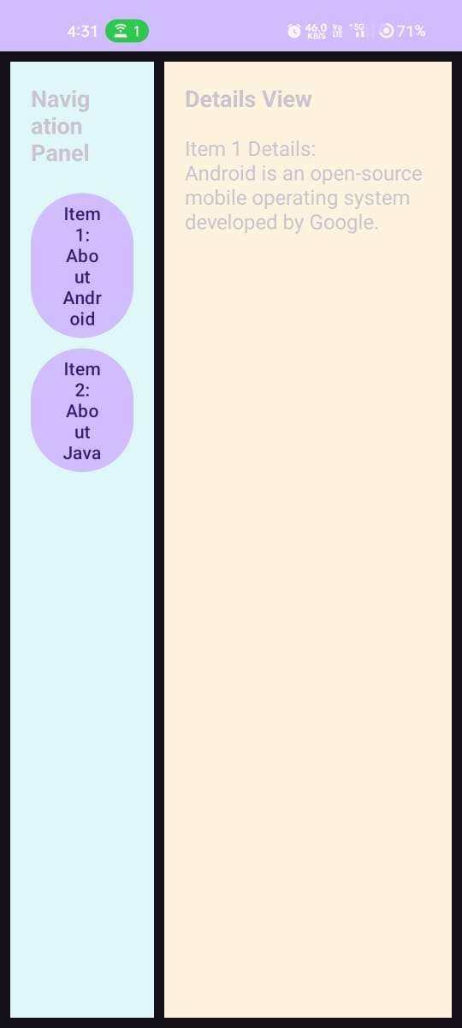

Design an android application Using Radio buttons.
activity_main.xml Code:
<?xml version="1.0" encoding="utf-8"?>
<LinearLayout
xmlns:android="http://schemas.android.com/apk/res/android"
android:layout_width="match_parent"
android:layout_height="match_parent"
android:orientation="vertical"
android:padding="20dp">

<TextView
android:layout_width="wrap_content"
android:layout_height="wrap_content"
android:text="Select Subject"
android:textSize="20sp"/>

<RadioGroup
android:id="@+id/group"
android:layout_width="match_parent"
android:layout_height="wrap_content">

<RadioButton
android:id="@+id/java"
android:layout_width="wrap_content"
android:layout_height="wrap_content"
android:text="Java"/>

<RadioButton
android:id="@+id/android"
android:layout_width="wrap_content"
android:layout_height="wrap_content"
android:text="Android"/>

<RadioButton
android:id="@+id/network"
android:layout_width="wrap_content"
android:layout_height="wrap_content"
android:text="Networking"/>

</RadioGroup>

<Button
android:id="@+id/submit"
android:layout_width="wrap_content"
android:layout_height="wrap_content"
android:text="Submit"/>

<TextView
android:id="@+id/result"
android:layout_width="wrap_content"
android:layout_height="wrap_content"
android:textSize="20sp"/>

</LinearLayout>

MainActivity.java
Code:
package com.example.radiobuttonapp;

import android.os.Bundle;
import android.view.View;
import android.widget.*;

import androidx.appcompat.app.AppCompatActivity;

public class MainActivity extends AppCompatActivity {

RadioGroup group;
Button submit;
TextView result;

@Override
protected void onCreate(Bundle savedInstanceState) {
super.onCreate(savedInstanceState);
setContentView(R.layout.activity_main);

group = findViewById(R.id.group);
submit = findViewById(R.id.submit);
result = findViewById(R.id.result);

submit.setOnClickListener(new View.OnClickListener() {
@Override
public void onClick(View v) {

int id = group.getCheckedRadioButtonId();

if (id == -1) {
result.setText("Please select a subject");
} else {
RadioButton r = findViewById(id);
result.setText("Selected: " + r.getText());
}
}
});
}
}

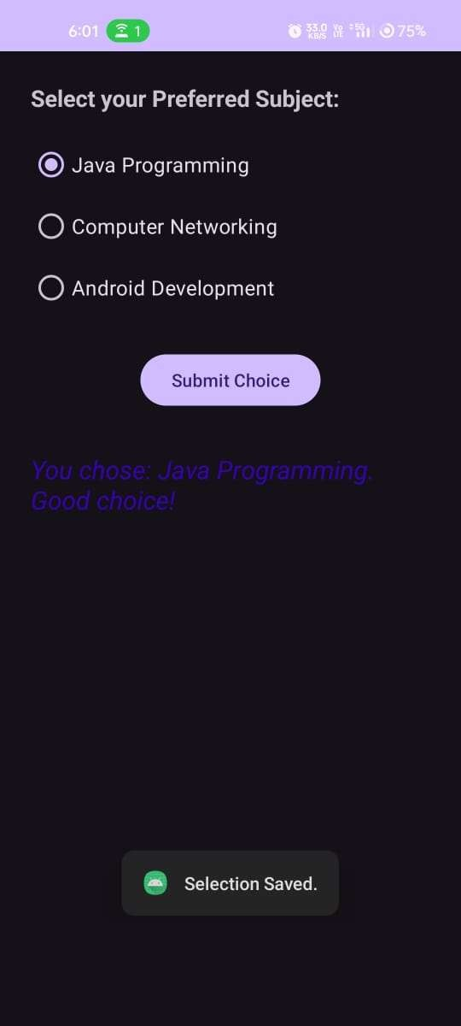
Output:

Design an android application for menu.
main_menu.xml Code:
<?xml version="1.0" encoding="utf-8"?>

<menu xmlns:android="http://schemas.android.com/apk/res/android">

<item
android:id="@+id/settings"
android:title="Settings"/>

<item
android:id="@+id/about"
android:title="About"/>

<item
android:id="@+id/exit"
android:title="Exit"/>

</menu>

activity_main.xml
Code:
<?xml version="1.0" encoding="utf-8"?>

<LinearLayout
xmlns:android="http://schemas.android.com/apk/res/android"
android:layout_width="match_parent"
android:layout_height="match_parent"
android:gravity="center"
android:orientation="vertical">

<TextView
android:id="@+id/result"
android:layout_width="wrap_content"
android:layout_height="wrap_content"
android:text="Select a menu item"
android:textSize="22sp"/>

</LinearLayout>

MainActivity.java Code:
package com.example.menuapp;
import android.os.Bundle;
import android.view.Menu;
import android.view.MenuItem;
import android.widget.TextView;

import androidx.appcompat.app.AppCompatActivity;

public class MainActivity extends AppCompatActivity {

TextView result;

@Override
protected void onCreate(Bundle savedInstanceState) {
super.onCreate(savedInstanceState);
setContentView(R.layout.activity_main);

result = findViewById(R.id.result);
}

@Override
public boolean onCreateOptionsMenu(Menu menu) {
getMenuInflater().inflate(R.menu.main_menu, menu);
return true;
}

@Override
public boolean onOptionsItemSelected(MenuItem item) {

if (item.getItemId() == R.id.settings) {
result.setText("Settings Selected");
return true;
}

if (item.getItemId() == R.id.about) {
result.setText("About Selected");
return true;
}

if (item.getItemId() == R.id.exit) {
finish();
return true;
}

return super.onOptionsItemSelected(item);
}
}

Output:
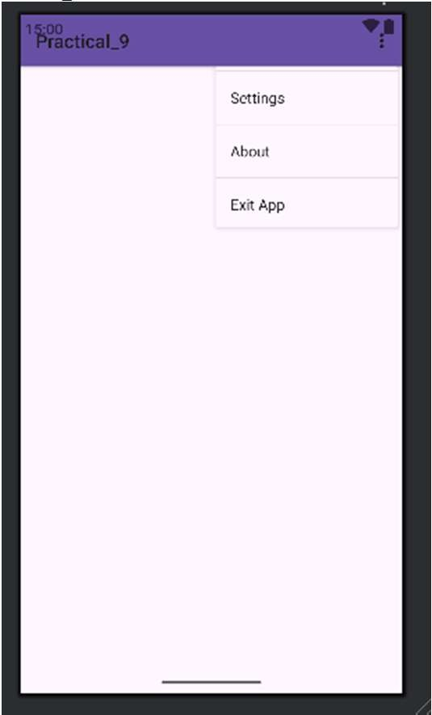

Create a user registration application that stores the user details in a database table.
activity_main.xml Code:
<?xml version="1.0" encoding="utf-8"?>

<LinearLayout
xmlns:android="http://schemas.android.com/apk/res/android"
android:layout_width="match_parent"
android:layout_height="match_parent"
android:orientation="vertical"
android:padding="20dp">

<EditText
android:id="@+id/name"
android:layout_width="match_parent"
android:layout_height="wrap_content"
android:hint="Name"/>

<EditText
android:id="@+id/email"
android:layout_width="match_parent"
android:layout_height="wrap_content"
android:hint="Email"/>

<EditText
android:id="@+id/password"
android:layout_width="match_parent"
android:layout_height="wrap_content"
android:hint="Password"
android:inputType="textPassword"/>

<Button
android:id="@+id/register"
android:layout_width="match_parent"
android:layout_height="wrap_content"
android:text="Register"/>

<Button
android:id="@+id/view"
android:layout_width="match_parent"
android:layout_height="wrap_content"
android:text="View Users"/>

</LinearLayout>

DatabaseHelper.java Code:
package com.example.registrationapp;
import android.content.ContentValues;
import android.content.Context;
import android.database.Cursor;
import android.database.sqlite.SQLiteDatabase;
import android.database.sqlite.SQLiteOpenHelper;
import android.util.Log;

public class DatabaseHelper extends SQLiteOpenHelper {

public DatabaseHelper(Context c) {
super(c, "Users.db", null, 1);
}

@Override
public void onCreate(SQLiteDatabase db) {

db.execSQL("CREATE TABLE users(" +
"id INTEGER PRIMARY KEY AUTOINCREMENT," +
"name TEXT," +
"email TEXT," +
"password TEXT)");
}

@Override
public void onUpgrade(SQLiteDatabase db, int oldVersion, int newVersion) {

db.execSQL("DROP TABLE IF EXISTS users");
onCreate(db);
}

public boolean insertUser(String name, String email, String password) {

SQLiteDatabase db = getWritableDatabase();

ContentValues values = new ContentValues();

values.put("name", name);
values.put("email", email);
values.put("password", password);

return db.insert("users", null, values) != -1;
}

public void showUsers() {

SQLiteDatabase db = getReadableDatabase();

Cursor c = db.rawQuery("SELECT * FROM users", null);

while (c.moveToNext()) {

Log.d("USERS",
c.getString(1) + " " +
c.getString(2));
}

c.close();
}
}

MainActivity.java
Code:
package com.example.registrationapp;
import android.os.Bundle;
import android.widget.*;

import androidx.appcompat.app.AppCompatActivity;

public class MainActivity extends AppCompatActivity {

EditText name, email, password;
DatabaseHelper db;

@Override
protected void onCreate(Bundle b) {
super.onCreate(b);
setContentView(R.layout.activity_main);

name = findViewById(R.id.name);
email = findViewById(R.id.email);
password = findViewById(R.id.password);

Button register = findViewById(R.id.register);
Button view = findViewById(R.id.view);

db = new DatabaseHelper(this);

register.setOnClickListener(v -> {

boolean result = db.insertUser(
name.getText().toString(),
email.getText().toString(),
password.getText().toString());

if (result)
Toast.makeText(this,
"Registration Successful",
Toast.LENGTH_SHORT).show();
else
Toast.makeText(this,
"Registration Failed",
Toast.LENGTH_SHORT).show();
});

view.setOnClickListener(v -> {
db.showUsers();

Toast.makeText(this,
"Users displayed in Logcat",
Toast.LENGTH_SHORT).show();
});
}
}

Output:

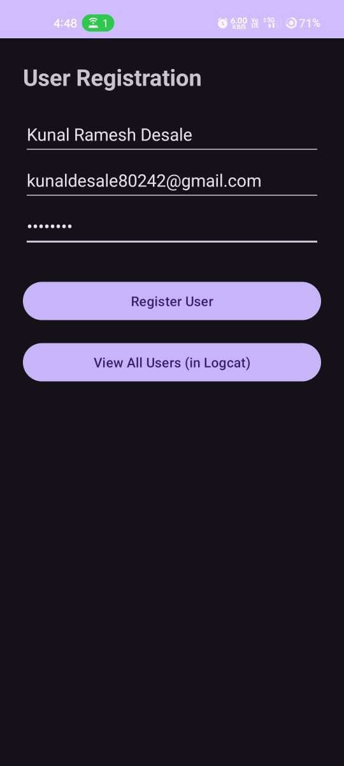
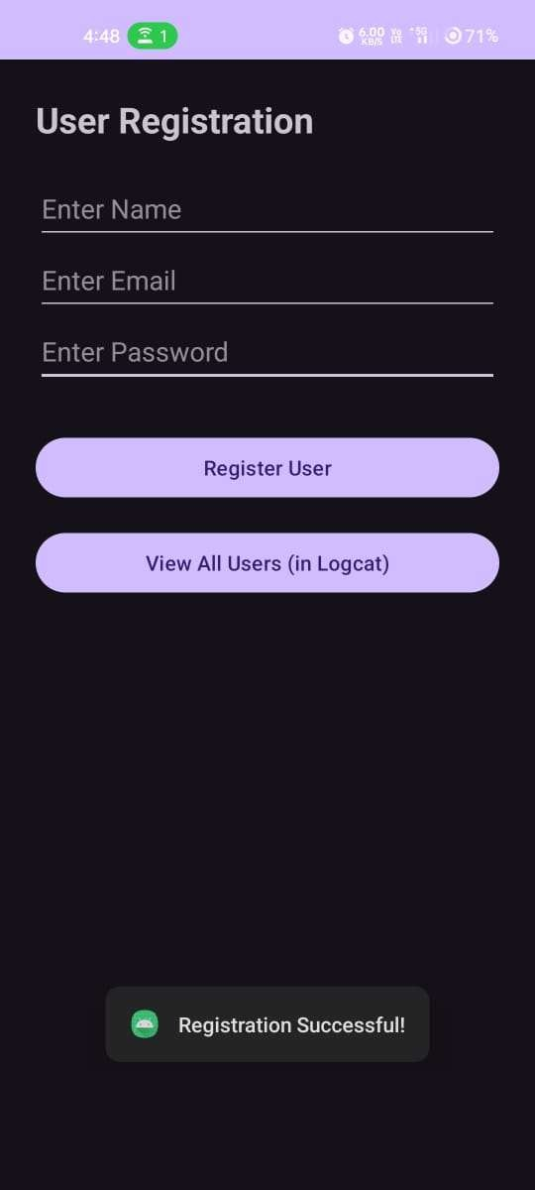

Create an appliction on to Create, Insert, update, Delete and retrieve operation on the database.

DatabaseHelper.java Code:
package com.example.crudapp;
import android.content.ContentValues;
import android.content.Context;
import android.database.Cursor;
import android.database.sqlite.SQLiteDatabase;
import android.database.sqlite.SQLiteOpenHelper;
import android.util.Log;

public class DatabaseHelper extends SQLiteOpenHelper {

public DatabaseHelper(Context c) {
super(c, "CrudDB", null, 1);
}

@Override
public void onCreate(SQLiteDatabase db) {

db.execSQL("CREATE TABLE users(" +
"id INTEGER PRIMARY KEY AUTOINCREMENT," +
"name TEXT," +
"email TEXT," +
"password TEXT)");
}

@Override
public void onUpgrade(SQLiteDatabase db,
int oldVersion, int newVersion) {

db.execSQL("DROP TABLE IF EXISTS users");
onCreate(db);
}

public boolean insert(String name, String email, String password) {

SQLiteDatabase db = getWritableDatabase();

ContentValues v = new ContentValues();
v.put("name", name);
v.put("email", email);
v.put("password", password);

return db.insert("users", null, v) != -1;
}

public boolean update(String id, String name,
String email, String password) {

SQLiteDatabase db = getWritableDatabase();

ContentValues v = new ContentValues();
v.put("name", name);
v.put("email", email);
v.put("password", password);

return db.update("users", v, "id=?",
new String[]{id}) > 0;
}

public boolean delete(String id) {

SQLiteDatabase db = getWritableDatabase();

return db.delete("users", "id=?",
new String[]{id}) > 0;
}

public void view() {

SQLiteDatabase db = getReadableDatabase();

Cursor c = db.rawQuery("SELECT * FROM users", null);

while (c.moveToNext()) {

Log.d("CRUD",
"ID: " + c.getInt(0) +
" Name: " + c.getString(1) +
" Email: " + c.getString(2));
}

c.close();
}
}

activity_main.xml Code:
<?xml version="1.0" encoding="utf-8"?>

<LinearLayout
xmlns:android="http://schemas.android.com/apk/res/android"
android:layout_width="match_parent"
android:layout_height="match_parent"
android:orientation="vertical"
android:padding="16dp">

<EditText
android:id="@+id/id"
android:layout_width="match_parent"
android:layout_height="wrap_content"
android:hint="ID (for Update/Delete)"
android:inputType="number"/>

<EditText
android:id="@+id/name"
android:layout_width="match_parent"
android:layout_height="wrap_content"
android:hint="Name"/>

<EditText
android:id="@+id/email"
android:layout_width="match_parent"
android:layout_height="wrap_content"
android:hint="Email"/>

<EditText
android:id="@+id/password"
android:layout_width="match_parent"
android:layout_height="wrap_content"
android:hint="Password"/>

<Button
android:id="@+id/insert"
android:layout_width="match_parent"
android:layout_height="wrap_content"
android:text="INSERT"/>

<Button
android:id="@+id/update"
android:layout_width="match_parent"
android:layout_height="wrap_content"
android:text="UPDATE"/>

<Button
android:id="@+id/delete"
android:layout_width="match_parent"
android:layout_height="wrap_content"
android:text="DELETE"/>

<Button
android:id="@+id/view"
android:layout_width="match_parent"
android:layout_height="wrap_content"
android:text="VIEW ALL"/>

</LinearLayout>

MainActivity.java Code:
package com.example.crudapp;
import androidx.appcompat.app.AppCompatActivity; import android.os.Bundle;
import android.view.View; import android.widget.EditText; import android.widget.Toast;

public class MainActivity extends AppCompatActivity {package com.example.crudapp;

import android.os.Bundle;
import android.widget.*;

import androidx.appcompat.app.AppCompatActivity;

public class MainActivity extends AppCompatActivity {

EditText id, name, email, password;
DatabaseHelper db;

@Override
protected void onCreate(Bundle b) {
super.onCreate(b);
setContentView(R.layout.activity_main);

id = findViewById(R.id.id);
name = findViewById(R.id.name);
email = findViewById(R.id.email);
password = findViewById(R.id.password);

Button insert = findViewById(R.id.insert);
Button update = findViewById(R.id.update);
Button delete = findViewById(R.id.delete);
Button view = findViewById(R.id.view);

db = new DatabaseHelper(this);

insert.setOnClickListener(v -> {

if (db.insert(
name.getText().toString(),
email.getText().toString(),
password.getText().toString()))
msg("Inserted Successfully");
});

update.setOnClickListener(v -> {

if (db.update(
id.getText().toString(),
name.getText().toString(),
email.getText().toString(),
password.getText().toString()))
msg("Updated Successfully");
});

delete.setOnClickListener(v -> {

if (db.delete(id.getText().toString()))
msg("Deleted Successfully");
});

view.setOnClickListener(v -> {

db.view();
msg("Data shown in Logcat");
});
}

void msg(String s) {
Toast.makeText(this, s, Toast.LENGTH_SHORT).show();
}
}

Output:

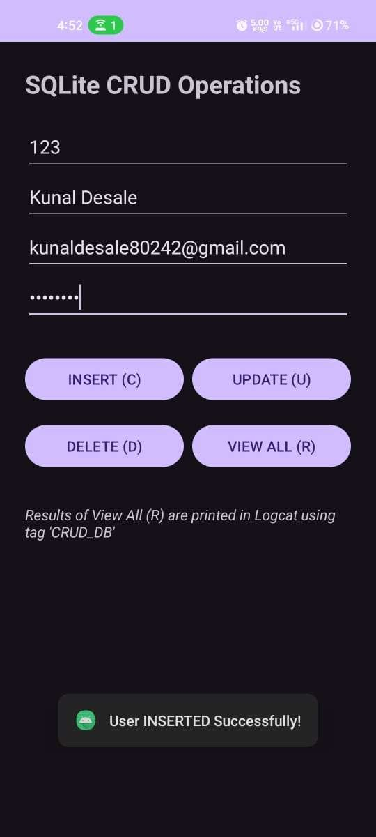

Create an application on with three op on buttonsons, on selecting a button color of the screen will change
activity_main.xml Code:
<?xml version="1.0" encoding="utf-8"?>
<LinearLayout
xmlns:android="http://schemas.android.com/apk/res/android"
android:id="@+id/main"
android:layout_width="match_parent"
android:layout_height="match_parent"
android:orientation="vertical"
android:padding="20dp">

<RadioGroup
android:id="@+id/colors"
android:layout_width="match_parent"
android:layout_height="wrap_content">

<RadioButton
android:id="@+id/red"
android:layout_width="wrap_content"
android:layout_height="wrap_content"
android:text="Red"/>

<RadioButton
android:id="@+id/green"
android:layout_width="wrap_content"
android:layout_height="wrap_content"
android:text="Green"/>

<RadioButton
android:id="@+id/blue"
android:layout_width="wrap_content"
android:layout_height="wrap_content"
android:text="Blue"/>

</RadioGroup>
</LinearLayout>

MainActivity.java Code:
package com.example.colorchangeapp;
import android.graphics.Color;
import android.os.Bundle;
import android.widget.*;

import androidx.appcompat.app.AppCompatActivity;

public class MainActivity extends AppCompatActivity {

LinearLayout main;
RadioGroup colors;

@Override
protected void onCreate(Bundle b) {
super.onCreate(b);
setContentView(R.layout.activity_main);

main = findViewById(R.id.main);
colors = findViewById(R.id.colors);

colors.setOnCheckedChangeListener((group, id) -> {

if (id == R.id.red)
main.setBackgroundColor(Color.RED);

else if (id == R.id.green)
main.setBackgroundColor(Color.GREEN);

else if (id == R.id.blue)
main.setBackgroundColor(Color.BLUE);
});
}
}

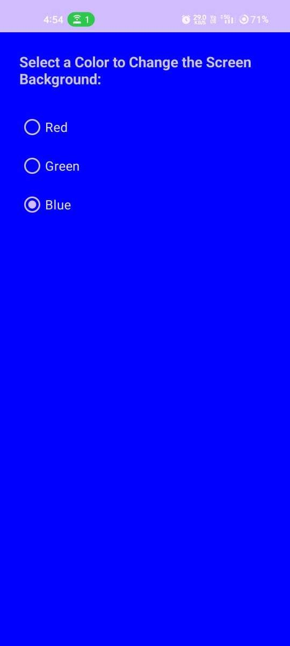
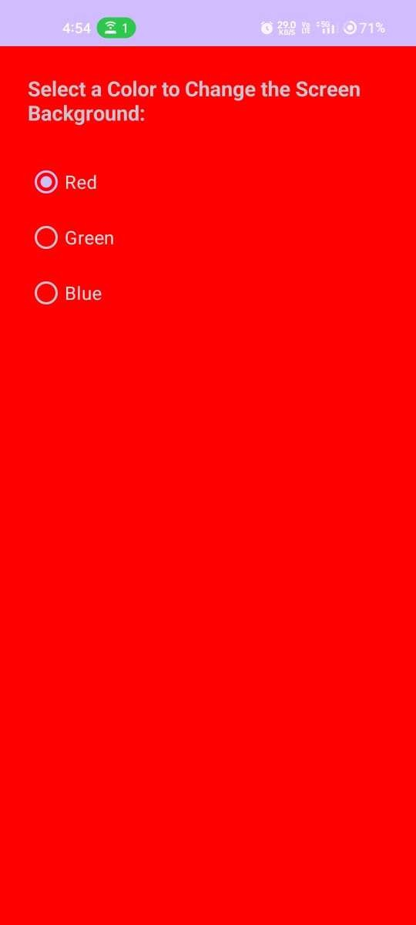
Output:

- Create spinner with strings taken from resource folder (res >> value folder) and on changing the spinner value, Image will change

strings.xml Code:
<resources>
<string name="app_name">SpinnerImageApp</string>
<string-array name="planets">
<item>Earth</item>
<item>Mars</item>
<item>Jupiter</item>
<item>Saturn</item>
</string-array>

</resources>

activity_main.xml Code:
<?xml version="1.0" encoding="utf-8"?>
<LinearLayout
xmlns:android="http://schemas.android.com/apk/res/android"
android:layout_width="match_parent"
android:layout_height="match_parent"
android:orientation="vertical"
android:gravity="center"
android:padding="20dp">

<Spinner
android:id="@+id/spinner"
android:layout_width="match_parent"
android:layout_height="wrap_content"/>

<ImageView
android:id="@+id/image"
android:layout_width="200dp"
android:layout_height="200dp"
android:src="@drawable/earth"/>

</LinearLayout>

MainActivity.java Code:
package com.example.spinnerimageapp;
import android.os.Bundle;
import android.view.View;
import android.widget.*;

import androidx.appcompat.app.AppCompatActivity;

public class MainActivity extends AppCompatActivity {

Spinner spinner;
ImageView image;
String[] planets;

@Override
protected void onCreate(Bundle b) {
super.onCreate(b);
setContentView(R.layout.activity_main);

spinner = findViewById(R.id.spinner);
image = findViewById(R.id.image);

planets = getResources().getStringArray(R.array.planets);

ArrayAdapter<String> adapter = new ArrayAdapter<>(
this,
android.R.layout.simple_spinner_item,
planets);

spinner.setAdapter(adapter);

spinner.setOnItemSelectedListener(
new AdapterView.OnItemSelectedListener() {

@Override
public void onItemSelected(
AdapterView<?> p, View v,
int position, long id) {

if (position == 0)
image.setImageResource(R.drawable.earth);

else if (position == 1)
image.setImageResource(R.drawable.mars);

else if (position == 2)
image.setImageResource(R.drawable.jupiter);

else
image.setImageResource(R.drawable.saturn);
}

@Override
public void onNothingSelected(AdapterView<?> p) {
}
});
}
}


Output:

Create an application with login module.
activity_main.xml Code:
<?xml version="1.0" encoding="utf-8"?>
<LinearLayout
xmlns:android="http://schemas.android.com/apk/res/android"
android:layout_width="match_parent"
android:layout_height="match_parent"
android:orientation="vertical"
android:gravity="center"
android:padding="20dp">

<EditText
android:id="@+id/username"
android:layout_width="match_parent"
android:layout_height="wrap_content"
android:hint="Username"/>

<EditText
android:id="@+id/password"
android:layout_width="match_parent"
android:layout_height="wrap_content"
android:hint="Password"
android:inputType="textPassword"/>

<Button
android:id="@+id/login"
android:layout_width="match_parent"
android:layout_height="wrap_content"
android:text="Login"/>

<TextView
android:id="@+id/result"
android:layout_width="wrap_content"
android:layout_height="wrap_content"
android:textSize="20sp"/>

</LinearLayout>

MainActivity.java Code:
package com.example.loginapp;
import android.os.Bundle;
import android.widget.*;

import androidx.appcompat.app.AppCompatActivity;

public class MainActivity extends AppCompatActivity {

EditText username, password;
Button login;
TextView result;

@Override
protected void onCreate(Bundle b) {
super.onCreate(b);
setContentView(R.layout.activity_main);

username = findViewById(R.id.username);
password = findViewById(R.id.password);
login = findViewById(R.id.login);
result = findViewById(R.id.result);

login.setOnClickListener(v -> {

String user = username.getText().toString();
String pass = password.getText().toString();

if (user.equals("admin") && pass.equals("123")) {
result.setText("Login Successful");
} else {
result.setText("Invalid Username or Password");
}
});
}
}

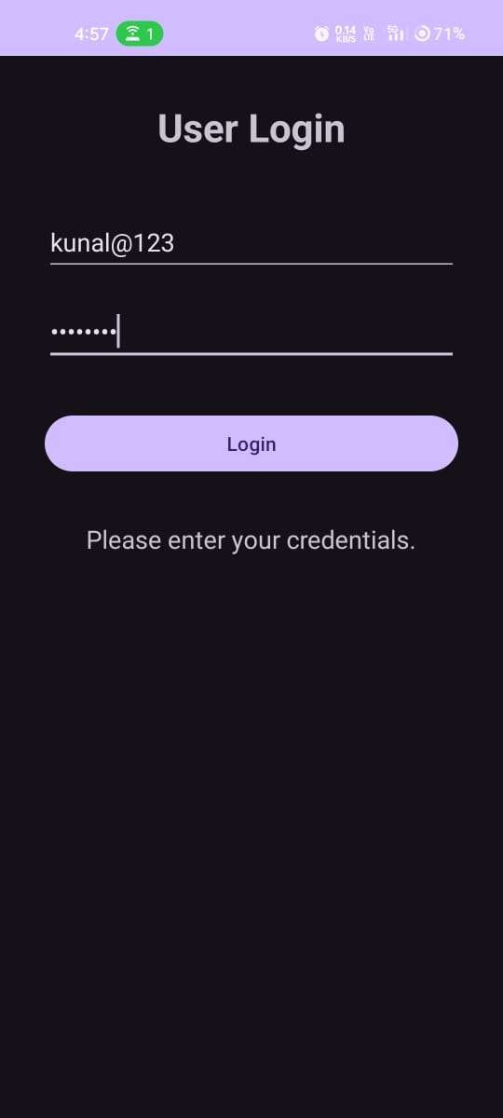
Output:

Create a list of all courses in your college and on selecting a particular course teacher charge of that course should appear at the bottom of the screen

strings.xml Code:
<resources>

<string name="app_name">CourseApp</string>
<string-array name="courses">
<item>Advanced Java</item>
<item>Android</item>
<item>Cloud Computing</item>
<item>DBMS</item>
</string-array>

<string-array name="teachers">
<item>Dr. Sharma</item>
<item>Prof. Kumar</item>
<item>Ms. David</item>
<item>Dr. Rao</item>
</string-array>

</resources>

activity_main.xml Code:
<?xml version="1.0" encoding="utf-8"?>
<LinearLayout
xmlns:android="http://schemas.android.com/apk/res/android"
android:layout_width="match_parent"
android:layout_height="match_parent"
android:orientation="vertical"
android:padding="20dp">

<TextView
android:layout_width="wrap_content"
android:layout_height="wrap_content"
android:text="Select Course"
android:textSize="20sp"/>

<Spinner
android:id="@+id/course"
android:layout_width="match_parent"
android:layout_height="wrap_content"/>

<TextView
android:id="@+id/teacher"
android:layout_width="wrap_content"
android:layout_height="wrap_content"
android:text="Teacher: "
android:textSize="20sp"
android:layout_gravity="center"
android:layout_marginTop="300dp"/>

</LinearLayout>

MainActivity.java Code:
package com.example.courseapp;

import android.os.Bundle;
import android.view.View;
import android.widget.*;

import androidx.appcompat.app.AppCompatActivity;

public class MainActivity extends AppCompatActivity {

Spinner course;
TextView teacher;

@Override
protected void onCreate(Bundle b) {
super.onCreate(b);
setContentView(R.layout.activity_main);

course = findViewById(R.id.course);
teacher = findViewById(R.id.teacher);

String[] courses =
getResources().getStringArray(R.array.courses);

String[] teachers =
getResources().getStringArray(R.array.teachers);

ArrayAdapter<String> adapter = new ArrayAdapter<>(
this,
android.R.layout.simple_spinner_item,
courses);

course.setAdapter(adapter);

course.setOnItemSelectedListener(
new AdapterView.OnItemSelectedListener() {

@Override
public void onItemSelected(
AdapterView<?> p, View v,
int position, long id) {

teacher.setText(
"Teacher: " + teachers[position]);
}

@Override
public void onNothingSelected(AdapterView<?> p) {
}
});
}
}

Output:
