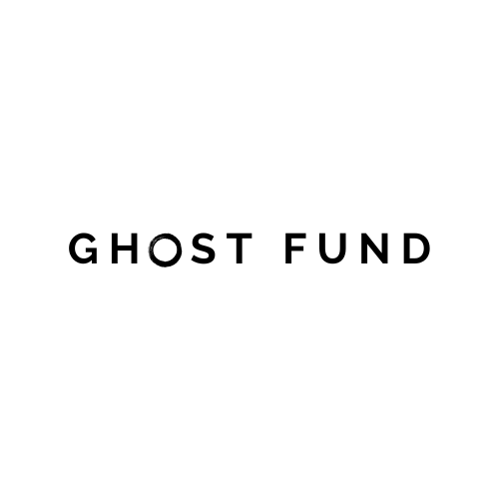

Name : Ghost Fund
Type : Software
Author : Milton T. Vafana
Date : 06 November 2025

GhostFund is a platform for investing and placig of money and funds to a company anonomously. This means you can place money in a company and quickly get returns. Users can come send funds to the platform which then selects from a list of hand picked companies and sends the funds to the company/business/entity.
The idea is to make the platform as simple as possible which is why the platform does not have a login or sign up page, all updates and alerts are sent to the user’s email. Although for legal & most technical reasons the user information is stored in the platform’s database, that way records of a transactions are kept and accessible.

Users cannot see any companies listed or shown, it will be hidden all the user does is just send the money, then after sometime, 1 to 5 working days they get their returns to the same account used to send the funds.

The companies are manually invited to be apart of GhostFund by the GhostFund Staff, once selected a company then needs to follow a simple term/policy that states that “All investments should have returns” , this basically means that once someone invests it’s now a “must” for the company / entity that recieved the funds to payback with returns with a minimum of 4%, this is done so that everyone wins!

How the Card works,

User goes to website and enters their [ email address, phone number, fullname ] then the [amount]. Boom! That’s it, now all the user has to do is wait for their returns!

So what we have been discussing above is the general summary of the whole idea and concept of GhostFund.

Now as we move on we will now dive into the “Ghost Card”....
The Ghost Card is a card much similar to a bank card but this time it uses a qrcode to make and recieve payments on GhostFund. The purpose of the card is to help the user to easily make investments to any company that is apart of GhostFund even when they physically enter the store, it also helps the user to cash out funds from the GhostFund agents around the CBD. With this users should be able to transfer their funds from the card to ecocash, telecash or even paypal.
How it works,

The card should have a qrcode that one will scan using the GhostFund Mobile app. (both the store user and the company).

The Card Design

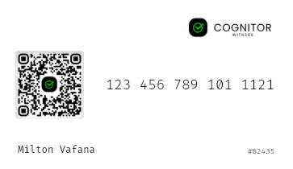
Card Number
Company Logo
:: This is not the official logo, this is for demonstration purposes
User ID!
:: This is not the official, this is for demonstration purposes
User’s Full name
:: This is not the official, this is for demonstration purposes
QR Code
:: This is not the official, this is for demonstration purposes

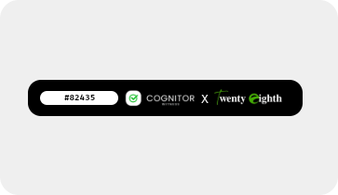

User ID!
:: This is not the official, this is for demonstration purposes

Company logos

The Team

- Milton Vafana – Founder.

- Patreck Chatondola – Co, Founder.

- Nicole Nkomo – User Acquisition Specialist

In conclusion, GhostFund is a platform that allows you to support or invest a company without having to know about it. This way, it helps avoid disputes on rights, shares and ratios while assisting companies to get momentum in the business world to achieve as much as possible. It helps users who have always wanted to feel apart of something to feel that way and get paid in the process!

WELCOME TO GHOSTFUND!

