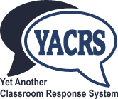
Introduction to YACRS
YACRS (Yet Another Classroom Response System) is a tool that allows students to use their mobile phones, laptops or tablet computers to answer questions during lectures.

Connecting to YACRS from a smartphone or computer.
You can use the data connection from your phone, however it is better to connect to the University's wi-fi network by following the instructions at http://www.gla.ac.uk/services/it/eduroam/
YACRS QR code
Once you are connected to the Internet, either use your web browser to go to https://classresponse.gla.ac.uk/ or use this QR code to launch your browser. You should then log in with your GUID.
Once you have logged into YACRS you should join the 'session' by typing session number indicated by your teacher. This will often be visible on the projector screen at the left hand side of the teacher control.
Once you have joined the session you will either see a message saying there is no active question, or a question to answer.
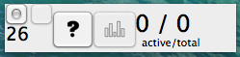Teacher control

