Faculty *of* Engineering & Technology

School *of* Computer Science & Math.

Coursework Title: **Training Centre Database**

Module Name: **Database Systems**

Module Code: **5102COMP**

Level: **5**

Credit Rating: **20**

Weighting: **50%**

Maximum Mark Available: **100**

Lecturer: **Mr. Glyn Hughes**

Contact: *If you have any issues with this coursework you may contact your lecturer whose contact details are:*

eMail: **g.d.hughes@ljmu.ac.uk**

Room: **604B**

Hand-Out Date: w/c 4th Oct ‘21

Hand-In Date: 1st Nov ‘21

Hand-In Method: **Canvas**

FeedBack Date: 22nd Nov ‘21

FeedBack Method: **eMail**

Programme(s): **CS, CSc, SE, CF, CSe, MC, DS**

Introduction:

This coursework is to be attempted **individually**. You must submit your work to Canvas on or before the due date.

Using MySQL, you are required to produce the **DDL** (**D**ata **D**efinition **L**anguage) statements needed to implement a database using a given **ERD** (**E**ntity **R**elationship **D**iagram) and system description. You must also produce a series *of* **DML** (**D**ata **M**anipulation **L**anguage) statements to populate the database with given sample data and query that data once it’s contained within the database tables.

Finally, you are required to complete, a partially complete, console application (*using Java*) that is ready to communicate with the database tables in MySQL so as to perform some basic connectivity tasks.

Learning Outcome(s) Being Assessed:

1. Implement relational database designs and query them using SQL.
2. Develop data driven applications.
3. *<not assessed in this coursework>*
4. *<not assessed in this coursework>*

Details *of* Task:

The diagram below shows a training centre database.

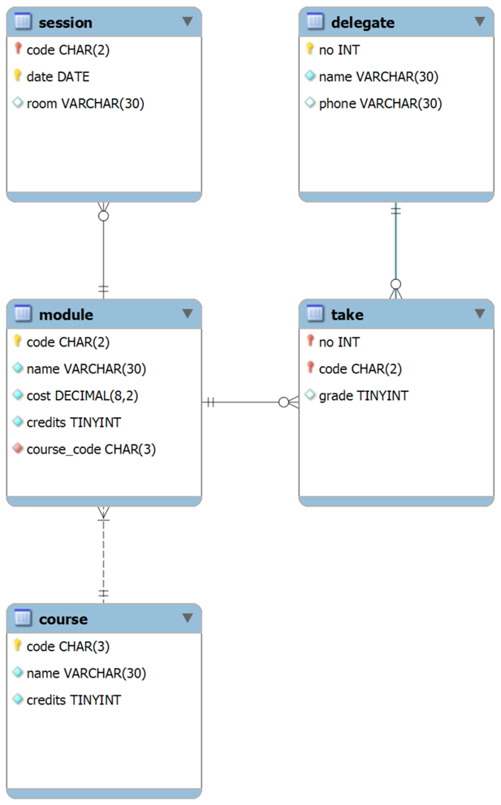

The core component *of* the database is the module, which is specified by identity, cost & credits (*25 or 50*) along with a teaching schedule set by date and room. Any delegate may sign up to any module and once they have completed the module they are given a grade.

A course is specified by identity & credits (*50, 75 or 100*) and is composed *of* modules that are closely related. Should a delegate successfully complete (*40 pass mark*) the course’s modules, they become recognised as completing the course.

You should produce the following **DDL** statements in MySQL . .

1. **CREATE TABLE** Statements.
   * Include constraints specified in the diagram or derived from the sample data including *DEFAULT*, *UNIQUE*, *CHECK*, *PRIMARY KEY* & *FOREIGN KEY* where appropriate.
2. **CREATE VIEW** Statements.
   * Produce a view that returns the sessions in the future and rejects any attempt to insert or update sessions in the past.
   * Write a simple statement to test rejection.
3. **CREATE PROCEDURE** Statements.
   * Produce a procedure that assigns a new schedule *for* a given course. The procedure should accept a course code & start date as arguments then schedule each *of* the given course’s modules on consecutive (working / week) days. The start date must be at least a month in the future otherwise, a suitable error should be raised.
   * *Tips . . CURSOR, LOOP, SIGNAL*
4. **CREATE TRIGGER** Statements.
   * Produce an audit trail (in a separate table) that records the current username, system date & grade change when someone attempts to update a delegate’s grade.

The file *DBSyS_CourseWork_01.xlsx* on Canvas, contains sample data *for* each *of* the five tables and should be inserted so as to ensure consistent testing data.

You should produce the following **DML** statements in MySQL . .

Write the appropriate statements to insert the sample data.

1. Fetch every module’s code, name & credits.
2. Fetch every delegate’s no & name in descending order by name.
3. Fetch the course’s code, name & credits where the name contains the string “Network”.
4. Calculate the highest grade in any module.
5. Modify the query from Q4 to now fetch only the delegate no.
   * *Tips . . Sub-Query*
6. Modify the query from Q5 to also fetch the delegate name.
   * *Tips . . Nested Sub-Query*
7. Fetch the session’s code & date *for* sessions which are running in the next year and *for* which no room has been allocated.
   * *Tips . . BETWEEN, IS NULL*
8. Fetch the delegate’s no & name along with the module’s code & name *for* delegates who have taken a module but have a failing grade.
   * *Tips . . INNER JOIN*
9. Solve the problem from Q6 using JOINS where possible.
   * *Tips . . INNER JOIN, Sub-Query*
10. Calculate and display every delegate’s no & name along with their attained credits versus the course’s code, name & credits.
    * *Tips . . SUM(), INNER JOIN, GROUP BY*
11. Modify the query from Q10 to only show a delegate when they have attained the course’s credits.
    * *Tips . . HAVING*

The file *DBSyS_CourseWork_01.zip* on Canvas contains a partially complete NetBeans 8.x project. The imports *for* MySQL connectivity are already present, as is a rough shell *of* the application. You should complete the application according to the comments in the project’s coding. In summary the application should . .

1. Connect with an instance *of* MySQL.
   * *Tips . . localhost etc.*
2. Display the module’s code & name along with the session’s date *for* sessions which are running in the next year and *for* which no room has been allocated in ascending order by date.
   * *Tips . . The WHERE clause is the same as Q7.*
3. Ask the users *for* a course code & start date which the application uses to invoke the procedure you wrote above.

What you should hand in:

* Microsoft Word (.docx) file containing the SQL code listings.
* Java (.java) file containing the Java code listings.

Marking Scheme/Assessment Criteria:

|  |  |  |
| --- | --- | --- |
| **Assessment** | **Assessment Criteria** | **% weighting *for* part** |
| 1 | **CREATE TABLE** Statements (*plus Constraints*). | 10 |
| **CREATE VIEW** Statements. | 5 |
| **CREATE PROCEDURE** Statements. | 20 |
| **CREATE TRIGGER** Statements. | 20 |
| **INSERT** Statements (*from Sample Data*). | 5 |
| Query Functionality. | 20 |
| 2 | Connecting. | 4 |
| Querying & ResultSet Processing. | 8 |
| Invoking CallableStatement. | 8 |

Guidelines:

* You may ask the tutors questions regarding the specification *of* the training centre database but not about the actual implementation.
* Tutors may deny marks when bad SQL / Java coding practice is employed.

Resources Required:

You may use the computing labs on the 6th & 7th floors *of* the Byrom Street Campus as well as the 1st floor *of* the Henry Cotton Campus.

You should make use *of* these specific tools & resources:

* MySQL Server 8.x CE
* MySQL WorkBench 8.x CE
* NetBeans 8.x
* Microsoft Office 2016 / 2019 (Visio & Word).
* Lecture Materials.
* The Internet.

Extenuating Circumstances:

If something serious happens that means that you will not be able to complete this assignment, you need to contact the module leader as soon as possible. There are a number *of* things that can be done to help, such as extensions, waivers and alternative assessments, but we can only arrange this if you tell us. To ensure that the system is not abused, you will need to provide some evidence *of* the problem.

More guidance is available here (*https://www.ljmu.ac.uk/about-us/public-information/student-regulations/guidance-policy-and-process/*). Any coursework submitted late without the prior agreement *of* the module leader will receive zero marks.

Academic Misconduct:

The University defines Academic Misconduct as ‘any case *of* deliberate, pre-meditated cheating, collusion, plagiarism or falsification *of* information, in an attempt to deceive and gain an unfair advantage in assessment’.

This includes attempting to gain marks as part *of* a team without making a contribution. The Faculty takes Academic Misconduct very seriously and any suspected cases will be investigated through the University’s standard policy (*https://www.ljmu.ac.uk/about-us/public-information/student-regulations/academic-misconduct/*).

If you are found guilty, you may be expelled from the University with no award. It is your responsibility to ensure that you understand what constitutes Academic Misconduct and to ensure that you do not break the rules. If you are unclear about what is required, please ask.

Misc.

For more information, you are directed to following the web pages:

* Information on Study Skills:

*https://www.ljmu.ac.uk/microsites/library/skills-ljmu/*

* Information on Referencing & EndNote:

*https://www.ljmu.ac.uk/microsites/library/skills-ljmu/referencing-and-endnote/*