## **MySQL Staging Table – 2019 SO Dataset Staged Volumes and Features Health Check**

Author: Niall Guerin

Student ID: 18235079

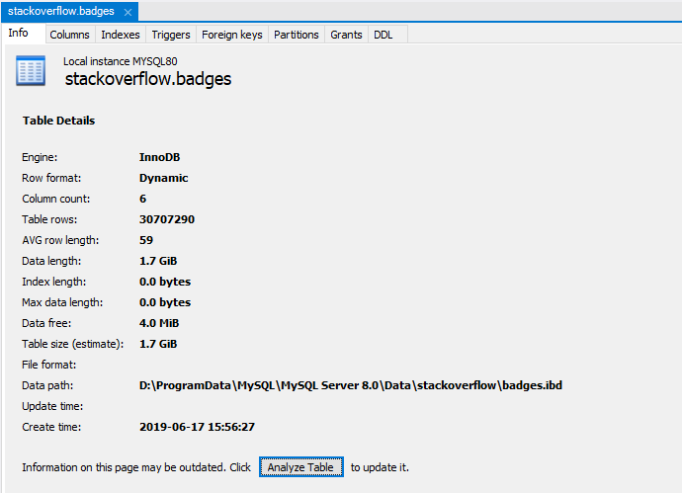

Column Features

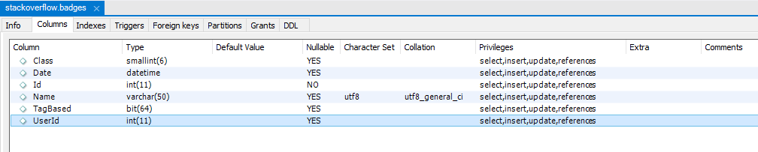

CREATE TABLE `badges` (

`Id` int(11) NOT NULL,

`UserId` int(11) DEFAULT NULL,

`Name` varchar(50) DEFAULT NULL,

`Date` datetime DEFAULT NULL,

`Class` smallint(6) DEFAULT NULL,

`TagBased` bit(64) DEFAULT NULL,

PRIMARY KEY (`Id`)

) ENGINE=InnoDB DEFAULT CHARSET=utf8

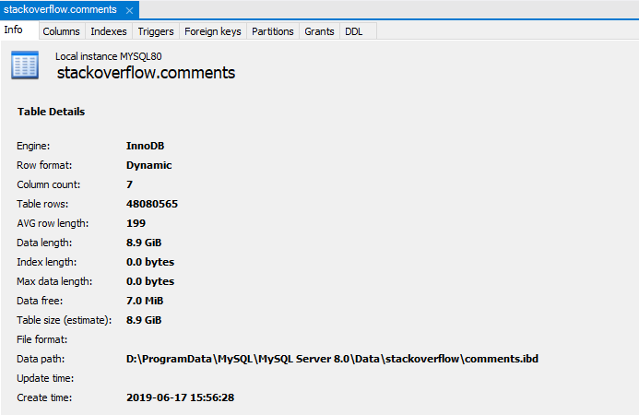

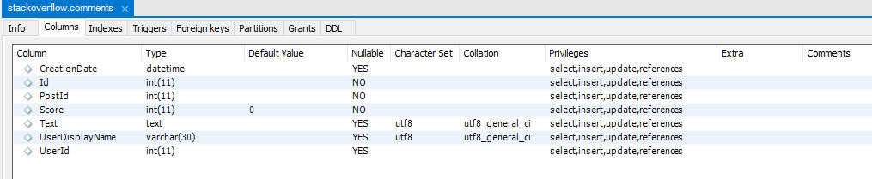

CREATE TABLE `comments` (

`Id` int(11) NOT NULL,

`PostId` int(11) NOT NULL,

`Score` int(11) NOT NULL DEFAULT '0',

`Text` text,

`CreationDate` datetime DEFAULT NULL,

`UserDisplayName` varchar(30) DEFAULT NULL,

`UserId` int(11) DEFAULT NULL,

PRIMARY KEY (`Id`)

) ENGINE=InnoDB DEFAULT CHARSET=utf8

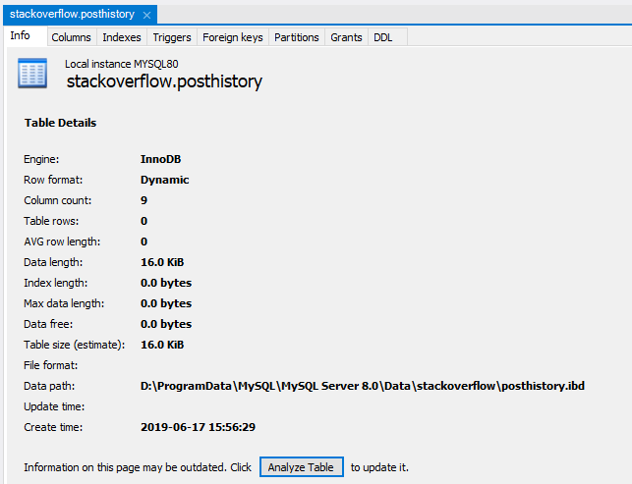

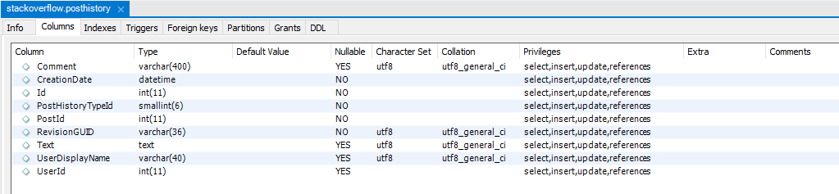

CREATE TABLE `posthistory` (

`Id` int(11) NOT NULL,

`PostHistoryTypeId` smallint(6) NOT NULL,

`PostId` int(11) NOT NULL,

`RevisionGUID` varchar(36) NOT NULL,

`CreationDate` datetime NOT NULL,

`UserId` int(11) DEFAULT NULL,

`UserDisplayName` varchar(40) DEFAULT NULL,

`Comment` varchar(400) DEFAULT NULL,

`Text` text,

PRIMARY KEY (`Id`)

) ENGINE=InnoDB DEFAULT CHARSET=utf8

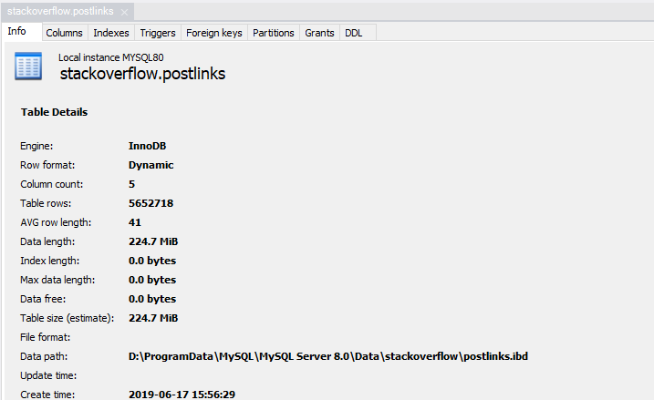

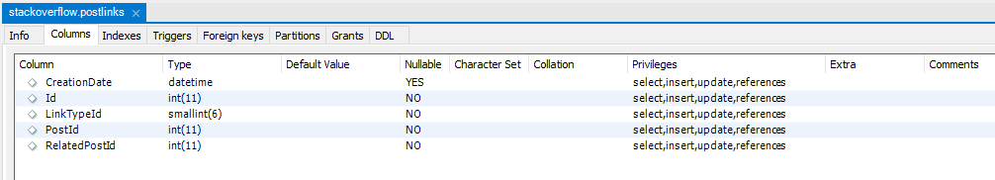

CREATE TABLE `postlinks` (

`Id` int(11) NOT NULL,

`CreationDate` datetime DEFAULT NULL,

`PostId` int(11) NOT NULL,

`RelatedPostId` int(11) NOT NULL,

`LinkTypeId` smallint(6) NOT NULL,

PRIMARY KEY (`Id`)

) ENGINE=InnoDB DEFAULT CHARSET=utf8

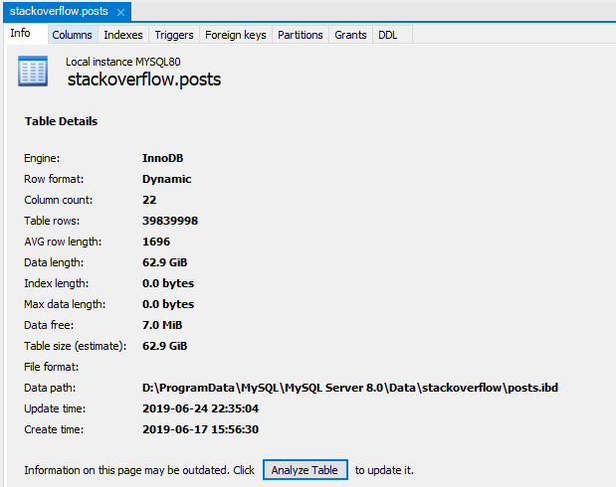

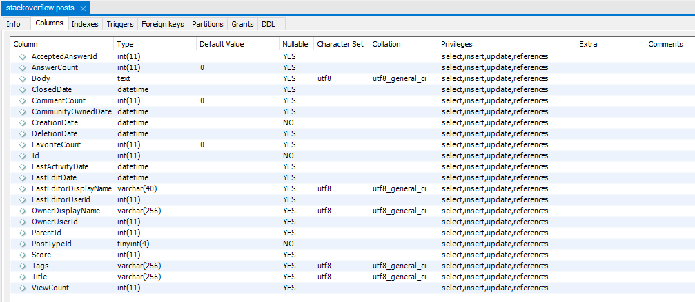

CREATE TABLE `posts` (

`Id` int(11) NOT NULL,

`PostTypeId` tinyint(4) NOT NULL,

`AcceptedAnswerId` int(11) DEFAULT NULL,

`ParentId` int(11) DEFAULT NULL,

`CreationDate` datetime NOT NULL,

`DeletionDate` datetime DEFAULT NULL,

`Score` int(11) DEFAULT NULL,

`ViewCount` int(11) DEFAULT NULL,

`Body` text,

`OwnerUserId` int(11) DEFAULT NULL,

`OwnerDisplayName` varchar(256) DEFAULT NULL,

`LastEditorUserId` int(11) DEFAULT NULL,

`LastEditorDisplayName` varchar(40) DEFAULT NULL,

`LastEditDate` datetime DEFAULT NULL,

`LastActivityDate` datetime DEFAULT NULL,

`Title` varchar(256) DEFAULT NULL,

`Tags` varchar(256) DEFAULT NULL,

`AnswerCount` int(11) DEFAULT '0',

`CommentCount` int(11) DEFAULT '0',

`FavoriteCount` int(11) DEFAULT '0',

`ClosedDate` datetime DEFAULT NULL,

`CommunityOwnedDate` datetime DEFAULT NULL,

PRIMARY KEY (`Id`)

) ENGINE=InnoDB DEFAULT CHARSET=utf8

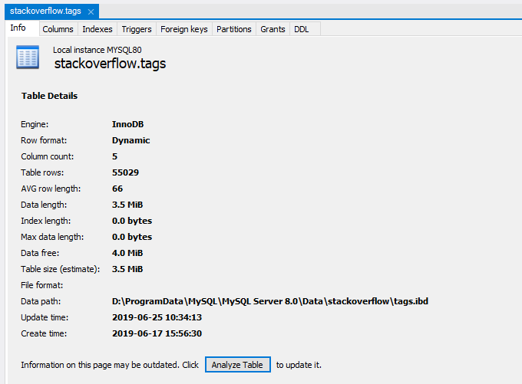

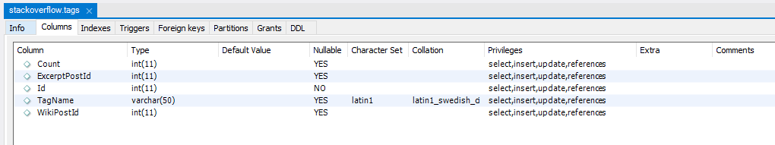

CREATE TABLE `tags` (

`Id` int(11) NOT NULL,

`TagName` varchar(50) CHARACTER SET latin1 COLLATE latin1_swedish_ci DEFAULT NULL,

`Count` int(11) DEFAULT NULL,

`ExcerptPostId` int(11) DEFAULT NULL,

`WikiPostId` int(11) DEFAULT NULL,

PRIMARY KEY (`Id`)

) ENGINE=InnoDB DEFAULT CHARSET=utf8

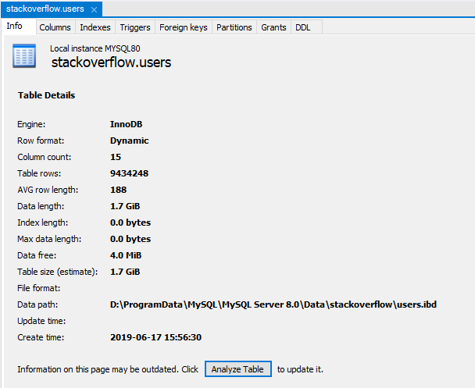

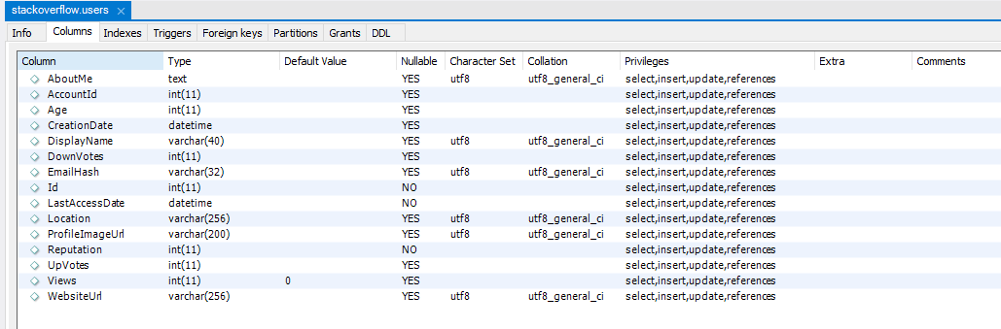

CREATE TABLE `users` (

`Id` int(11) NOT NULL,

`Reputation` int(11) NOT NULL,

`CreationDate` datetime DEFAULT NULL,

`DisplayName` varchar(40) DEFAULT NULL,

`LastAccessDate` datetime NOT NULL,

`WebsiteUrl` varchar(256) DEFAULT NULL,

`Location` varchar(256) DEFAULT NULL,

`AboutMe` text,

`Views` int(11) DEFAULT '0',

`UpVotes` int(11) DEFAULT NULL,

`DownVotes` int(11) DEFAULT NULL,

`ProfileImageUrl` varchar(200) DEFAULT NULL,

`EmailHash` varchar(32) DEFAULT NULL,

`Age` int(11) DEFAULT NULL,

`AccountId` int(11) DEFAULT NULL,

PRIMARY KEY (`Id`)

) ENGINE=InnoDB DEFAULT CHARSET=utf8

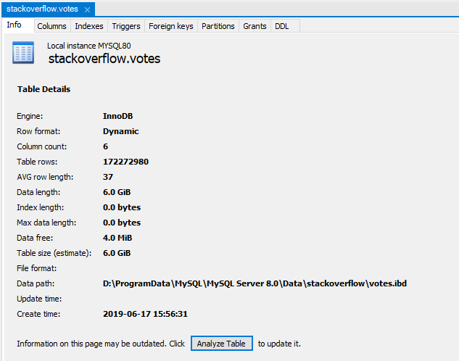

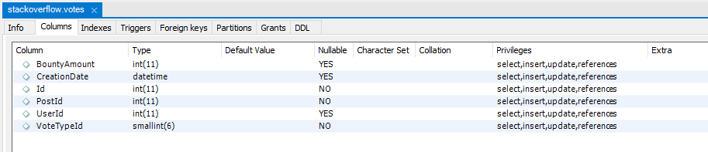

CREATE TABLE `votes` (

`Id` int(11) NOT NULL,

`PostId` int(11) NOT NULL,

`VoteTypeId` smallint(6) NOT NULL,

`UserId` int(11) DEFAULT NULL,

`CreationDate` datetime DEFAULT NULL,

`BountyAmount` int(11) DEFAULT NULL,

PRIMARY KEY (`Id`)

) ENGINE=InnoDB DEFAULT CHARSET=utf8