- Download list of 400 APOGEE giants in GBTDS footprint from Niall with DR19 parameters.
- Check logg/teff/etc regime. Is there gaia L? NO. g and distance though. Ughhhhhhhh
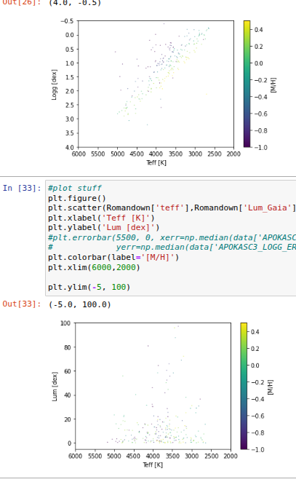
logg works, luminosity doesn’t. (far for gaia I guess) so we’ll just use logg.

- Grab machine learning age from APOKASC3 training from class project for each star (left join) actually use stone martinez- has M and age (well log10(M).. also did a cut M>0.6, c and n both not -9999)
- then each star has L, teff, metallicity, age, mass- all of this done in SampleCollation.ipynb
- use runner5py3.py Ran through garrett’s interpolator → RomanStoneMartinezInterpolate5.out (to read in replace header line and replace \t with spaces
- Split 1/3 into training and sample sets- nope only 84 stars, just gonna train on them all
- take training set and run through mixing length grid to compute mixing length as a function of metallicity
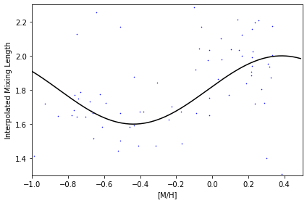
- fit corrected mixing length as a function of metallicity : CalibrateModels.ipynb ML=0.2*np.sin(mets*12/np.pi+0.1)+1.8
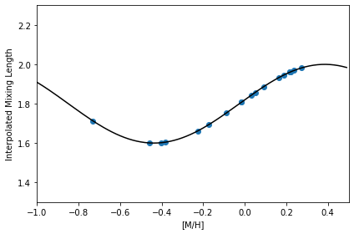
- Using spec interpolator, do we get the right age for each star with the corrected mixing length? Answer:ehhhhh
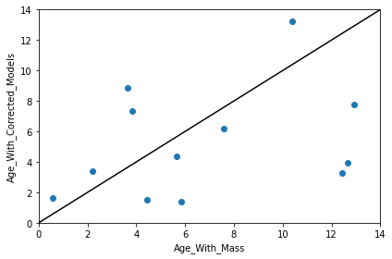

- using spec interpolator, interpolate ages for a range of metallicities for each star (20 points?) (do we want to add uncertainties to make the banana wider? Maybe up 1 sigma, down 1 sigma on each step and 10 metallicity points?)
just did steps of 0.1 from -1 to 0.4 (except 0.4 didn’t run because floating point, same with -1.0). Used runner5 noseispy3.py for different metallicities.

- make bananas bananamaker.ipynb
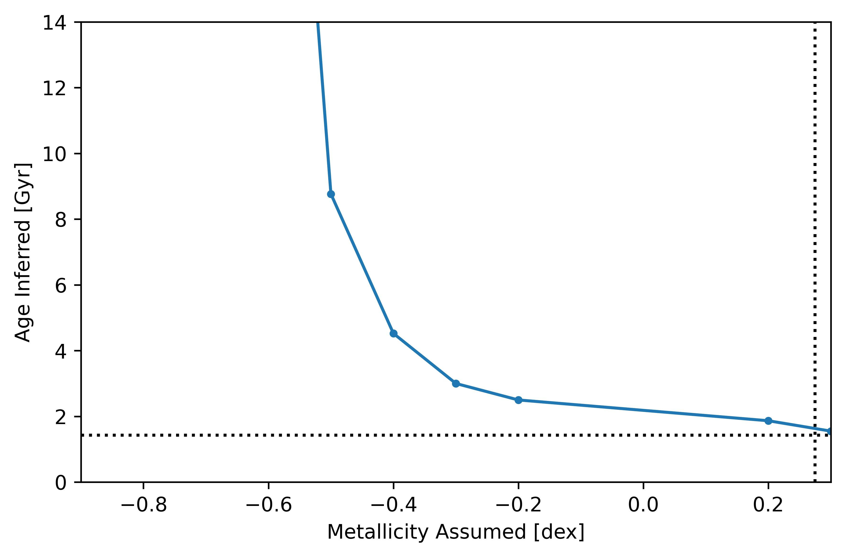

(most of them are way worse than this)

- get bdbs metallicity distribution for this region (can we break up into 3 bins?)
nope the entire roman footprint is in one bin of BDBS
- draw from bdbs- interpolate age in each case (also in bananamaker.py)
- plot age distribution (ML) in bins of whatever, as well as banana age distribution in bins of whatever
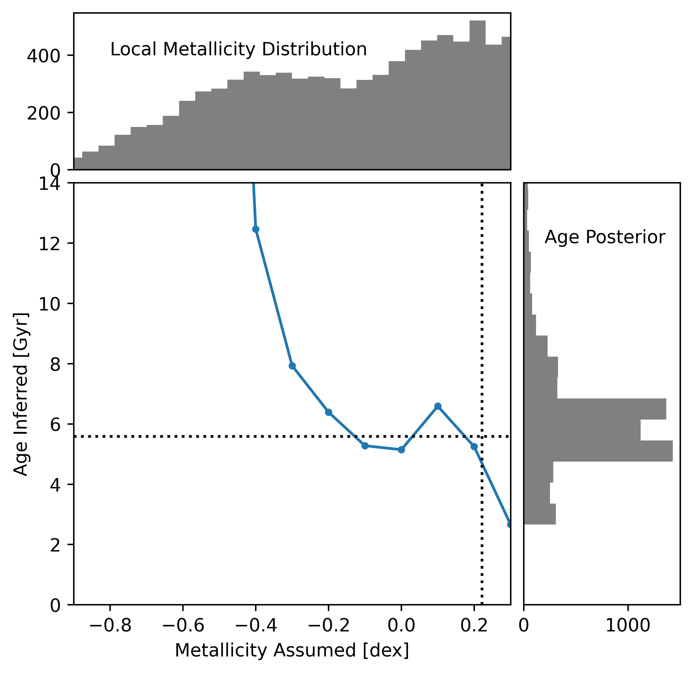
- plot true age metallicity relation vs jank age metallicity relation
Okay now redoing this with logg, Lum, teff, feh
- download Niall Roman_master.fits

use kiauhoku2017grid to load the models into a grid. Required making lots of changes to custom_install.py. Also I didn’t figure out how to remove the rgbbump from that so I should probably deal with that at some point.

copied everything to zull_4zKH deleted a bunhc of files that didn’t start
xargs -rd '\n' --arg-file=tracklisting.txt rm -f --
got tired of this not working and having to go file by file to fix it so I just added a try-except. Seems to be working, so far 1% failure rate + 700 files I already deleted (failure is on line 17000ish, something near the tip overflows so the number of columns goes from 83 to 82. this would be fine if it was reading in fixed width, but it’s python so it’s not doing that. Future yrec grids won’t have this problem because we added extra padding. So I’m ignoring it and crossing my fingers.

import numpy as np
import pandas as pd
import matplotlib.pyplot as plt
import kiauhoku as kh
import custom_install
kh.install_grid('custom_install')

3/26/2026 trying again:

for f in *.track; do awk 'NR % 50 == 1' $f > ${f%.*}.track2; done
to downsample the tracks by a factor of 50

for f in *.track; do awk 'NR <=1000 {print; next} (NR-1000) % 50 == 0' $f > ${f%.*}.track3; done

awk 'NR <= 100 { print; next } (NR - 100) % 10 == 0' filename.txt

okay still not working, try shrinking by another factor of 2.
for f in *.track3; do awk 'NR <=100 {print; next} (NR-100) % 2 == 0' $f > ${f%.*}.track4; done

Progress bar was crashing, so I commented that out
#JNT 2026_03_26 commenting out
# eep_tracks = parallel_progbar(partial_eep, idx,
# verbose=progress, nprocs=nprocs, **kwargs)
#JNT 2026_03_26 end commenting out

New error unlocked.
Saving to /home/jtayar/.kiauhoku/grids/JT2017t4/JT2017t4_full.pqt
Converting to eep-based tracks
---------------------------------------------------------------------------
UnboundLocalError Traceback (most recent call last)
Cell In[3], line 1
----> 1 kh.install_grid('custom_install')

File ~/miniconda3/envs/kiauhoku2026/lib/python3.14/site-packages/kiauhoku/stargrid.py:1145, in install_grid(script, kind)
1142 except AttributeError:
1143 eep_order = None
-> 1145 eeps = grids.to_eep(eep_params, eep_functions, metric_function, eep_order)
1147 elif kind == 'eep':
1148 eeps = module.setup()

File ~/miniconda3/envs/kiauhoku2026/lib/python3.14/site-packages/kiauhoku/stargrid.py:178, in StarGrid.to_eep(self, eep_params, eep_functions, metric_function, eep_order, progress, nprocs, **kwargs)
170 idx = self.index.droplevel(-1).drop_duplicates()
171 #tracks = self.groupby(level=list(range(idx.nlevels)))
172 #JNT 2026_03_26 commenting out
173 # eep_tracks = parallel_progbar(partial_eep, idx,
(...) 176
177 # Setup MultiIndex and remove Nones
--> 178 idx_list = [(*i, j) for i, tr in zip(idx, eep_tracks) if tr is not None for j in tr.index]
179 eep_tracks = [tr for tr in eep_tracks if tr is not None]
181 # Create MultiIndex for EEP frame

UnboundLocalError: cannot access local variable 'eep_tracks' where it is not associated with a value

I am worried that this is try-except function I added causing problems.

Okay first of all I deleted the CN weird track files.
Now we’ve got 9834 .track4 files, filling 7.4 Gbs

length is 9733 when it crashes now, which implies it hasn’t loaded the tracks with issues, so maybe that isn’t the problem.

Hmm okay somewhere in the parallelization step
eep_tracks = parallel_progbar(partial_eep, idx,
verbose=progress, nprocs=nprocs, **kwargs)

# Setup MultiIndex and remove Nones
idx_list = [(*i, j) for i, tr in zip(idx, eep_tracks) if tr is not None for j in tr.index]
eep_tracks = [tr for tr in eep_tracks if tr is not None]

# Create MultiIndex for EEP frame
multiindex = pd.MultiIndex.from_tuples(
idx_list,
names=[*idx.names, 'eep']

Okay I’m testing with subsets, and so far I have not had any problems.
m160fhp020y239a22al02_grnodf.track4 is the thing causing the problem!! (I have no idea why, but I have just removed it from the list :) )

Also m080fhm080y273a17al04_grnodf.track4 check
m070fhp020y273a22al00_grnodf.track4 check
m060fhp020y330a17al04_grnodf.track4 check

m120fhp040y273a12al00_grnodf.track4 check

m120fhm000y290a17al04_grnodf.track4 check

m120fhm040y273a17al04_grnodf.track4 check
m100fhp020y239a17al04_grnodf.track4 check
m090fhm000y330a17al02_grnodf.track4 check
m100fhm000y273a17al00_grnoov.track4 check
m100fhm000y273a17al00_grnoov.track4 check

m090fhp020y273a22al04_grnodf.track4 check

m080fhp040y239a17al00_grnodf.track4 check

m160fhp040y273a12al00_grnodf.track4
m160fhp040y239a22al02_grnodf

140-160 ok
060-080 ok
080-140 ok I think?

Full thing threw an error

190-260 worked

060-160 didn’t work so I missed one bad one. Uuuughhhhh
okay 09-160 okay.
060 okay
it’s in the 08s.

060-160
yep end of 160.

080-150 fine
160-180 bad

160-170 bad.

Just 180 fine.

160 broken again? Ughhhhhh

okay
JT2017t7 loaded!!!

t8 has no bump so only goes to lower rgb
t9 I tried to tell it to call luminosity~10^2 the bump.
Sure didn’t work. Cutoff at luminosity 10^0.1 which was the opposite of the goal. Maybe not logged?

No It’s logged. I’m pretty sure it was actually working much of the time, and I just was calling the thing wrong so it printed a bunch of nans. Awesome. I am so tired.

For some reason sometimes it’s replacing the ml 1.7 with 1.72…. and sometimes it isn’t (generally when running the whole grid). Which I’m too tired to understand.

