
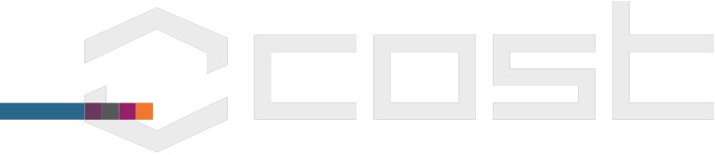
Stokes Modelling Workshop
COST Action no. TD1409
Action Title: Mathematics for industry network (MI-NET)
Galway, Ireland
Dates: Tuesday, 6 June 2017 – Friday 9 June 2017

 | Name |  | Country | Signature  Day 1 (06/06/2017) | Signature  Day 2 (07/06/2017) | Signature  Day 3 (08/06/2017) | Signature  Day 4 (09/06/2017)
 | Al Baydli | Daher
 | Allen | James
 | Alssaedi | Faiza
 | Atan | Reduan
 | Burke | Richard
 | Clancy | Colm
 | Clarke | David
 | Cloherty | Philip
 | Collins | Jack
 | Colson | David
 | Conroy Broderick | Hannah
 | Cormican | John
 | Destrade | Michel
 | Donnelly | Cliona
 | Dubovskaya | Alina
 | Donohue | John
 | Galizia | Roberto
 | Geraghty | Samuel
 | Gower | Artur
 | Greaney | Paul
 | Hanley | Tracey
 | Hill | Roisin
 | Hill | Aoife
 | Kamperis | Sam
 | Madden | Niall
 | Mangan | Robert
 | Manzari | Luca
 | Marshall | Christine
 | Martin | Richard
 | Mary | Rose
 | McAuliffe | Fergus
 | Meere | Martin
 | Moran | Claire
 | O’Callaghan | Jack
 | Okeke | Saviour
 | O’Kiely | Doireann
 | Onaga | Tomokatsu
 | Phoenix | Anna
 | Piiroinen | Petri
 | Qiu | Songkai
 | Rawle | Noeleen
 | Regan | Brian
 | Samantray | Suman
 | Sheil | Ashley
 | Smyth | David
 | Staunton | Eoghan
 | SULEIMAN | Issah Nazif
 | Urbas | Szymon
 | Vo | Thi Ngoc Tuoi
 | Walsh | Shane
 | Walsh | Dylan
 | Wisdom | Adrian
 | Zurlo | Giuseppe

Meeting Secretary
(Chair or local organiser)
Name + signature:
Niall Madden

