
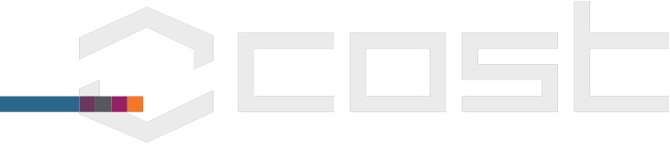
Title of Meeting
COST Action no. TD1409
Action Title: Mathematics for industry network (MI-NET)
[city], [country]
Dates from – to (weekday, date, month, year)

 | Name | Country | Signature  Day 1 [date] | Signature  Day 2 [date] | Signature  Day 3 [date] | Signature  Day 4 [date] | Signature  Day 5 [date]
 | Name | Country | Signature  25/07/2016 | Signature 26/07/16 | Signature  27/07/16 | Signature  28/07/16 | Signature  29/07/16
……

Meeting Secretary
(Chair or local organiser)
Name + signature:

