*Smart Security Using Biometrics and Cloud Computing for use in Car Sharing Platforms*

Drake Csage  
Electrical Engineering Student  
Central Michigan UniversityMount Pleasant, Michigan  
csage1da@cmich.edu

Benjamin Strandskov  
Electrical Engineering Student  
Central Michigan UniversityMount Pleasant, Michigan  
stran1b@cmich.edu

Niall Mulcahy   
IoT Applied Computing Student  
Waterford Institute of TechnologyWaterford, Ireland  
niallmul97@gmail.com

Laurie Fitzek  
Iot Applied Computing Student  
Waterford Institute of TechnologyWaterford, Ireland  
lauriefitz98@outlook.ie

Dr. Kumar Yelamarthi  
Professor of Electrical and Computer Engineering  
Central Michigan UniversityMount Pleasant, Michigan  
yelam1k@cmich.edu

***Abstract*— IoT is an electrical and computer engineering field that is growing rapidly. Unfortunately, the automotive industry is always a step behind when it comes to security. With the ability to rent out your car, smart toll systems on the rise, and more people utilizing the digital wallets, the smart security system opens up a very broad range of what this can optimize and make easier for the automotive customer, all while securing the customer’s vehicle(s). The idea behind the smart security system is to use facial recognition not only to secure the vehicle, but to safely transfer the car’s right to other users as well. The smart security system offers a valid form of security to the car, and the availability to offer safer driving techniques.**

***Keywords—IoT, Facial Recognition, Wia, MLab, Security***

# Introduction

Within recent years, the ever-expanding realm of the Internet of Things has made it possible to equip almost everything with electronics and access to the Internet. This has changed the way consumers interact with products. This has also made it possible for “dumb” products and services to become much “smarter,” enhancing all areas of daily life. The concept of a key unlocking a lock has been in practice for centuries, continuous becoming more sophisticated and complex to protect against theft but fundamentally staying the same. However, whatever is protected by a lock is only secure as the key itself. With the injection of technology into all aspects of society, many industries are looking at how to improve security beyond the use of keys. One such industry is the automotive business. More and more automotive companies are researching new ways of securing a customer’s car. From key fobs to phone apps, many automotive companies are looking for a new way to secure a car that is better than a key.

Biometric facial recognition is a topic that can increase the security of a car. With the internet of things, cars can now take advantage biometric security which could not be done without a powerful processor to accurately compare images. A camera connected to the Raspberry Pi 3 will image process the person trying to unlock the car by sending the information to the cloud. The cloud database will compare the biometrics with existing profiles and give a yes or no to unlocking the car. If “No,” the camera will take a screenshot of whomever is attempting to unlock the vehicle and send a screenshot to the owner of the vehicle. If “Yes,” the car will unlock and allow the car to be “checked out” by that person and be assigned to their profile.

In addition, the cost of operating a rental car varies from car to car and at different times of the day. The biggest factor in the operational cost is the price of gas being consumed by the car. With gas prices fluctuating several times a day and at varying amounts, it is quite difficult to quantify the cost of replacing the gas being consumed at that moment. With the use of a GPS device, the current gas prices in the area of the vehicle can be collected from sites like AAA or GasBuddy which regularly update their data. This data can be used with the known fuel efficiency of the car to create a price per distance cost of operating the car and inform the user of this price when the car is unlocked.

The use of biometrics for security and automatic cost adjustment based on real-time gas prices would allow users to not only operate the car without the need for a key but would also inform them before they enter roughly how much their drive would cost them. This system could improve the current car rental businesses; allowing for staffless depots and for more competitive personal car sharing programs.

# Literature Review

There exists a significant body of works that focuses on the use of biometrics as a form of user authentication and data security. However, there seems to be little academic literature in regard to scrapping gas prices online using gps coordinates for use in applications. All information found on that did not hold to the credibility level of academic literature.

A similar concept was explored in [1], in which facial recognition was used to unlock a personal assistant platform customized to the person who unlocked it. This system increased the processing capabilities of the system and response time by outsourcing the computations to web servers over using the onboard microcontroller processor.

The authors of [2] used the biometric of fingerprint scanning as their form of user authentication. This concept used PostgreSQL as the database management system, and PHP language for web platform coding.

The work done in [3] was to create a facial recognition system using Haar feature-based cascade classifier. This system boasted high accuracy and fast computational time in comparing biometric samples.

# Methods

## Facial Recognition

This project involved training the program to recognise faces and compare them with other faces. To begin, the program was given the task to pick out the face(s) on still pictures. Once it had learned to successfully do this regularly, it was trained on doing the same task on video and live camera feeds. The program analyzed facial features and took measurements by comparing two or more pictures of the same face to recognise it’s a single person (face landmarks algorithm). Our next task is to get the program to see who it is based on measurement patterns (Neural networks). We will be using as follow:

* Suggested libraries -> dlib
* Suggested language(s) -> python, C++
* Dlib was created by Davis King and Adam Geitgey wrote the face recognition module.
* Open Face: <https://cmusatyalab.github.io/openface/>
* Guidelines: <https://medium.com/@ageitgey/machine-learning-is-fun-part-4-modern-face-recognition-with-deep-learning-c3cffc121d78>
* Code Examples: <https://www.pyimagesearch.com/2018/06/18/face-recognition-with-opencv-python-and-deep-learning/>
* Live video feed code examples: <https://www.pyimagesearch.com/2018/06/25/raspberry-pi-face-recognition/>

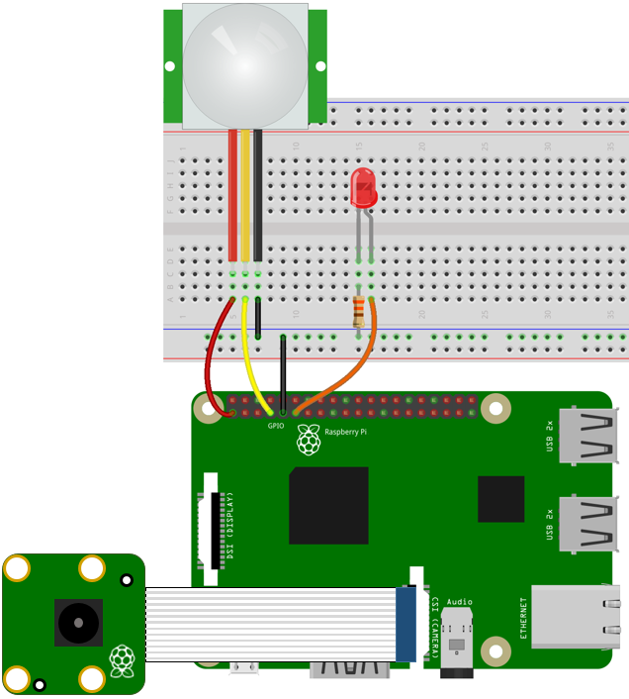

Figure 1: Pi with Camera Hookup for Facial Recognition

For picture recognition, the process for teaching the program started by making the picture black and white. The lighter pixels were compared to the darker ones by replacing each pixel with an arrow to show the flow of dark pixels to light. By considering only the gradient of the arrows, that’s how the computer was able to tell the difference between faces. Each person’s face has their personal gradients that are unique to them. Once the pixels were differentiated and the gradients detected, the image was converted to a Histogram of Oriented Gradients (HOG) image which clearly shows the major components on the face.

For face landmark detection, the program found the location of the different facial features. Using the algorithm face landmark estimation, specific points were noted about the face, so the face could be detected at different angles. This ensured higher accuracy and greater first-time recognition in the facial recognition.

With the use of Deep Learning, training the computation of identifying faces can be done quickly. This will allow for greater accuracy and speed of computation. Training the machine to use deep neural networking, the computer compares two pictures of the one face (different pictures) to one different face and is trained to calculate 128 different measurements of each face. The 2 of the same faces should have similar measurements compared to the other face. After comparing results, the computer will tweak the neural net so the 2 pictures are closer to each other rather than 1 of two being closer to the other picture.

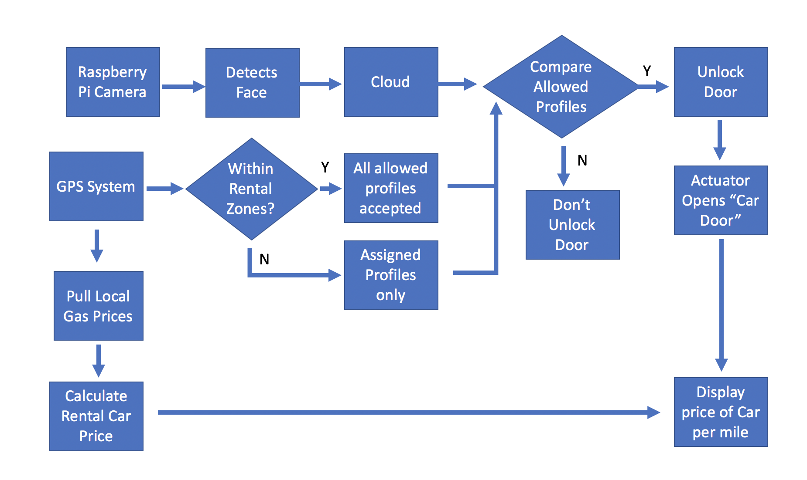

Figure 2: Flow Chart of System

*B. GPS Device*

Many of the new automotive vehicles coming into the market will have a built-in navigation system that uses the Global Positioning System (GPS). Using this data, the program can track the location of rental cars for availability as well as distances driven. Using the MTK3339 GPS module chip on the Adafruit Ultimate GPS Breakout board, the onboard GPS system of a car can be simulated.

*C. Gas Price Data Collection*

There are several services and mobile apps that assist drivers when searching for gas stations to fill up their vehicles. A similar system of gathering the current gas prices can be used in this project to calculate the local gas prices of any location. This feature is essential as the price of gasoline fluctuates regularly and is different depending on the geographical region the car is operating in. Gasoline prices are subject to different taxes and feasibility of shipping new gasoline to the area both play a role in the local prices. In order to ensure this system can work regardless of location, a uniform process for gathering this data is required.

One such way of gathering gas prices that are regularly updated is with GasBuddy.com. This site shares the different prices of the grades of gasoline entered in by local people who are at that station or passing by. This allows for the information to be regularly updated as users of this site will report if the prices have changed since the last posting. This site also uses geographical location to display nearby gas stations which can be used by this program.

# IV. Results

The raspberry pi and raspberry pi camera ended up with results that could change the automotive industry forever. With the automotive industry as the dynamic industry it is, they are soon going to be allowing users to use their phone as a key. The group thought of a way to add another security measure to this future application, as users will soon be able to transfer their rights to other users. The security measure allowed a user to upload his/her picture to the database, and the software would verify if the user is actually him/her.

Using Wia Cloud server and Mlab, the picture was uploaded to the database and successfully recognized known and unknown users. There were very few false positives and negatives, and it took a quick altering of the code and the database software to allow for less false negatives, and fewer false positives.

The GPS system was not used in the system. Instead, the team was able to scrape the gas price data via website scraping. The GPS system would allow for too much data to go through and from Wia, and the next step in this project to make it better would be to enable the GPS system and find a more efficient way of utilizing the large data.

# V. Evaluation

The evaluation criterion was based on testing the raspberry pi system. The group made several attempts to breach the system by trying other users, and there were false positives and false negatives. Niall made several algorithmic changes that helped so there were less of each. The group needed to make a change to the database so more than one user could be uploaded to the database, and this is what changed the system to make it more accurate. Our group successfully created a system that allowed to safely identify known users and unknown users for the automotive industry when phone as a key is released.

# VI. Discussion

This system could greatly improve the car sharing and rental car businesses by allowing for keyless vehicle operation. This could reduce overhead costs and fees revolving around lost keys or having to “check out” a car from an employee. With this system, renting a car can be much more automated and easier for the everyday person to get in on. The addition of the per distance travel cost factor could create a more competitive car sharing model. With adjusting for fluctuations in gasoline prices, the revenue generated by the car can remain at a more stable percentage removing any concerns about losing out on money from gas prices spiking or from no customers using this system due to a more attractive rate from a competitive program.

Further expansions on this project could be the addition of multiple grades of gas as different cars and car owners prefer different types of gas. Another possible continuation is with the inclusion of a fingerprint scanner to increase security by decreasing the chances of false positives.

##### References

1. R. Novosel, B. Meden, Z. Emersic, V. Struc, P. Peer. “Face recognition with Raspberry Pi for IoT Environments,” International Electrotechnical and Computer Science Conference, 2017.
2. L. Arunkumar, A. Arun Raja. “Biometrics Authentication Using Raspberry Pi.” International Journal for Trends in Engineering & Technology, vol. 5.2, 2015.
3. O. Nikisins, R. Fuksis, A. Kadikis, M. Greitans. “Face recognition system on Raspberry Pi,” International Conference on Information Processing and Control Engineering, 2015.**IEEE confer**

[4] R. A. Shinde, Y. B. Mane. “Advanced Vehicle Monitoring and Tracking System based on Raspberry Pi,” International Conference on Intelligent Systems and Control, 2015.

[5] R. Khan, S. Ahmed, F. Khan, P. Komte, B. Akhtar. “Biometric Scanning Based on Vehicle Ignition System,” International Journal of Engineering Science and Computing, vol. 7, no. 3, 2017.

[6] M. Martin, K. Stefan, F. L’ubor. “Biometrics Authentication of Fingerprint with Using Fingerprint Reader and Microcontroller Arduino,” Telkomnika, vol. 16, no. 2, pp. 755-765, 2018.

[7] S. Syed, M. Jain, P. Dey, N. Ahmed. “Embedded System for Automatic Door Access using Face Recognition Technique and Cloud Based Services,” International Research Journal of Engineering and Technology, vol. 06, no. 06, 2018.

[8] G. Senthilkumar, K. Gopalakrishnan, V. Sathish Kumar. “Embedded Image Capturing System Using Raspberry Pi System,” vol. 3, no. 2, 2014.

[9] H. Khodaskar, S. Mane. “Human Face Detection & Recognition Using Raspberry Pi,” International Conference on Science and Engineering for Sustainable Development, 2017.

[10] Q. Sun, R. Odolinksi, J. Xia, J. Foster, T. Falkmer, H. Lee. “Validating the efficacy of GPS tracking vehicle movement for driving behavior assessment,” Travel and Behavior Society, vol. 6, pp. 32-43, 2017.

[11] j. Balbin, R. Garcia, M. Latina, M. A. S. Allanigue, J. K. Ammen, A. V. Bague, J. Jimenez. “Vehicle Door Latch with Tracking and Alert System using Global Positioning System Technology and IoT Based Hardware Control for Visibility and Security of Assets,” International Conference on Humanoid, Nanotechnology, Information Technology, Communication and Control, Environment and Management, 2017.

**templates contain guidance te**