**CS 375 Final Project: How to Ride a Unicycle: Graphs and Plots**

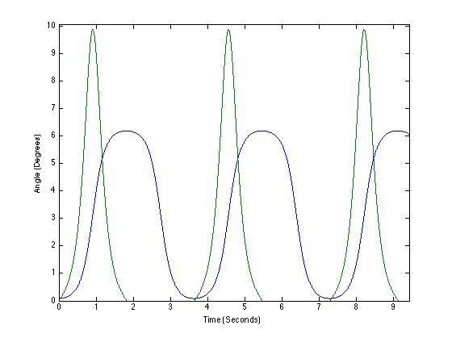

Figure 1a. Solution curves of Equation 1 with the given initial conditions (initial angle of 5 degrees, angular acceleration of 0 degrees/sec). Blue curve is phi, green curve is (phi)’ [For graphs 1a- ]

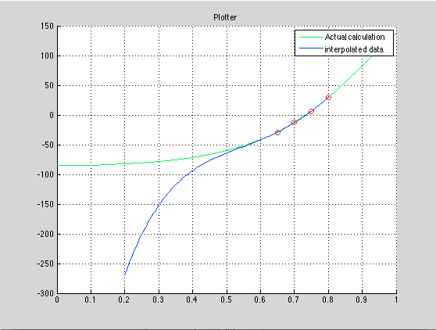

What we can see here is that the green line is the actual path the rider is taking, over the course of one second, we can see that the rider actually hits the ground when the line intercepts 0. Therefore, a reasonable is, when exactly does he hit the ground. To determine this we take 4 data points surrounding the point where the rider intercepts 0 and interpolate that line to find out.

The Roots of the interpolated line, or where the interpolated line crosses 0, or 90 degrees are at:

1.3682

0.7346

0.4090 + 0.2984i

0.4090 - 0.2984i

Where obviously 1.3682 cannot be the solution, and the imaginary solutions are also ruled out. Therefore, The solution where the rider hits the ground is at .7346 seconds, this means he has a period of .7346 seconds.

The second problem is when the rider attempts passive control over the unicycle.

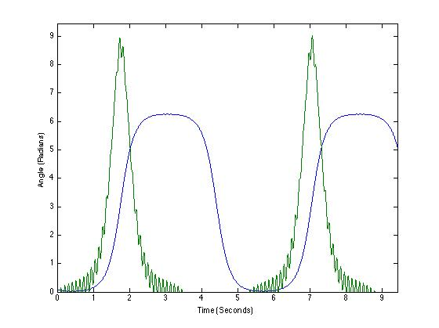

Figure 1b. Solution curves of Equation 1, same initial conditions, but with pedaling passive control. You can see how the angular velocity oscilates under the pedaling, which slows the fall of the rider (though he still falls).

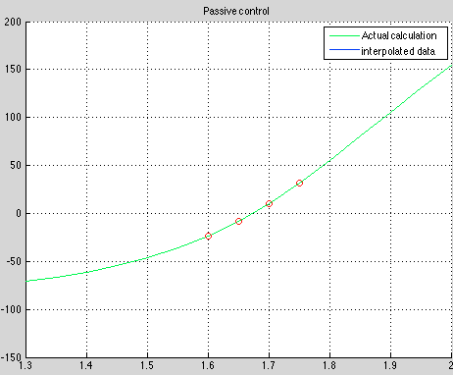

Here we can see that the rider does a little bit better with the passive controls. When we interpolate the four points where the rider first crosses the x axis we see that the roots we get back are:

* 2.089312193255840
* 1.673031032380639
* 1.471745118577493 + 0.231718001703095i
* 1.471745118577493 - 0.231718001703095i

Where the obvious solution is 1.67 seconds. Therefore we can say that the rider does better with passive controls than with no control at all.

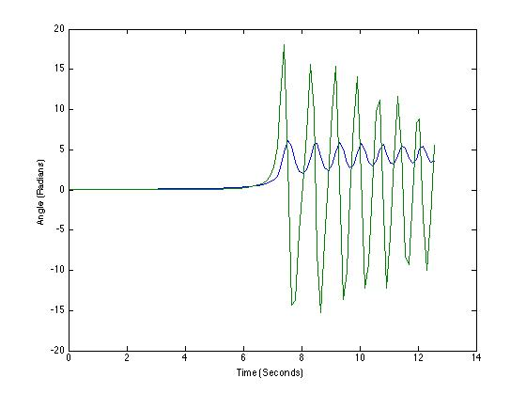

Figure 2a. Solution curves of Equation 1 with Active Control (h(t) = a*phi). Here the function is unstable (and the angle oscillates well above the maximum to stay upright of pi/2) because the constant a was chosen as 0.9999. Since that’s less than 1, the solutions are imaginary and the real parts are periodic because of their conversion into sin and cos using Euler’s Rule.

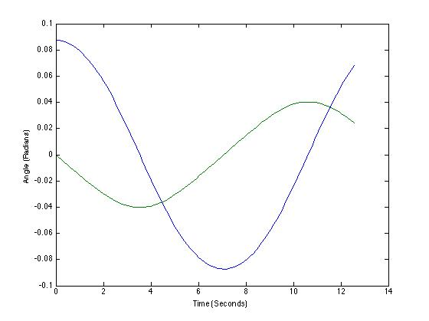

Figure 2b. Solution curves, but this time with a > 1, at a = 1.01. Now that the solutions are not imaginary, the angle can be much more stable in its motion, and the unicycle can stay more upright. The largest angle here is only about ~ 0.09 radians, because the rider is sufficiently strong to control the unicycle.

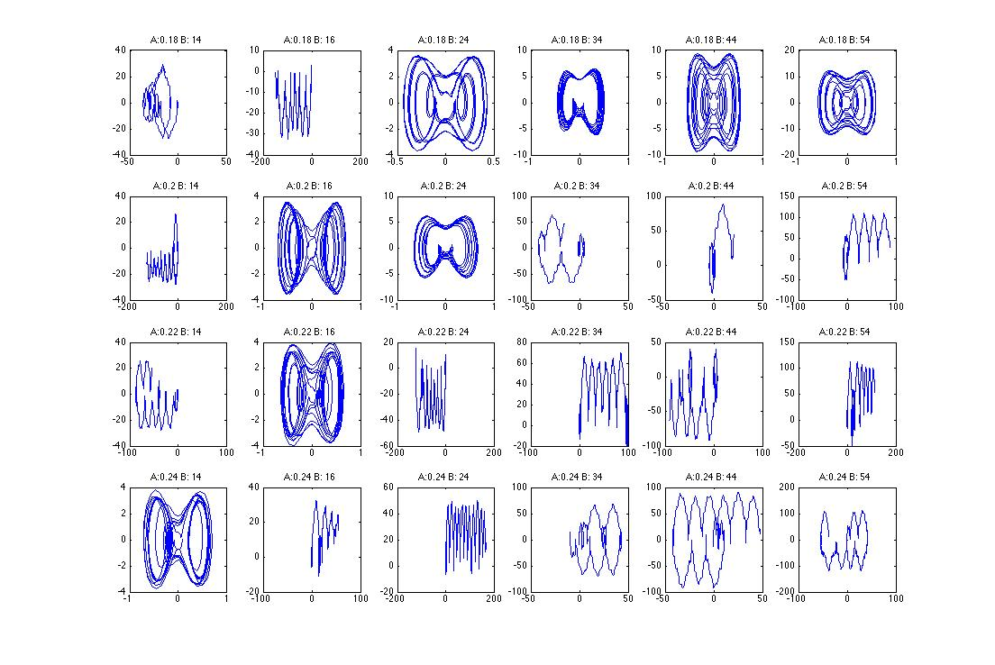

Figure 3a. Phase plot of phi vs. phi’. Each row is a value of a, each column is a value of omega (as labeled). You can see that for many values the system is very chaotic, while for a few it is much more harmonic and has less deflected in angle phi.

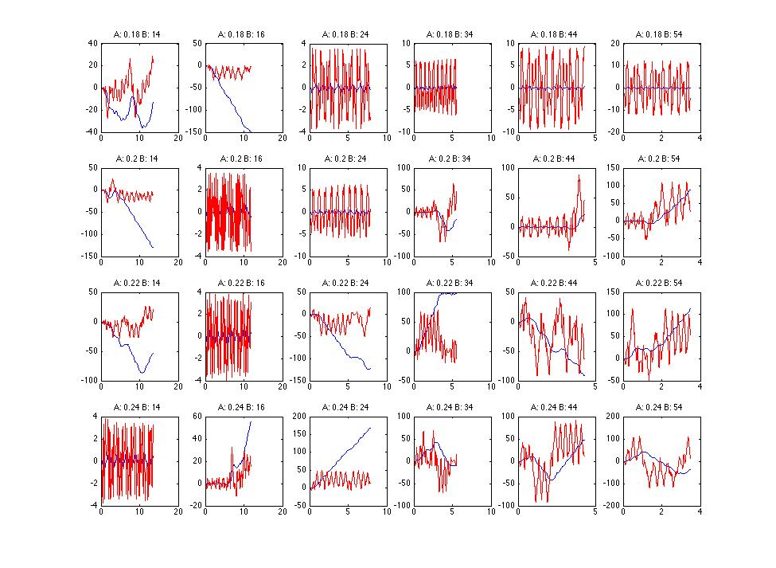

Figure 3b. Plots of phi vs time (blue) and phi‘ vs time (red) for different values of A and omega. The values of A and omega for which figure 3a has a harmonic and more stable form correspond to graphs in this figure for which the angle (in blue) stays relatively low by the rider jumping up and down on the unicycle (phi‘ in red goes high and low rapidly).

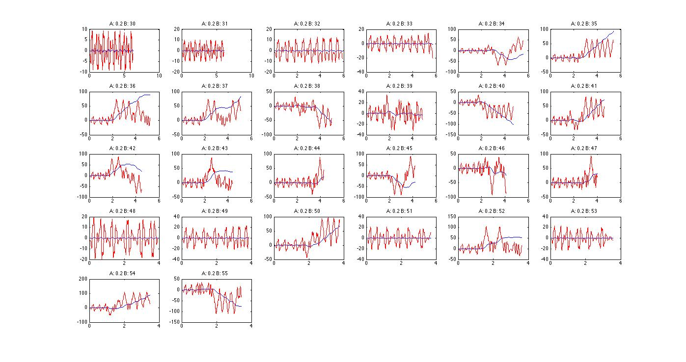

Figure 4a. Many graphs for omega in this interval (30-55) for the value of A = 0.2 are unstable and chaotic. One stable value of omega is = 33. For this value (and others where the phase plot is more periodic), the angle of deflection phi stays very low and this is a good value for riding the unicycle by this alternative design of jumping the wheel up and down.

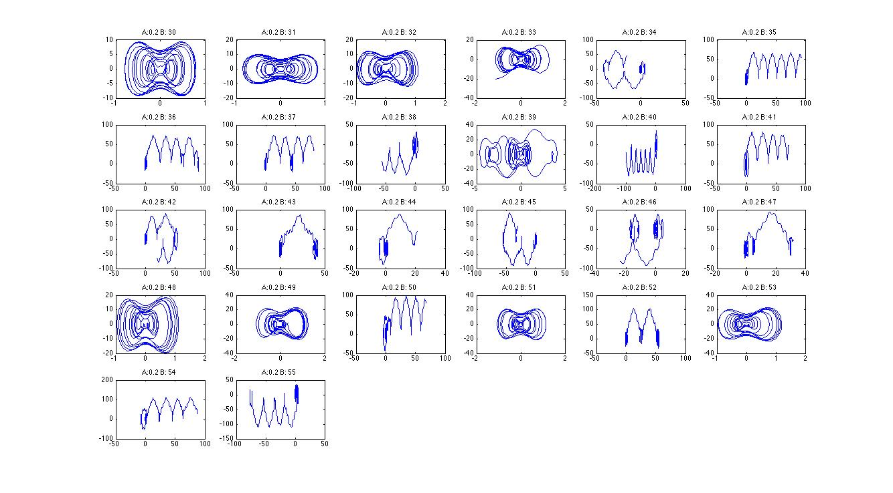

Figure 4b. The corresponding phase plot graphs (phi vs phi’) for A = 0.2 and omega in the interval of 30-55. Some of the more harmonic values of omega appear to be 30,31,32,33,48,49,51,53 (these values make the phase plot more periodic and have much smaller deflection for phi).