Advanced Database Programming Portfolio 2 - MongoDB

Niall Stack T00174406

2016

# Q1 - Implementing My Own CouchDB Database

## Introduction:

## Vision:

## Creating the Database:

To create the Database, the same command is used as to connect to it

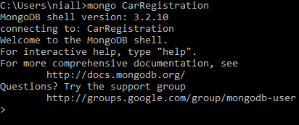

Creating a collection is also uses the same command as is used to add a document to a collection

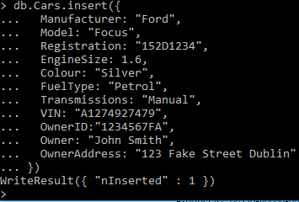

I inserted another document but instead of having a single string for address I created a array

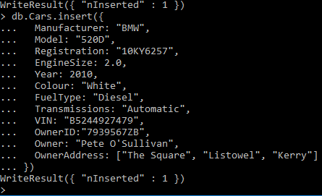

To view all collections in the database just use the simple command – “show collections”



To view all the documents in a collection

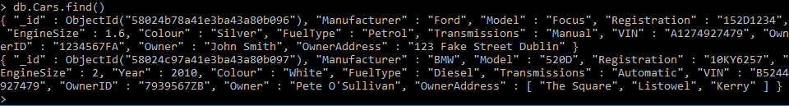

To make it easier to read add .pretty()

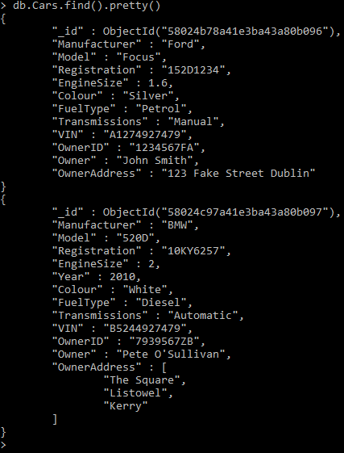

MongoDB allows for functions to be created that can speed up the population process



Using this function I can add a document to the collection with a more simplified insert



Which could then be seen in the collection

