Did the Allies Commit War Crimes with Their Bombing Campaigns during WWII?

Niall Stack

Institute of Technology Tralee
Co. Kerry
Ireland

Abstract
This paper describes a KDD process on data of allied bombing runs during the Second World War and attempts to use the data within to determine if the allies committed war crimes with these bombing campaigns. As well as some simple graphing to gain a better understanding of the data, a data mining technique called association rules was implemented to help verify the research question. Because of the age of the data, this paper focuses on the large and detailed amount of pre-processing that had to be performed on the data.

Introduction
Discussing war and crimes committed in war can be very difficult. For every entry on this dataset many people have most likely died, in Germany alone around 600,000 people died from the allied bombing raids (Harding, 2003). So although it is easy to distance oneself from this when looking at numbers it is important to remember what the data actually represents, as the quote often attributed to Joseph Stalin says “A single death is a tragedy; a million deaths is a statistic.”.
One of the main reasons that this topic was chosen for this paper is that this dataset provides a large number of data and columns which made it a great topic to follow the KDD process with. This paper goes through the 5 stages of the KDD process:
- Identifying the Problem
- Designing Data Requirement
- Pre-processing Data
- Performing Analytics Over Data
- Visualising Data
The first stage was completed with the decision over the research question.
The possible research question for this paper was another factor in this topic being chosen since that from the data alone, it could not be conclusively determined if the allies did indeed commit war crimes with their bombing campaigns. It can be seen if civilians were targeted and to what proportion they were targeted in comparison to valid military targets, but further research is needed to understand what exactly constitutes as a war crime. This makes it a deep and interesting topic and the controversy surrounding it further adds interest.
A combination of domain knowledge and study of the dataset was necessary to fully understand it. An example of domain knowledge being useful is the lack of data for the first year of the war, 1939. This was because very little happened during the first 8 months of the war, the war was even referred to as the “phoney war” (The Editors of Encyclopædia Britannica, 2010).
The main focuses of this paper are the pre-processing of data and the data mining, with a particular focus on the pre-processing as it took a significant amount of time to complete and was vital to gaining any conclusions from the data. There is also an emphasis on understanding the historical context in this paper since the war began over 78 years ago, so the circumstances surrounding the war are not typically present in the mind of modern readers.

Allied Aerial Bombing Operations in WWII
The Aerial Bombing Operations in World War II dataset from Kaggle originally came from the Theater History of Operations Reports (THOR) and was developed by Lt Col Jenns Robertson of the US Air Force. The original report includes data on WWI, WWII, the Korean War and the Vietnam War but only the WWII dataset was required for this research.
The dataset includes data from the U.S. Army Air Force (USAAF), the Royal Air Force (RAF), the Royal Australian Air Force (RAAF), the Royal New Zealand Air Force (RNZAF) and the South African Air Force (SAAF). The only data that is fully complete though is the U.S. data, with most of the RAF data being for the European Theatre (Theater History of Operartions Reports, n.d.).
A lot of the data is difficult to understand by itself so there is a THOR data dictionary that includes additional information on details such as acronyms or military terms.
The dataset is very large, it has 178,281 entries with 46 variables/columns so it is a good example of a dataset that the KDD process can be performed on. To perform this process R was used and a various amount of libraries were used to aid this analysis.

Pre-processing
For this particular dataset, the pre-processing stage of the KDD process is the most challenging and requires the most effort compared to the other stages. This is mainly because of the age of the dataset, a shortage of record keeping and differences in the methods of recording between different Air forces.
Before any cleaning or correction of the data could begin, the data had to first be analysed. As previously stated, there are nearly 180,000 records in this dataset covering the six years of the war (1939-1940) with each record having 46 columns of data. After checking the amount of null data in the table, it could be seen that just over half of the columns had over 70% missing data. Using R it was relatively simple to see what data was missing and what data was in each column.
All this data had to be filled in but to take appropriate action, each column had to be examined separately which was a very time consuming process. This followed the second stage of the KDD process, Designing Data Requirement.
The mission date and I.D. columns were the only two with 100% of all their data so there was no pre-processing that needed to be done on them.
The theatre of operations data was mostly complete but all the entries were in acronyms, so a look at the THOR data dictionary was needed to understand some of them e.g. ETO = European Theatre of Operations (THOR, n.d.). There were three categories where the data dictionary had to be consulted to understand the data for the previously mentioned column and for target priority they were left with just the missing data replaced with UNKNOWN or something more relevant. Target type however had numbers representing the mission types e.g. 6 = Reconnaissance or Search, these numbers were substituted for their corresponding meaning which made the data easier to understand.
For the altitude column the missing data was replaced with the mean as there wasn’t too much data missing and so it could still provide an accurate representation of what the typical height bombs were dropped at.
Many columns had mostly null data, with some having over 90% missing so these were typically removed from the data as they would not be reliable to draw any conclusions upon. Columns that were of little use, such as call sign were also removed.
The column target city contained targets that weren’t cities, which were listed by their coordinates instead. To make the title more accurate it was renamed to “target city or area”.
There were several columns in the data for the three main bomb types: High Explosives, Incendiary and Fragmentation. Each of these columns then also had type, weight in pounds and weight in tons columns as well as two final columns for the total weight in columns in both pounds and tons. Since there would only typically be one type of bomb in a bombing run these columns often didn’t apply, leaving lots of null data. The solution to this was to create a single column called bomb type that would contain the name of the type of bomb so the rest of these columns could then be removed. Some of the missions involved leaflet dropping so that was added as a bomb type and of course there was also two major outliers that had to be addressed, the two atomic bombs dropped on Japan (History.com Staff, 2009). The dataset had Atomic Bomb listed as a high explosive type so it was better to list it as its own bomb type as although there were only two occurrences of this, they are infamous and so deserve their own specific mentions.
The majority of the columns were categorical, so when there was enough data that it was not necessary to remove the column entirely, the missing data was replaced with “Unknown” since using the most common values to replace them could cause misleading data.
After removing all the redundant, or unusable columns there was just 22 columns left from the original 46 so over half of the categories of data were removed. All the NA’s were also replaced with the exception of the target latitude and longitude columns because putting in unknown would cause problems later on when it came to data visualisation and it was easier to just ignore the NA’s. It also wouldn’t be right to put in the mean for the missing values as it would leave to one place being disproportionally targeted to what it actually was.
This was the lengthy process of pre-processing that was performed on this dataset that cleaned the data so that analysis could be performed on it thus following the KDD process and completing the third stage, Pre-processing Data.

Methodology

Approach
The basic analysis that was performed on the data, as per the fourth stage in the KDD process, involved using various charts to display the information. The dataset provided information of the longitudes and latitudes of all the bombing targets this meant theses points could be plotted on a map to get an overview of the bombing campaigns.
The data mining technique used for this paper was Association Rules, using the Apriori algorithm. Association Rule Mining finds associations between variables. It is sometimes called “Market Basket Analysis” and is often used for marketing purposes. One real world example of Association Rule mining being used is when Walmart found out that there was a correlation between purchases of Pop Tarts and Hurricanes. This is most likely due to their long shelf life and them not requiring refrigeration. Because of this Walmart makes sure to stock extra Pop Tarts prior to Hurricanes (Bone, 2014).

Discussion
Before the Association Rule mining could begin and therefore the fourth step in the KDD process, the data had to be further stripped down to only the essential variables. This was to become a subset of the data and all further actions were performed on this subset. The three main target types that were civilian areas (Urban area, town area, village area) were all had their target type changed to Civilian area. When a chart was created now, clearly Civilian Areas were the most targeted but this was not necessarily a fair reflection. All the different military targets were divided into separate types. Once all the other target types were changed to Military Target then Military Target became the most popular target type. One of the bomb types that was present was Leaflet Dropping, this obviously would skew the results to the Civilian areas despite not causing any physical damage so it was removed.
There were many columns that provided little insight into what the bomb targets were or what ferocity they were attacked with so every column was removed with the exception of target type, target priority and bomb type. Target type was left because it was necessary to know if the target was a genuine military target or a civilian target. Target priority was also left since it would show how important a target was and so there would most likely be more resources devoted to the attack. Bomb type was kept as the type of bomb gave further insight into the bombing runs, fragmentation would be for personnel so would more likely be used to purposely kill. High explosives would clearly cause a lot of collateral damage and they would be typically used against infrastructure. Incendiary would be used to cause wide spread destruction and death. Of course there are the two atomic bombs which although listed as military targets, it was clear it would cause tremendous civilian deaths and thus would send a message and force Japan to surrender. All unknown targets were also removed as there was enough data left to get a conclusion from.
Several different rules were created, the first two had too many associations in them but still provided useful information. A third rule had priority targets on the RHS (right hand side), with the target type on the LHS. The fourth rule had the Incendiary bomb type on the RHS and the target type on the LHS. The fourth simply reversed this.

Results
The final step in the KDD process is visualising the data, which is how conclusions and results could be drawn. To give an overview of what locations where bombed most, several maps were created with the bombing runs plotted on them. One such example is the European and Mediterranean theatres plotted:
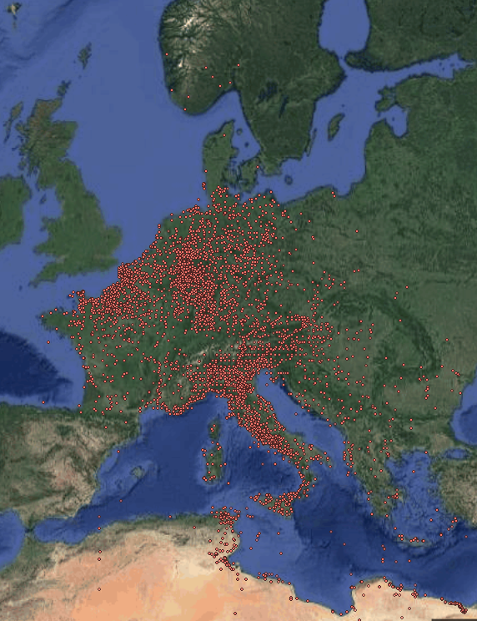
It can be clearly seen that the western section of Germany was the most frequently hit in the country and this makes sense since this is the Ruhr region which was the centre of Germany’s industrial infrastructure (World War II Today, n.d.).
A Pie chart was created that displayed what the most common target type was.
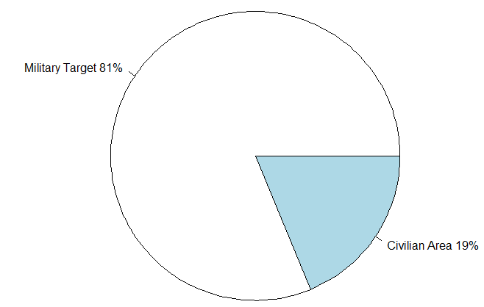
So this shows that the allies clearly targeted military targets more than civilian areas.
When the first rule was run, it showed an interesting association.
LHS | RHS | Support | Confidence | Lift
Bomb type =  Fragmentation | Target type =  Military Targets | 0.1428 | 0.9084 | 1.0132
This shows that over 90% of fragmentation bombs dropped were against military targets and the lift being over 1 shows that there is a strong correlation between the two variables. This makes sense as fragmentation bombs wouldn’t really be useful against civilian areas. Another rule showed a darker side of these bombing campaigns:
LHS | RHS | Support | Confidence | Lift
Target priority=Target of Opportunity,  Bomb type=Incendiary | Target type =  Civilian Areas | 0.0053 | 0.6667 | 6.4419
Target priority=Target of Opportunity,  Bomb type=High Explosives | Target type =  Civilian Areas | 0.0070 | 0.3165 | 3.0579
There is a very high association between the incendiary bombs being dropped as a target of opportunity. A target of opportunity was a target that was either unplanned or unanticipated. After October 1940, the RAF were told to attack any target of opportunity if they were unable to find their designated targets (Cox, 1998). This meant that these bombs that caused horrific damage were often dropped indiscriminately on civilian areas. To give an idea of how devastating incendiary bombs were, a firebombing campaign on the German city of Hamburg between the 24th of July and the 3rd of August killed around 37,000 people. On one night RAF bombers created a firestorm with winds over 150mph (241km/h) and burned at over 800 degrees Celsius. In comparison the Atomic bomb that was dropped in Nagasaki killed 40,000 in the initial blast (Selwood, 2015). The low support number shows that this didn’t occur too often but because of how horrific these weapons could be, it is an important association.
Indeed the allies intended to use the bombings as a psychological weapon. In Colonel T. Tracey Goetz’s research paper on the “DETERMINATION AND EFFECTIVENESS OF WWII STRATEGIC BOMBING STRATEGY”, the Chief of Staff of the RAF, General Trenchard felt “psychological damage from bombing had more effect than the physical” (Goetz, 2003).
Of course one of the most controversial bombings of the war were the two atomic bombs that the U.S. dropped on Japan. Including those who died of the long-term effects of radiation sickness, the two bombs killed an estimated 185,000 people (BBC, 2014). Typically it is stated that the dropping of the bombs saved many times lives that would have been lost in an invasion of the Japanese mainland than were lost from the dropping of the bombs, regardless of that it was known there would be a high civilian loss.
From the data, it is shown that most of the allied bombing campaigns were targeted against military targets. Despite this, a considerable amount of effort was put into targeting civilians with not just conventional bombs but the devastating incendiary and atomic bombs too. By modern standards, purposely attacking civilians is considered a war crime and so it is fair to look upon the actions of the allies as war crimes. Of course it is also important to remember that both sides took part in bombing civilians but the allies put a considerable greater amount of effort and resources into it. The dataset used for this paper only included information on allied bombing efforts, there is not as much detailed data available on the axis power’s bombing campaigns so that is the primary reason this paper only focuses on the allies.
Although there is overwhelming evidence that the allied bombing campaigns purposely targeted civilians but what actually constitutes as a war crime must first be considered. The oxford dictionary defines a war crime as “An act carried out during the conduct of a war that violates accepted international rules of war”. Legally, the allies did not commit a war crime. The Hague conventions of 1899 and 1907 were not updated to cover the rapidly advancing field aerial warfare and so there was no general agreement on how the laws should be interpreted for the then present day warfare (Steenhard, 2011). This means that international law was not necessarily broken by the bombing campaigns. So technically speaking, the answer to the research question – “Did the Allies Commit War Crimes with Their Bombing Campaigns during WWII?” is legally speaking, they did not.

Summary
A lot of time was needed to analyse the data found in the dataset from Kaggle. Preliminary analytics had to be performed first to get an understanding of the data. It was soon clear that the data had a lot of missing or poorly labelled information, all this information had to be refined and cleaned before any conclusions could be drawn from it. Working on such an old dataset showed how important the pre-processing of data can be and how it often is the most time consuming section.
Using association rule mining, correlations between variables that previously looked unrelated could be observed. The high correlation of incendiary bombs being dropped on civilian areas as a target of opportunity was not something that was obvious from looking at graphs of the data. This shows how important a data mining technique like association rule mining can be to finding out more about data.
From studying this data, it can be seen that tremendous amounts resources were spent by the allies on bombing the axis powers. Although the answer to the research question was legally no, it can be considered that morally the actions were a war crime but there is no easy way to define morals as they vary from person to person.
One area that would could be improved would be finding missing data for several fields, such as the amount of aircraft involved in a bombing run or how much bombs each plane was carrying. This would take considerable time though.

References
BBC, 2014. Fact File : Hiroshima and Nagasaki. [Online]
Available at: http://www.bbc.co.uk/history/ww2peopleswar/timeline/factfiles/nonflash/a6652262.shtml
[Accessed 24 April 2017].
Bone, K., 2014. ASSOCIATION RULE MINING – NOT YOUR TYPICAL DATA SCIENCE ALGORITHM. [Online]
Available at: https://mapr.com/blog/association-rule-mining-not-your-typical-data-science-algorithm/
[Accessed 23 April 2017].
Cox, S., 1998. The Strategic Air War Against Germany, 1939-1945: Report of the British Bombing Survey Unit, London: Frank Cass.
Goetz, T. T., 2003. DETERMINATION AND EFFECTIVENESS OF WWII STRATEGIC BOMBING STRATEGY, s.l.: USAF.
Harding, L., 2003. Germany's forgotten victims. [Online]
Available at: https://www.theguardian.com/world/2003/oct/22/worlddispatch.germany
[Accessed 23 April 2017].
History.com Staff, 2009. Bombing of Hiroshima and Nagasaki: History.com. [Online]
Available at: http://www.history.com/topics/world-war-ii/bombing-of-hiroshima-and-nagasaki
[Accessed 09 April 2017].
Selwood, D., 2015. Dresden was a civilian town with no military significance. Why did we burn its people?. [Online]
Available at: http://www.telegraph.co.uk/history/world-war-two/11410633/Dresden-was-a-civilian-town-with-no-military-significance.-Why-did-we-burn-its-people.html
[Accessed 23 April 2017].
Steenhard, R., 2011. Dresden 1945: An Allied War Crime?. [Online]
Available at: https://www.peacepalacelibrary.nl/2011/02/dresden-1945-an-allied-war-crime/
[Accessed 24 April 2017].
The Editors of Encyclopædia Britannica, 2010. Phony War | EUROPEAN HISTORY. [Online]
Available at: https://www.britannica.com/event/Phony-War
[Accessed 23 April 2017].
Theater History of Operartions Reports, n.d. Database: THOR. [Online]
Available at: http://afri.au.af.mil/thor/report.asp
[Accessed 09 April 2017].
THOR, n.d. THOR Draft Data Dictionary. [Online]
Available at: https://www.dds.mil/data/thor_data_dictionary_2016.pdf
[Accessed 09 April 2017].
World War II Today, n.d. The ‘Battle of the Ruhr’ begins with Essen. [Online]
Available at: http://ww2today.com/5th-march-1943-the-battle-of-the-ruhr-begins-with-essen
[Accessed 24 April 2017].

