1. Первая страница с выбором параметров

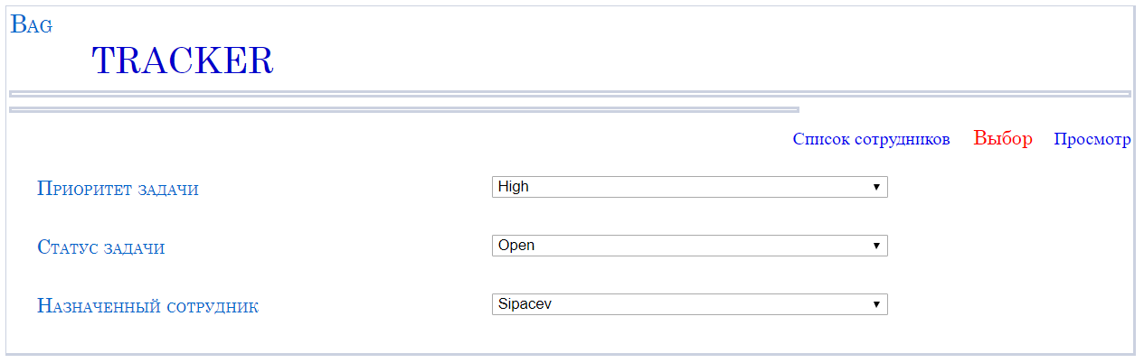

1. По кнопке «Список сотрудников» показывается таблица Employee

Запрос: string query = "select rtrim(TabelNumber) as tabNum, rtrim(LastName) as lastName, " +

"rtrim(FirstName) as firstName, rtrim(MiddleName) as middleName, " +

"CONVERT(CHAR(25),BirthDate,104) as birthDate, rtrim(email) as email, " +

"rtrim(PhoneNamber) as phone, rtrim(Department) as department, rtrim(Position) as position from Employee";

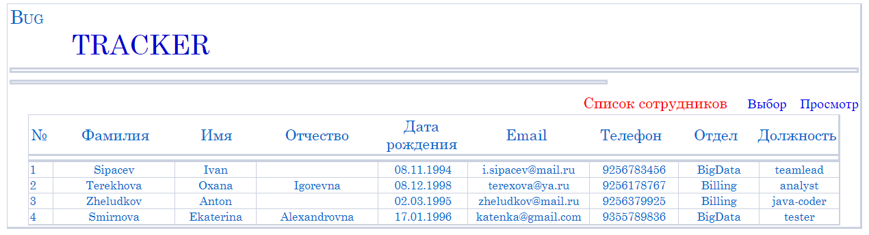

1. По кнопке «Просмотр» отображается поиск в таблице «Bug»

Отображение таблицы в БД:

 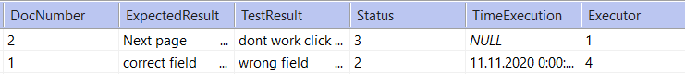

Делаем запрос

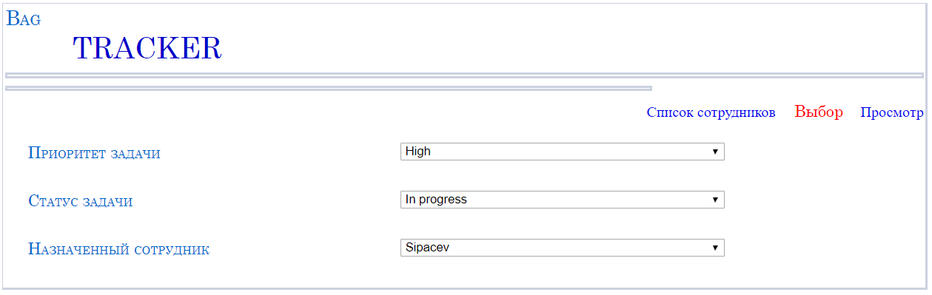

Запрос: string query = "select rtrim(Bug.BugNumber) as bugNum, rtrim(Bug.Brief) as brief, " +

"CONVERT(CHAR(25),Bug.Date,104) as dateOpen, rtrim(Bug.Project) as project, " +

"rtrim(Bug.Module) as module, rtrim(Priority.PriorityDescription) as priority, " +

"rtrim(Status.StatusDescription) as status, rtrim(Employee.LastName) as employee " +

"from Bug, Employee, Status, Priority " +

"WHERE Bug.Executor=Employee.TabelNumber AND Bug.Executor="+employee+" " +

"AND Bug.Status=Status.NumStatus and Bug.Status="+status+" " +

"AND Bug.Priority=Priority.NumPriority AND Bug.Priority="+priority;

Получаем результат: