1. **Num1.bat**

@echo off

chcp 1251

SET /p temp=[Way]

cd "%temp%"

echo Y|del *.*

pause

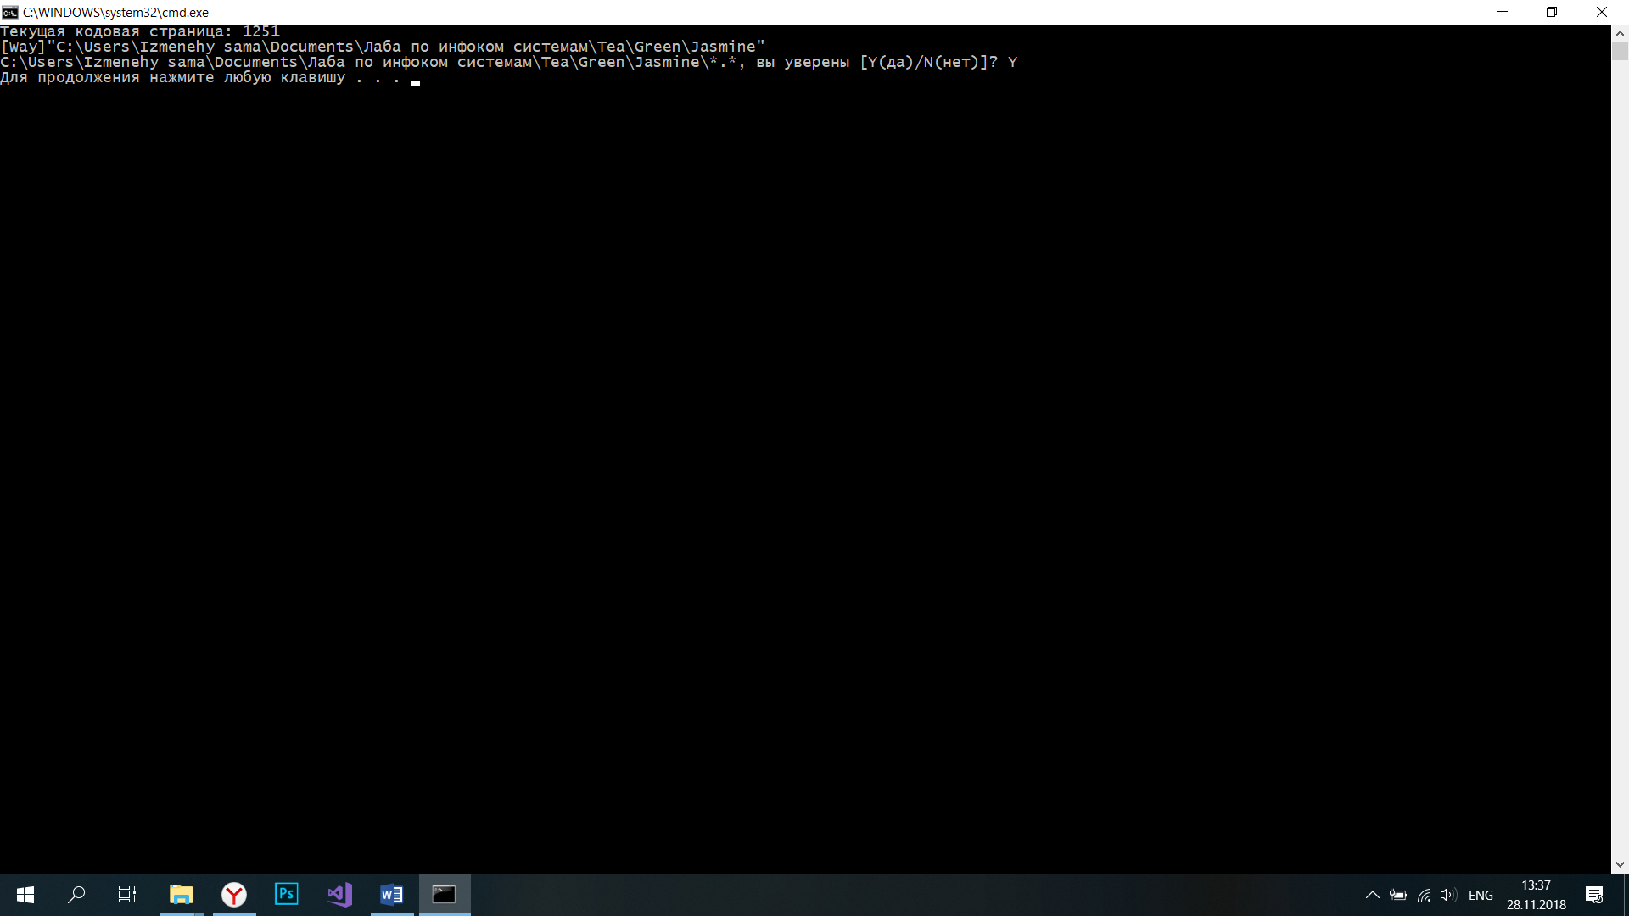

1. **Num2.bat**

@echo off

SET a=2

SET /p b=[Enter number]

SET /a c=%a%*%b%

echo %c%

pause

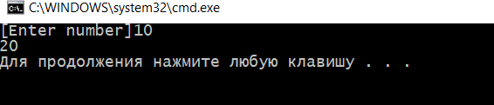

1. **Num3.bat**

@echo off

set /p number=[Number 1-5]

if %number%==1 (goto c1)

if %number%==2 (goto c2)

if %number%==3 (goto c3)

if %number%==4 (goto c4)

if %number%==5 (goto c5)

echo Enter right number

pause

exit

:c1

echo one

pause

exit

:c2

echo two

pause

exit

:c3

echo three

pause

exit

:c4

echo four

pause

exit

:c5

echo five

pause

exit



1. **Num4.bat**

@echo off

FOR /L %%a IN (1,1,5) DO set date=!date!& md "%date%+%%a"& cd "%date%+%%a"

1. **Num5.bat**

@echo off

chcp 1251

SET /p temp=[Way]

cd "%temp%"

ren %temp%\*.bat *.txt

pause

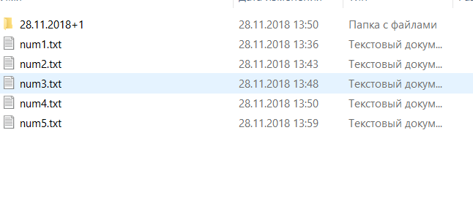

1. **Num6.bat**

@echo off

call num61.bat

call num62.bat

num61.bat

@echo off

explorer http://google.com

start calc.exe

num62.bat

@echo off

ipconfig /all >%CD%\ipconfig.txt

