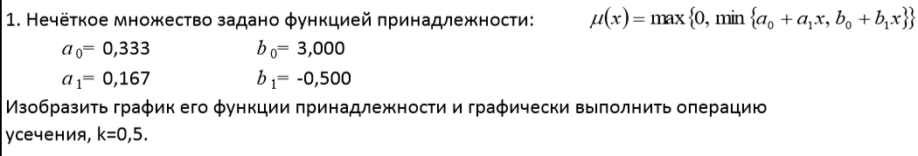

*µA(x)* = max {0, min {0.333+0.167x, 3-0.5x}}

Усечение: *µ0,5ΩА(x) =* min {0.5, µA(x)}

3-0.5x >= 0 х=6

3-0.5x <= 0.333+0.167x х=3,99

0.333+0.167\*3,99 = 0,999

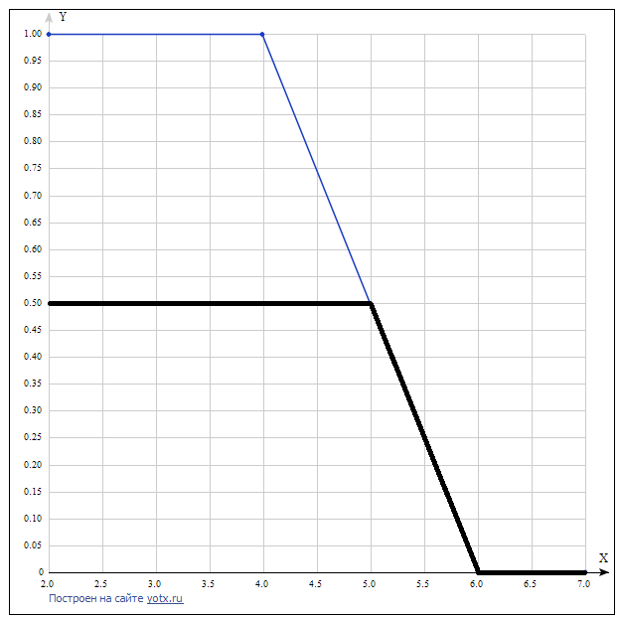

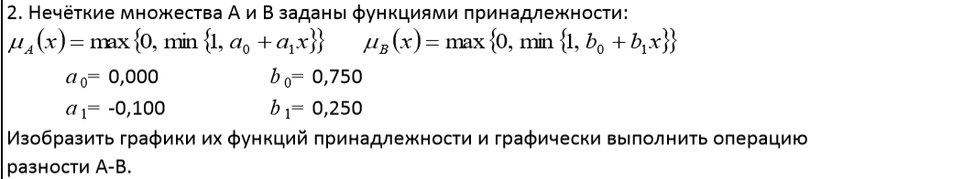

*µA(x)* = max {0, min {1, -0.1x}}

*µВ(x)* = max {0, min {1, 0.75+0.25x}}

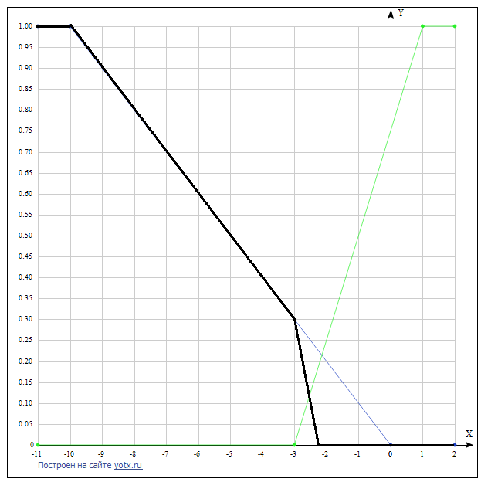

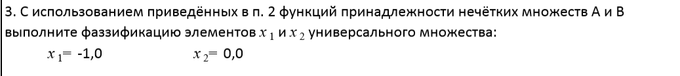

*µA(x1)* = 0,1

*µВ(x1)* = 0,5

x.1 = *µA(x1) \/ µВ(x1)*

*µA(x2)* = 0

*µВ(x2)* = 0,75

x.2 = *µВ(x2)*

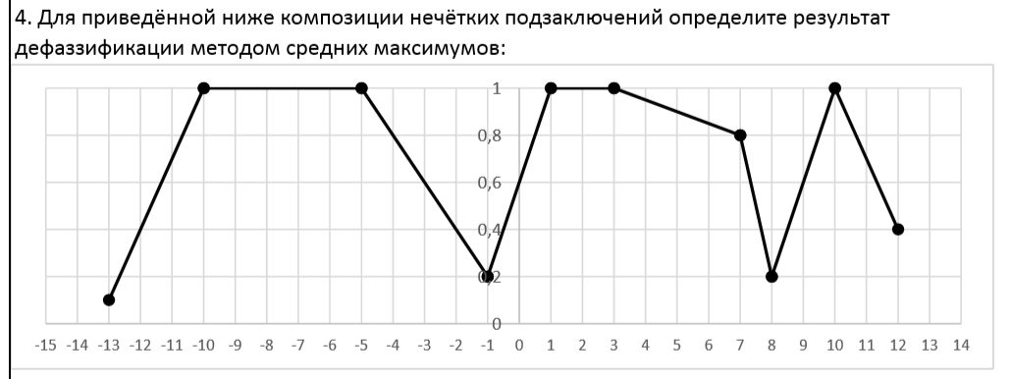

X1=-10

X2=-5

X3=1

X4=3

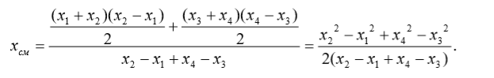=-4.786

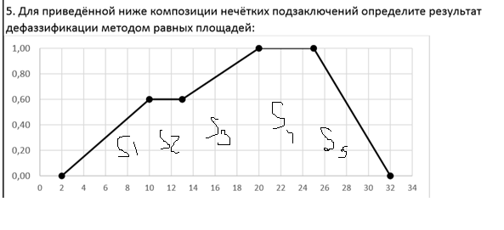

S1 = ∫210 (0.075x-0.15)dx=34.8?

S2 = ∫1013 (0.6)dx = 1.8

S3 = ∫1320 (2/35X-1/7)dx = 5.6

S4 = ∫2025 (1)dx = 5

S5 = ∫2532 (-1/7X-32/7)dx = 60,5?

не успела ☹