ANALY_descriptives.Rmd

Niamh MacSweeney

2022-08-31

##SET UP

#Load data

pds_y1 <- rio::import("/Volumes/GenScotDepression/users/niamh/puberty_ABCD/ABCD_puberty_depression/data/pds_timing_y1_R4.0.rds")  
   
dep_vars <- rio::import("/Volumes/GenScotDepression/users/niamh/puberty_ABCD/ABCD_puberty_depression/data/CBCL_dep_all_yrs_R4.0.rds")  
   
covs <- rio::import("/Volumes/GenScotDepression/users/niamh/puberty_ABCD/ABCD_puberty_depression/data/covs_main_R4.0.rds")

#Tidy data

pds_y1 <- pds_y1 %>%   
 select (-c("pds_m_pt_valid", "pds_f_pt_valid", "age_years")) #remove extra age column too.

## Merge

#inspect vars before merge  
colnames(covs)

## [1] "src_subject_id"   
## [2] "sex"   
## [3] "site_id"   
## [4] "site_id_6m"   
## [5] "site_id_y1"   
## [6] "site_id_18m"   
## [7] "site_id_y2"   
## [8] "site_id_y3"   
## [9] "interview_age_y1"   
## [10] "interview_age_y2"   
## [11] "interview_age_y3"   
## [12] "parent_dep_y0"   
## [13] "parent_dep_y2"   
## [14] "parent_dep_y3"   
## [15] "rel_family_id"   
## [16] "acs_raked_propensity_score_y0"   
## [17] "acs_raked_propensity_score_y1"   
## [18] "bmi_y0"   
## [19] "bmi_y1"   
## [20] "bmi_y2"   
## [21] "race_y0"   
## [22] "race_6m"   
## [23] "race_y1"   
## [24] "race_18m"   
## [25] "race_y2"   
## [26] "dti_mean_motion_y0"   
## [27] "dti_mean_motion_y2"   
## [28] "scanner_id_y2"   
## [29] "WBV"   
## [30] "ICV"   
## [31] "interview_date.baseline_year_1_arm_1"  
## [32] "household_income_y0"   
## [33] "parent_high_ed_y0"   
## [34] "age_y1"   
## [35] "age_y2"   
## [36] "age_y3"

colnames(dep_vars)

## [1] "src_subject_id" "sex" "interview_date_y0"  
## [4] "interview_date_y1" "interview_date_y2" "interview_date_y3"  
## [7] "cbcl_withdep_y0" "cbcl_withdep_y1" "cbcl_withdep_y2"   
## [10] "cbcl_withdep_y3" "cbcl_anxdep_y0" "cbcl_anxdep_y1"   
## [13] "cbcl_anxdep_y2" "cbcl_anxdep_y3"

colnames(pds_y1)

## [1] "src_subject_id" "sex"   
## [3] "pds_tot_m" "pds_tot_f"   
## [5] "pds_tot_all" "pds_1_p"   
## [7] "pds_2_p" "pds_3_p"   
## [9] "pds_m5_p" "pds_m4_p"   
## [11] "pds_f4_p" "pds_f5b_p"   
## [13] "pds_p_ss_female_category" "pds_p_ss_male_category"   
## [15] "gonad_avg" "adren_avg"   
## [17] "pt_m" "pt_f"   
## [19] "gonad_f" "gonad_m"   
## [21] "adren_f" "adren_m"   
## [23] "gonad_pt_m" "gonad_pt_f"   
## [25] "adren_pt_m" "adren_pt_f"

#merge by src_subject_id and sex as they are common to all dataframes   
  
#merge 1  
df <- covs %>%   
 left_join(y=dep_vars, by= c("src_subject_id", "sex"))  
   
#merge 2  
df <- df %>%   
 left_join(y=pds_y1, by= c("src_subject_id", "sex"))  
  
#check if merge worked okay  
colnames(df)

## [1] "src_subject_id"   
## [2] "sex"   
## [3] "site_id"   
## [4] "site_id_6m"   
## [5] "site_id_y1"   
## [6] "site_id_18m"   
## [7] "site_id_y2"   
## [8] "site_id_y3"   
## [9] "interview_age_y1"   
## [10] "interview_age_y2"   
## [11] "interview_age_y3"   
## [12] "parent_dep_y0"   
## [13] "parent_dep_y2"   
## [14] "parent_dep_y3"   
## [15] "rel_family_id"   
## [16] "acs_raked_propensity_score_y0"   
## [17] "acs_raked_propensity_score_y1"   
## [18] "bmi_y0"   
## [19] "bmi_y1"   
## [20] "bmi_y2"   
## [21] "race_y0"   
## [22] "race_6m"   
## [23] "race_y1"   
## [24] "race_18m"   
## [25] "race_y2"   
## [26] "dti_mean_motion_y0"   
## [27] "dti_mean_motion_y2"   
## [28] "scanner_id_y2"   
## [29] "WBV"   
## [30] "ICV"   
## [31] "interview_date.baseline_year_1_arm_1"  
## [32] "household_income_y0"   
## [33] "parent_high_ed_y0"   
## [34] "age_y1"   
## [35] "age_y2"   
## [36] "age_y3"   
## [37] "interview_date_y0"   
## [38] "interview_date_y1"   
## [39] "interview_date_y2"   
## [40] "interview_date_y3"   
## [41] "cbcl_withdep_y0"   
## [42] "cbcl_withdep_y1"   
## [43] "cbcl_withdep_y2"   
## [44] "cbcl_withdep_y3"   
## [45] "cbcl_anxdep_y0"   
## [46] "cbcl_anxdep_y1"   
## [47] "cbcl_anxdep_y2"   
## [48] "cbcl_anxdep_y3"   
## [49] "pds_tot_m"   
## [50] "pds_tot_f"   
## [51] "pds_tot_all"   
## [52] "pds_1_p"   
## [53] "pds_2_p"   
## [54] "pds_3_p"   
## [55] "pds_m5_p"   
## [56] "pds_m4_p"   
## [57] "pds_f4_p"   
## [58] "pds_f5b_p"   
## [59] "pds_p_ss_female_category"   
## [60] "pds_p_ss_male_category"   
## [61] "gonad_avg"   
## [62] "adren_avg"   
## [63] "pt_m"   
## [64] "pt_f"   
## [65] "gonad_f"   
## [66] "gonad_m"   
## [67] "adren_f"   
## [68] "adren_m"   
## [69] "gonad_pt_m"   
## [70] "gonad_pt_f"   
## [71] "adren_pt_m"   
## [72] "adren_pt_f"

#REDUCE TO SAMPLE NEEDED

For this RR, our final sample size requires participants to have complete pubertal data (i.e., complete PDS total score). Participants also need to have attended year 3 follow up. Due to the partial data release of year 3 follow up data in Release 4.0, only ~50% of depression data is available. For participants that attended year 3 follow up but do not have complete depression outcome measures, we will impute the depression scores (see PREP_imputation script for more details)

###Total N = 5727

#get summary first  
df %>%   
 select(src_subject_id, pds_tot_all, interview_date_y3) %>%   
summary()

## src_subject_id pds_tot_all interview_date_y3   
## Length:11876 Min. : 5.000 Length:11876   
## Class :character 1st Qu.: 7.000 Class :character   
## Mode :character Median : 8.000 Mode :character   
## Mean : 9.032   
## 3rd Qu.:11.000   
## Max. :20.000   
## NA's :1476

#get number of complete cases for pds total and interview date y3  
sum(complete.cases(df$pds_tot_all)) #N = 10,400

## [1] 10400

sum(complete.cases(df$interview_date_y3)) #6251

## [1] 6251

final_df <- df %>%   
 filter(!is.na(pds_tot_all)) %>% #N=10,400  
 filter(!is.na(interview_date_y3)) #N = 5727

#all vars including aux vars  
  
main_vars <- c("src_subject_id", #character variable  
 "age_y1",  
 "age_y2",  
 "age_y3",  
 "sex", #character variable   
 "site_id",   
 "parent_dep_y2", #continuous score  
 "acs_raked_propensity_score_y0" ,   
 "bmi_y1",   
 "household_income_y0", #character variable  
 "race_y0",   
 "dti_mean_motion_y2", #continuous score   
 "scanner_id_y2", #character variable  
 "cbcl_withdep_y3", #continuous score  
 "pds_tot_all",  
 "pt_f",  
 "pt_m", #continuous score  
 "gonad_avg",  
 "adren_avg",  
 "pds_p_ss_female_category",  
 "pds_p_ss_male_category"  
 )  
  
# main_vars <- c("Study ID" = "src_subject_id", #character variable  
# "Sex", #character variable   
# "Site ID" = "site_id",   
# "Parent depressive symptoms" = "parent_dep_y0",   
# "Population stratification weight" = "acs_raked_propensity_score_y0",  
# "BMI" = "bmi_y0",  
# "Household income" = "household_income_y0",   
# "Race/ethnicity" = "race_y0",   
# "DTI mean FD" = "dti_mean_motion_y2", #continuous score   
# "Scanner ID" = "scanner_id_y2",  
# "Age" = "age_years", #continuous score  
# "Youth depressive symptoms" = "cbcl_withdep_y3", #continuous score  
# "PDS total score" = "pds_tot_all",  
# "PT females" = "pt_f",  
# "PT males" = "pt_m", #continuous score  
# )

#Extract main variables   
  
main_df <- final_df[,main_vars]  
  
#reorder columns for table   
  
main_df <- main_df %>%   
 select("src_subject_id",   
 "sex",  
 "age_y1",  
 "age_y2",  
 "age_y3",  
 "pds_tot_all",  
 "cbcl_withdep_y3",   
 "race_y0",  
 "bmi_y1",   
 "household_income_y0",  
 "dti_mean_motion_y2",  
 "parent_dep_y2",  
 "acs_raked_propensity_score_y0" ,   
 "site_id",   
 "scanner_id_y2",  
 "pt_f",  
 "pt_m",  
 "gonad_avg",  
 "adren_avg",  
 "pds_p_ss_female_category",  
 "pds_p_ss_male_category"  
 )  
  
#tidy household income levels   
str(main_df$household_income_y0)

## int [1:5727] 4 9 9 9 9 9 5 NA 9 9 ...

summary(main_df$household_income_y0)

## Min. 1st Qu. Median Mean 3rd Qu. Max. NA's   
## 1.000 7.000 8.000 7.604 9.000 10.000 356

#make factor   
main_df$household_income_y0 <- as.factor(main_df$household_income_y0)  
main_df$household_income_y0 <- recode_factor(main_df$household_income_y0,   
 "1" = "<$5000",  
 "2" = "$5,000-$11,999",  
 "3" = "$12,000-$15,999",  
 "4" = "$16,000-$24,999",  
 "5" = "$25,000-$34,999",  
 "6" = "$35,000-$49,999",  
 "7" = "$50,000-$74,999",  
 "8" = "$75,000-$99,999",  
 "9" = "$100,000-$199,999",  
 "10" = ">$200,000")

#MAKE TABLE

Make descriptive table

des_table <- main_df %>%   
 select(-c(src_subject_id, site_id, scanner_id_y2, pt_f, pt_m, acs_raked_propensity_score_y0, gonad_avg, adren_avg,   
 pds_p_ss_female_category, pds_p_ss_male_category)) %>%   
 tbl_summary(  
 by = sex,  
 statistic = list(all_continuous() ~ c("{mean} ({sd}) ({min} - {max})"),  
 all_categorical() ~ c("{n} / {N} ({p}%)")),  
 digits = list(all_continuous() ~ c(2,2,0,0),  
 all_categorical() ~ c(0,0,2)),  
 label = c(cbcl_withdep_y3 ~ "Youth depressive symptoms", pds_tot_all ~ "PDS total score",  
 age_y1 ~ "Age (Y1)",  
 age_y2 ~ "Age (Y2)",  
 age_y3 ~ "Age (Y3)",  
 race_y0 ~ "Race/ethnicity",  
 parent_dep_y2 ~ "Parent depressive symptoms",  
 bmi_y1 ~ "BMI (Y1)",  
 household_income_y0 ~ "Household income",  
 dti_mean_motion_y2 ~ "DTI mean FD"),  
 missing_text = "Missing",  
 type = list (all_continuous() ~ "continuous"),  
 missing = "ifany"  
 ) %>%   
 bold_labels () %>%   
 italicize_levels() %>%   
 add_p() %>%   
 modify_table_body(  
 dplyr::mutate,  
 label = ifelse(label == "Missing",  
 "Missing (N)",  
 label))  
  
des_table

## Table printed with `knitr::kable()`, not {gt}. Learn why at  
## https://www.danieldsjoberg.com/gtsummary/articles/rmarkdown.html  
## To suppress this message, include `message = FALSE` in the code chunk header.

**Characteristic**

**F**, N = 2,726

**M**, N = 3,001

**p-value**

**Age (Y1)**

10.98 (0.63) (10 - 12)

11.00 (0.64) (10 - 12)

0.082

**Age (Y2)**

11.96 (0.64) (11 - 14)

11.98 (0.65) (11 - 14)

0.2

*Missing (N)*

34

35

**Age (Y3)**

12.87 (0.64) (11 - 14)

12.91 (0.65) (11 - 14)

0.021

**PDS total score**

10.37 (3.09) (5 - 20)

7.72 (2.12) (5 - 20)

<0.001

**Youth depressive symptoms**

1.49 (2.19) (0 - 15)

1.30 (1.90) (0 - 13)

0.012

*Missing (N)*

46

46

**Race/ethnicity**

0.072

*White*

1,876 / 2,696 (69.58%)

2,175 / 2,975 (73.11%)

*Black*

296 / 2,696 (10.98%)

278 / 2,975 (9.34%)

*Asian*

70 / 2,696 (2.60%)

73 / 2,975 (2.45%)

*AIAN/NHPI*

23 / 2,696 (0.85%)

17 / 2,975 (0.57%)

*Other*

105 / 2,696 (3.89%)

111 / 2,975 (3.73%)

*Mixed*

326 / 2,696 (12.09%)

321 / 2,975 (10.79%)

*Missing (N)*

30

26

**BMI (Y1)**

19.43 (4.24) (12 - 36)

19.43 (4.10) (11 - 36)

0.8

*Missing (N)*

51

43

**Household income**

0.6

*<$5000*

47 / 2,558 (1.84%)

66 / 2,813 (2.35%)

*$5,000-$11,999*

63 / 2,558 (2.46%)

69 / 2,813 (2.45%)

*$12,000-$15,999*

55 / 2,558 (2.15%)

43 / 2,813 (1.53%)

*$16,000-$24,999*

89 / 2,558 (3.48%)

111 / 2,813 (3.95%)

*$25,000-$34,999*

142 / 2,558 (5.55%)

133 / 2,813 (4.73%)

*$35,000-$49,999*

212 / 2,558 (8.29%)

233 / 2,813 (8.28%)

*$50,000-$74,999*

364 / 2,558 (14.23%)

388 / 2,813 (13.79%)

*$75,000-$99,999*

404 / 2,558 (15.79%)

438 / 2,813 (15.57%)

*$100,000-$199,999*

848 / 2,558 (33.15%)

964 / 2,813 (34.27%)

*>$200,000*

334 / 2,558 (13.06%)

368 / 2,813 (13.08%)

*Missing (N)*

168

188

**DTI mean FD**

1.20 (0.43) (1 - 8)

1.24 (0.53) (1 - 8)

0.14

*Missing (N)*

566

476

**Parent depressive symptoms**

3.96 (3.59) (0 - 24)

3.95 (3.54) (0 - 23)

>0.9

*Missing (N)*

35

38

#MAKE DISTRIBUTION FIGURES

##Puberty figs

#convert sex variable to factor  
  
colnames(main_df)

## [1] "src_subject_id" "sex"   
## [3] "age_y1" "age_y2"   
## [5] "age_y3" "pds_tot_all"   
## [7] "cbcl_withdep_y3" "race_y0"   
## [9] "bmi_y1" "household_income_y0"   
## [11] "dti_mean_motion_y2" "parent_dep_y2"   
## [13] "acs_raked_propensity_score_y0" "site_id"   
## [15] "scanner_id_y2" "pt_f"   
## [17] "pt_m" "gonad_avg"   
## [19] "adren_avg" "pds_p_ss_female_category"   
## [21] "pds_p_ss_male_category"

str(main_df)

## 'data.frame': 5727 obs. of 21 variables:  
## $ src_subject_id : chr "NDAR_INV030W95VP" "NDAR_INV03BDCNWM" "NDAR_INV03CV8RDT" "NDAR_INV03NW0RKL" ...  
## $ sex : chr "F" "F" "M" "F" ...  
## $ age_y1 : num 11.8 10.5 11.6 10.8 10.2 ...  
## $ age_y2 : num 13 11.8 12.7 12.2 11.2 ...  
## $ age_y3 : num 13.7 12.7 13.4 12.9 12 ...  
## $ pds_tot_all : num 20 12 6 9 10 16 9 7 5 6 ...  
## $ cbcl_withdep_y3 : num 5 5 0 0 2 4 3 1 0 1 ...  
## $ race_y0 : Factor w/ 6 levels "White","Black",..: 1 1 1 1 6 1 5 2 1 1 ...  
## $ bmi_y1 : num 24.9 19.8 13.9 16.2 24.2 ...  
## $ household_income_y0 : Factor w/ 10 levels "<$5000","$5,000-$11,999",..: 4 9 9 9 9 9 5 NA 9 9 ...  
## $ dti_mean_motion_y2 : num 1.438 NA 1.103 1.232 0.904 ...  
## $ parent_dep_y2 : int 8 4 1 1 1 2 2 3 1 2 ...  
## $ acs_raked_propensity_score_y0: num 1562 531 430 502 161 ...  
## $ site_id : chr "site19" "site13" "site09" "site17" ...  
## $ scanner_id_y2 : chr "HASH5ac2b20b" NA "HASH4d1ed7b1" "HASHdb2589d4" ...  
## $ pt_f : num 7.92 2.28 NA -1.31 NA ...  
## $ pt_m : num NA NA -2.32 NA 2.83 ...  
## $ gonad_avg : Named num 4 2.33 1.33 2 1.67 ...  
## ..- attr(*, "names")= chr [1:5727] NA NA NA NA ...  
## $ adren_avg : Named num 4 2.5 1 1.5 2.5 3 2 1 1 1.5 ...  
## ..- attr(*, "names")= chr [1:5727] NA NA NA NA ...  
## $ pds_p_ss_female_category : int 5 3 NA 3 NA 4 3 2 NA 2 ...  
## $ pds_p_ss_male_category : int NA NA 1 NA 2 NA NA 1 1 NA ...

main_df$sex <- as.factor(main_df$sex)  
  
#plot pds total  
pds_tot <- ggplot(main_df, aes(pds_tot_all))  
  
pds_tot + geom_bar(aes(fill = sex)) +  
 ggtitle("PDS total score") +  
 labs (x = "Total PDS") +  
 theme(plot.title = element_text(face = "bold"))

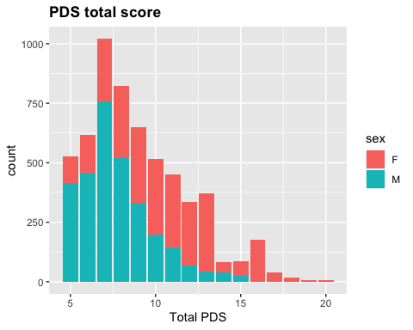

pds_tot

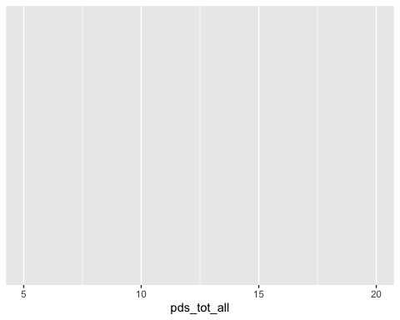

#make histogram of gonadal and adrenal development within each group   
gonad_hist <- main_df %>%  
 ggplot(aes(x=gonad_avg, color=sex, fill=sex)) +  
 geom_histogram(bins = 7, alpha = 0.5, position = "identity") +  
 ggtitle("Gonadal score") +  
 labs (x = "Gonadal PDS") +  
 theme(plot.title = element_text(face = "bold"))  
gonad_hist

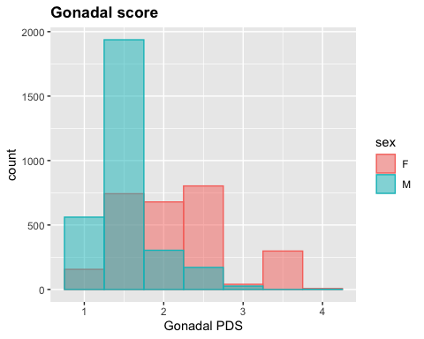

adren_hist <- main_df %>%  
 ggplot(aes(x=adren_avg, color=sex, fill=sex)) +  
 geom_histogram(bins = 7, alpha = 0.5, position = "identity") +  
 ggtitle("Adrenal score") +  
 labs (x = "Adrenal PDS") +  
 theme(plot.title = element_text(face = "bold"))  
adren_hist

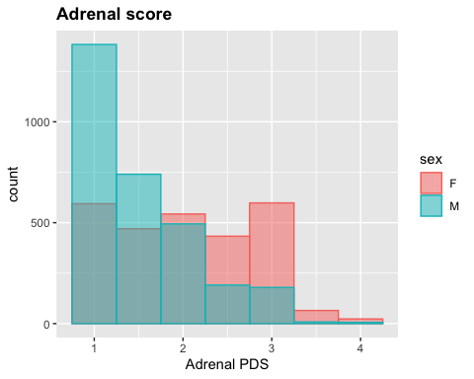

#PDS category data - there seems to be some missing data in these variables provided by ABCD.   
#let's check  
summary(main_df$pds_p_ss_female_category)

## Min. 1st Qu. Median Mean 3rd Qu. Max. NA's   
## 1.000 2.000 3.000 2.655 3.000 5.000 3018

#tidy pds category data  
cat_df <- main_df %>% mutate(pds_cat = coalesce(pds_p_ss_female_category, pds_p_ss_male_category)) %>%  
 select(src_subject_id, pds_cat, sex)  
  
str(cat_df)

## 'data.frame': 5727 obs. of 3 variables:  
## $ src_subject_id: chr "NDAR_INV030W95VP" "NDAR_INV03BDCNWM" "NDAR_INV03CV8RDT" "NDAR_INV03NW0RKL" ...  
## $ pds_cat : int 5 3 1 3 2 4 3 2 1 2 ...  
## $ sex : Factor w/ 2 levels "F","M": 1 1 2 1 2 1 1 2 2 1 ...

cat_df$pds_cat <- as.factor(cat_df$pds_cat) # N = 60 missing  
  
#get levels in factor  
levels <- cat_df %>%   
 group_by(pds_cat) %>%  
 summarise(no_rows = length(pds_cat))  
  
#rename factor levels   
cat_df$pds_cat <- recode_factor(cat_df$pds_cat,   
 `1` = "Pre",  
 `2` = "Early",  
 `3` = "Mid",  
 `4` = "Late",  
 `5` = "Post",  
 `NA` = "NA"  
)  
  
cat_hist <- cat_df %>%  
 drop_na(pds_cat) %>%   
 ggplot(aes(x = pds_cat, fill = sex)) +  
 geom_bar() +  
 ggtitle("PDS Category") +  
 labs(x = "") +  
 theme(plot.title = element_text(face = "bold"))  
cat_hist

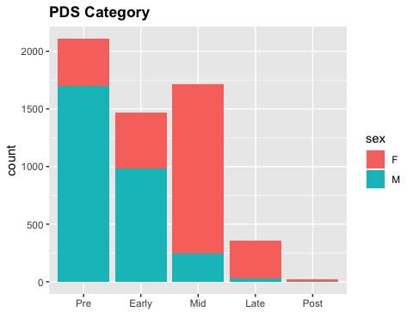

#with count scores  
cat_hist2 <- cat_df %>%  
 drop_na(pds_cat) %>%   
 ggplot(aes(x = pds_cat, fill = sex)) +  
 geom_bar(position = "fill") +   
 geom_text(stat='count', aes(label=..count..), position = "fill", vjust=1.5) +  
 ggtitle("PDS Category") +  
 labs(x = "") +  
 theme(plot.title = element_text(face = "bold"))  
cat_hist2

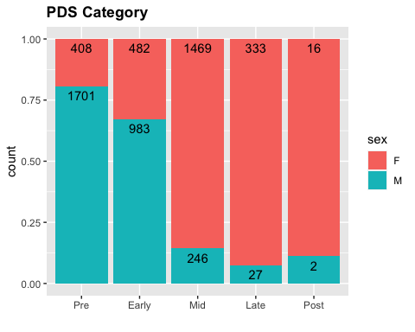

## Depression figs

dep_hist <- main_df %>%  
 ggplot(aes(x=cbcl_withdep_y3, color=sex, fill=sex)) +  
 geom_histogram(bins = 7, alpha = 0.3, position = "dodge2") +  
 ggtitle("Youth depressive symptoms") +  
 labs (x = "CBCL Withdrawn/Depressed (raw score)") +  
 theme(plot.title = element_text(face = "bold"))  
dep_hist

## Warning: Removed 92 rows containing non-finite values (stat_bin).

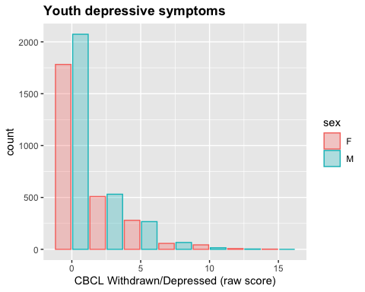

####END OF MAIN SCRIPT #######

Variables:

(split by sex) - PDS total -CBCL depression - BMI

(overall sample) - Income - Race

## Density plots

# #create separate df with variables we want to plot  
# plot_df <- main_df %>%   
# select(src_subject_id, sex, pds_tot_all, cbcl_withdep_y3, bmi_y0, household_income_y0, race_y0)  
#   
# summary(plot_df)  
#   
# #PDS TOTAL   
#   
# #get mean and save as tmp variable mu  
# mu <- ddply(plot_df, "sex", summarise, grp.mean=mean(pds_tot_all))  
# head(mu)  
#   
# (pds_plot <- ggplot(main_df, aes(x=pds_tot_all, fill=sex, group=sex)) +  
# geom_density(adjust=4, alpha=.4) +  
# geom_vline(data=mu, aes(xintercept=grp.mean, color=sex),  
# linetype="dashed") +  
# theme_classic()) +  
# labs(title=" Perceived pubertal development density curve",x="Pubertal Development Scale (total score)", y = "density") +  
# scale_fill_brewer(palette="Dark2")   
#   
# #CBCL depression  
# mu <- ddply(plot_df, "sex", summarise, grp.mean=mean(cbcl_withdep_y3))  
# head(mu)  
#   
# (dep_plot <- ggplot(main_df, aes(x=cbcl_withdep_y3, fill=sex, group=sex)) +  
# geom_density(adjust=4, alpha=.4) +  
# geom_vline(data=mu, aes(xintercept=grp.mean, color=sex),  
# linetype="dashed") +   
# xlim(0,15) +  
# theme_classic()) +  
# labs(title="Depressive symptoms density curve",x="CBCL Withdrawn Depressed (raw score)", y = "density") +  
# scale_fill_brewer(palette="Dark2")  
#   
# #BMI   
# mu <- ddply(plot_df, "sex", summarise, grp.mean=mean(bmi_y0))  
# head(mu)  
#   
# (bmi_plot <- ggplot(main_df, aes(x=bmi_y0, fill=sex, group=sex)) +  
# geom_density(adjust=4, alpha=.4) +  
# geom_vline(data=mu, aes(xintercept=grp.mean, color=sex),  
# linetype="dashed") +  
# theme_classic()) +  
# xlab("Body Mass Index (BMI)") +  
# ylab("density") +  
# labs(title="BMI density curve",x="Body Mass Index (BMI)", y = "density") +  
# scale_fill_brewer(palette="Dark2")  
#   
#   
# des_fig_2 <-   
# #display plots together  
# (des_fig <- ggarrange(  
# pds_plot,   
# ggarrange(dep_plot, bmi_plot, ncol= 2, labels = c("B", "C")),  
# nrow = 2,  
# labels = "A")  
# )  
#   
# ggarrange(  
# lp, # First row with line plot  
# # Second row with box and dot plots  
# ggarrange(bxp, dp, ncol = 2, labels = c("B", "C")),   
# nrow = 2,   
# labels = "A" # Label of the line plot  
# )

##Waffle charts for Race and income - waffle charts too complicated.

Stick to bar chats

# # Data transformation  
# plot_df$race_y0 <- as.character(plot_df$race_y0)  
#   
# race <- plot_df %>%   
# select(race_y0) %>% #select race variable only to get correct freq.   
# dplyr::group_by(race_y0) %>%   
# count() %>%   
# dplyr::ungroup() %>%   
# mutate(perc = `freq` / sum(`freq`)) %>%  
# arrange(perc) %>%  
# mutate(labels = scales::percent(perc))  
#   
# race_chart <- ggplot(race, aes(x = "", y = perc, fill = (race_y0)) +  
# geom_col() +  
# geom_text(aes(label = ""),  
# position = position_stack(vjust = 0.5)) +  
# coord_polar(theta = "y") +  
# theme_void()  
# )  
#   
#   
#   
#   
#   
# ggplot(race, aes(x = "", y = perc, fill = (race_y0)) +  
# geom_bar(width = 1, stat = "identity") +  
# coord_polar("y", start = 0) +  
# geom_label_repel(aes(label = perc), size=5, show.legend = F, nudge_x = 1) +  
# guides(fill = guide_legend(title = "Group"))  
# )  
#   
#   
# ###code working above this####  
#   
#   
# ggplot(race, aes(values = perc, fill = race_y0)) +  
# geom_waffle(n_rows = 8, size = 0.33, colour = "white") +  
# scale_fill_manual(name = NULL,  
# values = perc,  
# labels = label) +  
# coord_equal() +  
# theme_void()  
#   
# geom_text(aes(label = labels),  
# position = position_stack(vjust = 0.5)) +  
# coord_polar(theta = "y")