**House price predictor (GhorbariBechaKena.com)**



**Project Members:**

**1. 2. 3.**

Niamul Hasan Md. Anik Khan Tahura Nasrin

Id : 17201026 Id: 17201021 Id:17201031

# 

**Version Control System:**

[**https://github.com/niamul64/GhorBariKenaBecha-ecommerce-website-by-django-and-machine-learning.git**](https://github.com/niamul64/GhorBariKenaBecha-ecommerce-website-by-django-and-machine-learning.git)

**Website Hosted to This Link:**

[**http://niamul26.pythonanywhere.com/**](http://niamul26.pythonanywhere.com/)

**Profile:**

Niamul Hasan: Backend developing and hosting the website.

(github: <https://github.com/niamul64>)

MD. Anik Khan: Frontend developing.

(github: <https://github.com/CodeAnik>)

Tahura Nasrin: Quality assurance sector.

(github: <https://github.com/Tahura31>)

**1.Purpose/objective of the project:**

We will build a proper, Dedicated, free E-commerce website for the people of Dhaka city, where they will able to post advertisements about lands, flats, and apartments.   
Also, we will provide a machine learning-based flat price predicting system where people will able to predict the price of a flat based on some inputs.

**2.Project problem definition in details:**

There are many e-commerce websites to post Advertisements to sell or buy products (bikroy.com, ebazar.evaly.com.bd). Recently bikroy.com become a paid website (you need to pay, for post-Advertise).

There is no dedicated free E-commerce website to post advertisements about houses, lands, apartments (in Dhaka city). On the other hand, selling the land or flat through a broker also not financially efficient for both sides, buyer and seller. So, it is difficult for the people of Dhaka city, to buy or sell, a flat or land at a good price.

Here a dedicated website may solve the problem.

Furthermore, often a person who newly thinking to buy a flat, do not have the proper idea about pricing. So, a flat price predicting system with this dedicated website may help that person.

**3.Benefits of the Project:**

I. Effect on Society: Basically, this is an e-commerce web application. The impact of the application could be like other e-commerce web apps. The website will provide easy to use buy-and-sell platform. It will help the people of society to become economically benefited by buying or selling houses, apartments, lands at competitive prices.

II. Effect on environment: This project dose not have any bad effect on environment.  
This software is not consuming any energy from environment.

III. Sustainability: We built this Web-app on django2.2. This website making frame-work provides better security, sustainability. So, we can say that, our system is sustainable.

**4.** **Investigation:**

Depth of analysis is required to select the most feasible machine learning model. We studied about other machine learning models (Single-Variable -Linear-Regression-Model, Naïve Bayes) and we picked Multivariable-Linear-Regression-model for our project

**5.** **Project Management and finance:**

Suppose, we are working for a company and doing contract based project.(cash Amount depends on weekly work)

|  |  |  |  |
| --- | --- | --- | --- |
| Week | Work | Workers on lead | Cash Amount |
| 1 | Project Idea Finding | Niamul Hasan,  Md. Anik Khan,  Tahura Nasrin | 10000 |
| 2,3 | System Analysis and Design | Niamul Hasan,  Md. Anik Khan,  Tahura Nasrin | 10000 |
| 4 | Database Design | Niamul Hasan,  Tahura Nasrin | 10000 |
| 5 | Database Implementation | Niamul Hasan | 10000 |
| 6,7 | Backend Developing, Frontend Developing | Niamul Hasan,  Md. Anik Khan, | 20000 |
| 8 | Quality assuring | Tahura Nasrin | 10000 |
| 9,10,11 | Backend Developing, Frontend Developing, Quality assuring | Niamul Hasan,  Md. Anik Khan,  Tahura Nasrin | 20000 |
| 12 | Project Demonstration and report generation | Niamul Hasan,  Md. Anik Khan,  Tahura Nasrin | 15000 |

**6.** **Design model of solution:**

UML class diagram: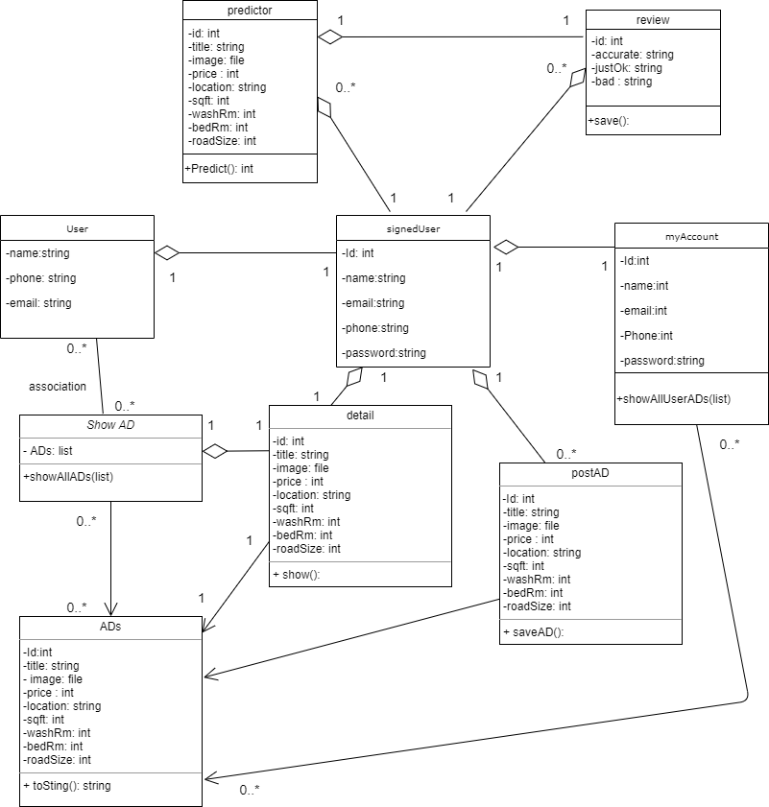

ER-Diagram:

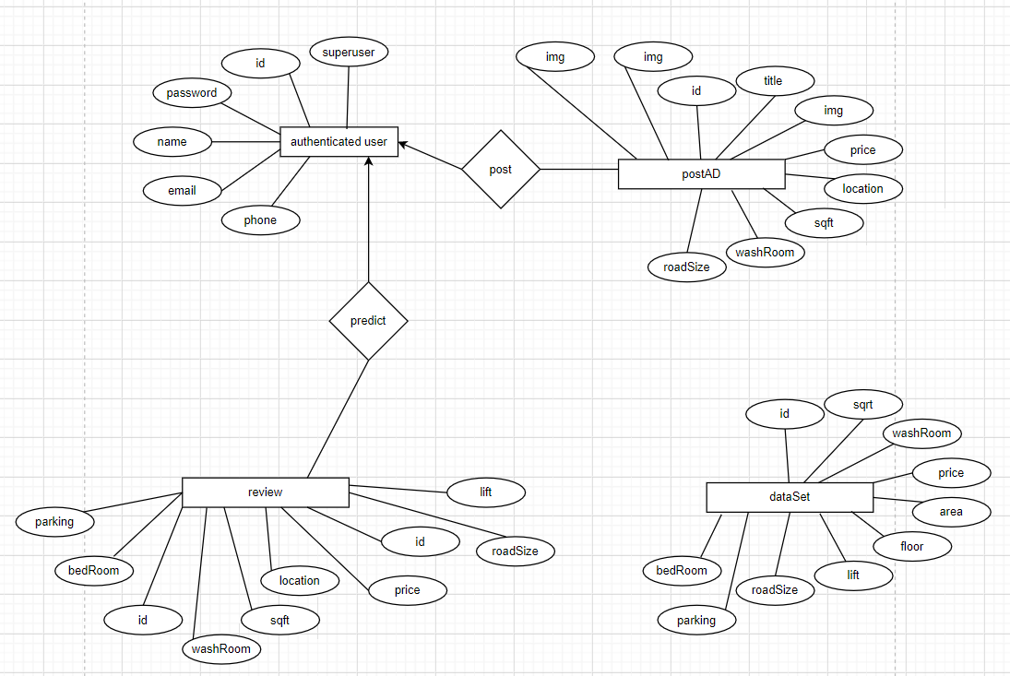

Schema diagram:

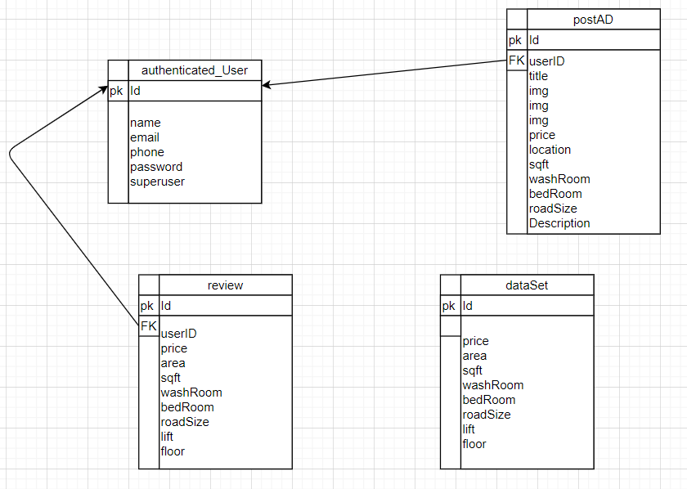

Project Developing resource:

1. sqlLite3 (database)
2. Django2.2 (framework)
3. Joblib (package)

**7.** **Risk Analysis:**

At first, we had started our project with python3.8 environment. we used joblib to use our machine learning model in django2.2. But later we faced a problem that we getting unexpected error for using joblib in python3.8 environment. After a lot of research, we found that joblib package works till the python version 3.7. joblib package wont work on python3.8.

**8.** **Final Project (sample image):**

Home page:

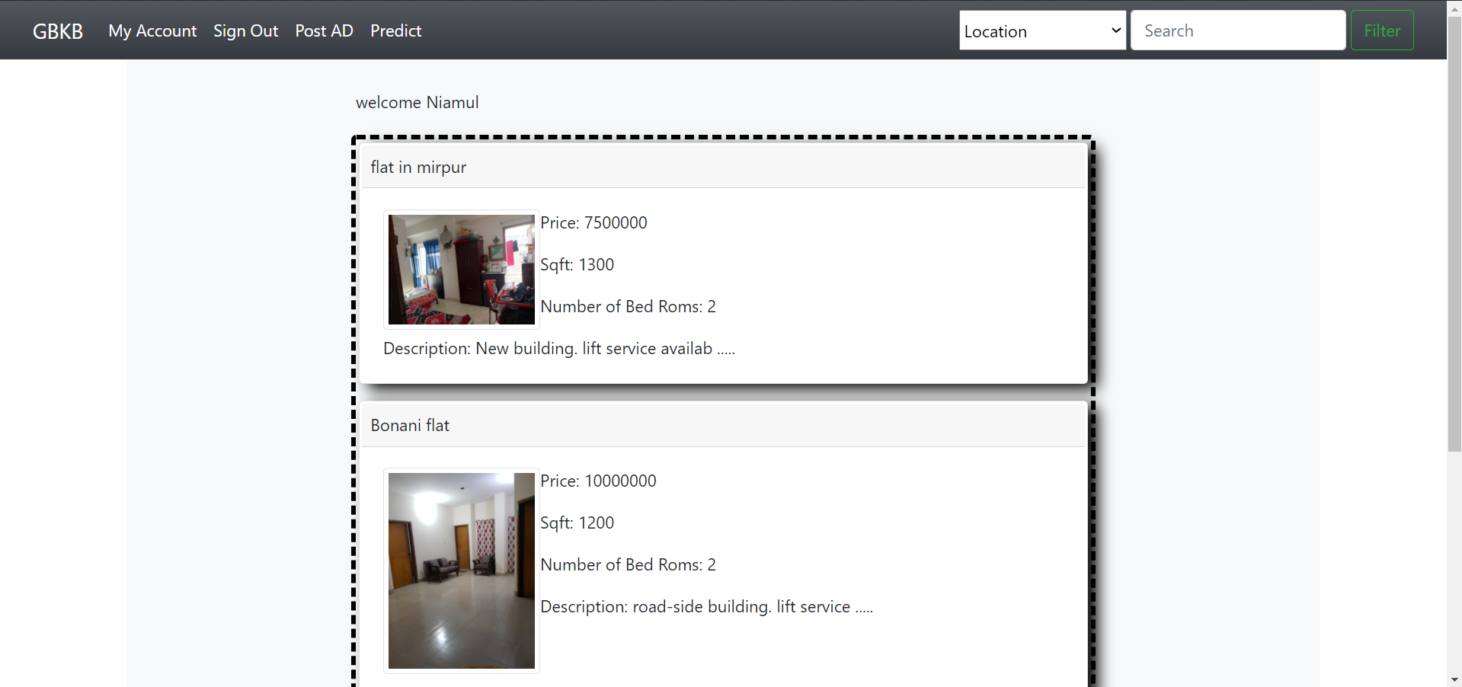

My Account page:

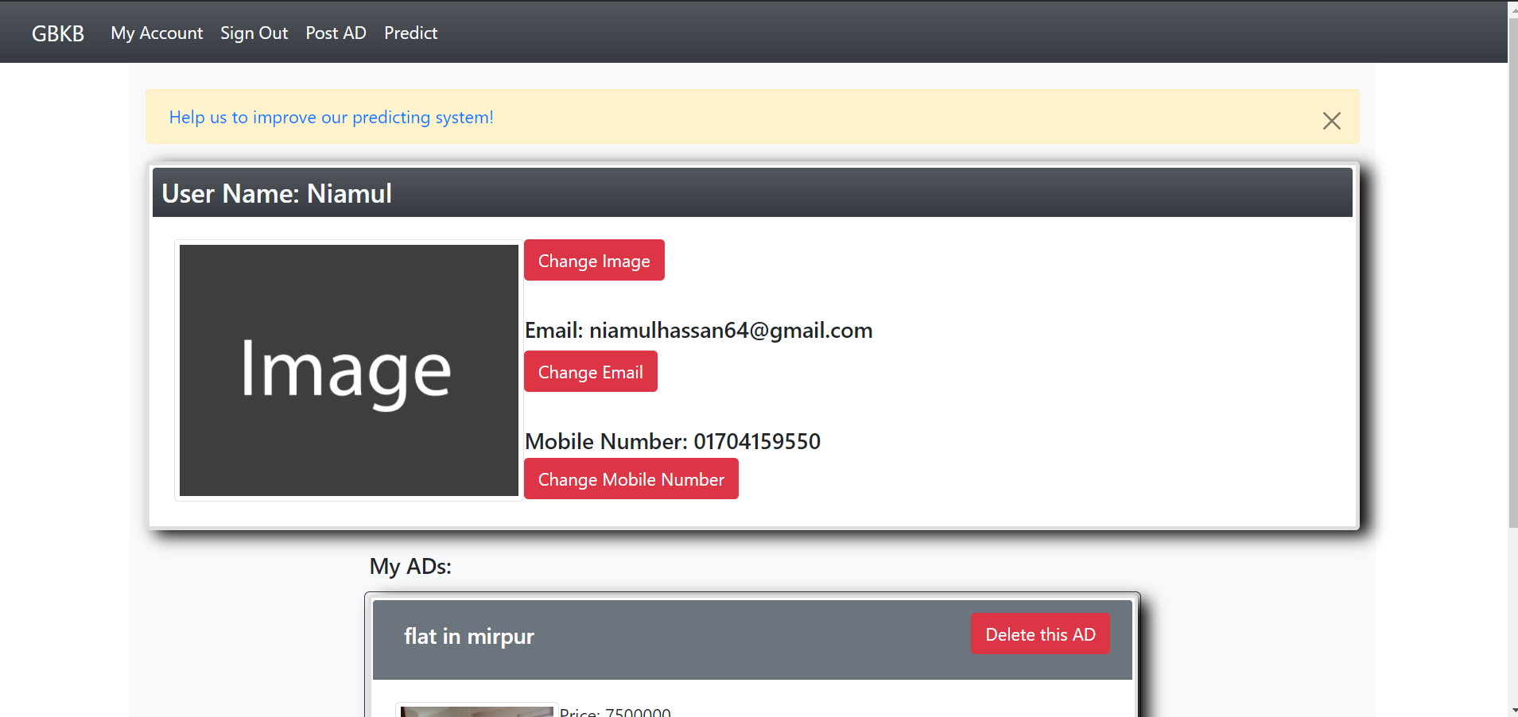

AD posting page:

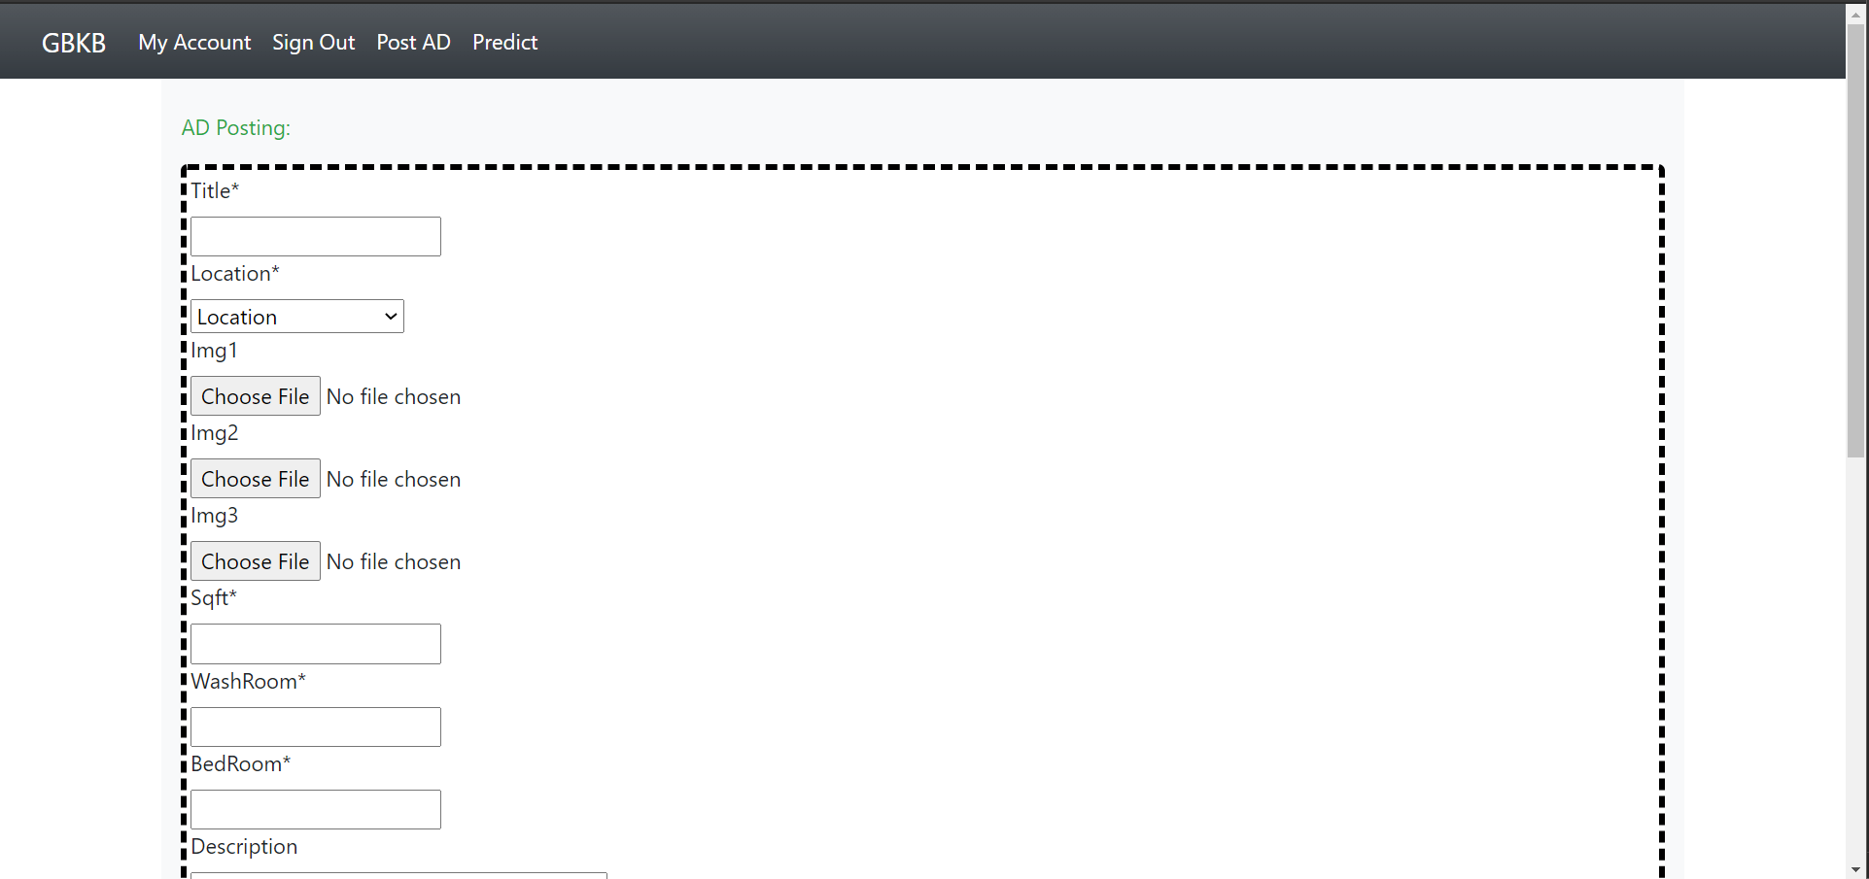

Price prediction page:

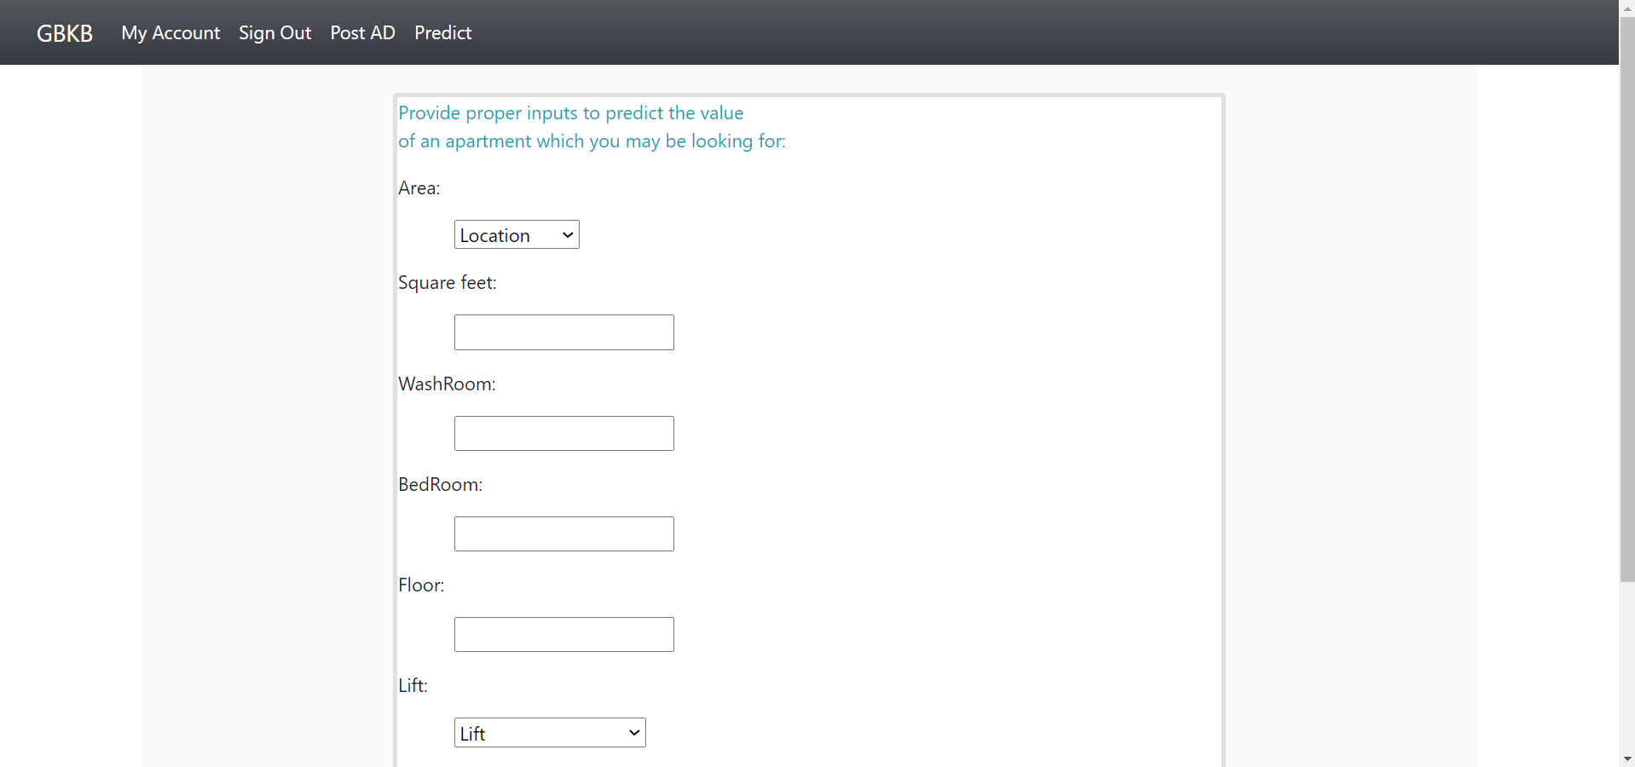

About page:



**9.** **Testing And Debugging Report:**

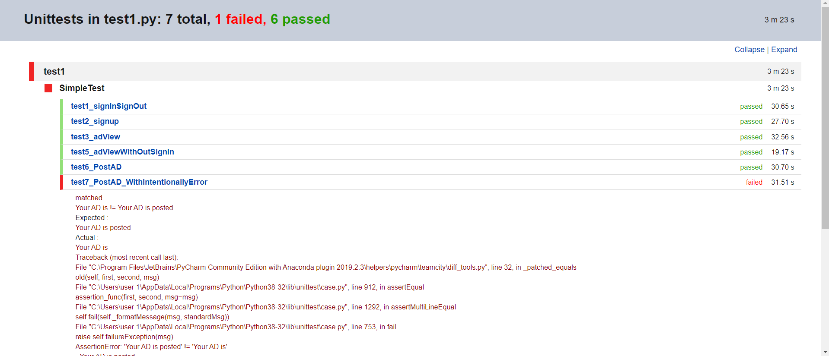

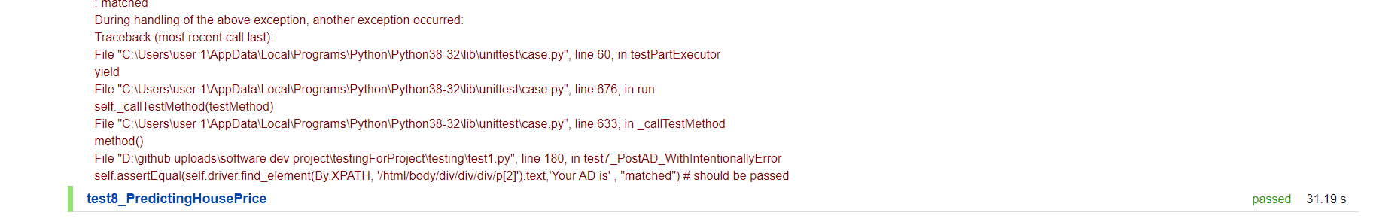

**10.** **Testing And Debugging Report:**

We learned how to use a machine learning model in a django project.

We learned about joblib package.

**11. Deployment :**

The website is deployed to this link:

[**http://niamul26.pythonanywhere.com/**](http://niamul26.pythonanywhere.com/)

Otherwise, if You want to deploy this website in local machine: (follow the steps)

1. At first set up the virtual environment. (python 3.7)
2. clone the GitHub directory, under that environment. ($ git clone <https://github.com/niamul64/GhorBariKenaBecha-ecommerce-website-by-django-and-machine-learning.git> )
3. Now change directory to ‘GBKB. ($ cd GBKB)
4. Install Django==2.2 ($ pip install Django==2.2)
5. Now again change directory to Django project ‘GBKB’. ($ cd GBKB)
6. Now run commands(1 by 1):  
   $ pip install django-crispy-forms  
   $ pip install requests

$ pip install -U scikit-learn

$ pip install numpy

$ pip install joblib

$ pip install Django-Verify-Email

$ pip install pillow

$ python manage.py collectstatic

$ python manage.py makemigrations

$ python manage.py migrate  
$ python manage.py runserver

1. Now the server is running.