1.Every thing in bootstrap is in a grid system. Container or container-fluid

Check : getbootstrap.com/css/#grid

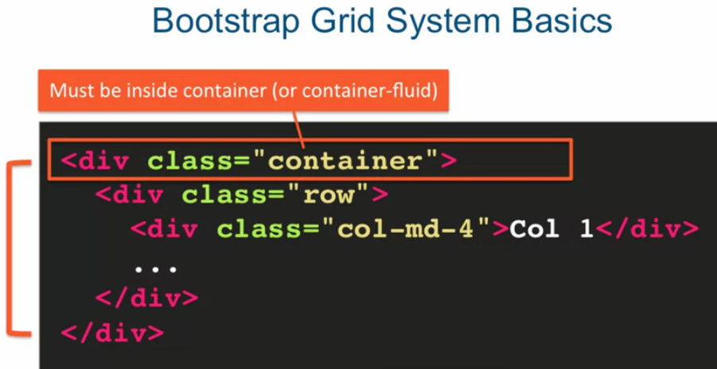

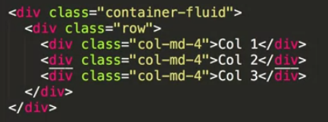

Here: “col-md-4”

‘col’ means column

‘md’ means medium

‘4’ is span size

2. <ul class="ml-auto"> used to take elements at right side

3.<h1 class="text-center pt-3">Welcome to my blogs</h1> used for spacing :"text-center pt-3"

4.<hr/> have line:”----------------------------------------------------------------------------------------”

5.<blink></blink> to make a text blinking

6.<div class="container"></div> its used to have a mrgine in the page

7. NAVBAR: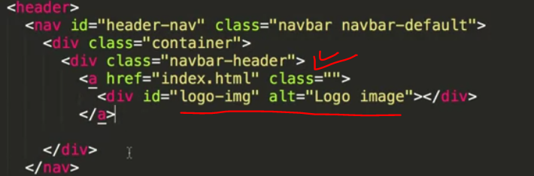

We should place all the Navbar element inside the class div of “navbar-header”

We can place the icon img as background image inside the css file to make the image better setup.

So that we can use the div of id “logo-img” now at css file:

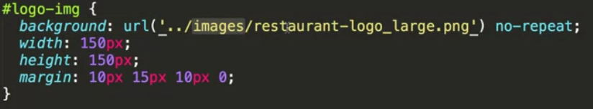

And we should give the name of the company in “navber-brand”

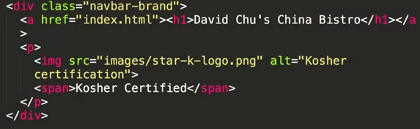

8.in bootstrap class=“pull=left” is float-left

9. if, we want some thing to display only if the browser window is big enough then we use:

Class= “visible-md visible-lg”

It means if the is browser large size and medium size the show it otherwise don’t.

10. navbar toggle button.

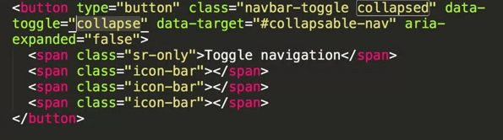

Now we need to specify the list of button and other things for this toggle:

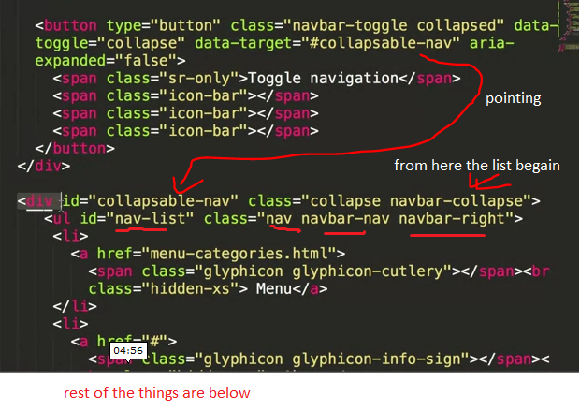

Here the id= “navbar-list” is for the coustom style from our css file.

Here nav and navbar-nav classes are used to say that this list is components of navbar

navbar-right is used to say -> stay at right of navbar

11.when the screen is extra small the not show this element : class= “hidden-xs”

12. tap and directly dail to phone number:

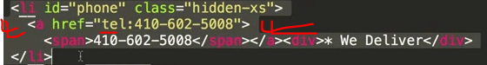

Here id= “phone” used to have some coustome style

13.change color when hover over: 