import numpy as np  
import matplotlib.pyplot as plt  
  
x = np.linspace(0, 5 * np.pi, 1000)  
  
x=[0,1,2]  
y=[0,1,0]  
  
  
plt.fill_between(x, y, facecolor="b")  
  
plt.show()

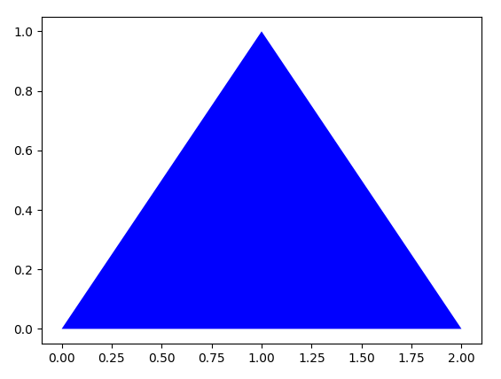

参考资料：

1、<https://matplotlib.org/api/_as_gen/matplotlib.pyplot.fill.html>