1 课题内添加标签或者设置标签显示/隐藏错误:

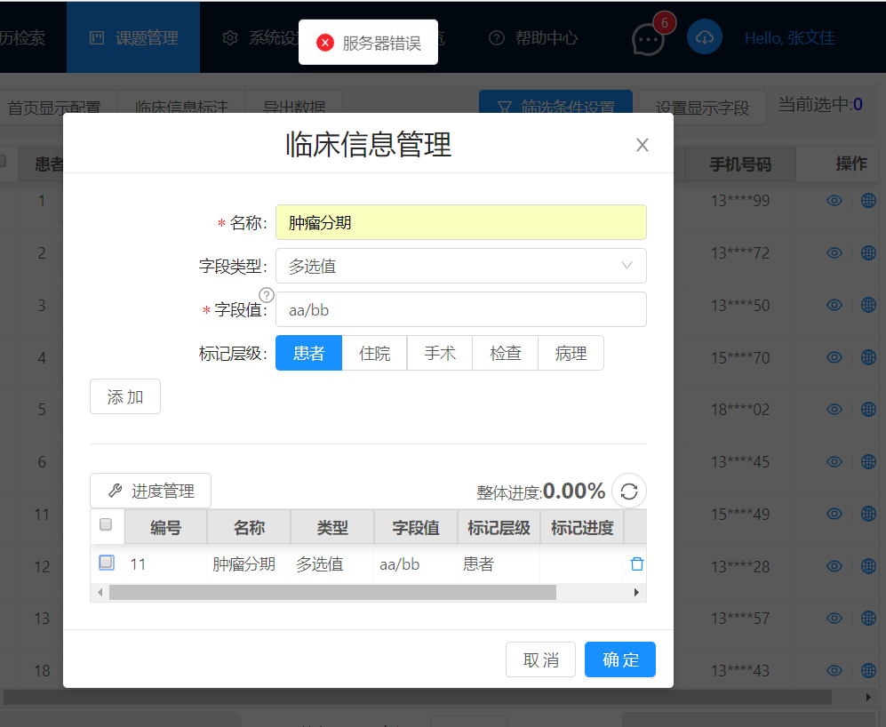

API: <http://192.168.17.165:3000/api/ProjectTag/TagShow> POST

Body: [{"id":11,"isShow":true}]

2. 设置标注进度报错500

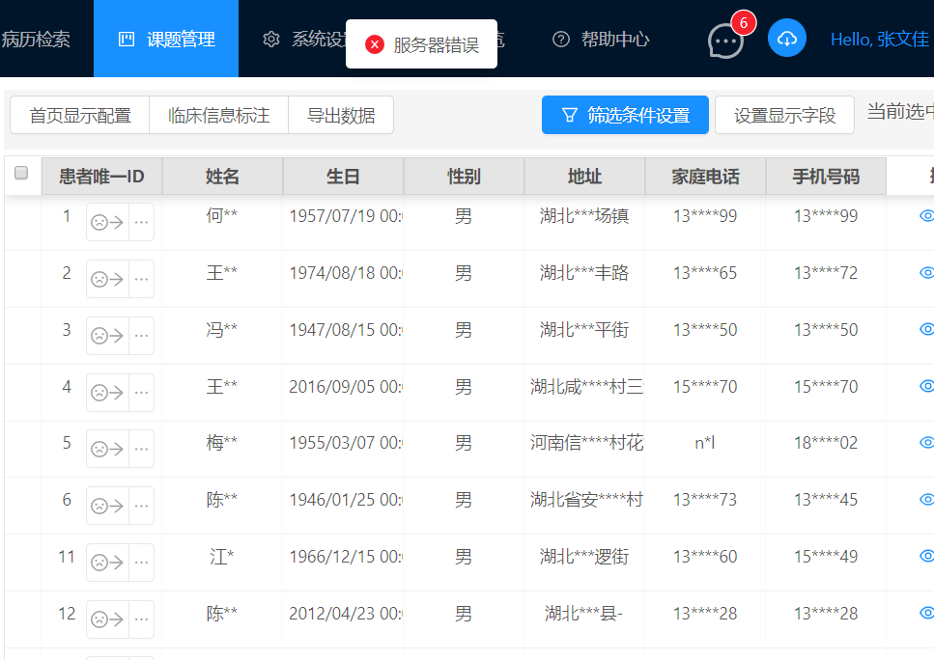

API: <http://192.168.17.165:3000/api/ProjectDataStatus/Data> POST

body: {"projectid":"7","patientGlobalId":1,"projectDataStatusId":"20"}

3. 课题内无法选中条目, 返回的数据没有_key字段

示例数据:

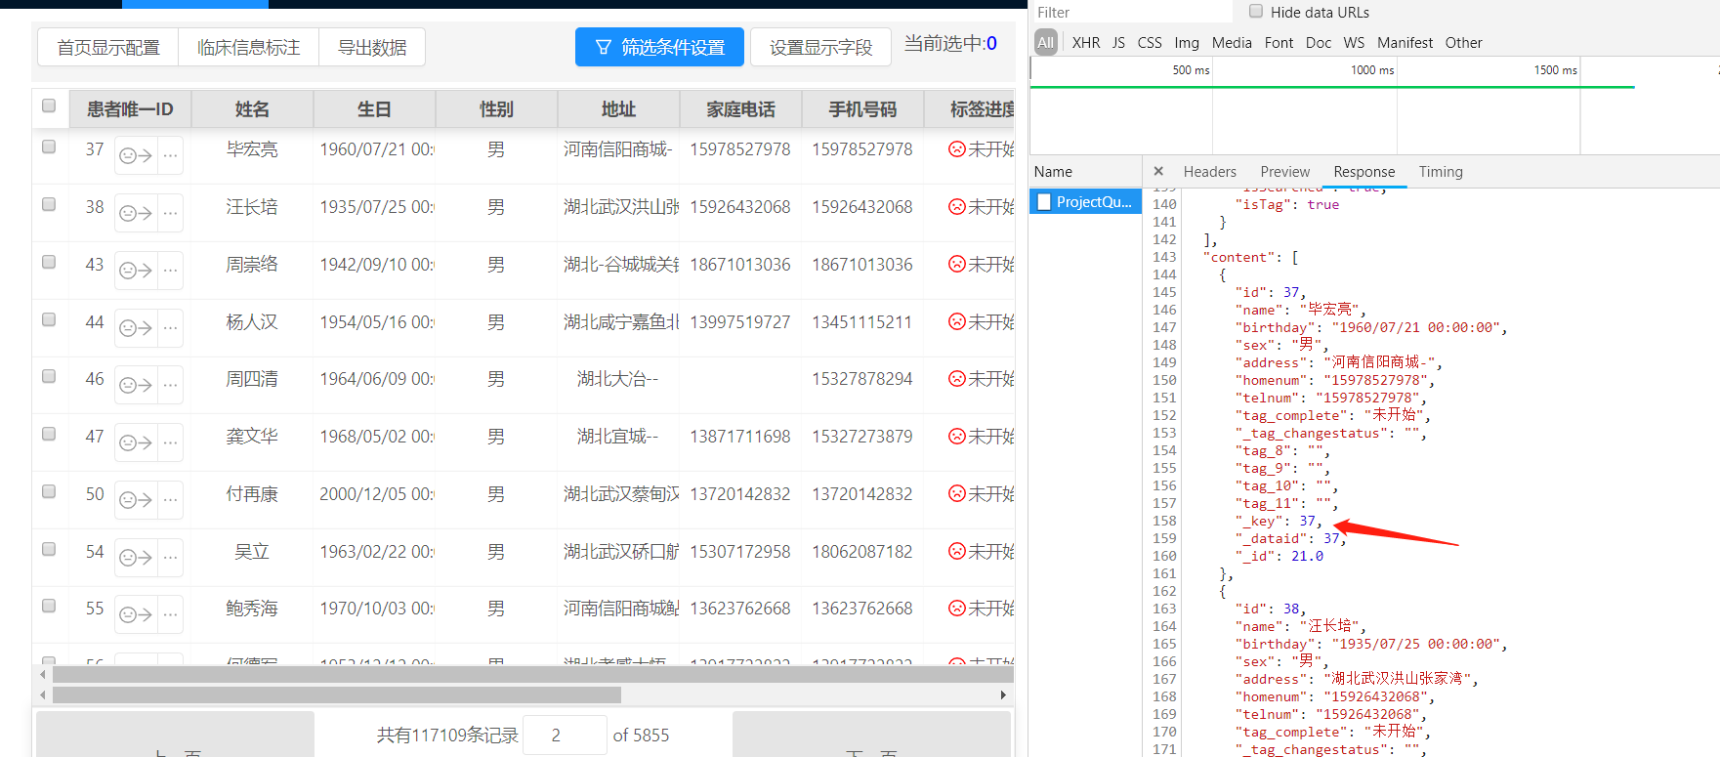

4 进度过滤无效(即过滤以后全部为空了！)

